The new Event Attendance Module with Check-in enables the Reps to identify Retail Pros in attendance as well as to start, complete or confirm their links to both the Retail Engagement Program and ExpertZone program when attending an event.

Note that some options require internet connectivity at the event.

There are changes added to the existing Event report in which Retail Pros are the primary audience. Visible changes are:
- The text ‘Store Associates’ has been replaced by ‘Retail Pros’ throughout the event report form.
- Two global questions are removed from the Attendee Details section.
- Added the Check-in Attendees button to trigger an attendance sub-form.
- Count of total attendees is shown right above the new Check-in button.
There will be no change if the primary audience of the event is selected as Customers.

How to enable the new Check-in feature for a country
The new check-in feature can be enabled through Action center by the admins for their respective countries. Open Action center. There will be one Event Report Check-in question as shown in the image below. By approving this question, all the changes will be updated in the Event report forms.
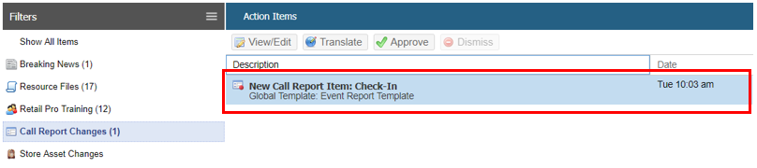

The notable changes made to the Event report includes deletion of the Retail Pro related global questions under the Attendee Details section, “Which retail chains were represented at this event?” and “How many Retail Pros attended this event?” Secondly for Retail Pros audience only, there is a new Check-in Attendees button and counter. (No changes will be made for Customer events.)
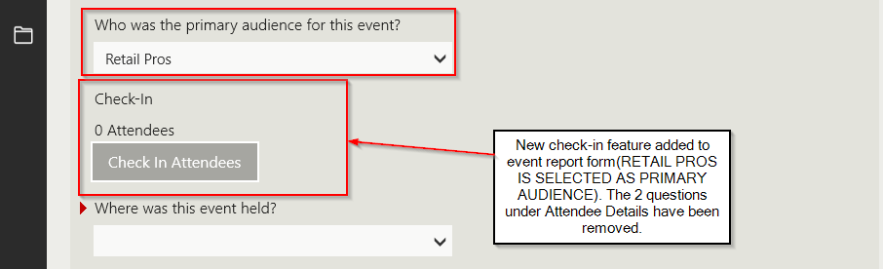

Note: for detailed information on using the Check-in feature in the app, see the Rep User Guide for Check-in.
When reps use the Check-in button to open an attendance sub-form, they will be able to do the following:
- Retail Pro attendees can be checked in to an event by scanning or entering the EZ ID (requires internet connectivity at the event) or by using the RP name, from the REP database.
- Reps can check-in and add the attendees as a new Retail Pro with store location and email address and assign an EZ token on the spot. The new RP will be added into the REP Retail Pro database.

Changes in Call Reports > Manage > Transaction Report page
In the manage call report page, following changes are made to the Event report.
- Question prompt “Which retail chains were represented at this event? (select all that apply)” is now populated from Check-in data entered by the rep.
- Question prompt “How many store associates attended the event?” is now populated from the count of attendees which belongs to a chain.
- Question prompt “List the name and title of the attendees of the event” is populated from Check-in data entered by the rep. The name of the RPs checked-in and the store they represent are displayed under this column.
- An additional column named Check-In has been added to display the total count of all the attendees that have attended the event. (Includes the count of totally anonymous RPs too).

