User Management Controls for Administrators
User Management UI Improvements:
1. Admins can now make changes directly to the Product Categories supported by Reps using a new checkbox grid in an interactive UI. The checkbox grid has replaced the Yes / No indication in all the Rep rows. The previous method of using the Edit User function for each individual user to open a pop-up is still available with the Products tab, but the interactive UI will allow making changes to several Reps at one time much easier and quicker.
After checking or unchecking a Product category, click the Save Changes button to complete. (Figure 1)
Tip: You may want to use the collapse / expand control to expand the panel of the UI first.
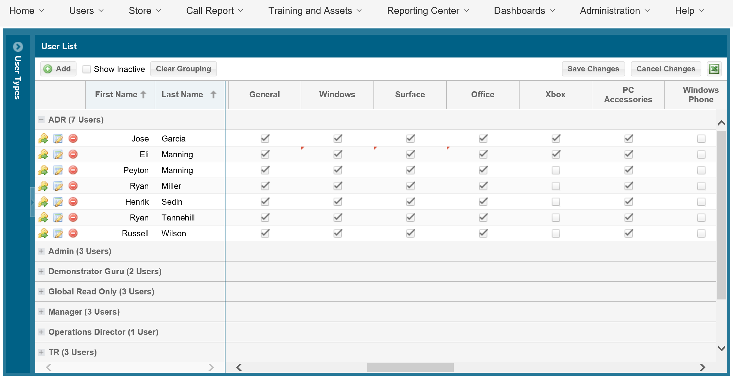
Figure 1

2. In a similar fashion as above, Admins can make direct changes to other important fields. This feature is available for modifying any user and all titles just by clicking on the field to produce a text box or a dropdown with choices. To make this even easier, we have added the ability to scroll while freezing the First Name and Last Name columns. (Figure 2)
Tip: The fields that can be changed in the interactive UI are: First Name, Last Name, Email, Time Zone, Rep Type, Full Time / Part Time, Title, Active, Submissions Alerts, Managers Assigned.

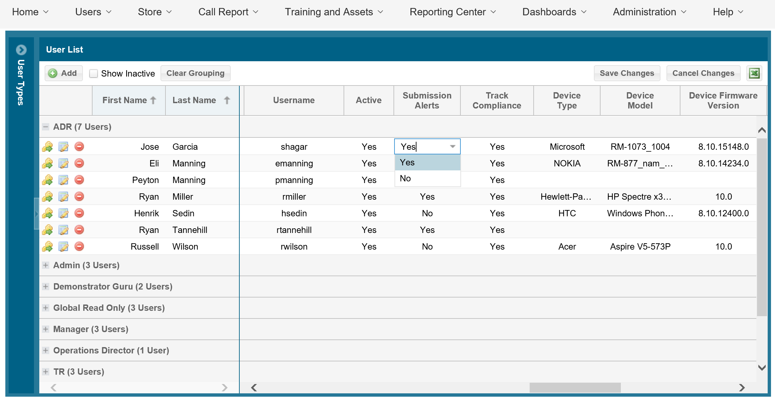
Figure 2

