What’s new in the Android App 2.0.11 update?
Changes have been made to the look of the Android REP app. These are mostly cosmetic except that the Settings are now on their own page and the back button is used to get back to the main/home page.
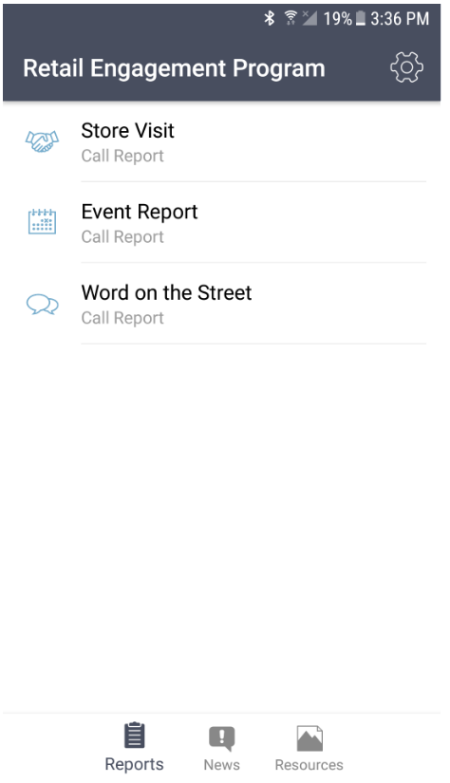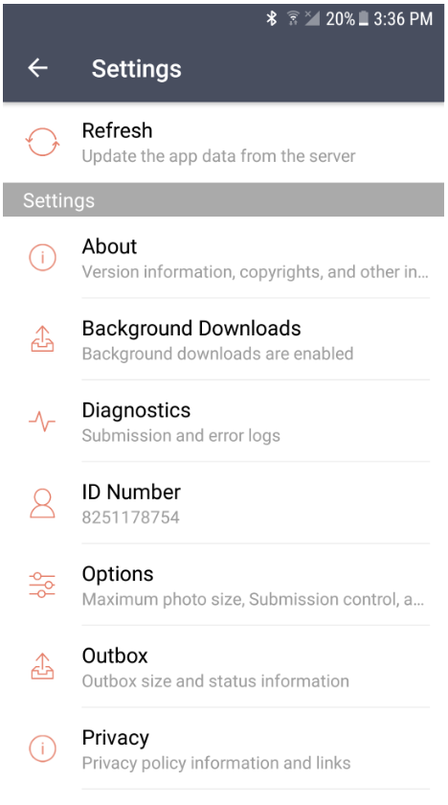

Here is what users will see with the latest Android REP app:

- The settings icon button is in the upper right of the app in the header.
- There is no refresh icon button on the home page.
- A swipe down of the home page will do a refresh.
- There is a refresh button in the list of Settings on the settings page. It is at the top of the list.
- News item images are always downloaded when the user does a refresh.
- Non-news images and other files are only downloaded if the user has enabled it with the new Background Downloads setting.
- There’s a new Background Downloads setting. The default setting is “Enabled.” Users will no longer see a “do you want to download resources?” question!
- If the user disabled background downloads and they want to open a Resource file, the app will download it right then when attempting to open it. From then on, it will be available even offline.

I am seeing more data usage on the mobile network than usual; how can I control that?
There are several possible causes for high data usage. Here are some tips to reduce it.
1. Check your device network settings before opening the app. Whenever possible, use Wi-Fi to download content for the app’s first usage of the day, and later in the day to upload completed forms. Uploading photo-heavy call reports can use quickly use a high amount of mobile data. Set the device camera to take the smallest acceptable photo size.
2. In the app there is an option to enable/disable the download of available Resource Files. If the device is using the mobile network, and you are concerned about data usage, you may want to disable. Once the device can connect to a Wi-Fi network, then change to Enabled.
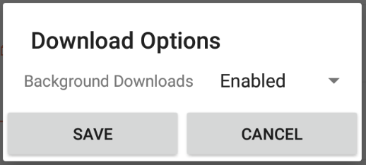
3. During a new installation of the app there is a larger download of Resource Files, form questions, Location information and Retail Pro information. This can use a high amount of mobile data, especially if the file doesn’t finish downloading. (The app will continue to try until the file is fully downloaded.) Admins should check to be sure that no old, unnecessary Resource or Training Files are active (and set to download).

Can I delete old copies of the app APK?
Yes, previous versions of the app installation package can be safely deleted. On the device, go to Apps > Files > Downloads (may be slightly different by device) and look for the “app.apk” files. Simply select them and then delete.

Where can I download the app if I have trouble using the Google Play Store?
Reps can also download the app here:
https://www.msftreps.com/altrepinstall/reptool.apk
When not using the Google Play Store, the app can be “side-loaded” using the steps below. Do not store the app itself on an installed SD card. Follow the steps to download and install on your Android device (OS 8.0 and above):
- Set your device to allow “Install unknown apps” or “Install apps from unknown sources”
  - Go to Settings, then search the word “unknown”
  - Select “Install unknown apps” or “Unknown Sources”
  - Some devices will enable this setting by browser, click “allow” or “allow from this source”
  - Check the box to allow or enable
  - If you cannot find that option with these steps, refer to the manual for your make and model to allow for Unknown App install
- Make sure you have a strong highspeed internet connection on Wi-Fi or your mobile network (using Wi-Fi network will save mobile data)
- Close all the browsers that are currently running
- Click the link or copy and paste into a new browser session: https://www.msftreps.com/altrepinstall/reptool.apk
- Watch for the download message at the bottom of the browser screen
- Follow the steps given on the device to download and install the app
- Open the downloaded app and enter your 10-digit REP ID
- The main menu should be visible once the steps are complete

How do I know that I have the latest update for the app?
Check the bottom of the REP landing page at www.Msftreps.com. Current versions are listed for all the apps.

How do I edit the photos taken for Photo questions in call reports?
There is an option to delete the photos taken, allowing reps to retake the shot. There is no option to upload a photo from a file folder such as found in the Windows app.

The REP support team has asked for a copy of the diagnostics from the app. How do I copy the diagnostic file for support tickets?
Go to Settings > Diagnostics. Tap the Share button at the top of the page. Next, when “Share” options appear, select your preferred email app. This will automatically paste the diagnostic file into your email and your 10-digit REP ID in the subject. Then send the email to msftreps@westlakesoftware.com.

Android testers are stuck in beta version of the app.
Some reps in the beta test group can’t see the production app in the Play Store. Here are the steps to release from the beta program for Android:
1. On device, uninstall the current app
2. Visit testing opt-out page (any browser) https://play.google.com/apps/testing/com.westlakesoftware.rep
3. Under “Leave the testing program,” choose Leave the program.
4. Search the Play Store for Retail Engagement and install the latest REP app
(May require a restart of the device.)
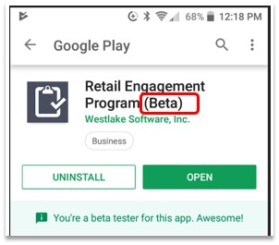

Can I use the Event Report on Android?
Yes, provided you have upgraded to version 1.0.5 or higher. The Event form now has the check-in feature and works much like Windows (requires a bar code scanner app). Check-in is used for checking in attendees at Retail Pro and Commercial Rep events.
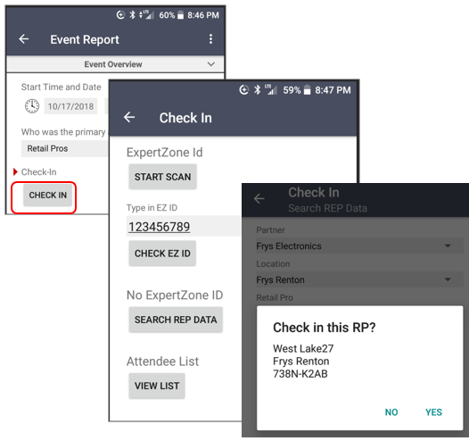

Revised: June 11, 2019

