App Studio for Admins
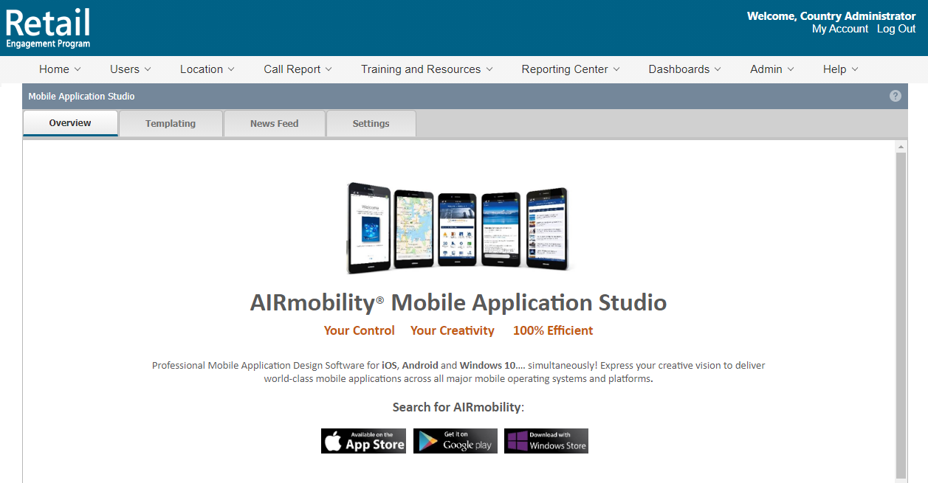

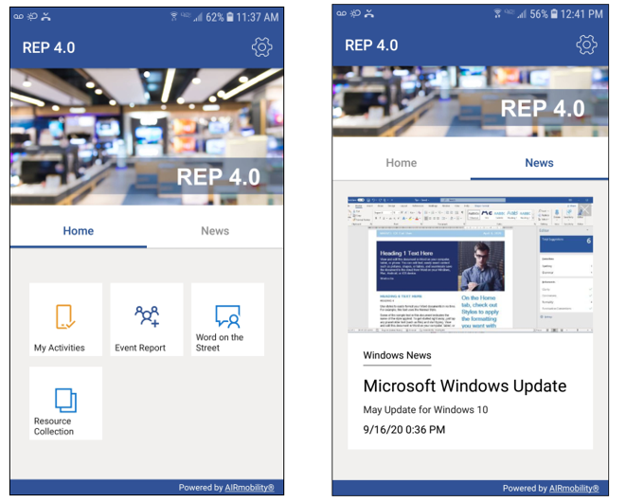

For: www.msftreps.com
Published: 10-02-2020

OVERVIEW
The Application Studio (“Studio”) is a design center to enable REP Admins to control many aspects of the REP application experience to the end-user.
The edits made in the Studio are driven out to our REP 4.0 apps in near real-time and do so simultaneously across platforms:
- Android
- iOS
- Windows 10
- Web Entry (mid-October, 2020)

This documentation will:
- Guide you through the Studio tabs and functionality as a Country Admin or Regional Admin*
- Illustrate how your changes affect the REP 4.0 apps
- Offer tips on providing a more engaging app user experience in the field
- How to use the Admin Preview ID prefix 999- for simulating a REP 4.0 user experience
*Mentioned but not covered in this document is using App Studio for the Champions Program.

Opening App Studio
Login to MSFTREPS.com with your email and password. Open the Admin top menu drop-down and select App Studio. The Studio opens and you will see 4 tabs.
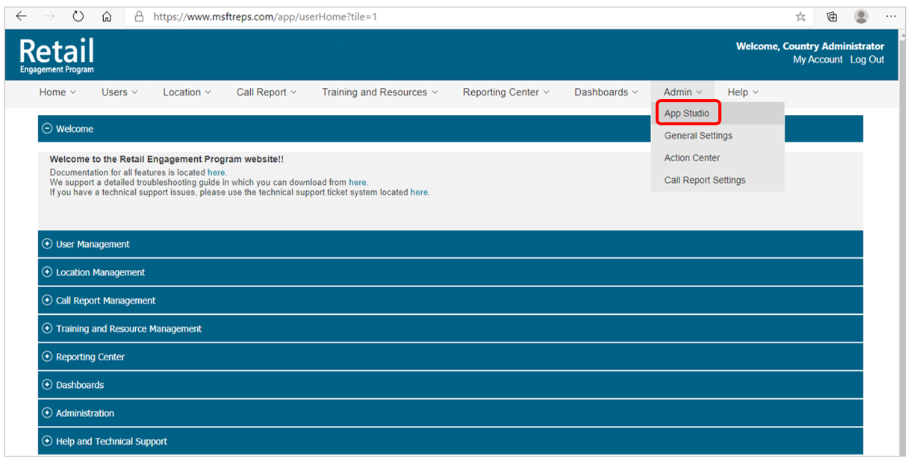

Overview Tab
This tab provides a bulleted table of contents to help find a feature or function that you are looking for. This document is linked to the “?” info button in the upper right-hand corner.
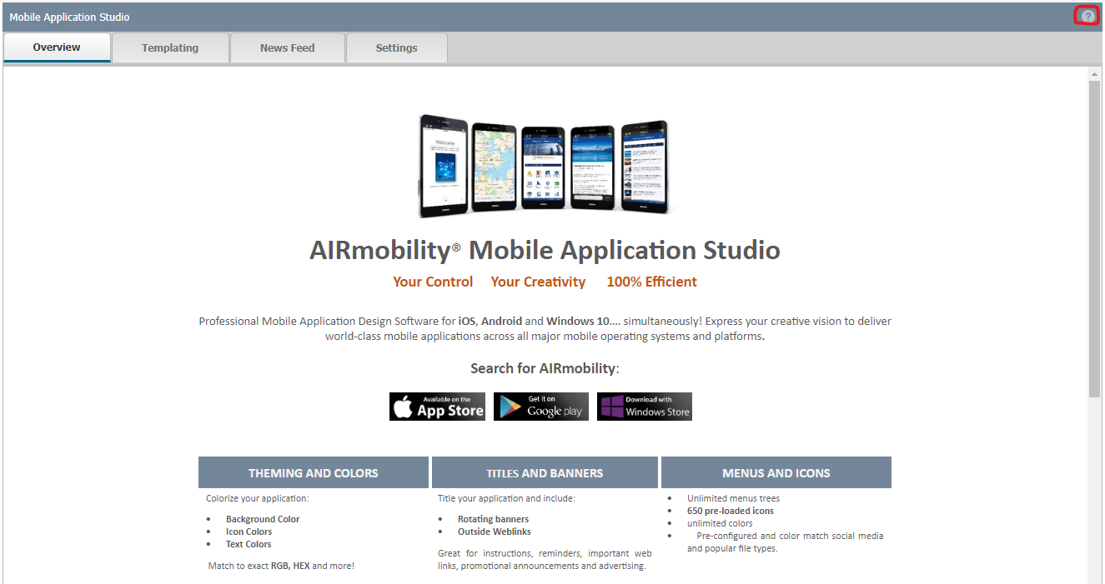
Templating Tab
This tab allows for customization of the app title, theme color and banners. Microsoft defaults have been pre-configured at launch but can be amended as follows.
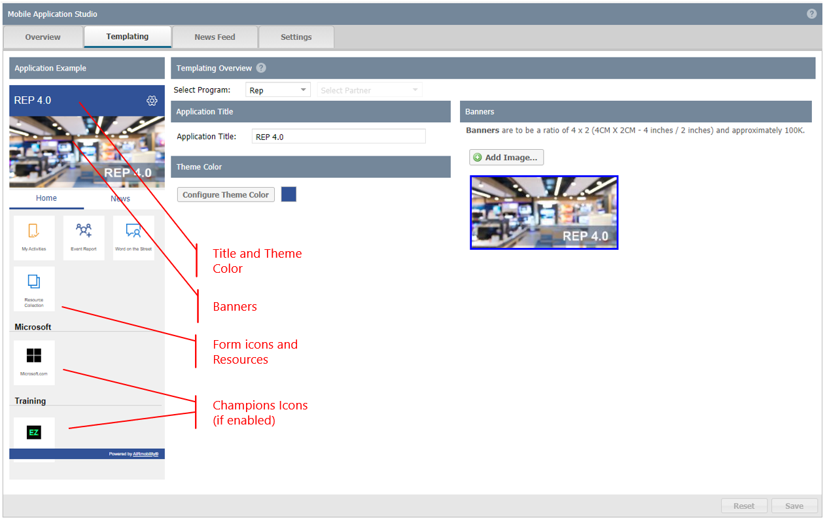
Application Example (emulator):
Note that in the left side of the Studio there is an Application Example (emulator) which closely approximates what will be seen on the app. Remember that changes made here are immediately available to the 4.0 apps and will be seen after a refresh!

To make changes to the Application Title (in the header of the app):
- Select Program – choose the REP option
- Type your new Title text in the Application Title field (not recommended to exceed 25 characters, max is 100 characters)
- Review the change in the emulator on the left
- When satisfied with the new Title click the Save button in the lower right corner
- A confirmation will pop up…click OK
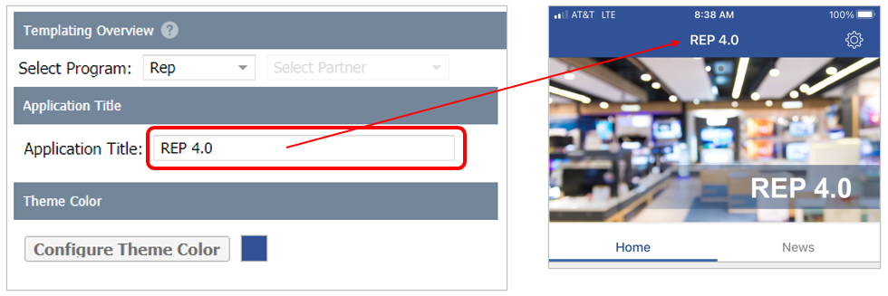
To make changes to the theme color:
- Select Program – choose the REP option
- Click Configure Theme Color button; this will open a color matrix to choose from
- A set of stock colors are available
- Advanced options enable you to match to exact HEX/RGB to corporate colors, etc.
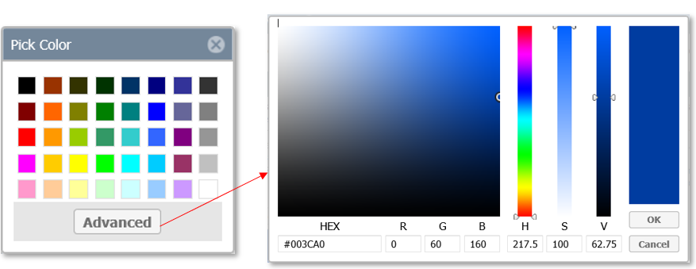
- Select the color choice and review in the emulator on the left
- When satisfied with the selection click the Save button in the lower right corner
- A confirmation will pop up…click OK

TIP: To abandon any change that you have started you can click Reset in the lower right corner of the tab to restore the tab to its previous state.

Banners:
Banners is a multi-purpose feature that has high visual impact on the app.
- Upload more than one banner graphic (which will then rotate on the app)
- Banners support links to URLs if desired
To add an additional image:
- Select Program – choose the REP option
- To add an additional image, click the Add Image button
- Click Browse to search your computer folders for the desired image or graphic (recommended aspect ratio is 4 x 2: width x height)
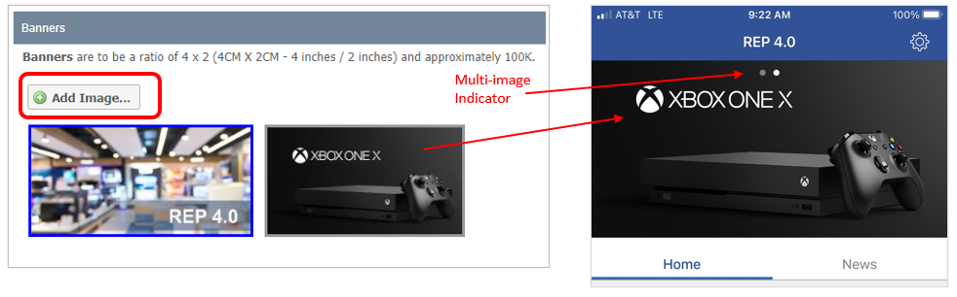
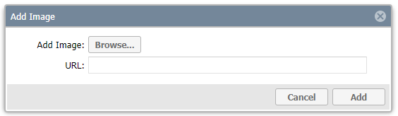

- Select the image file and click Open to import it to the Studio page
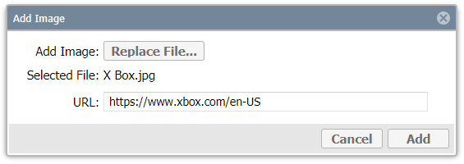
- Enter in a URL if the image is to be linked to a web page, including the http:// or https:// in the URL field
- Click Add to complete the image upload
- When satisfied with your changes click the Save button in the lower right corner
- A confirmation will pop up…click OK
- The new image should be visible in the Banners area of the page; the best way to test the change is to follow the Admin Preview procedure at the end of this document

To make existing banner images “clickable” with a link to a URL:
- Select Program – choose the REP option
- To add a URL to an existing image, right click the image
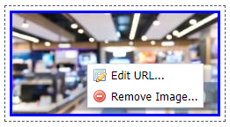
- Click Edit URL
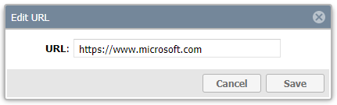
- Enter in the web page including the http:// or https:// in the URL field
- Click Save in the Edit popup
- When satisfied with your changes click the Save button in the lower right corner
- A confirmation will pop up…click OK
- The only way to test the change is to follow the Admin Preview procedure at the end of this document

To remove an image:
- Select Program – choose the REP option
- To remove an existing image, right click the image
- Click Remove Image
- Click Save button in the lower right corner
- A confirmation will pop up…click OK

News Feed Tab
Another highly effective way to communicate with your team with visual impact is by adding regular news updates. There is no limit to the topics and categories of news articles you can send directly to the app, in near real-time. Articles can be targeted to an audience by using filters for Partner, User Title and individual Users.
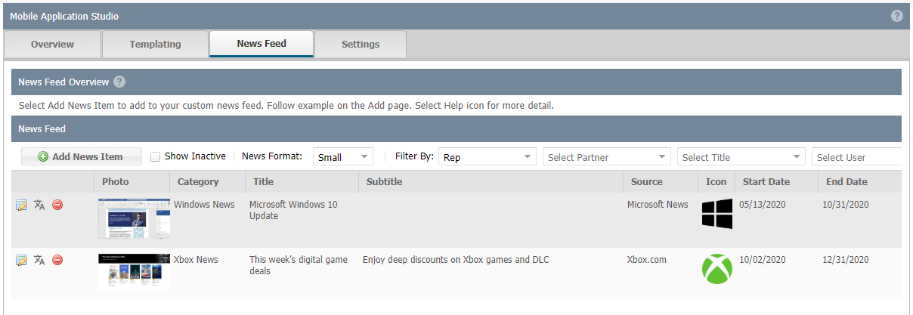

To add a news article:
- Click on Add News Item
- Create News Item user interface opens
- Enter the Title, Subtitle (optional) and Body of the article in the top of the UI
- At the bottom there are 3 tabs to use for customizing and targeting to the correct audience: News Settings, Image and Assignments
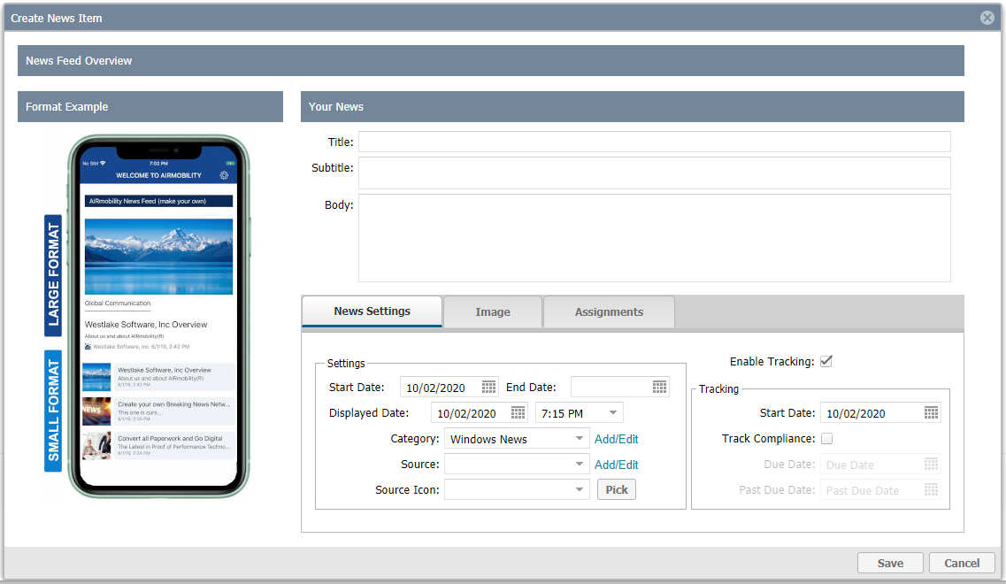
TIP: Some of the steps and fields will be like Breaking News in the legacy REP application but the articles created here will only appear on the REP 4.0 apps.

News Settings:
- Start Date and End Date – active status range of dates
- Displayed Date and Time – when you want the article to appear on REP 4.0 apps
- Category- configurable option that will appear in the article preview and article
- Source – configurable option that will appear in the article preview and article
- Source Icon – select from a list of icons to tag the article for visual appeal
- Enable Tracking and Tracking – for future use (can be disregarded for now)
Image:
- Upload the image that aligns with the content of the article
Assignments:
- Program - select “Reps” (Champions program will also use this filtering scheme)
- Start with Partner tab, then Title and Users for simplest method of filtering (work L to R)
- Choices available in tabs are dynamic based on selection of the previous tab
- Partner tab - drag and drop left to right, or select and use the arrow controls to move the desired Partner audience for this article
- Title tab – filtered based on Partner selection, select any additional filtering by Local User Title, uses same controls, drag left to right
- Users tab– most granular filter is possible at the user level
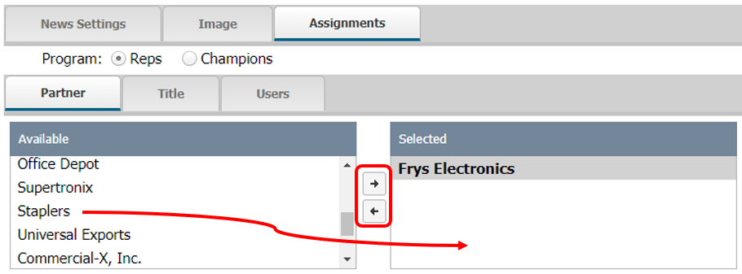
- If no Partner – Title – Users filters are used, the article will just be available to all REP 4.0 apps
- Click Save in the lower right corner to complete the configuration of the news article.
- The article will be available to view the next time the Reps refresh the app.
- Back on the News Feed UI use the News Format selector to designate the format on the apps in the News tab. Examples are shown in the Add / Edit News Item UI.
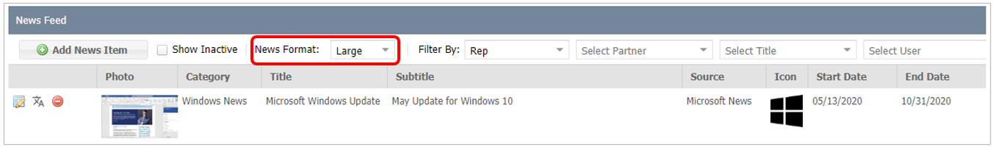
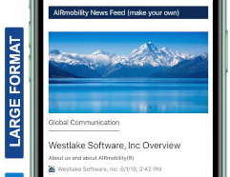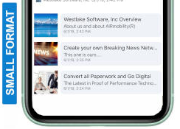
TIP: Filters on the News Feed header are used for filtering your list of articles by audience for a convenient way of viewing.

Settings Tab
Use the setting to designate the Studio tab you wish to start on when returning.
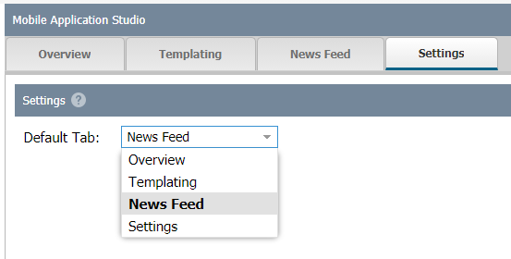

Admin Preview for simulating a REP 4.0 user
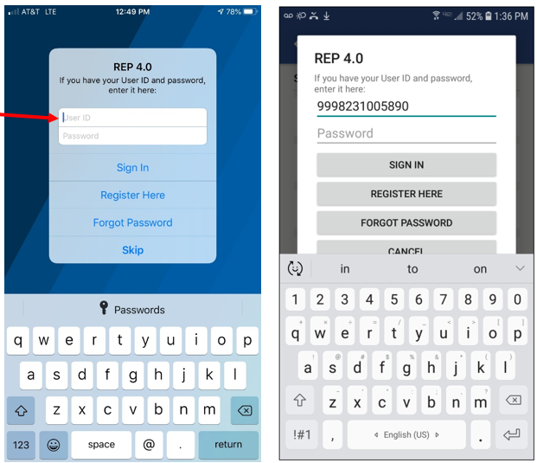
To view what a specific Rep is seeing on the app:
- Works on REP 4.0 apps only
- Provides “Read only” access (will not submit a report)
- Enter 999 prefix plus the Rep’s 10-digit ID
- No password needed
- Click “Sign In”

Support
Send any questions or concerns to msftreps@westlakesoftware.com. Please include the following.
- Your name
- MSFTREPS user email
- Country / Region
- Browser information
- Description of the issue with any screenshots or error messages
Note: The more information you can give us to reproduce the issue, the more quickly we can diagnose the problem.

