Store Asset Tracking Overview
Asset Management is a new REP feature used to track the physical assets for each store. The new REP app (versions 3.0.88.0 and higher) will display those assets associated with each store, and allow the rep to view and update this content. There will also be a review process in which the local Administrator accepts or dismisses the changes which are reported by a rep through the standard form submission process.
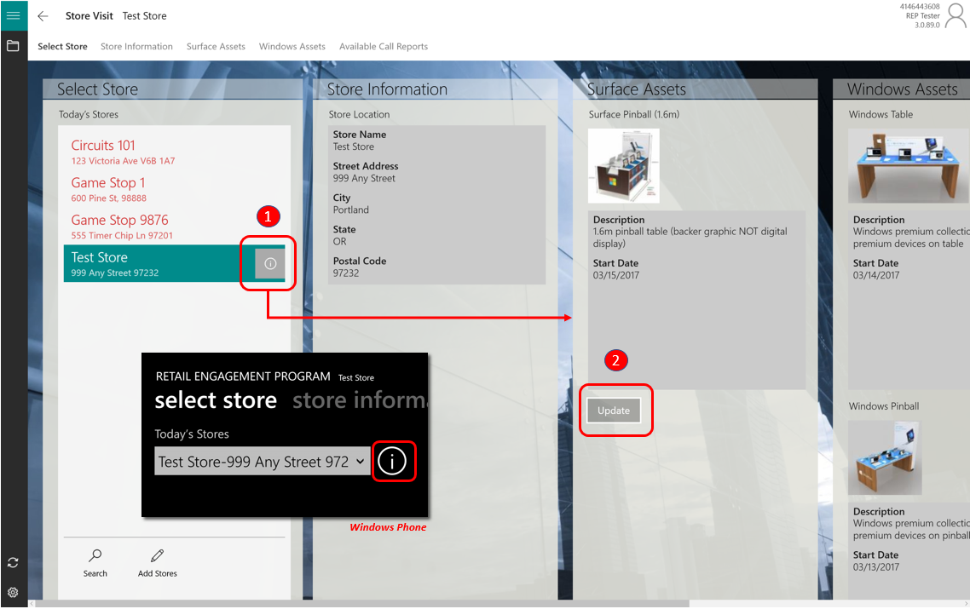

Using the new App
Open the Store Visit page of the REP app to preview the new Store Information panel and assigned Asset Types present in store, organized into Product category panels. A description and start / end dates will be visible for each Asset Type.

- In the Select Store panel click the “i button” to expand the page and view the information
- If updates need to be made, click the Update button to be taken directly to the Assets call report
The new Assets call report is also available as a sub-form inside the Store Visit Call Report, with the same “i-button” visible in the left tray taskbar.

Assets Call Report
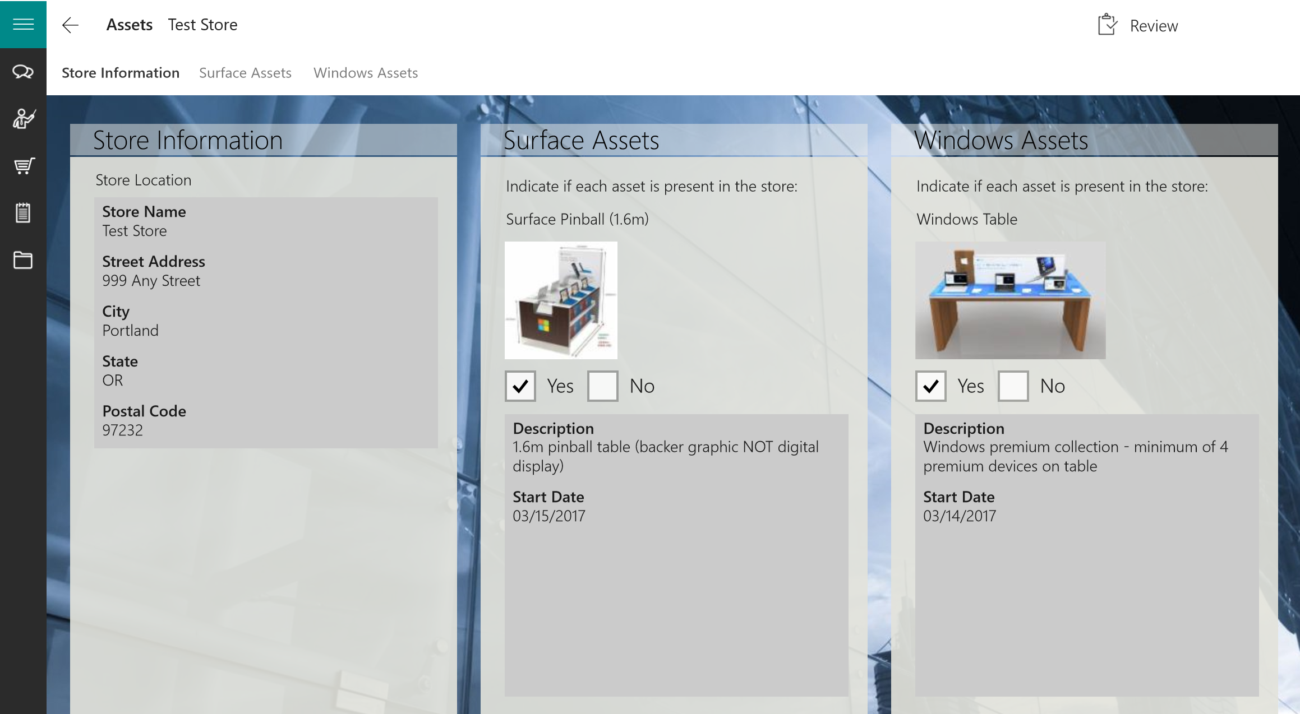
In the initial phase of Asset Management, this will work on a very simple basis:
- For any Assets that are NOT present in the store location, checkmark them “No.” Then review and submit the form as usual. This will trigger a notification for the Country Admin to approve or dismiss the change to the Asset assignment in this store location.
- If all Assets are present as indicated in the Assets call report, then no submission is necessary. (No changes to the Asset Type assignments are to be made.) Note: there is no harm in submitting a report with all Assets marked “Yes”, it just won’t trigger any changes to be made at this time.
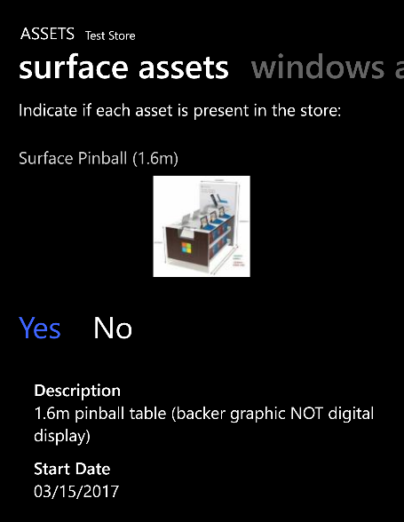
- Multiple of the same Assets at a store but some are not present. In some store locations, there could be multiple of the same Asset Type listed in the Assets call report. Example: if there are 3 of the same Surface Pinball fixture listed as present in the location but upon inspection there are actually only 2 present, then mark one of them “No” and then review and submit. A notification will be triggered for the Country Admin.
In the next phase of Asset Management, there will be a way to add an Asset to the list when there is one present but not listed.
Tip: Using the new Windows Phone App
Same Assets form functionality can be found in Windows Phone app. Just scroll the page right to left to see the new Store Information and Assets by product category

