Store Asset Question Filtering – for Administrators
Asset Management is a new REP feature used to track merchandising for each store for a variety of fixtures and demos that are managed by Microsoft at a global level. See the Asset Management User Guide for further details. The Global Question Library in the Store Visit Report has a new Filter tab feature that builds upon the assets assigned to stores and Admins can now filter questions based on any Assets assigned.
Country Administrator Steps:
- Go to Call Reports > Manage, and then the Configure link for the Store Visit Report.
- Click the Edit button for a local question that you would be triggered by an Asset assigned or create a new question and use the same steps.
- On the Filter tab at the bottom is the new Assets filter option. (Figure A).
Figure A
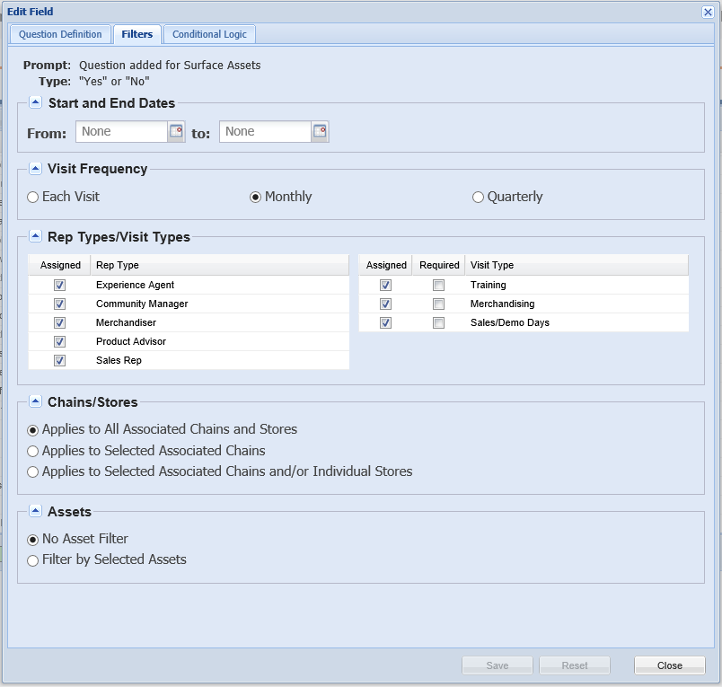

Figure B
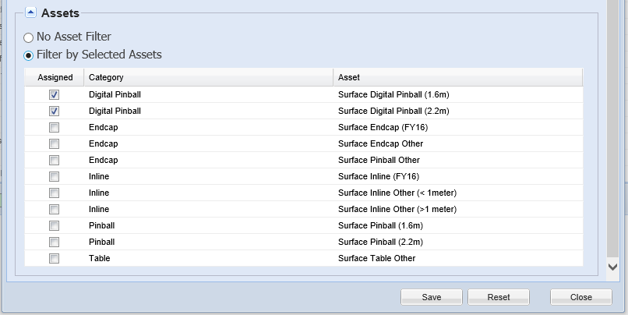
- Click the Filter by Selected Assets button, which will open the Asset Type list in a box below.
- Select the Asset Types that should trigger the question and then Save.
- Save the call report to enable the question and/or the filter change.

Note that the Microsoft REP Global Admin will also have this feature and may set filters for certain global questions from time to time. Also, there is a second Assets option in development that will enable the filter if the Asset Type IS NOT assigned to the store. Exact timing is still TBD but Admins will see a third radio button option in Figure B above when it is deployed.

