Location Asset Management
Asset Management is used to track merchandising for each location for a variety of fixtures and demos that are managed by Microsoft at a global level. The menu item (Location > Location Asset Management) and UI will allow a Country Admin to select, modify, localize and assign those fixtures and demos associated with each location/chain. In conjunction, the REP client app allows a rep to view and update this content in the Asset Form. An Action Center review process allows Country Admin to accept or dismiss the updates which are reported by a rep through the standard form submission process.
Country Administrator Steps:
Go to menu option Location > Location Asset Management, and notice there are 3 tabs:
- Asset Type Assignment – use to assign Asset Types to each location and Bulk Import tool
- Asset Type Management – use to customize the English description and photo for the Asset Type
- Language Tools – use to localize and translate the Title and Description of the Asset Type
Asset Type Assignment Tab:
Asset Types can be assigned either manually (drag from left side and drop on right side) or through the Bulk Import process. Install and Removal dates can be added now or with the Edit button. The photo preview button to the left of the first column, will show the photo associated with the Asset Type. This is what the Rep will also see in the client app as the photo example. If the photo doesn’t exactly match what you have in your country, you can easily change it. See the next section to find out how to manage the photo and the description field.
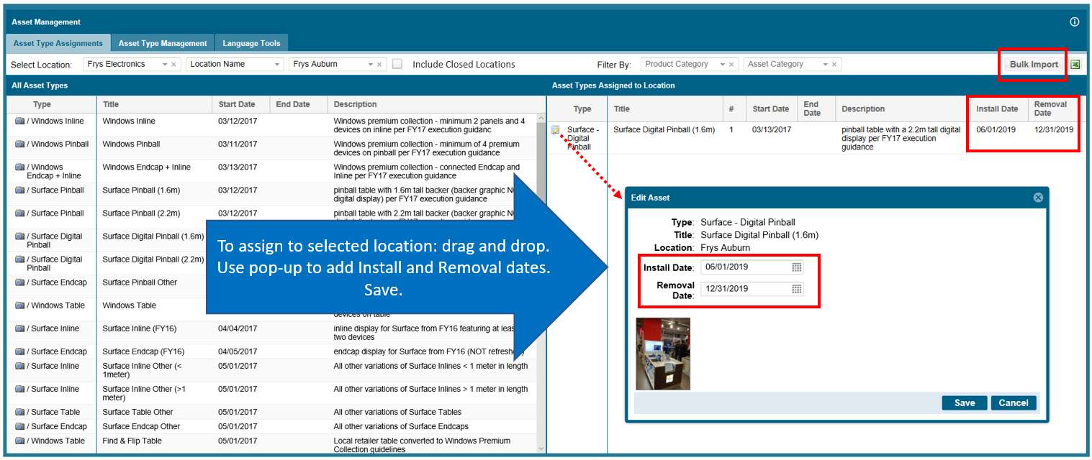
TIP: On the far right of the page, there is an Excel export button that allows you to export all or just part of your location assignments or information. Bulk Import works in a similar way to allow editing all or just one location at a time.

Bulk Import:
The standard Import templates are available to Add assignments or Edit assignments and can include Install and Removal dates. Download either Excel template and complete using the macro-enabled cell content.
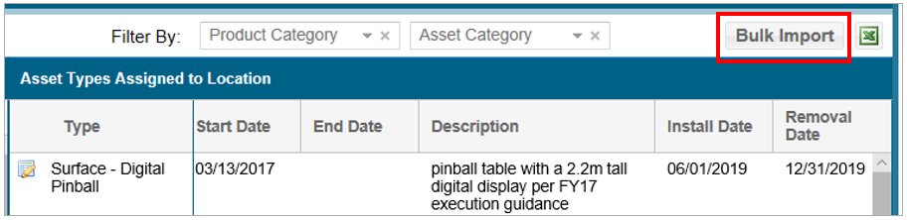
The Edit template Action column is restricted to “Assign” or “Unassign” and there is no “Modify” available, meaning you can’t edit from one Asset Type to another using a single row. That would require two steps, one to unassign and one to assign (or Add). Partner, Location, Asset Type and Count are required fields. Use the far-right columns to indicate the physical Install Date and Removal Date, if known. Save the file to a local folder when complete.
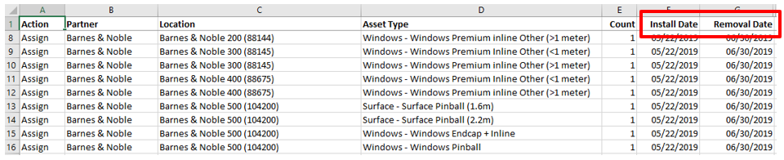
Browse for the file, select and check for status and exceptions. Click Import Asset Assignments to complete; then Close.
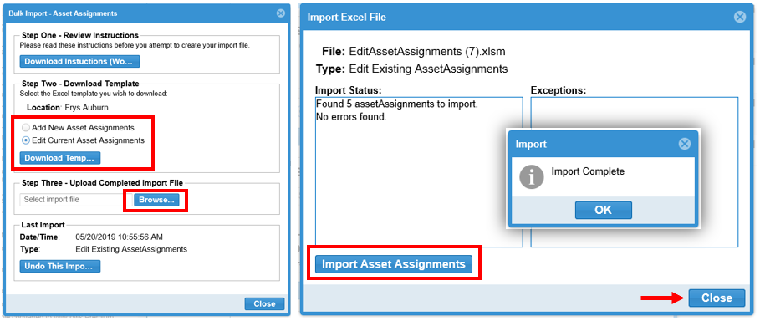
Asset Type Management Tab:
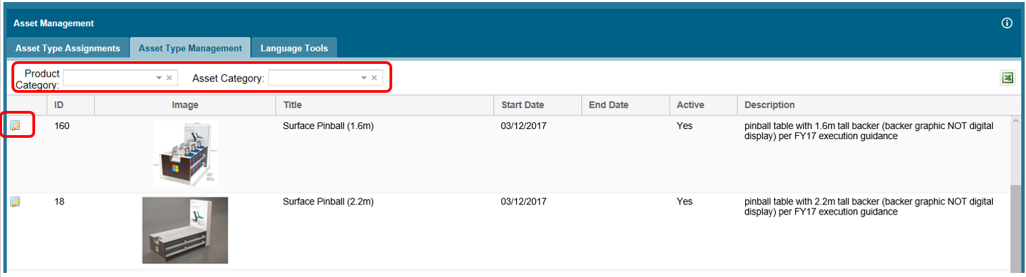
Pick a Product category and/or Asset Category to narrow down the list. Now you can click on the thumbnail of the photo to pop-up a larger view. Or, to make changes to what the Reps will see on their client app click the Edit button of the Asset Type to open the following interface.
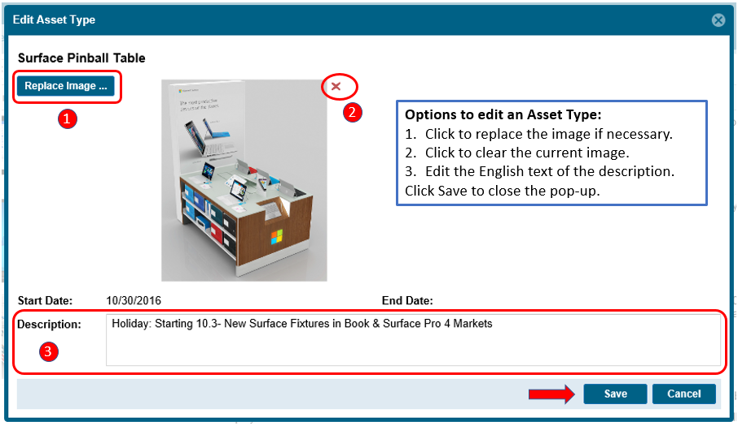
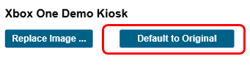
If the global image was replaced previously, there is a way to revert to the original when needed. Open the Edit Asset Type pop-up again and use the Default to Original button.

Language Tools Tab:
Now that you have your Asset Type customized in English, it’s time to localize the Titles and Descriptions in additional languages where needed.
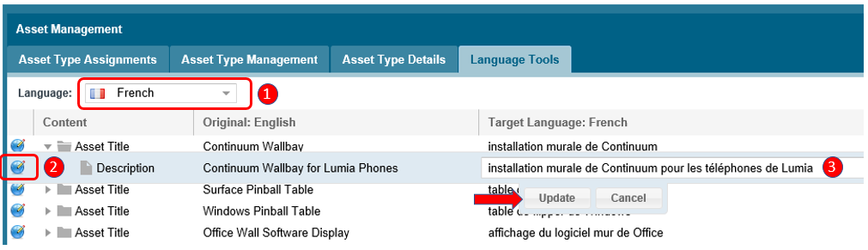
This works much like the Language Tools UI in the Location Visit Reports.
- Select the language to work with (multiple are possible)
- Click the blue globe or double click on the English text to open the Target Language field
- Enter your translation text in the Target Language field and then click Update to save the update.
You can then move down through the Content list to translate all the Titles and Descriptions.
Location Asset Reporting
Go to the Reporting Center > Location Asset Reporting menu to find the dashboard to view, filter and export all or some of your Asset information and assignments.
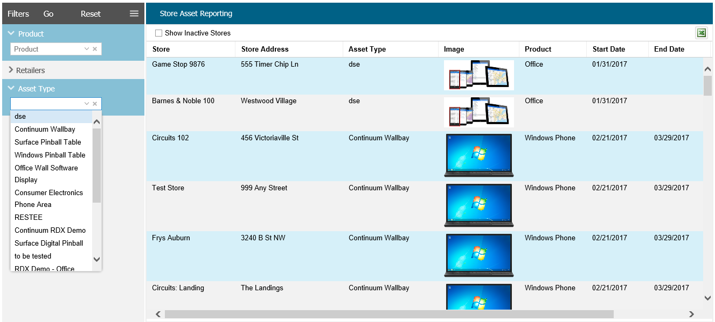
Location Asset Field Changes

The Reps can use their REP app to view, identify and confirm the Asset Type is present (or should be present) in the location during their usual location visits. Asset Type information will appear in the app in two places:
- Location Visit and Information (Today’s Location List) page as a preview by click of the “i button”
- In the Assets call report (sub-form) available from the Location Visit and Information page or from the left tray while in a Store Visit Report, also using the “i button”
The Rep’s interaction with Asset Management will work on a very simple level. If the Rep submits an Assets call report and indicates that an Asset Type IS NOT present in the location, it triggers a notification to the Admin. For example, the “No” checkbox for Surface Digital Pinball below (when submitted) would indicate that the fixture was not in the location, which creates an Action Center item for the Admin.
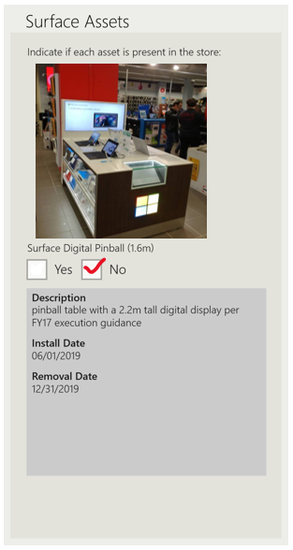
If the Rep submits an Assets call report and indicates that an Asset Type is present in the location, “Yes” checkbox, then no Action Center notification is created and no changes to the Asset Type assignments are made. In fact, the Rep does not need to submit an Assets report if the Install Date is in the future, or there is an exception (some Asset Type is not present as expected), or a fixture removal has taken place.
Action Center:
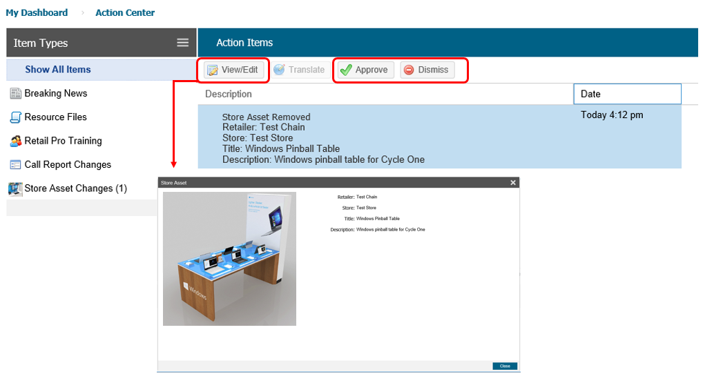
In the illustration above, the Rep has clicked “No” on the app and submitted a form that this Asset Type was not present or recently removed from the location. The Country Admin can view the item using the View/Edit button, and then decide to:
- Approve that notification (which will unassign the Asset Type from the location)
- Dismiss the notification as irrelevant (nothing happens in the Asset Type assigned list, it stays assigned for the location)

Note: It is important for both Reps and Admins to understand that the form submission with “No” initiates unassignment of the Asset fixture from the location. This underscores the importance of the Install Date and Removal Date.

Have questions or comments? Send your inquiry with screenshots to the REP support mailbox at: msftreps@westlakesoftware.com.

Revised May 20th, 2019.

