Chains / Classifications tab for store assignment
Assigning stores to a special project report form has a new user interface (UI) which simplifies the process. The new UI is a single tree structure shown while creating a new special project in the Call Report Wizard or while making changes to the existing special projects currently active for your country.
Administrator Steps:
- Go to Call Reports > Manage and then the Configure, or use in the Create function and new form wizard
- Select the second radio button if the special project form does not apply to every active store to open up the store tree
- Click the carrot to the left of the Chain or Classification to expand and view the list of stores
- Select the individual stores that should assigned or select the top box to select (or unselect) all stores
- Save the call report to enable the change, or if creating a new report hit Next
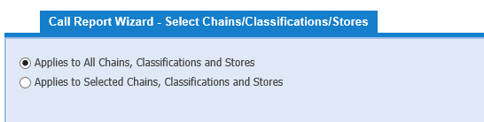
-When creating a new form
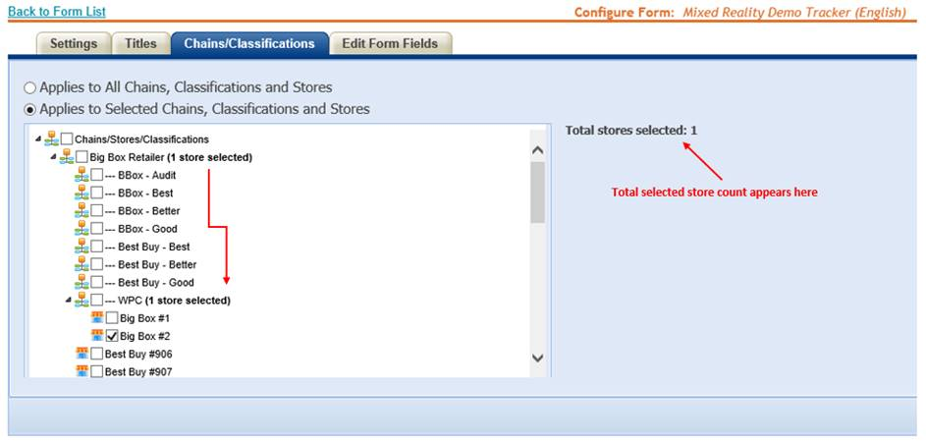
-Modifying an existing form
On the right side of the tab you will see the total count of the stores selected change as Chains and Stores are selected or deselected.
Important note: Using the “Applies to All Chains…” radio button and then saving (or hitting Next if creating a new form) will clear all previous selections made in the “Applies to Selected Chains…” store tree.

