Step 1:

Uninstall the current version of REP app installed on your computer.

To uninstall the application, right click the app tile / icon or hold down the app tile / icon for a second, it will then turn to select-mode as shown in the picture below. Click un-install button and confirm.

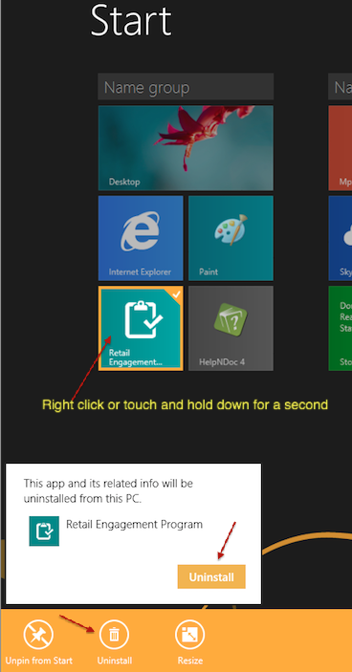
Step 2:

Download the latest beta version 1.2.0.29 from this URL : http://1drv.ms/1ARTqgz

When you open this web page, you will see two packages. Choose the airmobilityws_1.2.0.29_x86_REPS_Test.zip and save it to default ‘Downloads’ folder of your computer. It can take 1 – 2 mins to complete the download.

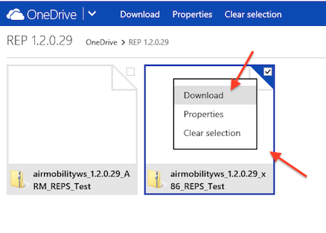

Step 3:
Open Downloads folder and “Extract All” the zip file to the same location

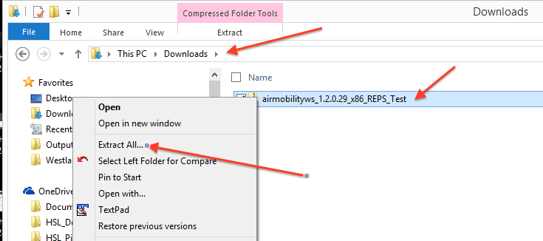

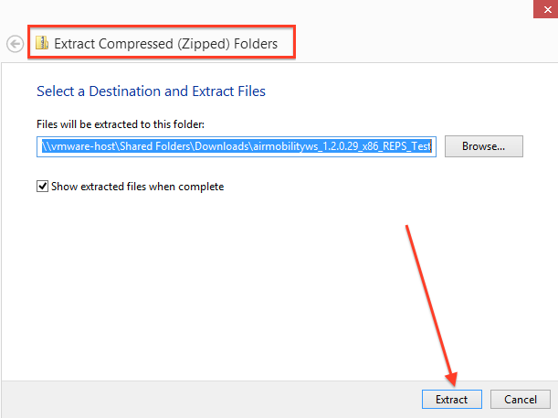

Extracted folder will appear like shown below:

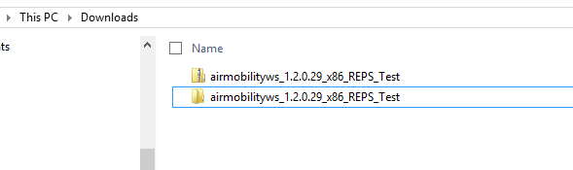

Step 4:
Go inside the extracted folder (not the zip file). You will see a file named “Add-AppDevPackage”. This is a PowerShell script file. Run this file.

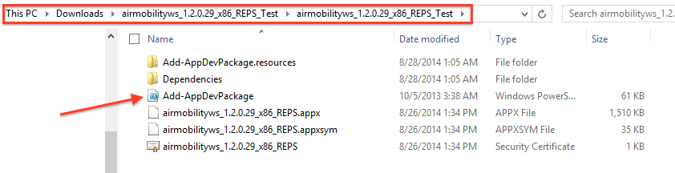

Step 5:

Right click and Run “Add-AppDevPackage” with PowerShell

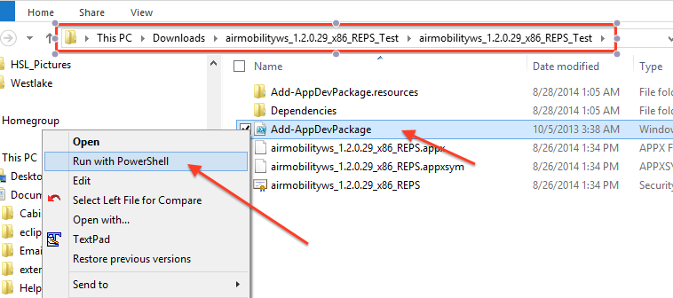

A terminal window like this will appear.

Step 6:

Enter “Y” key on the key board and hit “Enter”

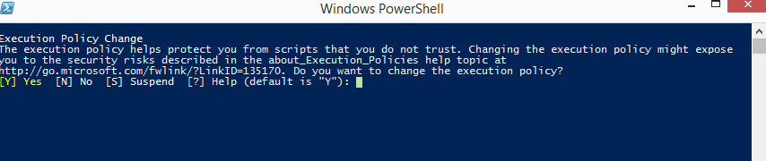

Then you will see a window like below:

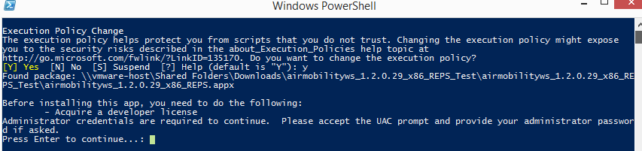

Step 7:

Click “Yes” on this window

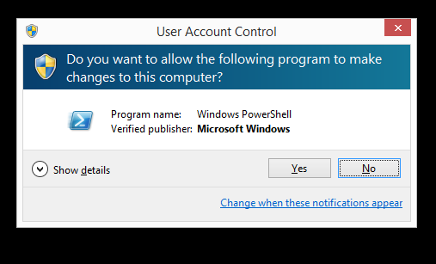

It will then prompt you to add Developer License.

Step 8:

Click “I Agree”

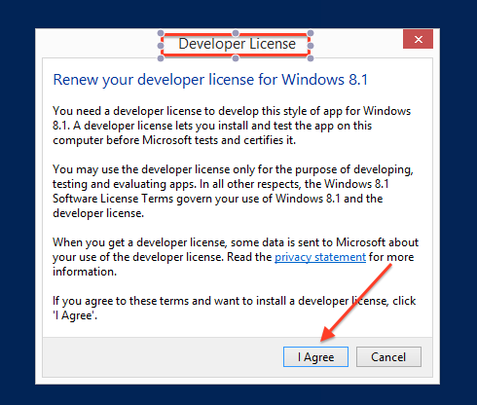

Then you will see a window to enter your Microsoft email ID and password.

Step 9:

Enter your outlook email ID and password and click “Sign In”

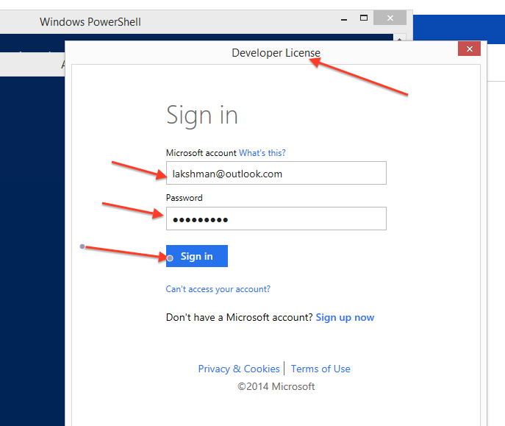

Then you will see a success message like below:

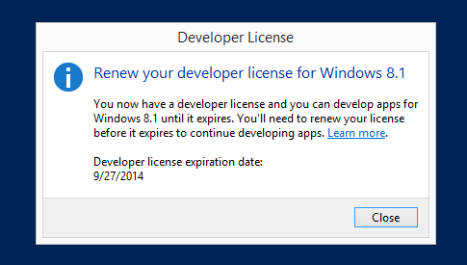
Then you will see a window like below.

Step 10:

Hit “Enter” button on your keyboard.

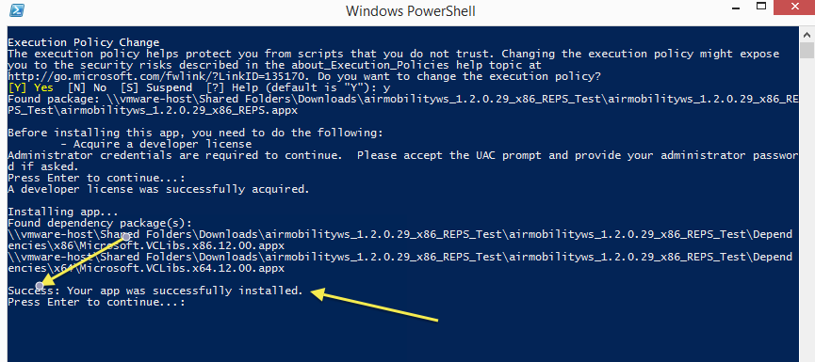

Now the installation is complete.

Step 11:

Go to the Start Screen and open the app.

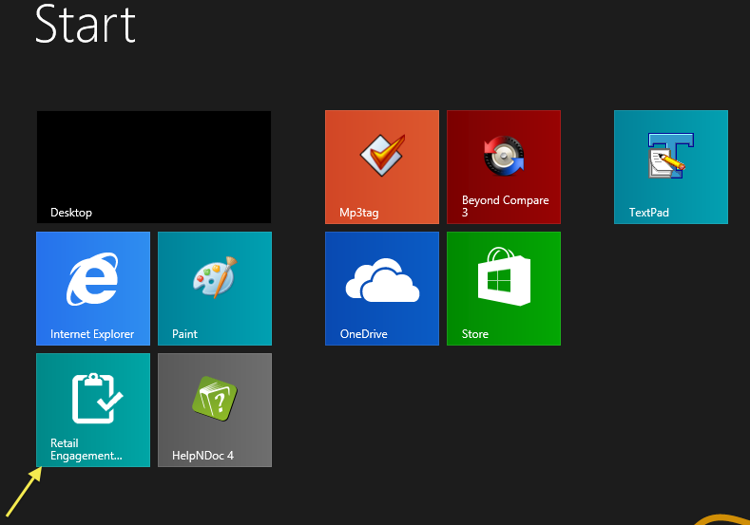

Step 12:

Enter your 10 digit ID and click “OK”

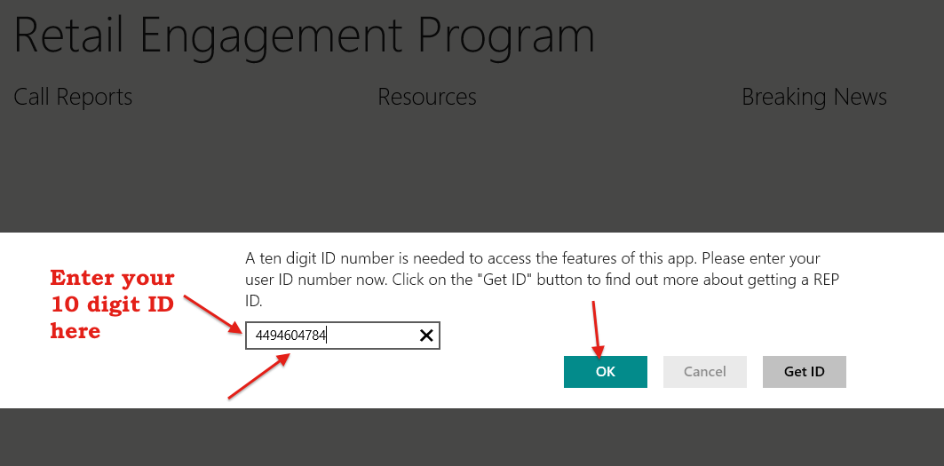

Step 13:

Once the app is open, go to Diagnostic pane and check the version number. It should read as 1.2.0.29

