Overview
This feature allows an administrator to add or edit calendar visits in bulk using a Microsoft Excel template.
Read this First Before You Start
- This process will not add any new Partners, locations or assignments. That function is conducted online as you do today and will be added to any new exported Excel file template for editing/adding.
- It is required that the structure and formatting of the Excel template that you download remain intact. Examples of re-formatting items that will produce errors upon uploading include, but are not limited to:
  - Adding, removing or moving columns.
  - Adding, removing or changing any of the header cells.
  - Unhiding or making any changes to hidden columns or worksheets.
  - Renaming worksheets.
  - Adjusting any cell formats or data validations.
  - Entering “Developer” mode, Safe mode or making any changes to macros.
- You can move rows (other than the header row), either by cutting/pasting, or using Excel’s Data -> Sort feature while making your edits. The order in which the visits are listed will not affect the import.
- You can use Excel’s Filter feature to limit the display of rows while you are making your edits. All rows will be imported, whether or not they are filtered.
- Avoid leaving any blank rows in between other rows that have data.
- When you download an “Edit Current Scheduled Visits” template, neither you nor any other Admin in your organization should make any changes in the Calendar page until the file has been successfully imported. Any changes made after the template was downloaded may present a conflict when you import.
Instructions
- Navigate to Location > Calendar menu or the Users > Calendar menu
- Click on Bulk Import
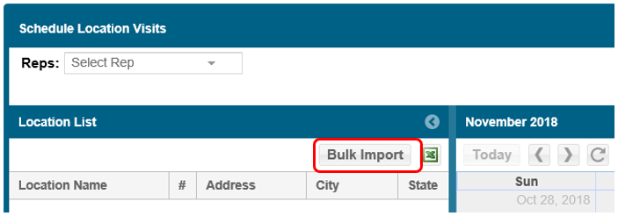

- The Bulk Import window will appear which will present three steps: (1) Quick access to this document, (2) Add/Edit Scheduled Visits - Download Template and (3) Upload Completed Import File:

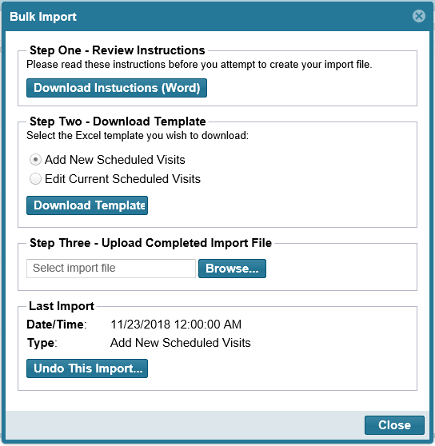
- In “Step Two” select either:
  - Add New Scheduled Visits
  - Edit Current Scheduled Visits
- Select Download Template
- Open the template file
  - Select Enable Editing (Protected View) if prompted
  - Select Enable Content (Security Warning) if prompted
- Add new visits, make edits with Update, or delete visits with Delete
- When double-clicking in cells for columns such as Chain, Name, Store ID, Rep, Visit Type, or Supported Areas, those fields will be pre-populated from your current list found on the www.msftreps.com website:

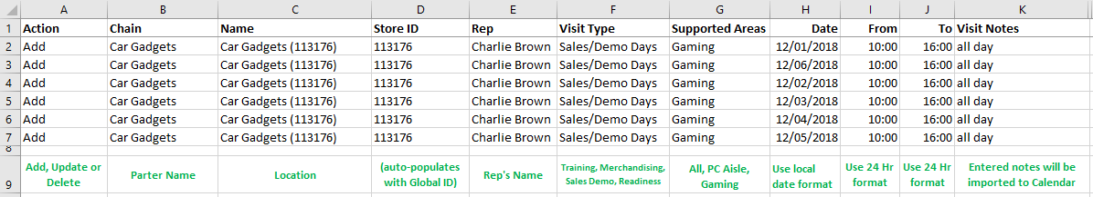

- Double-clicking in cells in the Action column will bring up available options (Add, Update, Delete)
- Save your modified template file to your desktop or other folder
  - It is OK to rename the file
  - Be sure to keep the .xlsm extension
- Return to the Bulk Import window
- (Step Three) Click Browse to locate and select the modified Excel template
- Click Open to start the import process
- A status window will appear with the file name, type of template, Import Status and Exceptions
  - Any format issues found by the system will be displayed as errors in the Exceptions box.

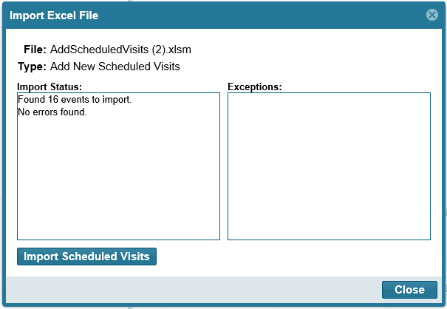

- If the Import Status finds:
  - No Exceptions, Select the Import Scheduled Visits button
  - You do have Exceptions, see the next section: Exception Management
  - If you have Exceptions, you still have the option to Import. Select the Import Scheduled Visits button and only the rows without Exceptions will be imported.
  - This process may take a few seconds or minutes to complete
- A final confirmation will then appear; click OK and then Close the Import Excel File popup window

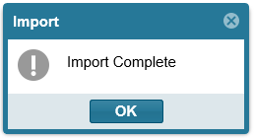

- Use the Calendar page to review the additions/edits just added.
  - If you are satisfied with your changes, the process is complete.
  - If you are not satisfied with your changes, you can
    - Manually change them (same as supported today in Calendar)
    - Use the Undo This Import option (calendar will revert back to status before the upload)
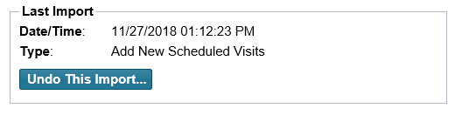
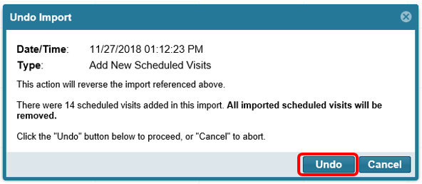
    - Edit your template and upload again
Exception Reporting
This is a list of issues/exceptions the import process can detect:
- An event already exists for this user/location/date.
- Invalid "Rep": (name)
- "(Rep name)" is not assigned to location "(location name)"
- Duplicate (Add): a visit listed as new matches a visit already in the system
- Duplicate (Edit): an edited existing visit matches another visit already in the system
- Invalid Data: “From” value
- Invalid Data: “To” value
- Invalid Data: “Name” value
- Invalid Data: “Chain” value
- Invalid Data: “Supported Areas” value
- Invalid Data: “Visit Type” value
- Invalid file: this file was downloaded from a different account (country)

If you receive any of these exceptions, as a first step, review and edit your import file and try uploading again. If you believe you resolved the issue and it is still happening: email msftreps@westlakesoftware.com with your name and country for assistance. If your file appears to have imported correctly and you have any other issues, email msftreps@westlakesoftware.com.
Revised November 26, 2018.

