Overview
This feature allows an administrator to add or edit multiple locations at once using Microsoft Excel.
Read this First Before You Start
- This process will not add any new Chains, Classifications or regional hierarchy (examples: Area, Region, District). That function is conducted online, as you do today, and will be added to any new exported Excel file template for editing/adding.
- It is required that the structure and formatting of the Excel template that you download remain intact. Examples of re-formatting items that will produce errors upon uploading include, but are not limited to:
  - Adding, removing or moving columns.
  - Adding, removing or changing any of the header cells.
  - Unhiding or making any changes to hidden columns or worksheets.
  - Renaming worksheets.
  - Adjusting any cell formats or data validations.
  - Entering “Developer” mode or making any changes to macros.
- You can move rows (other than the header row), either by cutting/pasting, or using Excel’s Data -> Sort feature while making your edits. The order in which the locations are listed will not affect the import.
- You can use Excel’s Filter feature to limit the display of rows while you are making your edits. All rows will be imported, whether they are filtered.
- Avoid leaving any blank rows in between other rows that have data.
- When you download an “Edit Current Locations” template, neither you nor any other Admin in your organization should make any changes in Location Management until the file has been successfully imported. Any changes made after the template was downloaded will be overwritten when you import.
Instructions
- Navigate to Location > Location Management menu and then select the Locations tab
- Click on Bulk Import
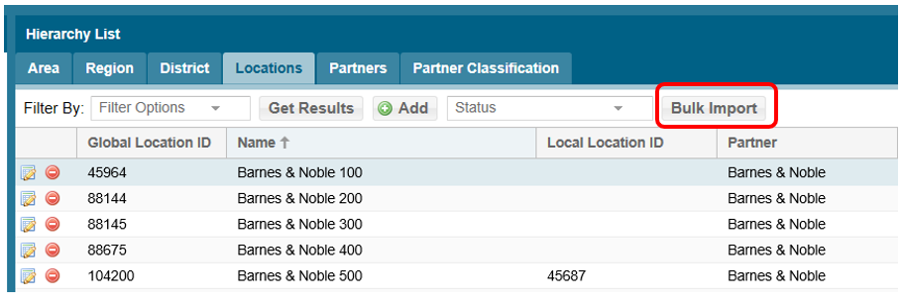
- The Bulk Import window will appear which will present three steps: (1) Quick access to this document, (2) Add/Edit New Locations/Download Template and (3) Upload Completed Import File:

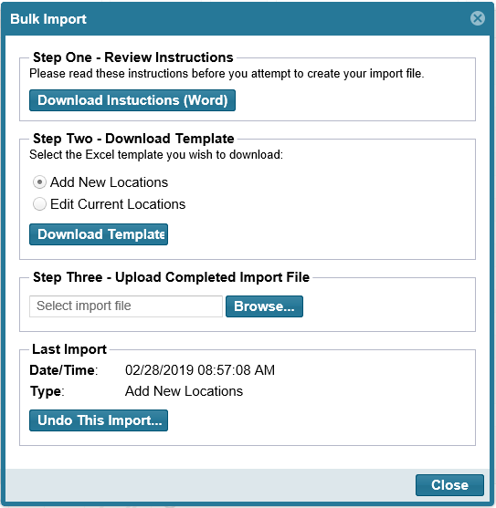
- In “Step Two” select the appropriate template (can’t combine):
  - Add New Locations
  - Edit Current Locations
- Select Download Template
- Open the template file
  - Select Enable Editing (Protected View) if prompted
  - Select Enable Content (Security Warning) if prompted
- Add the new locations or make edits to the existing locations.
- When double-clicking in cells for columns such as Support Tier, Partner, Classification, Area, Region, District, those fields will be pre-populated from your current list found on the www.msftreps.com website:
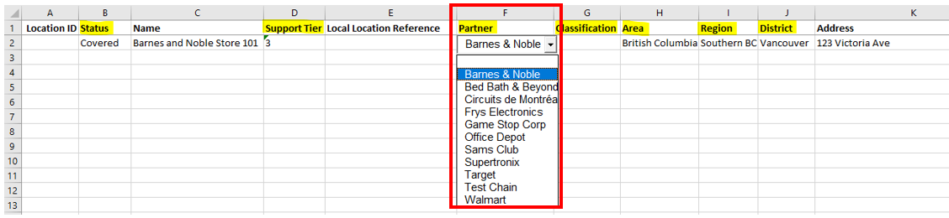

- Double-clicking in cells in the Status column will bring up coverage options.
- Save your modified template file to your desktop or other folder
  - It is OK to rename the file
  - Be sure to keep the .xlsm extension
- Return to the Bulk Import window
- (Step Three) Click Browse to locate and select the modified Excel template
- Click Open to start the import process
- A status window will appear with the file name, type of template, Import Status and Exceptions
  - Any format issues found by the system will be displayed in the Exceptions box.

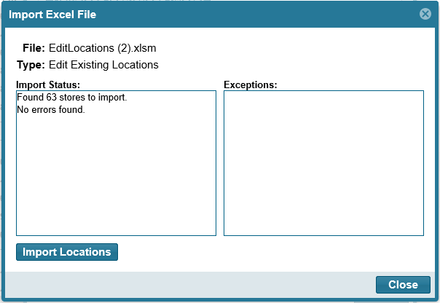

- If the Import Status finds:
  - No Exceptions, select the Import Locations button
  - You do have Exceptions, see the next section: Exception Management
  - You have Exceptions, you still have the option to Import Locations. Select the Import Locations button and only the rows without Exceptions will be imported.
  - This process may take a few seconds or minutes to complete
- A final confirmation will then appear; click OK and then Close the Import Excel File popup window

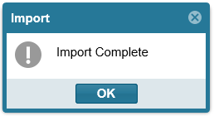

- Use the Locations tab to review the additions/edits just added.
  - If you are satisfied with your changes, the process is complete.
  - If you are not satisfied with your changes, you can
    - Manually change them (how this is supported today in Location Management)
    - Use the Undo This Import option (Location list will revert back to before the upload)
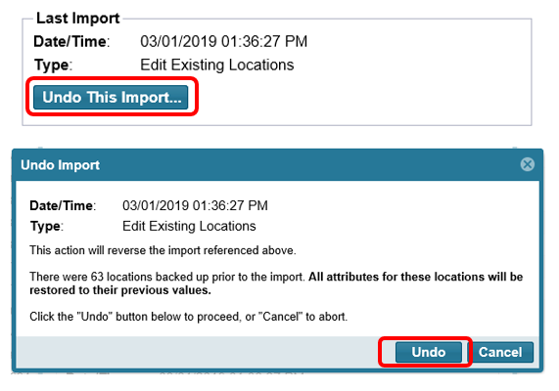
    - Edit your template and upload again
Exception Reporting
This is a list of issues/exceptions the import process can detect:
- Missing or Altered Header: <Header Name>
- Missing or Added Columns
- No Locations Listed
- Blank Row
- Missing Required Information: “Name” field
- Missing Required Information: “Active” field
- Duplicate (Add): a location listed as new matches the name and address of a location already in the system
- Duplicate (Edit): an existing location is changing its name and address to values that match another location in the system
- Invalid Data: “Location ID” field
- Invalid Data: “Chain” field
- Invalid Data: “Classification” field
- Invalid Data: Regional field (these titles will vary depending on how you have your regional hierarchy defined)

If you receive any of these exceptions, as a first step, review and edit your import file and try uploading again. If you believe you resolved the issue and it is still happening: email msftreps@westlakesoftware.com with your name and country for assistance. If your file appears to have imported correctly and you have any other issues, email msftreps@westlakesoftware.com.

Special Note on Support Tier:

Pay close attention to the formatting of the Tier cells in the Excel template. For Support Tier especially, you must keep the same format that is embedded in the template, which is text, not a number. You can’t manually enter numbers in that column. Instead, just double-click to retrieve the Tier text. Then you can copy that cell and paste it to the rest of the cells with that same value. Alternatively, you can type an apostrophe before the number (example ‘1) and enter that to format the cell correctly. Either method will work equally well.

See the example below. In row two double-click and chose a “1” first. It must look exactly like the picture below. Then, copy and paste the “1” to rows three and four. Continue and do the same for the other tiers.

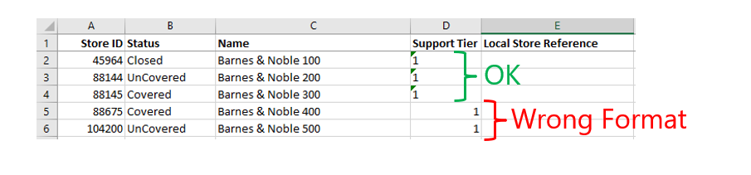
Revised March 1, 2019.

