CCGI ADMIN CALENDAR INTEGRATION
Phase 1 of store assignment management improvements:
Adding interactive CCGI store assignment statistics to the Admin calendar.
As you select Reps from the Manage Rep Visits drop down (Graphic A), stores assigned to each Rep will appear in the list below on the left. As you drag and drop assigned stores to the calendar:
- The Visit Type box will display (Graphic B) to allow you to select a visit type.
- The stats in the upper right (Graphic A) will change count (that count will show for the Rep, All Reps and All Retailer Goals).
- The number of times that store has been placed on the calendar for that Rep will total in the store list box on the left (shown below has a few stores with 1 assigned; another one with 2 on the calendar).
Graphic A
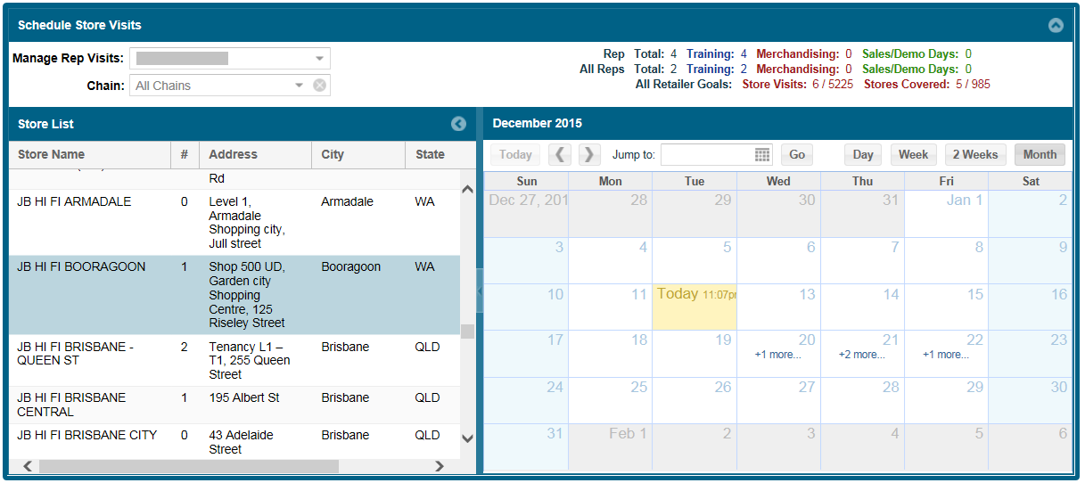
Graphic B
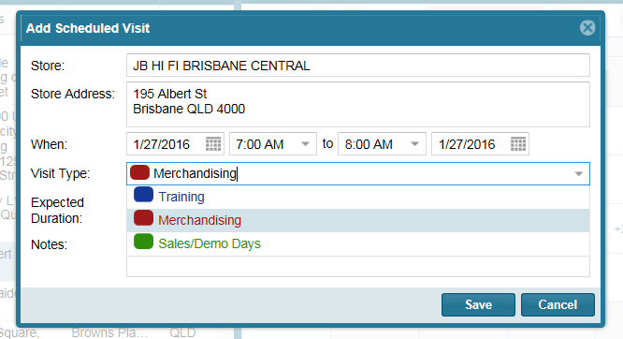

You can also sort to display just the stores associated with a particular CCGI Retailer by selecting the Chain drop down option and making a selection (Graphic C).
Graphic C
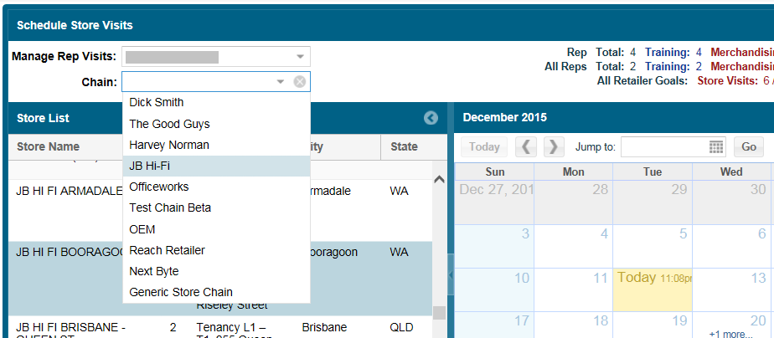

This will now also display (see forth line in upper right of Graphic D) the number of total expected visits to be made to that CCGO retailer and how many have been currently assigned for that given month.
Graphic D
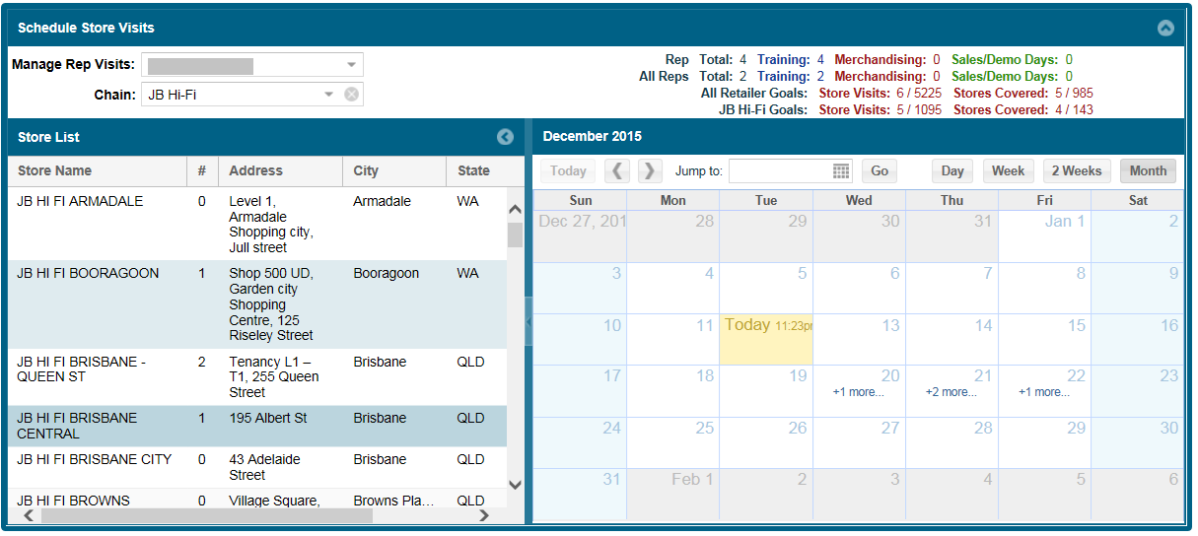

Phase 2 of this project will provide a new user interface for the Administrator to quickly and easily:
- Assign the total number of visits to each CCGI Retailer to each Rep
- Denote which stores a Rep will be visiting (individual stores and their frequency/volume to those stores each month).
Look for this new option for more Rep and Store Management control in Apr-June/2016.

