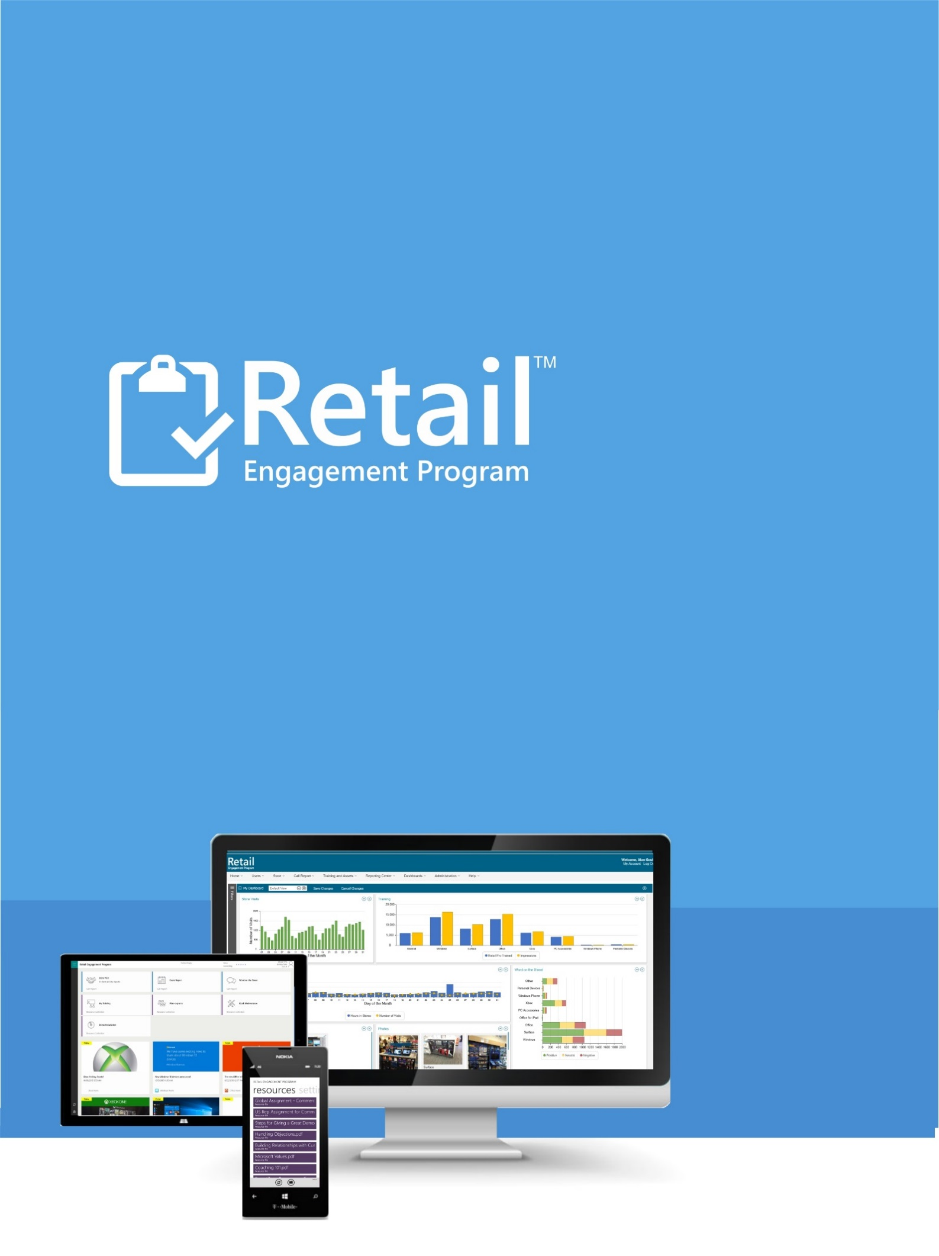

INTEGRATED CCGI GOALS WITH DASHBOARD

December 9th, 2015

INTEGRATION OF CCGI GOALS WITH DASHBOARD
The system now accepts a feed from CCGI for every country and selected goals for each month and quarter. You can now create a custom dashboard monitoring volumes and objectives of CCGI from the Retail Engagement Program Dashboard right with real-time data being reported.
This feed initially supports:
- Store Visits (total number of stores visited).
- Store Covered (total number of unique stores visited).
- Time In Store 1:1 Training (time in store calculated by start and stop time in app).
- 1:1 Training (number of 1:1 trainings from RP Training).
- 1:Many Training (number of 1:many trainings from the Event form).
You will find these new items located in the Common Charts and Graphs section of My Dashboard. They are currently displayed as:
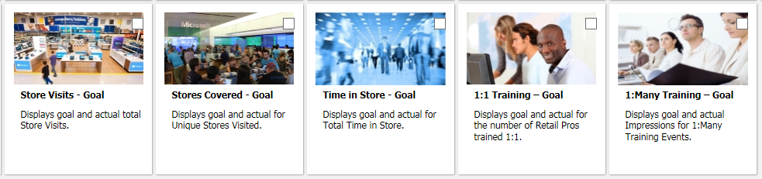

Day-by-Day View (select a single month view in filters):
The total sum of your goals is displays by a diagonal line. This line, for all goals being tracked above, starts at zero on day one and rises to the final goal for that month on the last day of the month. For example, if we were in a 30 day month and it was the 15th and you had 1000 stores to visit in this month, the line would be hitting 500 on the 15th.
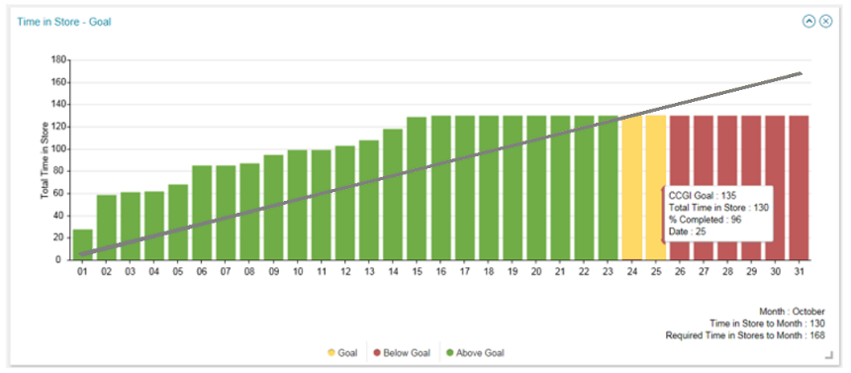
The work-product for your country is displayed in vertical bars as shown. As you accumulate statistics each day, the gray line is now our average target. If you are on target for your goals, the bars will display in green. If you are slightly behind, the columns will display in yellow. If you are further behind, the columns will display in Red.
Note: a month starting off when your staff is off might have you in the red early, but that would be expected. This is just a barometer on these metrics graphically to make staying on target to your goals easier to visualize.

Month-Over-Month View (select quarter view for date range in filters):
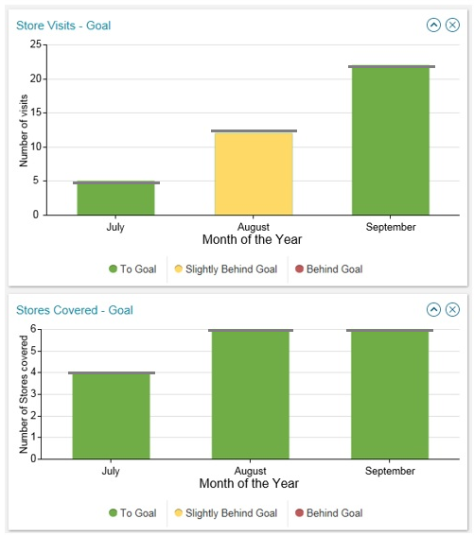

Sub-Dashboard Reports:
Each of the five items supported also supports a new tracking/monitoring sub-dashboard. They are the following:
Store Visits, Stores Covered, 1:1 Training and 1:Many Training will take you to the Visit and Training Stats sub-dashboard with these four new reports:
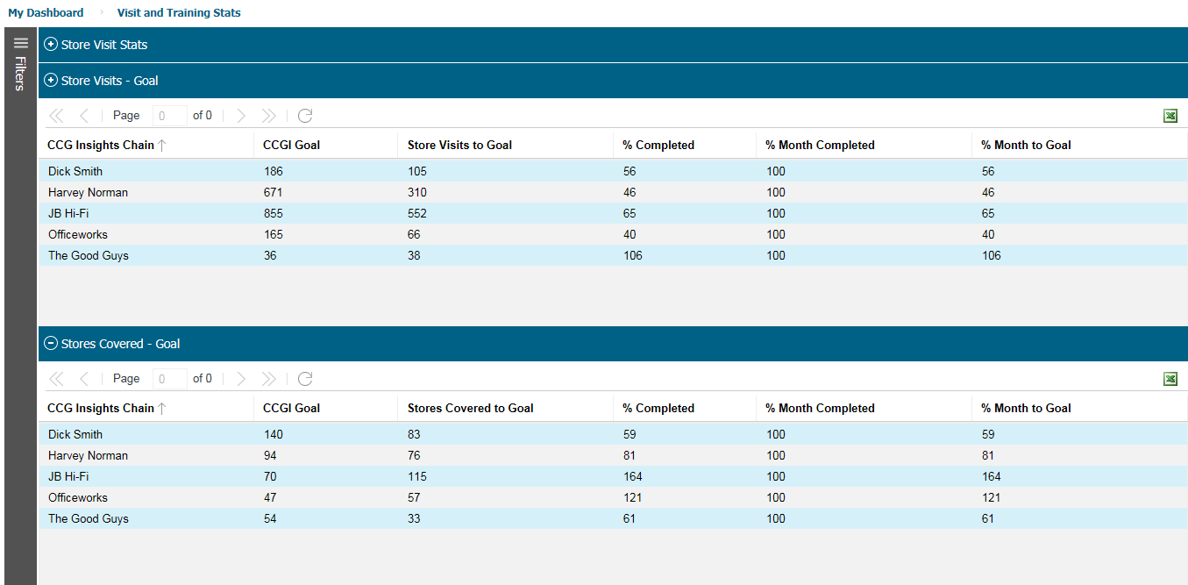
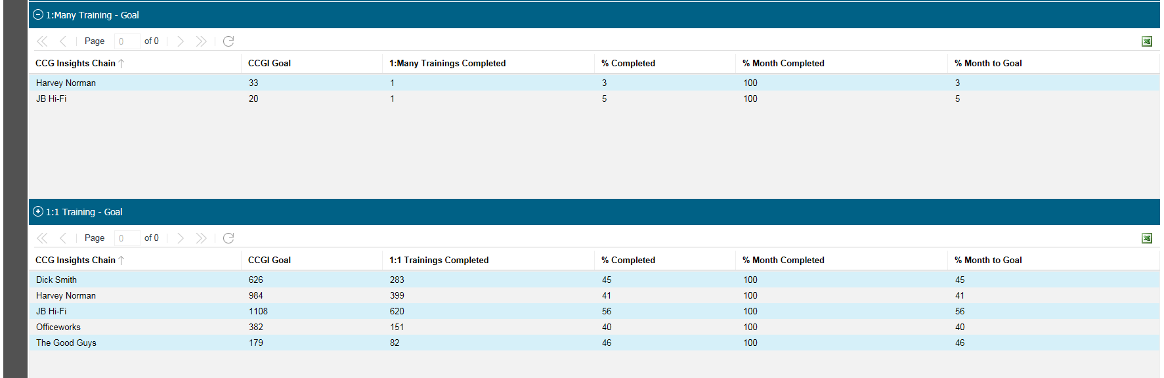

Time in Store will take you to the compliance sub-dashboard:
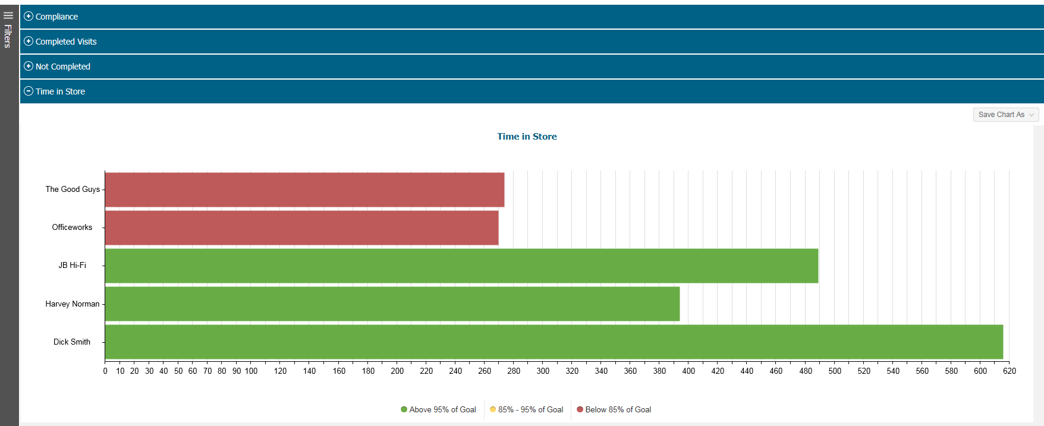
This report is broken down by each CCGI retailer chain.
Color is also used here to indicate if the hours being invested into that particular chain is behind, slightly behind or on target for the hours expected that month.

