Calendar Scheduling for Admins
The new calendar functionalities make using it easier with a set of new features and functionality.
Recurring Schedule Feature
Using the recurring function in Microsoft Outlook as our basic guide, a store assignment can now be not only scheduled but set to reoccur at your desired interval.
Scheduling a recurring store visit
- Navigate to the Calendar page at www.msftreps.com.
- Select a rep from the drop down for whom the visit needs to be scheduled (or if you are a Rep, this is your view by default).
- Drag and drop the store from Store List tab to the corresponding day in the calendar for which the initial start point schedule needs to be created.
- Add scheduled visit pop-up is displayed (Figure A).
- Choose the visit type and expected duration. If there are any notes to be added, add them in the notes section.
- Choose the date and time for the visit.
- If there is no need to repeat the visit, then click on save button and the visit will be scheduled.
- Check the Recurring check box if recurrence is desired (Figure A highlight).
- A pop-up is displayed with two sections named Recurrance Pattern and Range of Recurrance. Make appropriate selection (Figure B).

Figure A Figure B
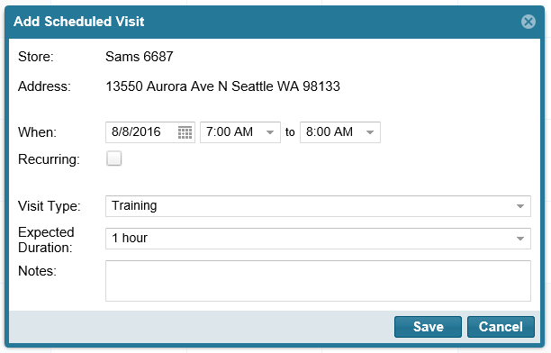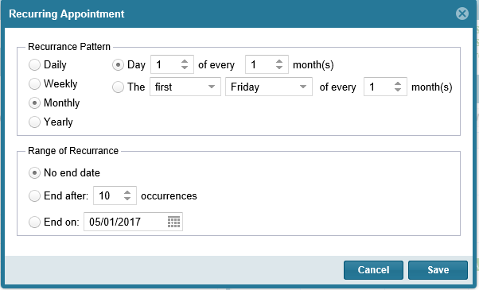

Different Recurring patterns:
- Daily – if the schedule needs to be repeated daily.
- Weekly – if the schedule needs to be repeated on a particular day of a week.
- Monthly – if the schedule needs to be repeated on a particular day on a monthly basis.
- Yearly – if the schedule needs to be repeated on a particular day on a yearly basis.

Range of Recurrence:
- No end date – if there is no halt for the recurrance after a particular number of occurrance/date.
- End after – if the schedule needs to be halted after a particular number of occurances.
- End on – if the schedule recurrance needs to be stopped after a particular date.
- Click on the save button
- The store visit is now scheduled.
Edit or Remove a Recurring Scheduled Item
Click directly on your calendared item in the calendar. This pop up will display:
Figure C
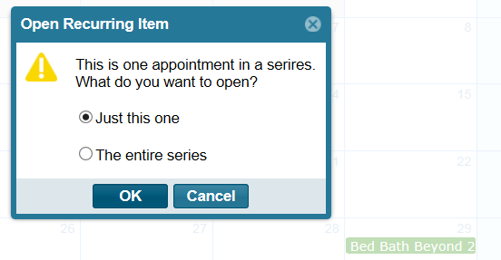
- You can select to edit or remove just the single calendared item you have
- You can select to edit or remove the entire series of your calendared item
Calendar colors
The calendar colors have changed and are driven by scheduled status now and not by the type of visit scheduled. The four modified colors which will help in identifying the visit status are:
- Grey – A visit that is scheduled (pending to be completed)
- Green – Visit was scheduled and completed
- Black – Completed a visit that was unscheduled (ad-hoc or “on-the-fly” store visit)
- Red – Did not complete a visit that was scheduled.
See Figure D below.
Note: On the REP app, as scheduled visits are completed by the rep, the Store will drop off the Today’s Stores list after the app has been refreshed with content from the server. This will happen only after refreshing the app from the main page of the app.
Note 2: When scheduling recurring visits that over-write or duplicate the same store on the same day, the latter of the scheduled visits will be used to record the Visit Type. In other words, the Visit Type on the app will reflect the last change to the calendar for the rep if same store is scheduled more than once on the same day.
Figure D
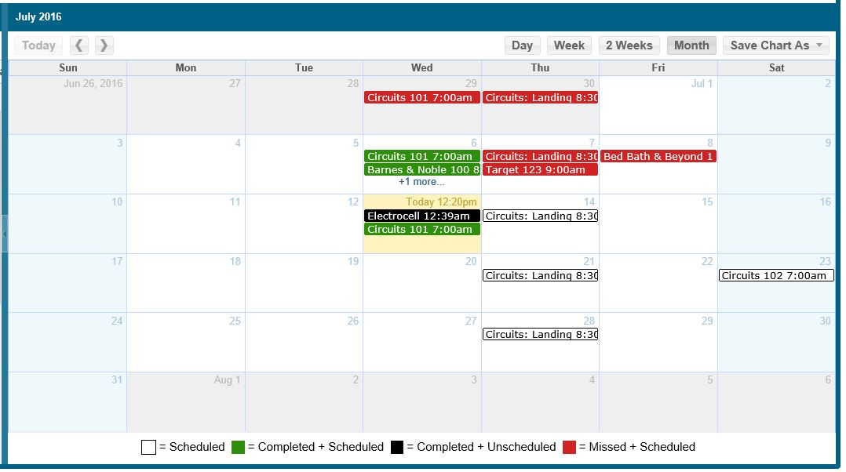
Calendar Export Feature
The calendar can be exported into an excel file or as a calendar file. In order to export the calendar, click on the ‘Save Chart As’ option.
- The calendar export will provide a .ics file which can be imported to the outlook calendar or any other calendars. It will contain all the details of the scheduled visits.
- The excel export (Figure E) will contain all the details of scheduled visit and also provides information such as ‘schedule status’, and ‘transaction id’.
Figure E
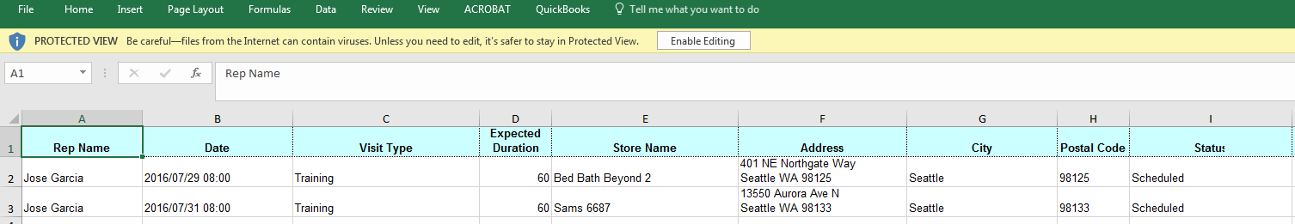

Revised 7.21.2016

