NEW! Rep’s Calendar access from within REP 4.0 App
Reps now can access their online Calendar page through a preloaded global Icon on the app.
Expected usage and limitations:
- Simple access to add an Event or Store Visit appointments
- Edit future Events and Store Visit appointments
- Not for scheduling recurring appointments
- Not for adding expected, estimated attendees in Event appointments
- Access requires an active Internet connection
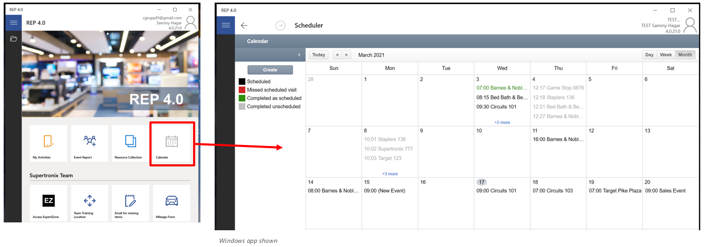
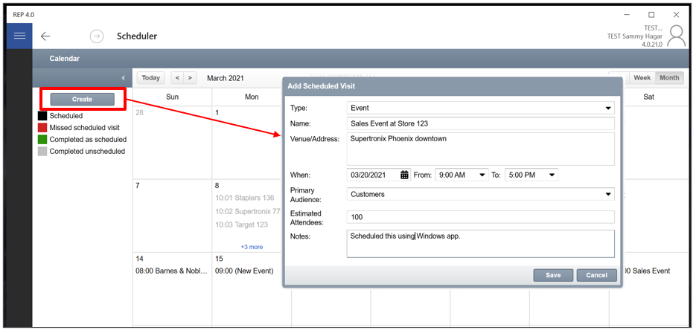
To use the mobile Calendar:
- Click the Calendar icon tile on the main page of the app.
- Create to add an Event or Store Visit in the Windows app.
- Tap on a future appointment to edit.
- Complete the necessary fields and then click Save.
- Tap to open and view any appointment.
- There are controls for changing the calendar view as Day – Week – Month. In Android and iOS view, there are “hamburger” and “plus” control buttons to change the calendar view and Add an appointment.
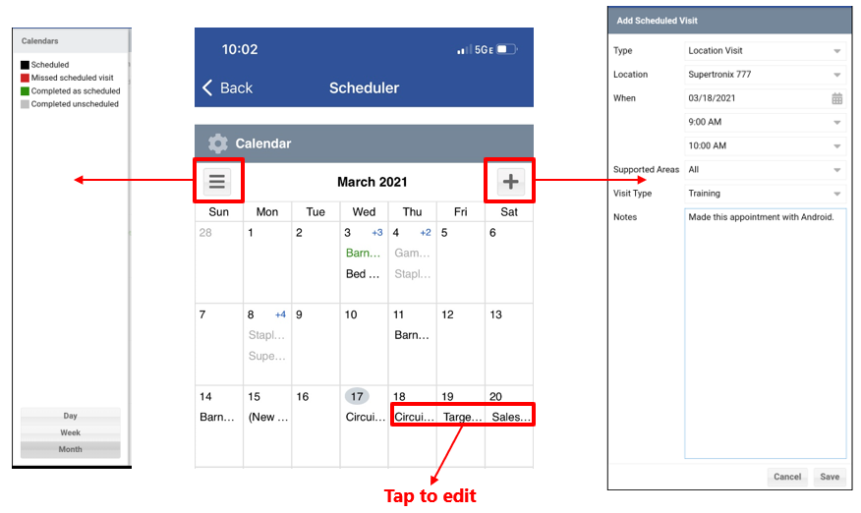

The remaining sections of this document pertain to general usage of the online Calendar at www.msftreps.com.
Calendar Scheduling for Events and Commercial Topics
Calendar updated with three new features.
- New field setting in the Calendar Add / Edit UI for scheduling an Event for any Rep and any Audience
- Commercial Audience uses the list of commercial products: Server, Windows Pro, Education, Microsoft 365, Windows Devices. (Same as Event form question: “What was the main commercial topic of this training?”)
- The online Calendar tool allows Partners from multiple countries for Regional Rep to pre-register and list how many expected attendees will be attending
Steps to follow:
- Login and navigate to Users > Calendar
- Select the Rep (if Admins’ view) and set the month desired for the Event
- Click on Call Report tab (as opposed to the Location List tab for Visits)
- Click and drag the “Scheduled Event” to the Calendar day and release (drop)
- Popup UI displays with the fields to Add a Scheduled Event
- Complete the fields and enter (optional) Scheduled Partners / Expected Attendees
- Save both popups to finish; on the Rep’s app the Event will be visible on that day in Today’s Activities
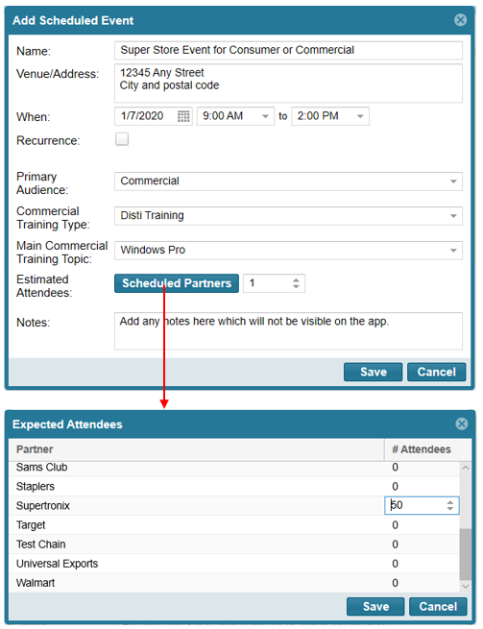
Calendar Scheduling for Visits with PC Aisle and Gaming Option
This feature allows the Store Visit Call reports to focus on specific product categories’ sections of the call report and hide the rest. The scheduling options now include a setting for PC Aisle (Windows / Office / Surface / Widows Phone / PCA) or Gaming (Xbox). The default will be All categories, and note that “adhoc” unscheduled visits will continue to see all applicable categories for that country and retailer.
Using the Calendar and Scheduled Visit Option Feature
The Calendar scheduling steps have not changed in general, however a new set of control buttons labeled Supported Areas have been added.
- Navigate to the Calendar page in the Users or Store menu at www.msftreps.com.
- Select a Rep from the drop down to be scheduled (or if you are a Rep, this is your view by default).
- Drag and drop the store from Store List tab to the corresponding day in the calendar for the visit, or the initial start point if a recurring visit needs to be created.
- Add scheduled visit pop-up is displayed. (Figure A)
- Choose the visit type and expected duration. If there are any notes to be added, add them in the notes section.
- Choose the date and time for the visit.
- Key step: for Supported Areas, select PC Aisle or Gaming to focus on just those product categories for this visit or series of recurring visits. (Figure A)
- If there is no need for a recurring visit, then click on the Save button and the visit will be scheduled.
- Check the Recurring check box if recurrence is desired.
- A pop-up is displayed with two sections named Recurrance Pattern and Range of Recurrance. Make appropriate selection (Figure B).
Figure A
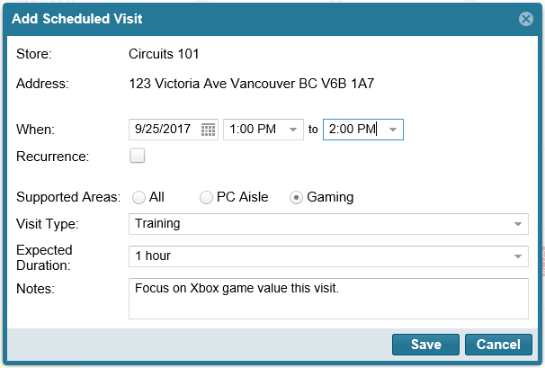

Figure B
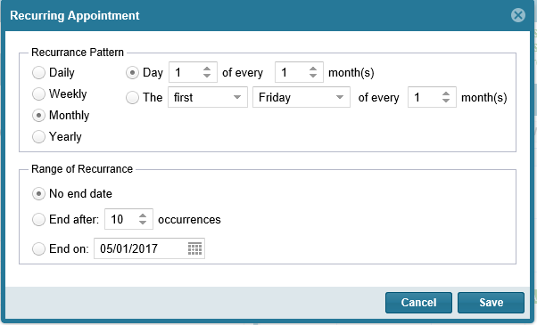

Different Recurring patterns:
- Daily – if the schedule needs to be repeated daily.
- Weekly – if the schedule needs to be repeated on a particular day of a week.
- Monthly – if the schedule needs to be repeated on a particular day on a monthly basis.
- Yearly – if the schedule needs to be repeated on a particular day on a yearly basis.
Range of Recurrence:
- No end date – if there is no halt for the recurrance after a particular number of occurrance/date.
- End after – if the schedule needs to be halted after a particular number of occurances.
- End on – if the schedule recurrance needs to be stopped after a particular date.
- Click on the save button
- The store visit is now scheduled.

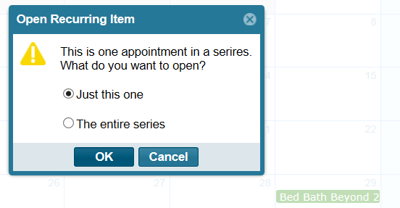
Editing or Removing a Recurring Scheduled Item
Click directly on your calendared item in the calendar. A pop up will display as shown.
- You can select to edit or remove just the single calendared item you have
- You can select to edit or remove the entire series of your calendared item

Calendar colors
The calendar colors have changed and are driven by scheduled status now and not by the type of visit scheduled. The four modified colors which will help in identifying the visit status are:
- Grey – A visit that is scheduled (pending to be completed)
- Green – Visit was scheduled and completed
- Black – Completed a visit that was unscheduled (ad-hoc or “on-the-fly” store visit)
- Red – Did not complete a visit that was scheduled.
See Figure D below.
Note 1: On the REP app, as scheduled visits are completed by the rep, the Store will drop off the Today’s Stores list after the app has been refreshed with content from the server. This will happen only after refreshing the app from the main page of the app. Calendar date of a completed visit is determined by the Start Visit timestamp in the form.
Note 2: When scheduling recurring visits that over-write or duplicate the same store on the same day, the latter of the scheduled visits will be used to record the Visit Type. In other words, the Visit Type on the app will reflect the last change to the calendar for the rep if same store is scheduled more than once on the same day.
Figure D
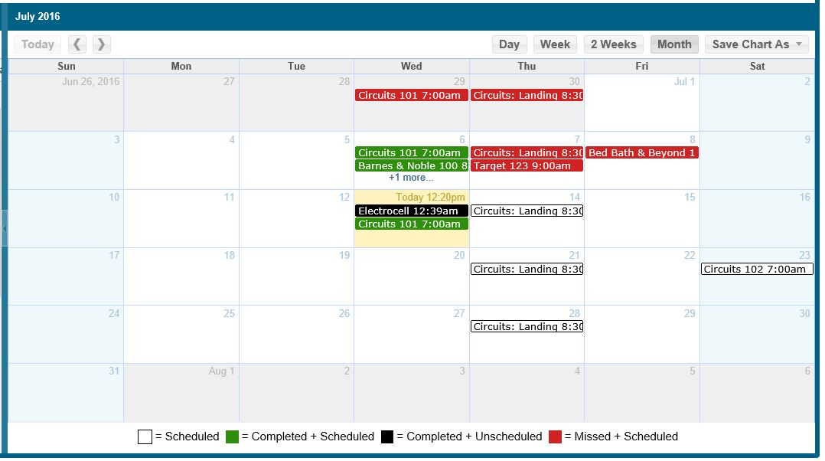

Calendar Export Feature
The calendar can be exported into an excel file or as a calendar file. In order to export the calendar, click on the Save Calendar As option.
- The calendar export will provide a .ics file which can be imported to the outlook calendar or any other calendars. It will contain all the details of the scheduled visits.
- The Excel export (Figure E) will contain all the details of scheduled visit and provides information such as ‘schedule status’, and ‘transaction id’.
Figure E
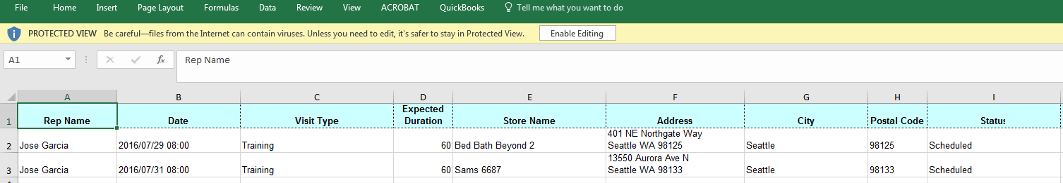

The Calendar .ics file and the Excel file can be exported to include all the Reps or just one Rep. For example, if Admins wish to export all Reps in one Excel file, here are the steps:
- Login and navigate to Users > Calendar
- Do not select any Rep in the dropdown
- Set the month you wish to export
- Click Save Calendar As
- Select Excel
- Confirm popup shows “Would you like to download the chart as an Excel?”
- Click Yes and the export will complete with all reps for the entire month, including appointments scheduled in the future

The export will include both Visits and Events.

Revised 3/26/2021

