Overview: Product Category Association in Partners / Classifications / Locations tabs
The settings on the 3 tabs under Call Report Settings > Product Category Associations will determine what the reps will see on the app in the Store Visit Report and Retail Pro Training form, on a store by store basis. Recent changes to this page have made it more user friendly for the Admins to use.
Some simple logic rules to know:
- Changes on the tabs flow in one direction: downward. If you make a change on the Partners tab, it will flow to the Partner Classification tab and Locations tab
- Changes to the Partner Classification tab will flow to the Locations tab
- Changes on the Locations tab do not affect the other tabs
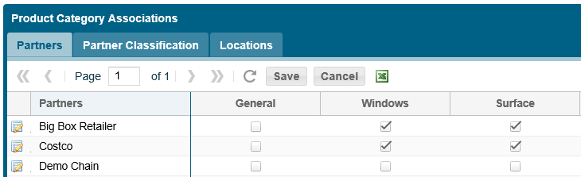
Steps to follow for making changes:
Log in to Msftreps.com and navigate to Administration > Call Report Settings menu.
After opening the page and ready to make Product Category Association changes, it is recommended to first take a “snap-shot” of what your current settings are by using the Excel export on all 3 tabs. This may serve as a handy reference should you need to revert any changes you make.
NOTE: Changes made are live and will go into effect immediately!
Procedure:
- A checkmark on Partners tab will checkmark all classifications for that partner on the Classification tab and all the locations on Locations tab
- Click Save
- On the Classification or Locations tabs If there are some classifications / locations that do not have the product category, then uncheck any classifications / locations that do not have the product
- Click Save again

Alternate Method:
- An “un-checkmark” on Partners tab will remove all checkmarks for that partner on the Classification tab and on the Locations tab
- Click Save
- On the Classification or Locations tab if there are some classifications / locations that DO have the product category, then checkmark any locations that have the product
- Click Save again
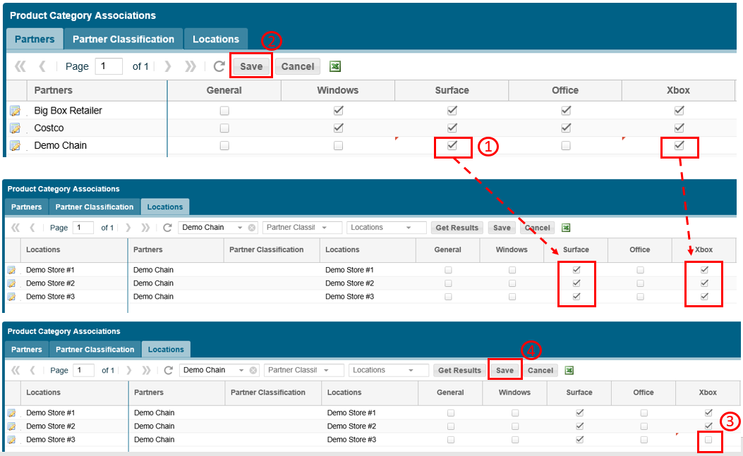

Other Release Notes:
- New locations added after Product Category Association settings are made as described above, will not reflect any checkmarks and settings must be made on the Locations tab.

Published November 30, 2018

