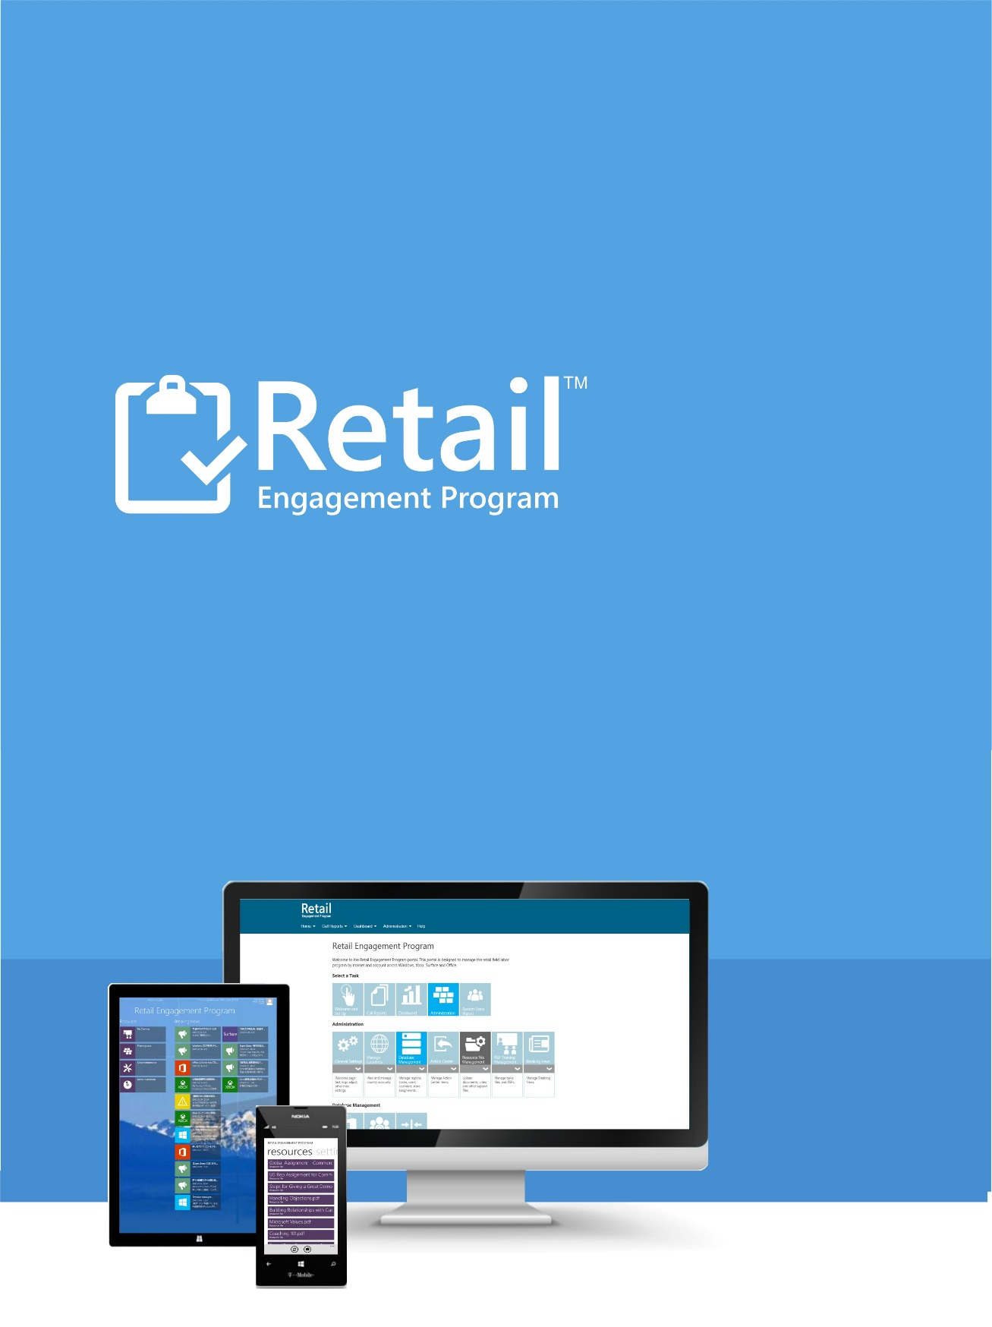

Custom Dashboard Quick Start Guide
Version 091015

September 10th, 2015

CUSTOM DASHBOARD QUICK START GUIDE

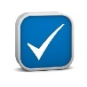
After reading this document, you should be able to:
Have a general understanding of the new custom dashboard.
Create your own dashboard with the provided default common charts and graphs.
Add and share pie chart or graph from call report questions.

Contents
Overview 4
What to Expect 4
Custom Dashboard Overview 5
Filters 5
Common Charts and Graphs 8
Adding Common Charts and Graphs to a Dashboard 10
My Dashboard - Viewing Common Charts and Graphs on My Dashboard 11
Manipulating Common Charts and Graphs 11
My Saved Items 12
Add Saved Items to a Dashboard 15
Sharing Items with Others 16
Items Saved by Others 17
Dashboard Views 18

Overview
The Custom Dashboard feature allows each user to design their own dashboard with items that are most relevant in how you personally use the Retail Engagement Program. The new controls offer a variety of common charts and graphs to choose from. There is also a way to (1) create your own charts and graphs from select questions found within any call report and (2) share those created charts and graphs with others.
You will also find:
- A set of advanced filter controls to drive displayed data in which you want to view it (date, products, rep type, visit type, retailers, etc.).
- The ability to create multiple dashboard views for your own personal use.
The dashboard have been built using responsive design. This is a method that helps to hold formatting using mobile devices and browsers. This means you can point and tablet or a phone to the new custom dashboards and the pages will auto format. It is important to note that every implementation of a browser by device manufacture may require the site to be re-worked to offer support. This site is to be optimized for Microsoft browsers on Microsoft devices. You may see formatting issues using an iPhone, Android or other mobile devices.

What to Expect
We have tried hundreds of variations of this new dashboard work in our testing. However, there are unlimited (billions) of possible combinations one could attempt with these new controls using an unlimited number of devices and browsers. As you start to create your own dashboards, and you do experience trouble, reporting these issues to us in a complete and organized way will be paramount to our ability to help.
Support tickets should be submitted using our online form on the help tab at www.msftreps.com. We will need as much detail as possible in helping us help you best. Include your device, browser type, browser version number, your name, country, what you were attempting to do, the expected behavior and behavior you experienced. If this detail is not provided, we will be following up to ask you for this detail as it is critical for our support department to help resolve.

Custom Dashboard Overview
The new custom dashboard follows many new web design elements. As you can see, the filters can be open and collapsed on the left side and each section of the dashboard is a bar that can be open and collapsed as well. Click the plus sign in the bar to open each.
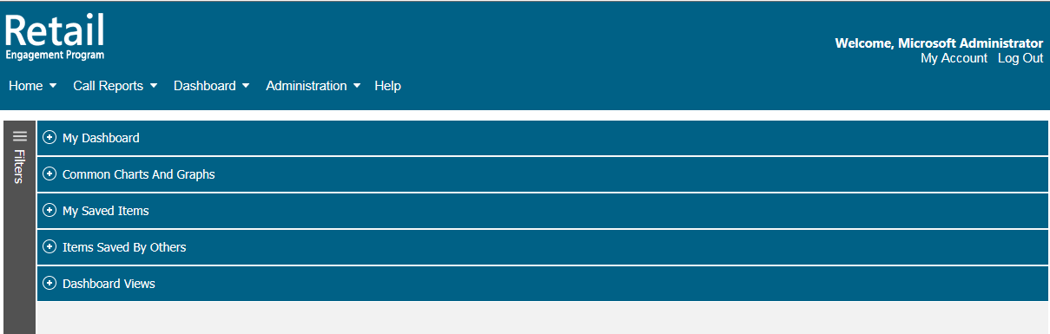
There are 6 main section to the custom dashboard:
Filters | Location to set the criteria of data to be displayed in the dashboard charts, graphs, etc.
My Dashboard | Where you design, modify and display the elements of your custom dashboard.
Common Charts and Graphs | Options of common charts and graphs supporting a wide variety of displays (pictures, charts, breaking news, etc.).
My Saved Items | Create your own pie charts and graphs from select questions found in call reports. Share them with others.
Items Saved by Others | Location where items share by others are stored.
Dashboard Views | Name and save multiple dashboards for your own personal use.

Filters
Click the hamburger icon to expand the filters view:
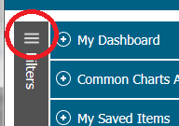

Once expanded, all filter options display:
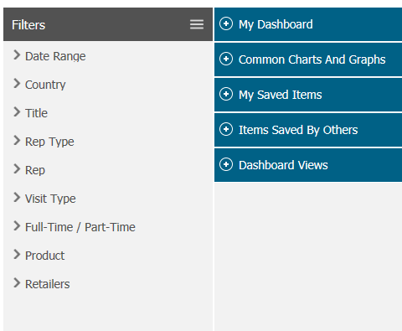
Quick note: not all filter options are available to each user. For example, Country filtering is not available to a country admin as the data is limited to just their country. In this case, the Country option would not be present.
Options include:
Date Range | Current Month, Previous Month, Current Quarter, Last Quarter, Year-to-Date, Last Year and Select a Month.
County | Select Countries individual or by Region
Title | Support to filter data by titles used within country
Rep Type | Support to filer data by MS titles of Reps globally.
Rep | Filter by individual Rep
Visit Type | Filter by the type of visit being made
Full-Time / Part-Time | Choose between part-time, full-time status or both.
Products | Narrow your view of data by product or products
Retailers | Narrow your view by retailers (Retail BI, Chain, Chain Classification, Store, Region, Market, and District).

- Click on each filter type to expand.
- Make your selections.
- Select the Go control at the top.
For example:
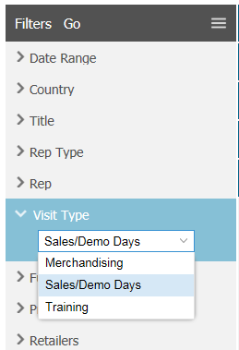
- Select Sales/Demo Days.
- Select Visit Type to open.
- Select Go to set the filters.
You can select any filter or any combination of filters for your dashboard settings.
If you want multiple sets of filters for your data, see section on Creating Multiple Dashboards.
The filters also support a built-in multiple-select option. In the graphic below, all Visit Types have been marked as selected:
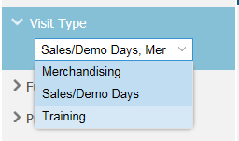
To un-select an option, click the item a second time:
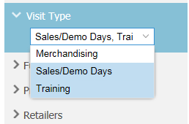
Note: To see the item un-selected, move your mouse away from the item to show as not selected.

Common Charts and Graphs
The following items have been pre-configured items which are known as common charts and graphs. You can add any of these elements to your custom dashboards.
Each item supports a sub-dashboard link that can take you to much greater detail of each item. These items are simply to support a general/generic display. For example, Breaking News might show just three breaking news items. But when you link from the Breaking News common chart, it will take you to a page that shows all available breaking news. The idea here on all of these items is to provide a cumulative statistical snap shot; will easy access to more detail as desired. Items are:
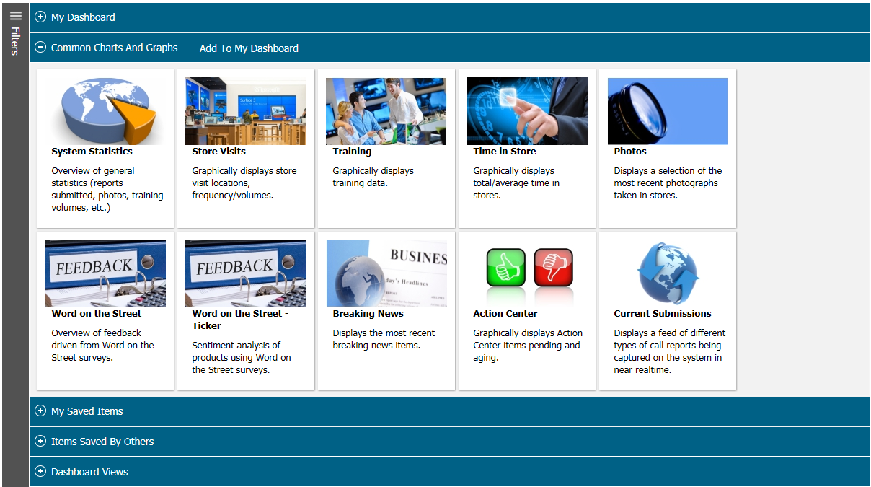
Note: Graphics associated with each item are subject to change. New common charts and graphs are expected over time.
System Statistics | Big stats on the server. Total submissions, hours in store, trainings, total RSPs, etc.
Store Visits | Displays volume of store visits.
Training | Larger view of training statistics.
Time in Store | Graph showing time in store stats.
Photos | Last known photos submitted to the server.
Word on the Street | Color bar chart showing negative, positive or neutral sentiment.
Word on the Street | Data shown as similar to a stock ticker, trending positive/negative.
Breaking News | Most current breaking news items.
Action Center | Action center status by country /compliance.
Current Submissions | Live feed of records being received by the server.

Examples:
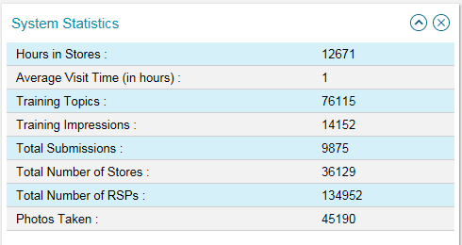
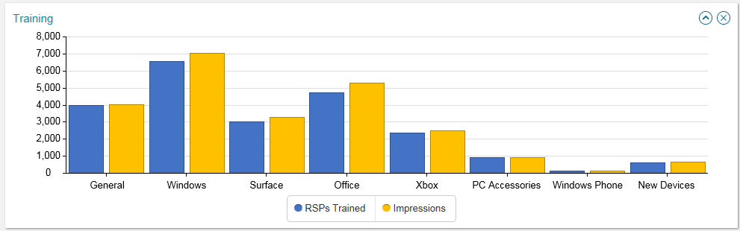
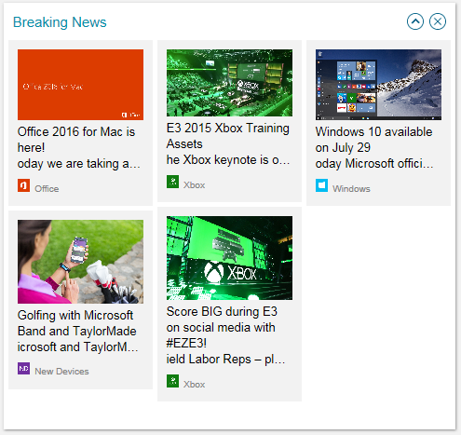
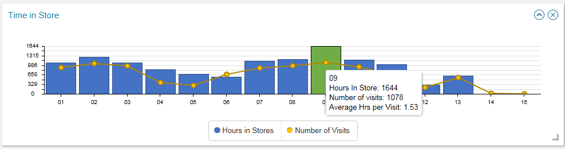

Adding Common Charts and Graphs to a Dashboard
- Open Common Charts and Graphs
- Move your mouse over one of the items
- Check off the box in the upper right of the graphic
- Select Add To My Dashboard
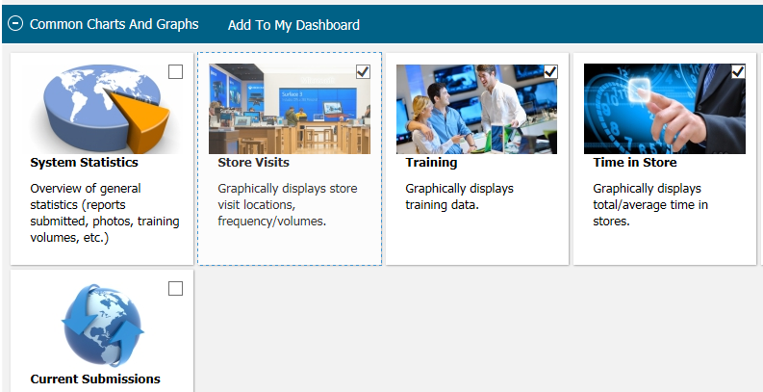
- Check an item to be added.
- Click Add To My Dashboard.

My Dashboard - Viewing Common Charts and Graphs on My Dashboard
Collapse Common Charts and Graphs then open My Dashboard.
Selected items will display on the My Dashboard page. For example, this page shows System Statistics, Word on the Street Ticker, Time in Store and Breaking News selected.
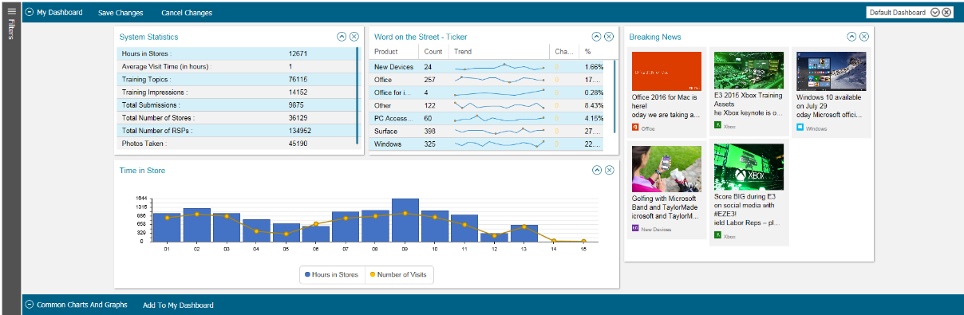

Manipulating Common Charts and Graphs
Every item on the My Dashboard view can be stretched to show more or less data, rolled up out of the way ore removed.
Stretch - Place your mouse in the bottom right corner of each item. Hold your mouse down and move it to a new position.
Moving – you can also move each item to a different location by grabbing anyone in the item and sliding your mouse.
Roll Up – use the arrow up in the upper right of each box to roll the item up. If rolled up, use the arrow down to expand.
Remove – select the X option in the upper right of each item.
The title of each item is a link to the sub-dashboard of each of those pages. This is a quick and easy way to come about much greater detail in each item of interest.

My Saved Items
The Dashboard offers support to graphically display individual questions from either global or local items added to call reports. Options include a pie chart or bar chart. This is limited to questions that support a response type of Yes/No, Single Select or Multiple Select responses.
Expand the My Save Items bar and click on Create Dashboard Item.
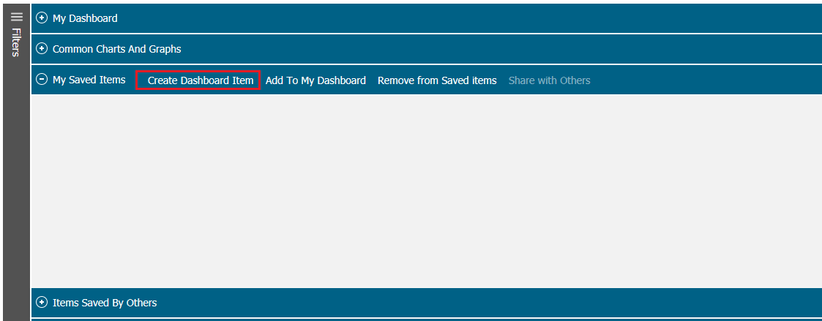
This opens a pop-up window.
You can select a question that from the Global template or a local question created by your country or countries you may have access to depending on your permissions.
Select a Call Report (note, as we move to a question centric system in Aug/15, this will be supporting a single master call report).
Choose an available question/prompt from the dropdown list (as shown).
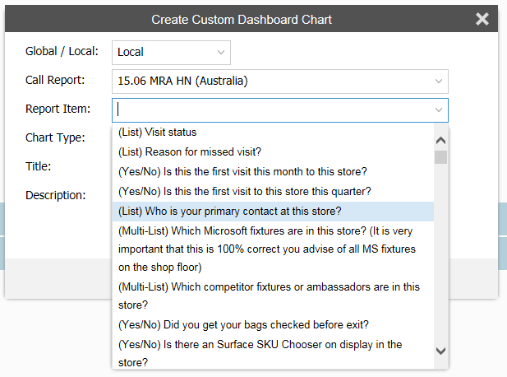

Once you select a Report item, that report item copies itself intot he description box.
Select if you want the data to display as a pie chart or bar chart.
Add a Title.
Edit the description as desired.
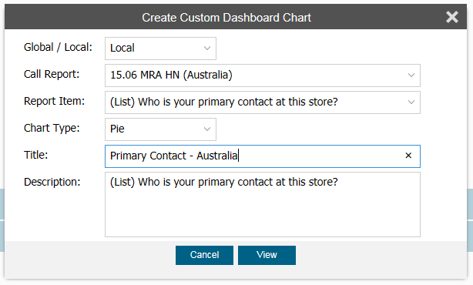
Select the View button.
This will display your data as a pie chart or bar chart:
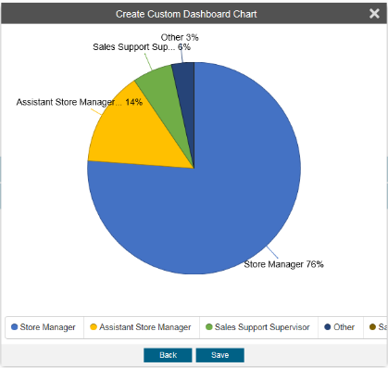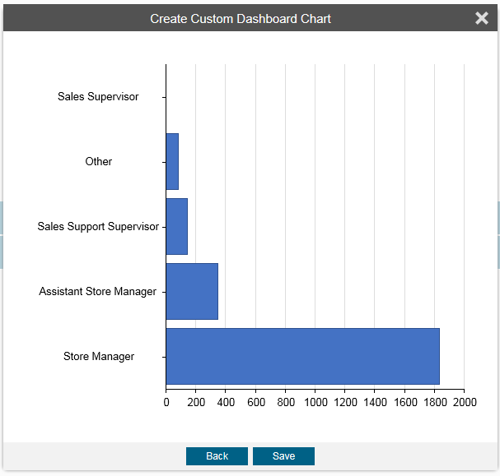
If you like the option, select Save, if not, select Back.

By selecting Save, you are taken back to the Custom Dashboard where your My Saved Items are stored. The example below shows we saved a bar chart.
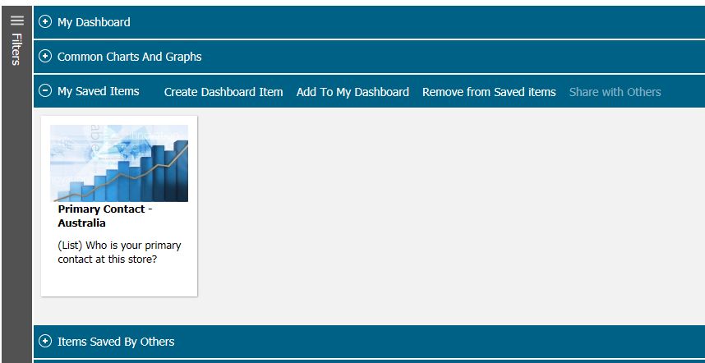
As you repeat this process, more and more items will start to store in this location. If you create a pie chart, the graphic added will look like this:
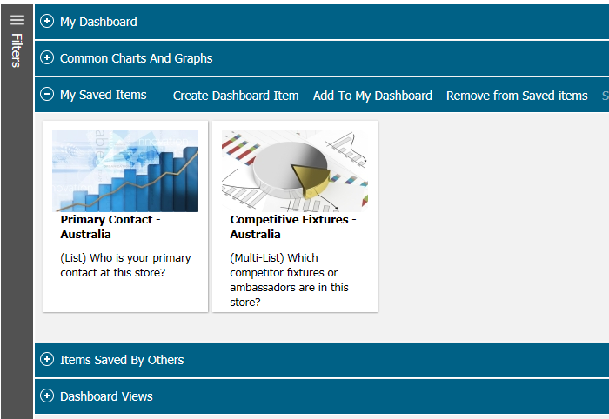

Add Saved Items to a Dashboard
Take your mouse, hover over the graphic to make the check box appear. Check the items in which you want to add to your My Dashboard and select Add to My Dashboard.
Your items will be added to whatever My Dashboard is currently open.
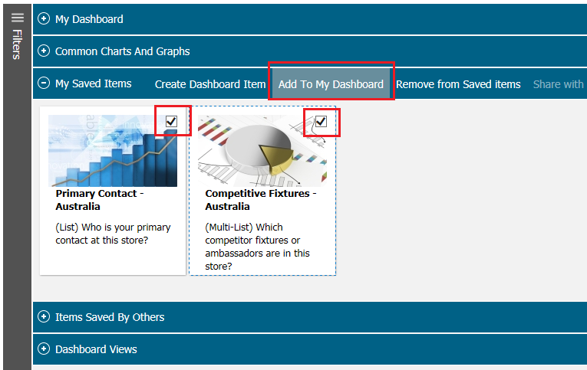
Which displays the items like this (note: graphic here does not show data plotting for the bar chart).
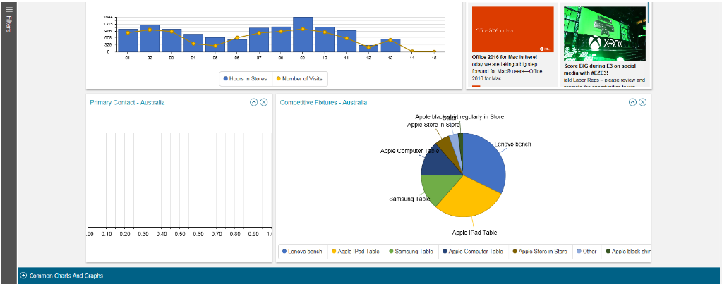
Note: Feature pending on taking to share items with others.

Sharing Items with Others
Once you have created an item, you can now select this item and tag it to be shared with others.
Select: Share with Others option. This will display a Choose County option and a Choose User option.

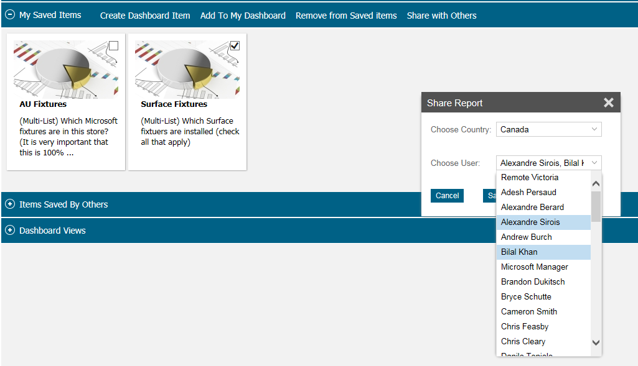
The item will now show up as available in their Items Saved by Others section and can then be added or removed from any of their own My Dashboards.

Items Saved by Others
This section will display items shared by others. It behaves exactly the same way as the function of the previous section on My Saved Items.

Dashboard Views
This section is where you title and manage your dashboard views from. You can have multiple dashboards associated with your account.
Open the Dashboard Views bar.
Select Add.
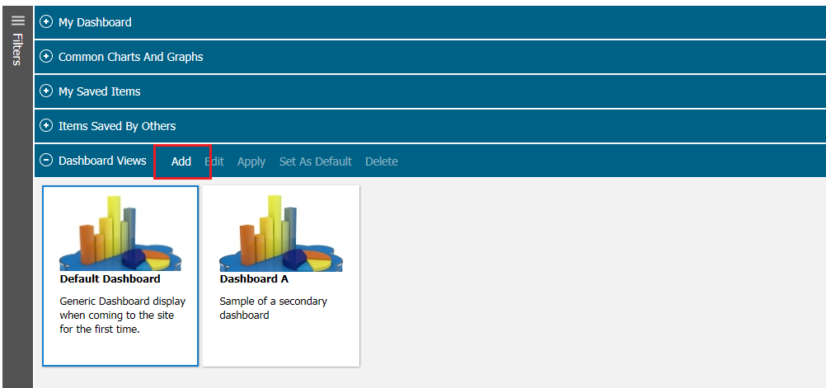
Title your Dashboard and add a Description.
Select Add or Cancel.
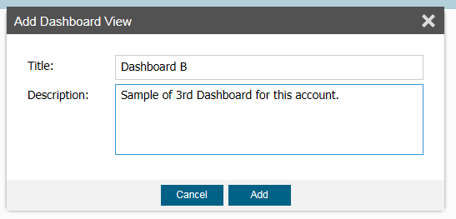
By Selecting Add, a New Dashboard tile with that title and description will appear as shown:
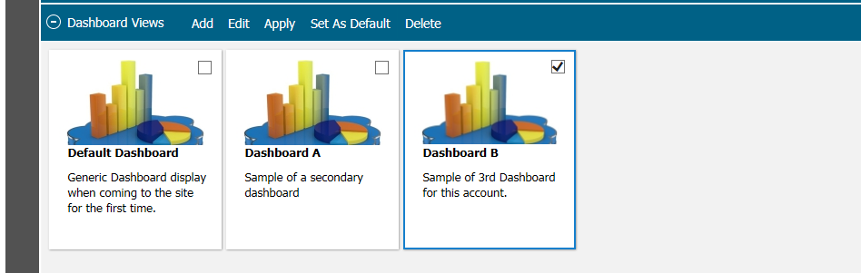
Hover over the tile, check the box in the upper right, and select Apply from the Menu. This will now display this Dashboard in the My Dashboard Section.
Note: Controls here are not as intuitive as we would like; this is being updated at this time to more user-friendly interface.

