EXPORT ALL DASHBOARD ITEMS TO POWERPOINT, EXCEL AND GRAPHIC FILES
The My Dashboard section of www.msftreps.com now offers several new export options. Users can export a single item on a dashboard or an entire dashboard to PowerPoint, Excel and or as graphic files (note, not every option on the dashboard is supported by every export option like photos for example).
In the upper right of the My Dashboard bar, select the Save Dashboard As drop down to select either Excel, PowerPoint or Image.
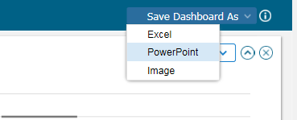
This will bring up a selection box that lists all current items on the open My Dashboard view. All items have been pre-selected for download/export as shown below. Leave items checked that you wish to export; uncheck items in which you would like to leave out. Then select the download button.
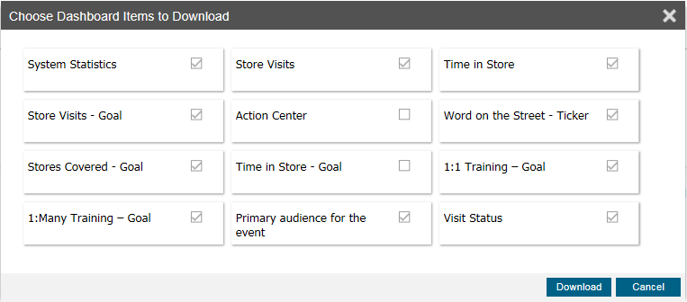
If exporting to PowerPoint, PowerPoint will open and place each item on its own page in PowerPoint. Note, to size the graphics in PowerPoint, remember to turn editing on for the document:
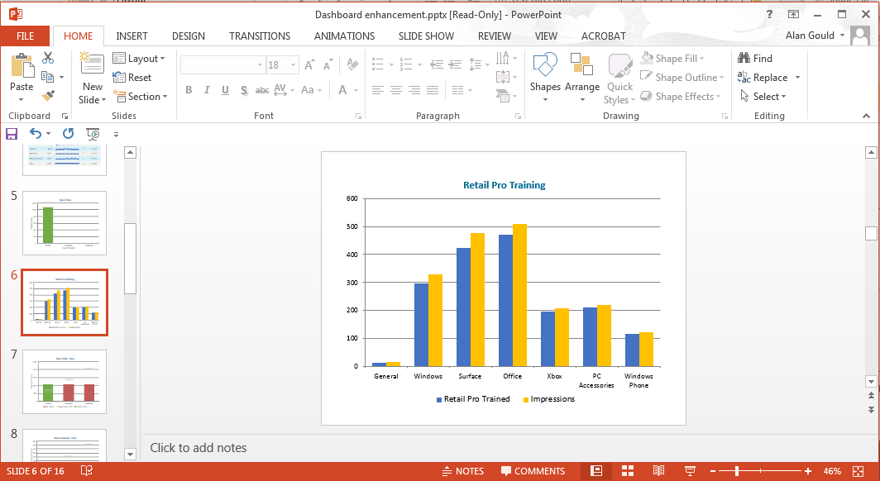

- When exporting to Excel, each graphic will display on multiple pages.
- When exporting Images, a zip directory will display with files selected included.

EXPORTING INDIVIDUAL DASHBOARD ITEMS TO POWERPOINT, EXCEL AND GRAPHIC FILES
Similar to the functionality above, all individual dashboard items can be exported one at a time with the new drop down “Save As” options shown here:

