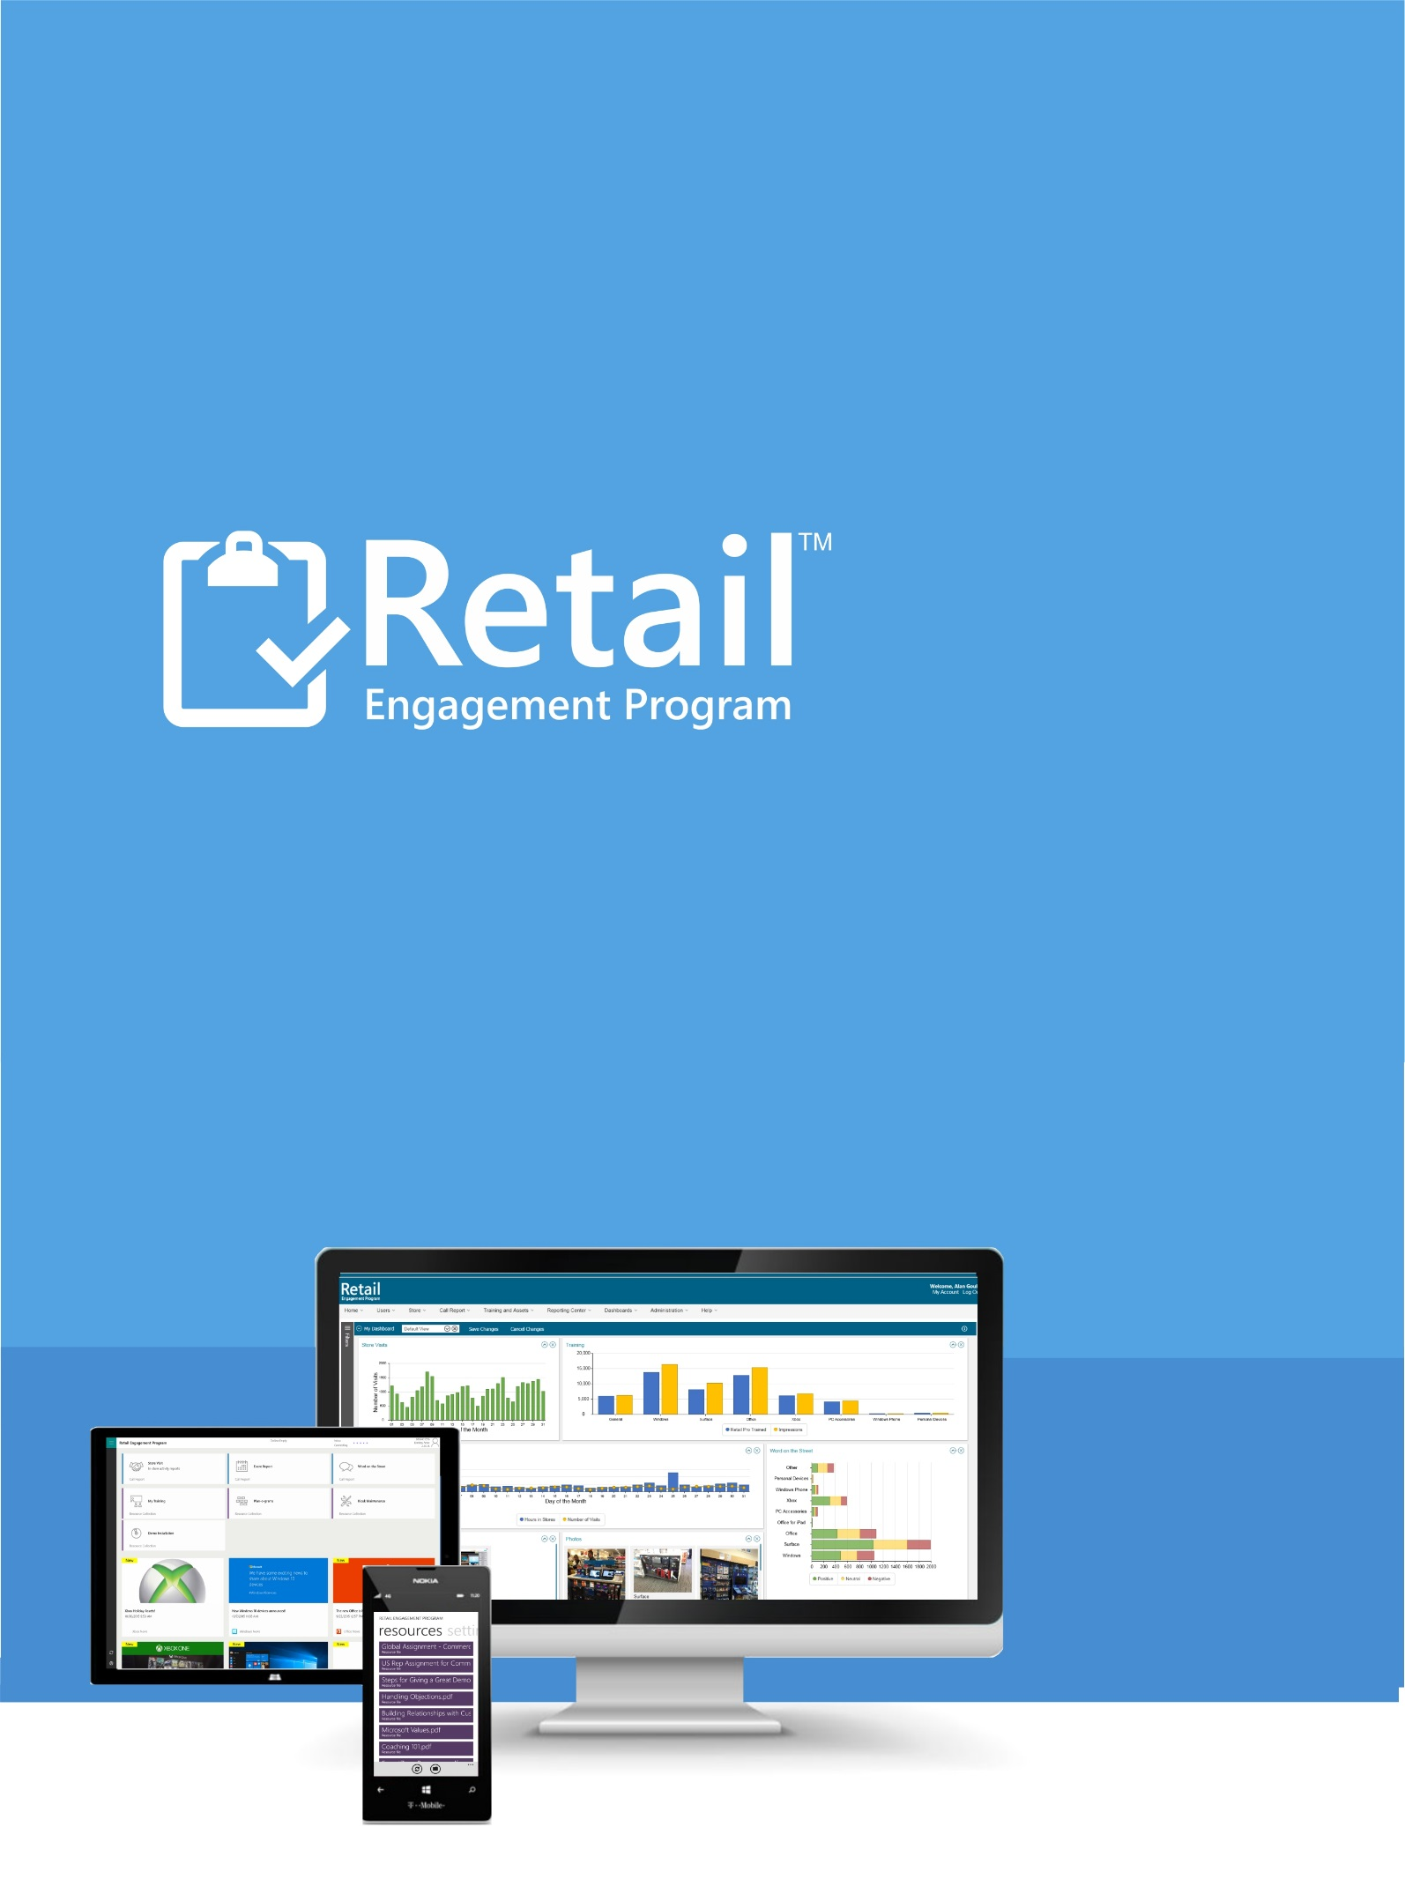

Dynamic Call Report Guide
Version 070516

June 30, 2016

Question Centric Call Report Guide


After reading this document, you should be able to:
Understand the newly added features in manage call report section.
Create a Dynamic/Question Centric Call Report(QCCR) and distribute that report to your field labor teams.

Table of Contents

Overview 4
Review of Configure View – New Features 6
Advanced New Functions: 8
Adding/Editing Questions 10
Troubleshooting 14
Support 15

Overview
The MSFTREPS site supports a call report building system designed for multiple call reports for multiple types of store visits. It is cumbersome and requires some Admins to copy and support many call reports every month.
The new method shifts away from a call report building model and towards dynamic call report creation using a “question-centric” approach. More specifically, there will now be one single large call report where all global questions, regional questions and local questions will reside. However, you now use a set of rules for each question to either have them display or not display based on those rules.
What is the result?
You will now have one very large call report to manage. You will now “filter away” questions that are not relevant to that store visit.
For example, if I am a Community Manager conducting a training visit to a Best Buy retail chain location, all the questions that match those criteria will “dynamically” display for that specific visit. Items that do not match that criteria will not. This will be discussed in detail in this document. However, this is a quick view of the new filters page available for each question:
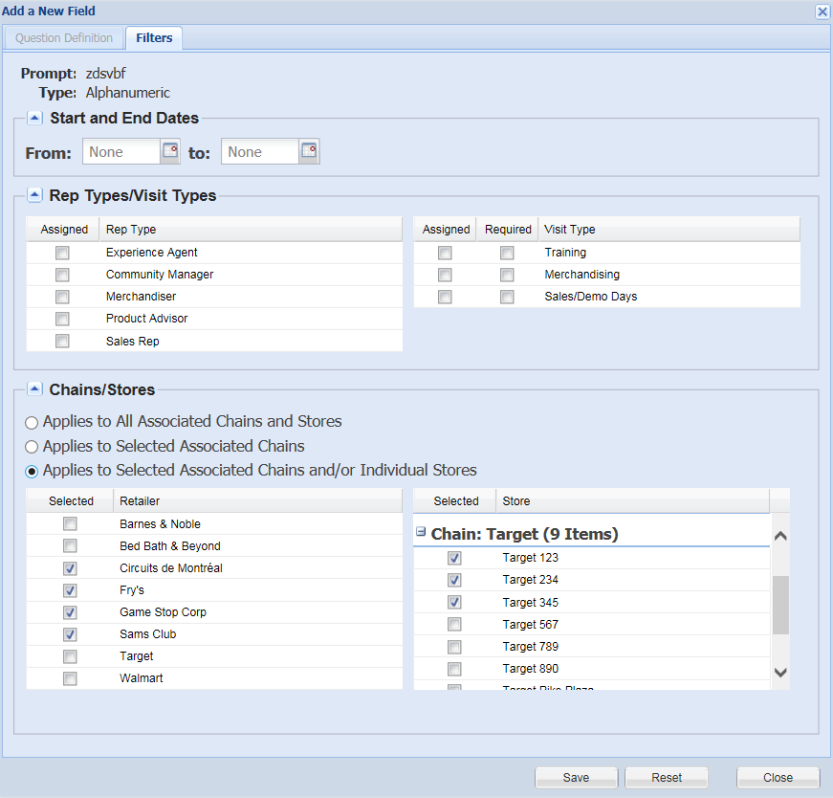
As you can see, for each question you will now denote the Date Range, Rep Type, Visit Type and chains/retailers.
Important items to note before you start. Most of these items are discussed in detail in this document:
- The new master call report is called ‘Store Visit Report’ available in Call Report >> Manage page.
- Filters are now required for all individual questions.
- Just like before, some questions added by the Global Admin cannot be edited but can be translated. When this happens, items in the above view will be dithered (visible but not editable).
- Country Admins can continue to add additional questions as previously supported and use the new filtering options as shown.
- A transition period will be supported in which your existing call reports will be live and the new Store Visit Report will be available for testing.
- Testing tools have been built into the system to allow you to view what your call report filters will look like.
  - This is available online to see the questions based on your criteria.
  - This is available with a unique ID number to do true field view testing on Windows Phone and Windows.
- When you have the question centric call report just right, you can switch to start using it 100% for all Reps and turn off all other call reports permanently.
- Note: this is largely an Admin tool. Reps will see very little difference in functionality on their mobile devices. No material field training should be required other than telling them to use the new call report for all visits.

Review of Configure View – New Features
- Login to MSFTREPS.com
- Select Manage from the Call Report Menu
- Click on Configure corresponding to the new: Store Visit Report
General New Functions: See numbers on graphic 1, 2 and 3:
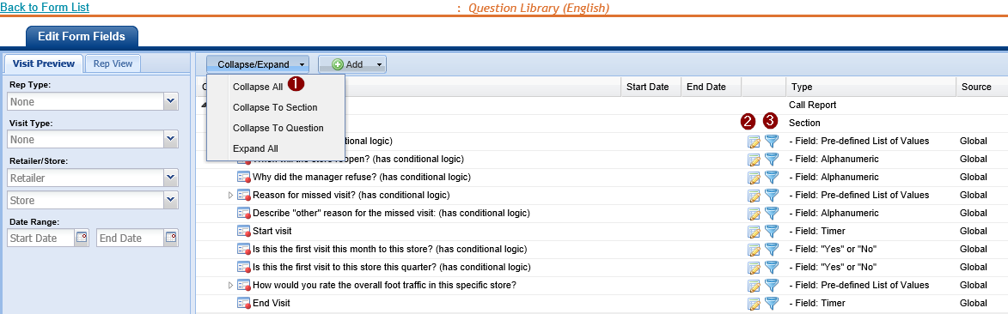
- Newly added Collapse/Expand button
The Collapse/Expand button provided on the top allows the following options:
- Collapse All – Collapses the call report content entirely
- Collapse to Section – Collapses the call report content to the different sections of the call report.
- Collapse to Question – Collapses the List of Values and all the questions are displayed.
- Expand all – All the questions are expanded up to the list of values.
- Edit Question Icon
Clicking on the edit icon will display the edit window.
The edit window has two tabs
- Question definition – Existing call report question edit features are retained here (same as before).
- Filters – Newly added tab with filter options for a particular question.
- This is discussed in detail later in the document.
- Filters Review Shortcut Icon
The Filters review icon will pop up a view to the assignment filter tab to directly view and manage settings.

Other Notes:

- Conditional form logic remains in the same location by using the right mouse command over a particular question.
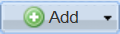
- Add Button - Add questions for your local field labor needs.
  - Select a Section
  - Select New Question
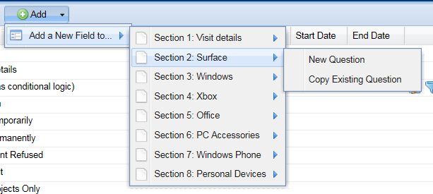
- If you select Copy Existing Question, you can now tap into questions that have been created by any country of the world and add them to your own:
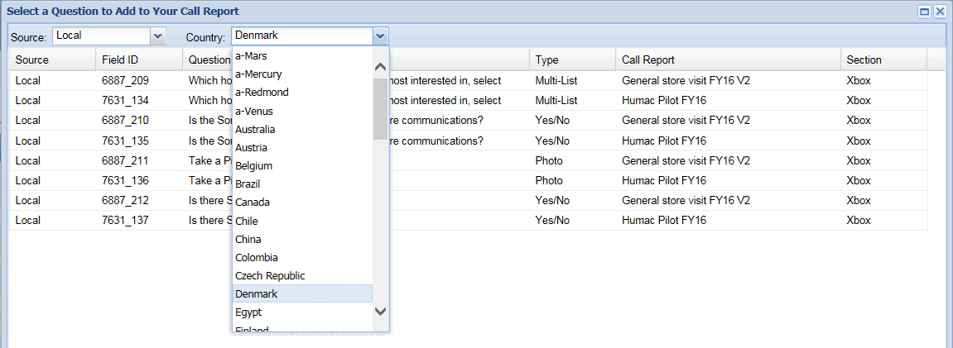
NEW!! – If you use the right mouse command to Add a new Question, the Question will NOT be pushed to the bottom of that section; it will now hold in the place in where you are adding it.
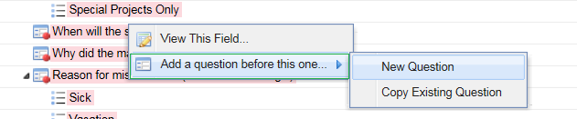

Advanced New Functions:
Figure G
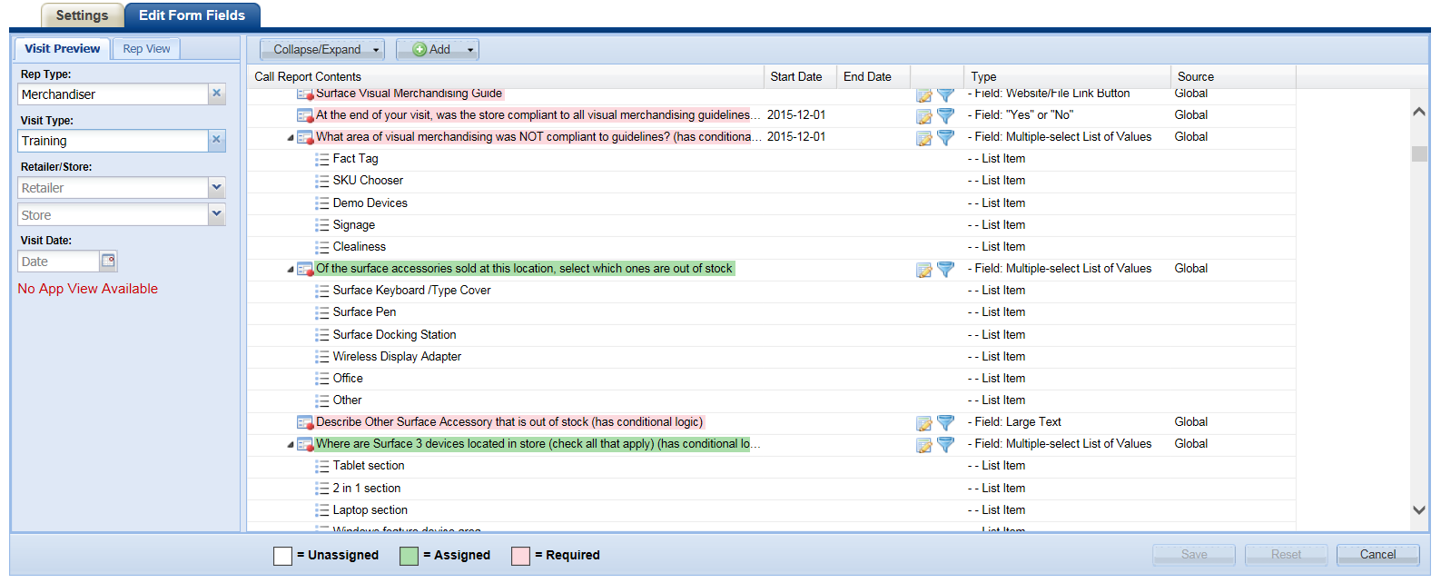
- Visit Preview/Rep View Tabs
Figure H Figure I Figure J
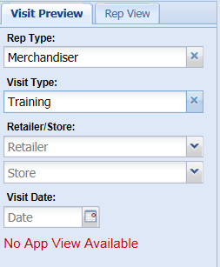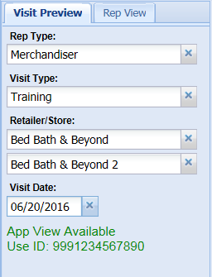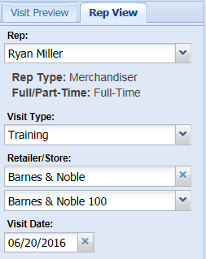
  - Visit Preview (Figure H) and Rep View tabs (Figure I) offer a filtered view of the question displayed on the right (Figure G). This is a quick and easy way to review all questions in the library and see which questions will be supported with different views/filters selected.
  - Visit Preview Tab Special Feature (bottom of Figure H): If you have less than all 4 criteria selected (Rep Type, Visit Type, Retailer/Store and Visit Date), the words No App View Available will display. However, if all 5 are selected, the system will say App View Available Use ID: xxxxxxxx. By entering in the ID number generated (bottom of Figure I), you can do a true review of what that view will look like in the App. Submissions using this test ID from the apps are rejected from the server so you can fully test as desired. If you change the filters, the app view will also change but you need to re-fresh the app to view. Enter that ID number into the Windows or Windows Phone App to view.
    - Common issue when testing:
      - It is required that the app re-fresh from the server when changing filter views. If you do not refresh, the Store Visit Report will stay the same as your previous filtered settings.
        - You can select the refresh forms icon in the app to refresh.
        - You can exit the app and re-enter to refresh.
      - Note: not setting the date field correctly and thinking your questions are missing. If you have scheduled questions to be live/active you must select a date that falls on that date range.
- Question Color Bars (right side of Figure G)
  - Unassigned
    - Displays as White
    - If you have filters set to your desired view and a question displays in white, it has not met any of the criteria of those filters. It is fully unassigned for that view. If you want it to display for this criteria, open using the Edit icon and re-configure your filters to support it.
  - Assigned
    - Displays as Green
    - If your filters have questions in which are assigned but not required, the question will display in a green bar as shown above.
  - Required
    - Displays as Red
    - If you filter have question in which are assigned and are also required, the question will display in the red bar as shown above.

Adding/Editing Questions
How you add, edit and delete questions in the system remains the same. However, a new tab has been introduced called Filters.
Click the Save Button as you do today when adding or editing a question. This will now enable the new Filters tab.
Note, this is disabled until you Save:
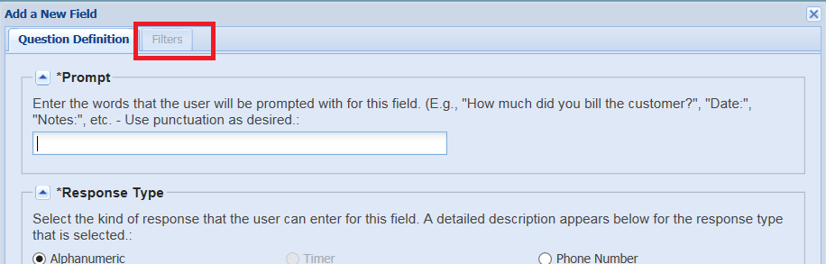
After Saving:
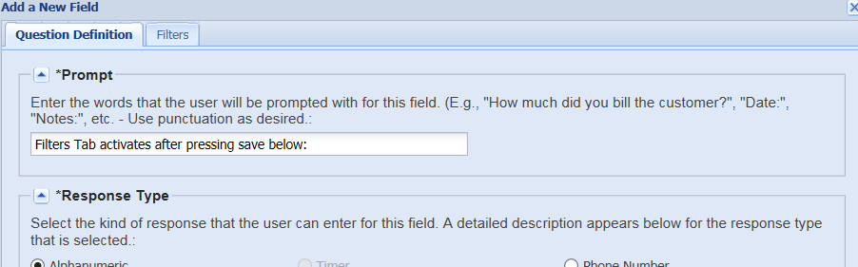

Filters Tab
As a question-centric system, you will need to assign the question to matched criteria.
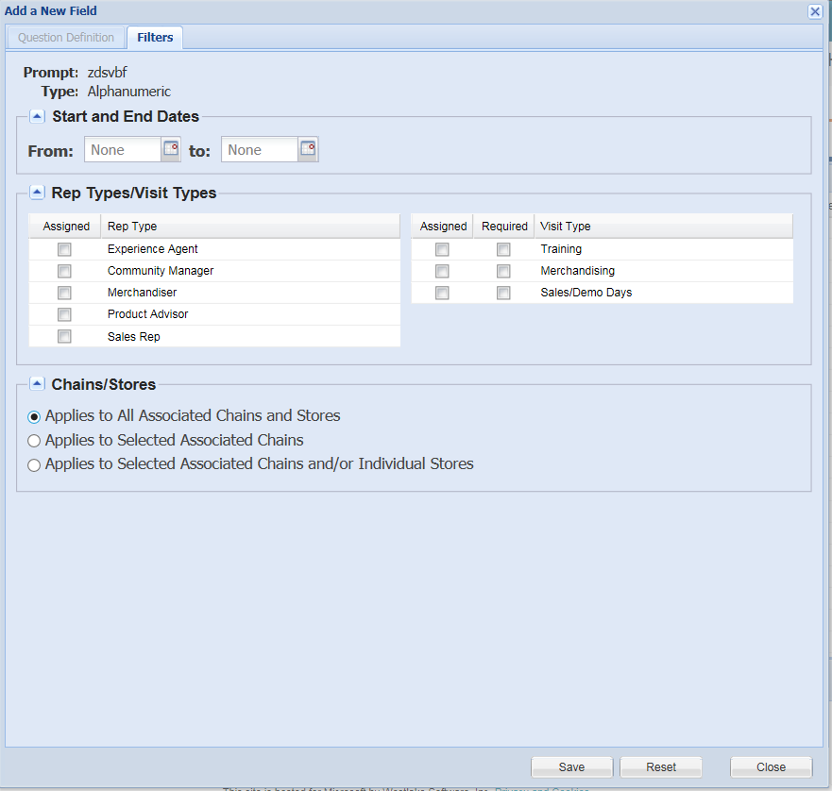

- Start date and End date

On setting a Start date for a question, it will be visible/active in the client application only from that selected date. Similarly, if an end date is assigned for a question, then that particular question gets deactivated after that date. You can also have a start date with no end date.

NOTE: Common error when testing: Setting a start date in the future and expecting to see it during testing prior to that start date (it will not display until that calendar day has arrived).

- Rep Type
Check off all corresponding Rep Types that support this question, that question will be assigned to all Reps under the selected Rep type.
- Visit Type

Check off corresponding Visit Types by selecting the ‘Assigned’ checkbox corresponding to that Visit type. This question will be displayed only if you select the assigned Visit type in the client application.

On selecting ‘Required’ checkbox, this question will be displayed as mandatory in the client application.

- Chain/Store

The Chains in the list are filtered first by the product categories in which you selected for each Chain under: Administration Menu - Call Report Settings as shown here:

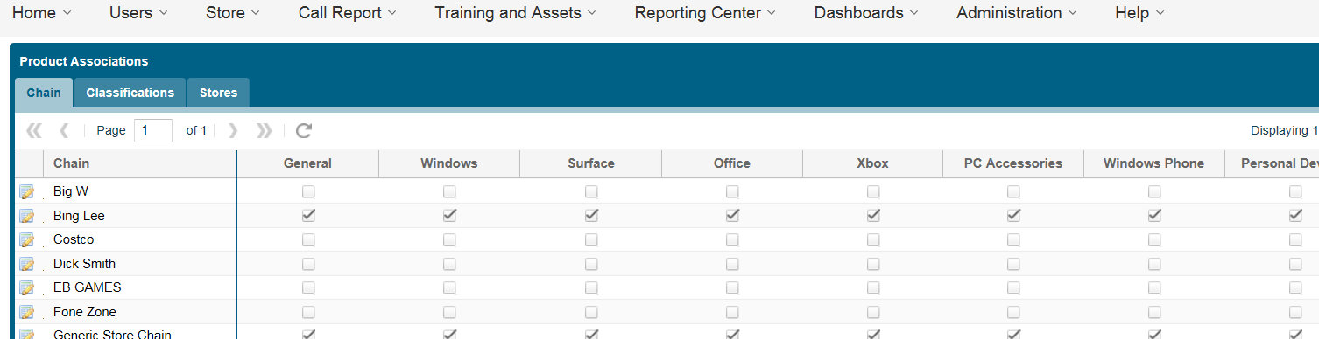

For example: If you are entering a question under the Xbox category/section, only chains in which you have denoted as supporting Xbox will display in the list below.

Chain/Store filter options are:

- Applies to All Associated Chains and Stores (default) – Leaving/selecting this option will have the question apply to all chains and stores.
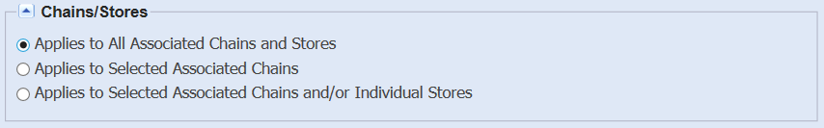
- Applies to Selected Associated Chains – This option enables you to limit which chains in which the question will be supported. Check off the Chains in which you want the question to apply to.
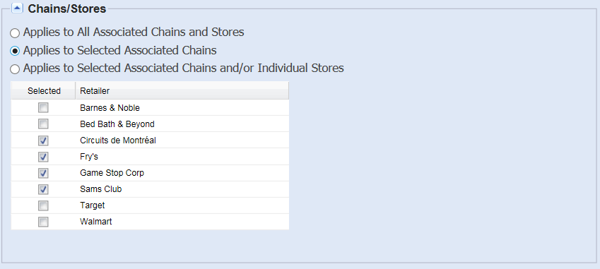
- Applies to Selected Associated Chains and/or Individual Stores – This option enables you to assign questions to a single or multiple stores.
  - You can select a chain on the left if you wish to associate the question with all stores in that chain.
  - You can individually select stores from chains from the menu system on the right. Open and check as desired.

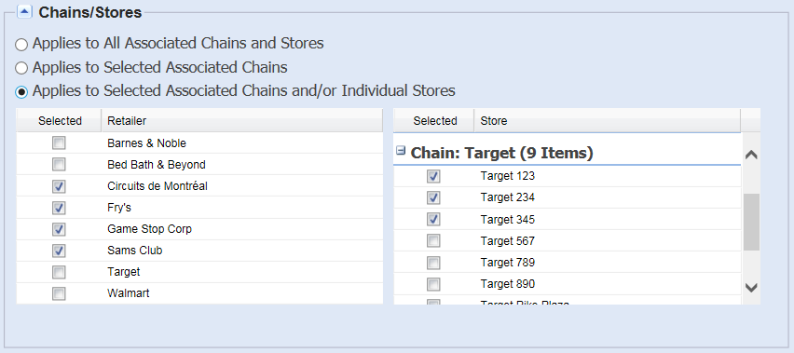

Steps to Move to New Store Visit Report
Schedule Training
- In training make live the new Store Visit Report (SVR) in an inactive state.
- Provide documentation.
From Inactive State:
- Open new SVR and import/add all location questions from the question library. Country Admin is reminded this is a single form now so ALL questions they use for ALL variations of call reports in which they use today needs to be added.
- Enter to edit all global and local questions to review (1) general settings of existing question settings and to now (2) configure all items in the new question filters page.
- Test Visit Preview filter function
- Test Visit Preview client testing with auto-generated IDs
- Test Review filter function
- Test turning on and off Rep Types, Visit Types, Retails and Date Ranges

From Active State:

- Turn on new SVR. SVR is to co-existing with other active call reports until full testing is complete.
- Reps can use (1) either their existing call reports to submit a store visit or (2) use the new SVR. Reps are NOT to use both for the same visit as this will double their submissions. This is a training point that needs to be made.
Going Live:
- Cut over to the new SVR is at Country Admin discretion. De-activate all existing store visit call reports; leave new SVR on.

Troubleshooting
I am using the client test feature with the provided ID number but some of the questions I added are not showing up.
Check the start date of the question to make sure that the date option you selected to test with is not out of the date range of the date filters you set for the question.
I want to limit a question to particular chains but I noticed that not all of my chains are displaying. Why?
Chains will display only if that chain is active and supports that product. Review the Administration Menu – Call Report Settings. If you are adding a question for Office and that Chain is noted as not supporting Office, it will not display in the filters section.
I changed my filters during client testing but the client did not update.
The client needs to be refreshed to see those changes. Use the refresh icon to do this or exit and re-enter the software.
The Filters Tab is not active when I press on it.
You must Save your question before the filters tab becomes active

Support
There are two ways to contact us for help and support:
Website: and then use the Help menu to open a support ticket.
Email: msftreps@westlakesoftware.com
IMPORTANT: This new feature has many features and options that are all new. It is very important that you describe in detail the issue you are having; screen shots help.
- Screenshots (if applicable)
- Contact information
- Device model / type
- Every step taken that caused the problem (filter settings, what you clicked on and in what order, can you repeat the process, etc.).
- Expected behavior and behavior you experienced
Thank you
Westlake Support Team

Example of a good trouble ticket submission:
I am Dave Johnson from Antarctica. I have added all of my questions into the question centric call report of Store Visit Report. I have set all my filters and have check them twice. When testing this against the ID number 999123456789 I am missing the following questions: Question 1, Question 2 and Question 3 here.
What we are looking for is ALL OF THE INFORMATION in which enables us to go online and replicate the issue you are having as fast as possible. This allows us to write up internal tickets to the development team that help us solve issues faster for you our customer.

