Overview
This document contains information on the changes and features added in the FY23 Q1 release:
- New feature: ExpertZone (EZ) Course added as a Champion Mission
- New feature: User Management Email field synchronization with ExpertZone
- Questions and Answers section
1. ExpertZone Course as Champion Mission
A new Mission Type has been added that is linked to ExpertZone. Admins can select ExpertZone Course as a Mission Type, which then opens the Course ID and URL fields. In the Course ID field, slowly type the Course ID if known or the Course Name and the possible choices will be presented to choose from. The URL field will auto-populate from ExpertZone. Then enter “Click Here” or “Click for EZ” or other short text to URL Text label the button which opens the ExpertZone website or EZ app on the device. Complete the remaining fields of the Mission as before. Note that the image upload currently supports JPEG files only and not PNG file format.
Note that a new completion timeframe has been added with the above change that can be used for any Mission. If Assigned Until Completed is checked, the Mission can extend beyond the usual month timeframe to finish. When ready, click Save to deploy the Mission.
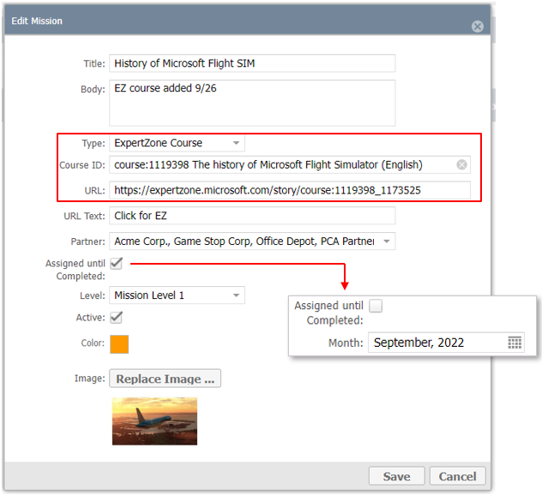
The Champion user will need to do two things to register successful Mission completion:
- Take the course in ExpertZone and fully complete it
- Mark the Mission complete in the Champions App within the specified period

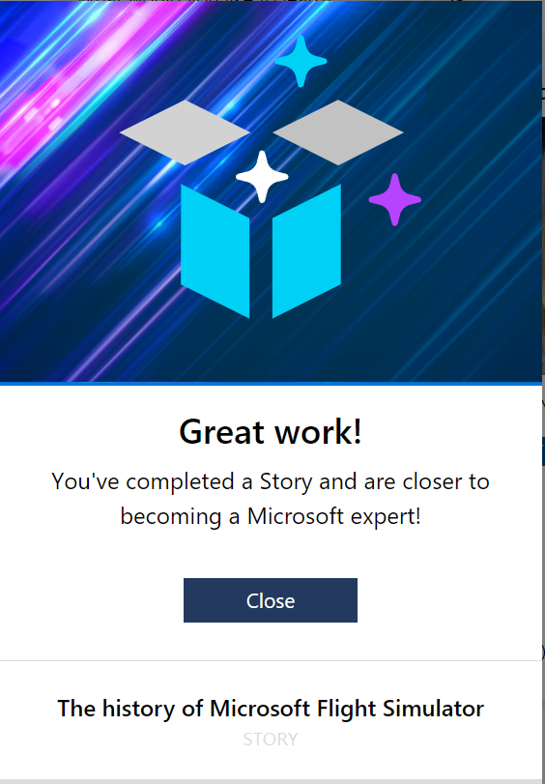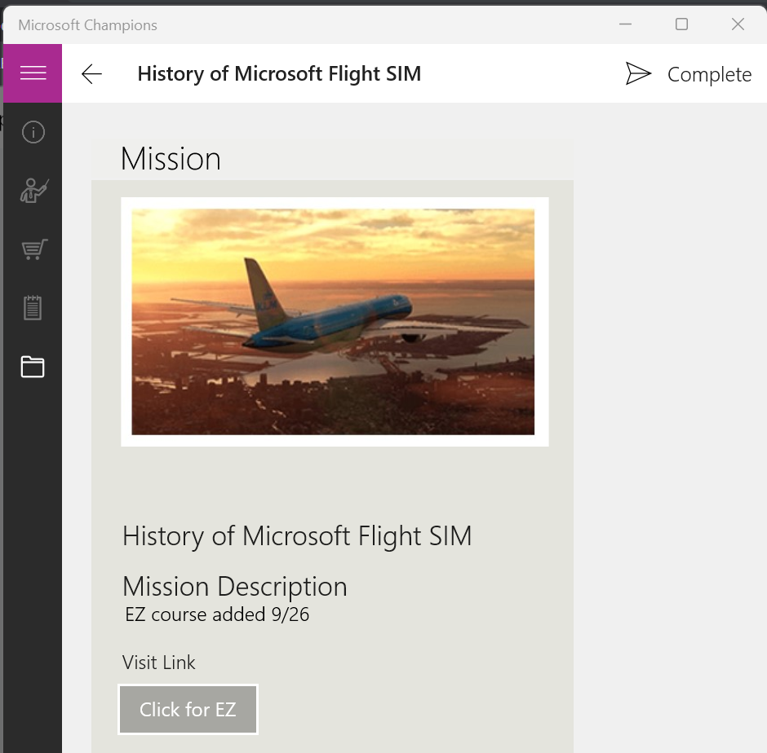

Champion Manager will then display successful completion of the Expertzone Course and auto-approve the Mission with associated points earned. This is found in the Reporting > Activity tab.
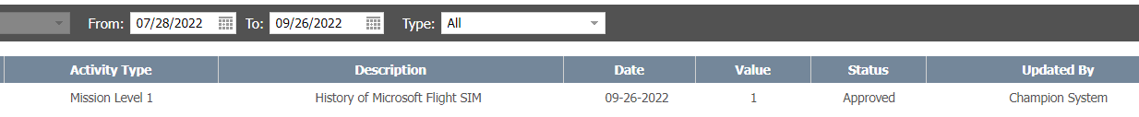
Champion Manager will display the course as “Pending” if the Champion has marked the course complete in the app but not yet completed it in ExpertZone.
The Approvals tab will also display the pending Mission but is it not necessary to manually approve here since the auto-approval will take place later. This row will disappear once the Champion has completed the course.

Note: as an Admin override option, approval is possible in Approvals tab if the Champion conveys to you that they have previously taken the course and you want to give credit for it.
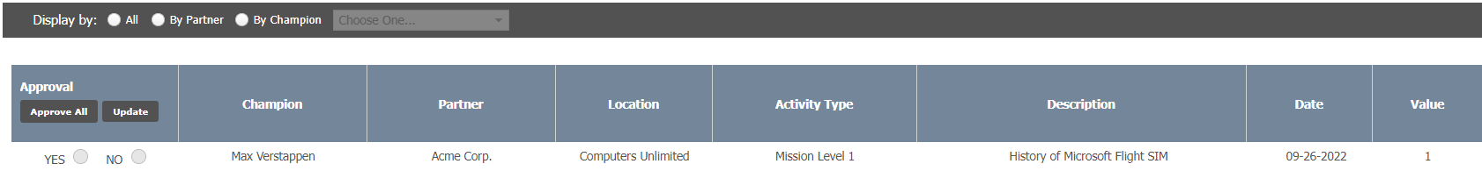

2. User Management – Email field sync with EZ
To enable synchronization between MSFTREPS and ExpertZone for both Champions and Representatives, a second email address field has been added in User Management profiles. The EZ Email field is the one used to link data between the two systems.
- Old Email field: has been renamed to REP Email for MSFTREPS and REP app login
- EZ Email checkbox: adds an option to not have to retype the email
- Applies to all Rep types and Champions
- Allows synchronizing with EZ User Groups to share active, inactive status
- New Users are added to the EZ User Groups automatically
- Inactive users are removed from the EZ User Groups automatically
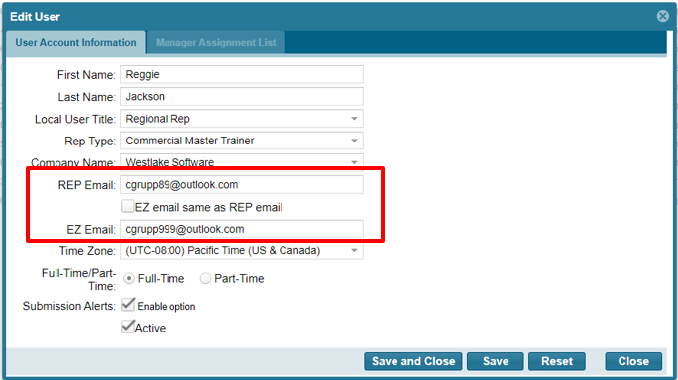
Instructions for use:
Simply add the Rep’s or Champion’s email in REP Email and if the Rep/Champ has a different email that is used in ExpertZone, enter it in the EZ Email field.

3. Q and A
As questions come up on the above topics, they will be listed here with answers.
Q1: Should the Champion mark the Mission complete in the app first before completing the course in ExpertZone?
A: Generally, the order doesn’t matter if the course is marked completed in the app before the EZ Course completion or after. However, if the EZ Course Mission is set to expire at the end of the month and the Champ never marks it complete before it disappears from the app at month end, then the Champ will be out of luck for earning Champions program credit for completing the Mission.
Q2: Champion uses the app to open the Mission and then opens the course in ExpertZone. Champion DOES NOT complete the course in EZ. Champion backs up to Champ app and then marks the Mission Complete. How much time does the Champ have to complete the course in ExpertZone for proper Champion program credit?
A: If the EZ Course Mission ends at the last day of the month, then the Champ has until the end of the month to complete the course in ExpertZone. If the Mission is set to run until completed, then the Champ will have until the Admin retires the Mission by marking it inactive. Note: The EZ Course Mission will actually show up in the Admin approval tab while in pending status, but no action is needed to approve.

Have questions or comments? Send with screenshots to the REP support mailbox at msftreps@westlakesoftware.com.
Published October, 2022.

