Login/Security Changes for FY21

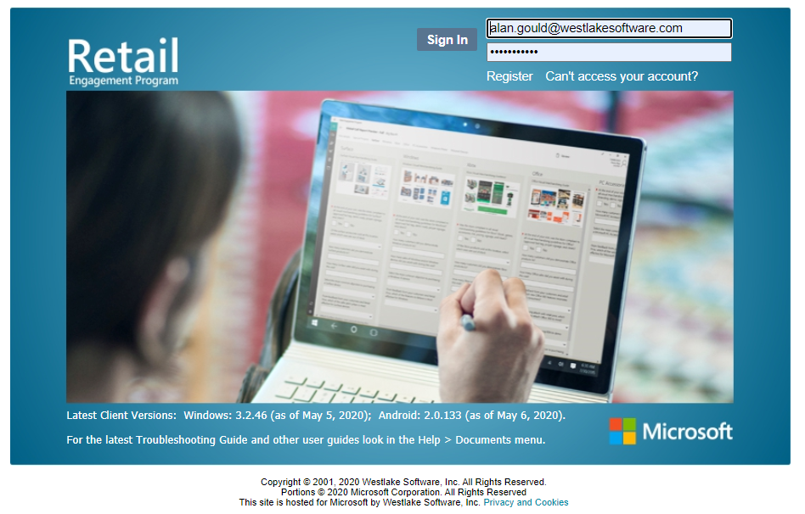
For: www.msftreps.com

Ver: 8-03-2020
Q1 - FY21

OVERVIEW

The Username and Password functionality at www.msftreps.com has been migrated to a more secure model per Microsoft Corporate policies.
What has largely been introduced is an email verification process.
Username on the main login page will become your email address after completing the process.
PHASE 2 TBD
App Login – The iOS, Android and Windows 10 app will also be migrating away from a 10 Digit ID number to using both the same User ID (email address) and newly created password. This will apply to both REP 4.0 and the new MS Champions program (used in some markets).

This documentation will:
- Guide you through this process for yourself as an Admin and a User.
- Provide instructions on how to help others as an Admin.
- Offer a troubleshooting guide how to resolve common issues.

EXISTING USER EXPERIENCE
Step1 - Login as you do today with your existing login and password:
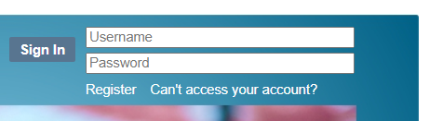
You will be immediately prompted to enter in your email address. Use the email address that was used by each user in User Management and submit.
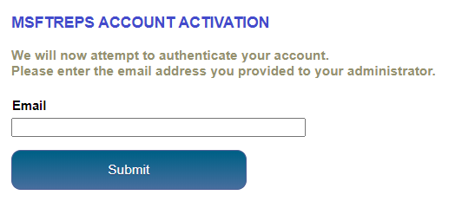
What if I am an Admin and I forgot what email address I used in the system?
Email us for support at msftreps@westlakesoftware.com. Let us know you are an Admin and whatr country you are with.
NOTE FOR ALL ADMINS ONLY:
THERE IS AN EMAIL DOMAIN VERIFICATION PROCESS THAT REQUIRES YOU, AS AN ADMIN, TO USE AN APPROVED EMAIL ADDRESS WHEN MIGRATING TO THIS NEW SECURITY. AN @MICROSOFT.COM EXTENTION AND ALL AGENCIES EMAILS HAVE BEEN CONFIGURED TO WORK. IF YOU ARE TRYING TO USE A @GMAIL.COM, @OUTLOOK.COM, @YAHOO.COM, ETC. (OUTSIDE NETWORKS), THESE EXTENTIONS WILL BE REJECTED. IF YOU NEED HELP AND ARE STUCK IN THIS SCENARIO, PLESE REACH OUT TO US AT MSFTREPS@WESTLAKESOFTWARE.COM AND PROVIDE US YOUR APPROVIED CORPORATE EMAIL AND WE CAN UPDATE THIS IN THE SYSTEM FOR YOU.

Email Recognized | Email Not Recognized
If your email is recognized:  - Enter a new password  - Confirm password  - Check Privacy after reading  - Select the Send Authentication Email  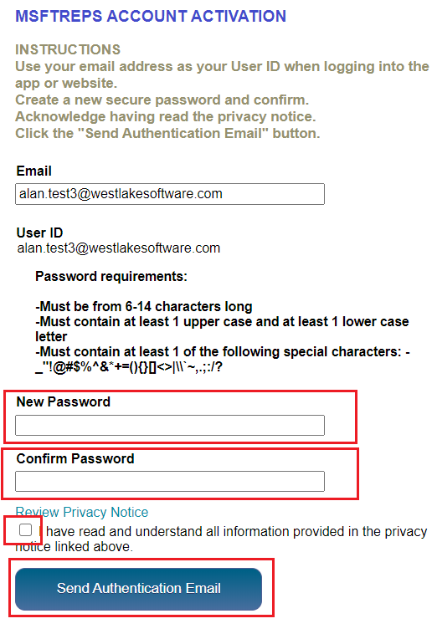 | A display message will show suggesting you verify you spelled or entered in the correct email address and ask to try again:  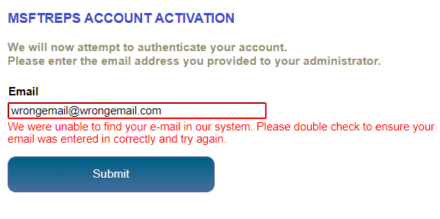
If you try again and find that it is still not working, a message is noted to contact your country Admin.

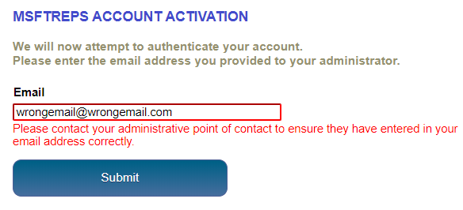
If you are an Admin and you have stalled out at this point in the process, please email us at:

msftreps@westlakesoftware com

Let us know what country you are an Admin for and we will help verify the current email in your account in the system.

Email Successfully Sent | Email Not Sent
Click on the link at the top of the email received to finish authentication:  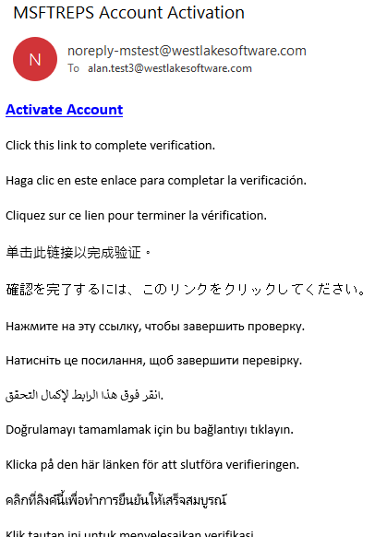 | Select the Resend Email button and wait 5 minutes. Check your spam folder as well.  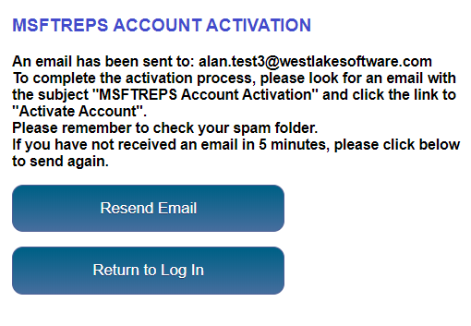
If after two attempts and waiting 5 minutes each and email does to arrive to activate your account, please email us at:

msftreps@westlakesoftware.com

State that you have made multiple attempts using the email address of: _____________ and have not received the authentication email.
Upon clicking the link in the email, you will be taken to a Success page in where you can no click on the login button. User your email as your new User ID and new Password on the main page.

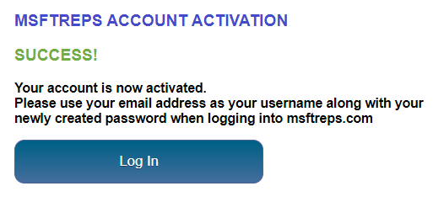

User Management Review
For logging in online (and in the near future, logging in with the app), onboarding anyone new; both for REP 4.0 as well as the MS Champions program, everything will be keyed off the email address in User Management. That email will be used for verification as well as the new User ID.
It is the responsibility of the Administrator to ensure all users of all types have their email in the system correctly and that they are using the email that as been placed into the system.
In all cases and users:
- A User Management profile needs to be set up
- An email be placed into that profile.

No exceptions.
There is no onboarding any user for any purpose in any existing or new program without a profile having been established with an email as minimum, step 1.
Access User Management from Users > User Management:
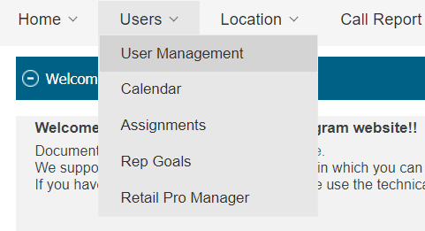
Select the Add button and complete all fields. Note (shown in Red) all security and passwords have been removed. This is now managed by the user in the new registration system outlined in this document.
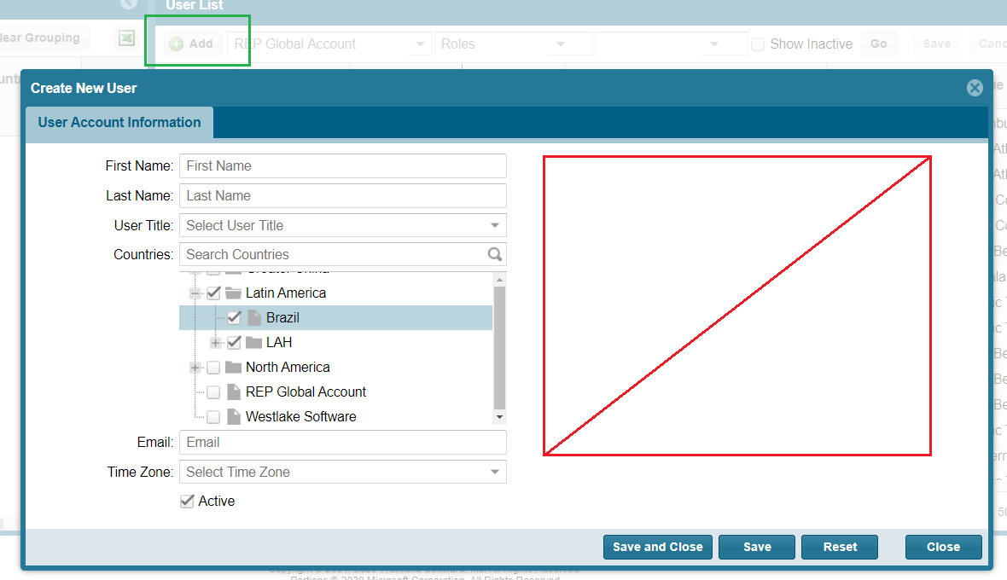
TROUBLESHOOTING GUIDE

Issue | Steps to Resolve
User reports their email is being rejected and they cannot re-register. | - Confirm the email they are using is the one that is currently in the system.  - Work with the User to make sure that both the email in the system and the email they re using are the same.  - Ensure that you have added the email of the user into the system accurately.
User never gets confirmation email | - Resend and try again 5 minutes later  - Check spam or junk folder  - Ask for help at msftreps@westlakesoftware.com. Include your country and the email address in which is being used.

