The new menu system is designed to better organize the many features of REP tool. All features that were available to you previously are still active; the only thing that has changed is the organization and view.
New Home Screen
The Home Screen provides a Top menu bar and a Horizontal menu bar.
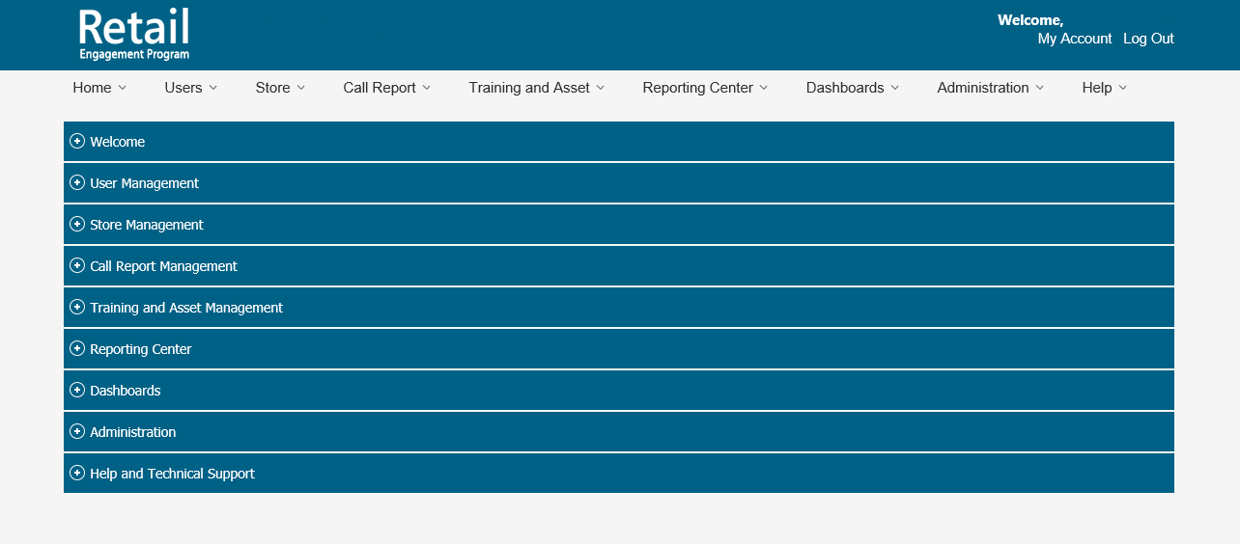
New Top Menu Bar
The Top Menu Bar provides easy navigation to different features available in the application. Mouse hover on each menu item, displays a drop-down with sub menus under corresponding category. The item selected from the drop down will be highlighted as shown in the screenshot below.
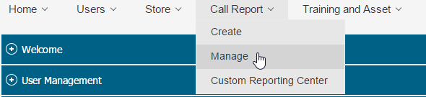

New Horizontal Menu Bar
A Horizontal menu bar is provided for smoother navigation in touch screens. These menu bars can be expanded in two ways:-
- By clicking on the horizontal menu bar that needs to be expanded.
- By clicking the required menu item from the Top menu bar.
On expanding each Horizontal Bar, the sub menu items are displayed as separate tiles. Each tile contains the title, description and image. The tiles are clickable and clicking on each tile will navigate to the corresponding page.
