Overview
This document contains information on the following new features added in the May 2019 release:
- New conditional logic, to trigger questions from multi-select or follow-up question
- Retail Pro Manager update for 1:Many, including new dashboard for Check-in data
- Changes to Rep Goals page including new filters, plus Managers can now set goals
- Enabled Proficiency Tasks with sliders, for Local and Regional Admins at country level
1. New Conditional Logic
The form wizard has been given a major upgrade to allow new options for conditional logic. The original option (Figure 1) was commonly used to trigger a question (“show if”) when one list item designated is selected in a multi-select. However, it did not work on multi-select follow-up questions.
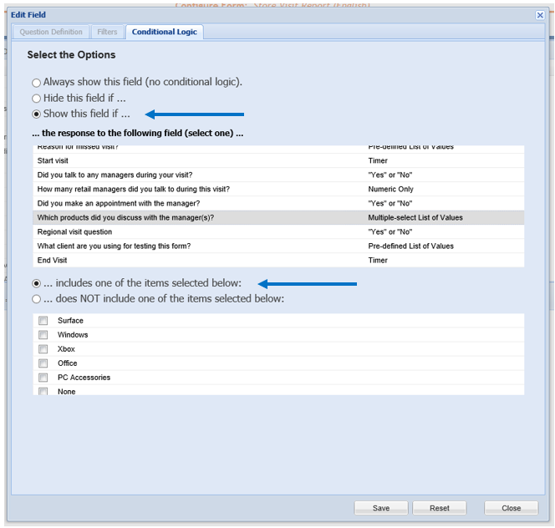
Figure 1 – Original functionality for trigger from multi-select

The first new option (Figure 2) can be used to trigger a question (show) if all or some list items are selected in a multi-select.
- Navigate to the menu Call Reports > Manage
- Use the configure option for the form you wish to modify
- Create the new question that you wish to trigger from a multi-select question
- On the Conditional Logic tab select the “Show this field if…” radio button
- Select the multi-select question field from which to trigger
- Click the radio button for “…includes all of the items selected below”
- Select the list items (all or some of them) for the combination required to trigger
- When finished, click Save and then Save the form
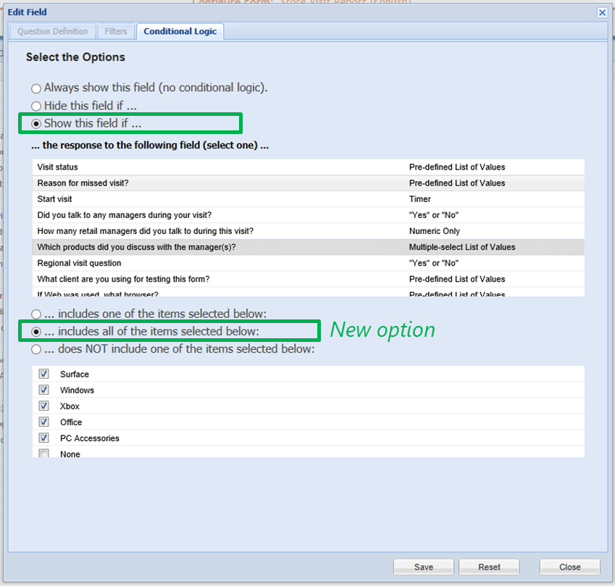
Figure 2 – new option for trigger from multi-select
Note: The “Show if…includes all the items…” option is not recommended for Multi-select follow-up question. The triggered question may not be hidden from view on the app. See next option instead.

The second new option (Figure 3) has been designed for Multi-select follow-up questions to trigger an extra question. This logic option can be used to trigger a question if some or all of the list items are selected in either the primary multi-select question or the follow-up question.
- Navigate to the menu Call Reports > Manage
- Use the configure option for the form you wish to modify
- Create the new question that you wish to trigger from a multi-select + follow-up set of questions
- On the Conditional Logic tab select the “Hide this field if…” radio button
- Select the multi-select follow-up question field from which to trigger
- Click the radio button for “…does not include one of the items selected below”
- Select the list items (all or some of them) for the combination required to trigger
- When finished, click Save and then Save the form
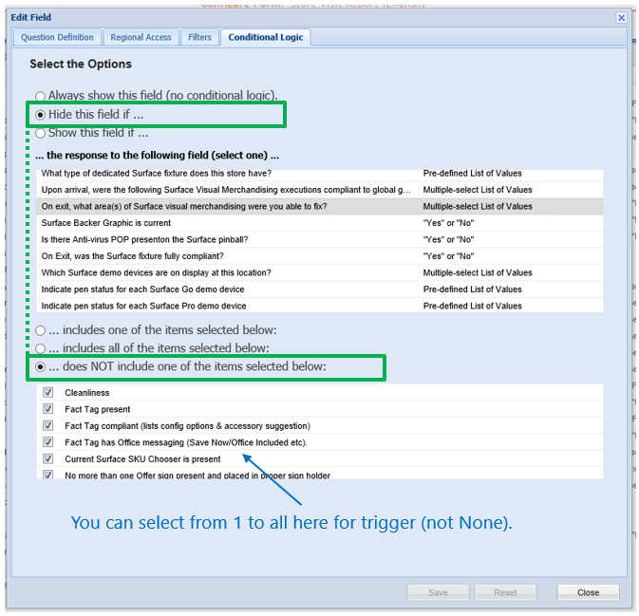
Figure 3 - New option for multi-select plus follow-up
On the app, the triggered question will be hidden unless those list items are check-marked in either the primary or follow-up question. In the example above if the Rep checked half the list in the “Upon Arrival…” question and rest of the list in the “On Exit…” follow up question, then the conditional logic will trigger the extra question.

2. Retail Pro Manager Update with 1:Many Training
Several enhancements have been implemented for 1:Many training reporting and Retail Pro data.
- In the Users > Retail Pro Manager >> Edit Employee profile data, the 1:Many trainings using Check-in by RP name have been added to the data
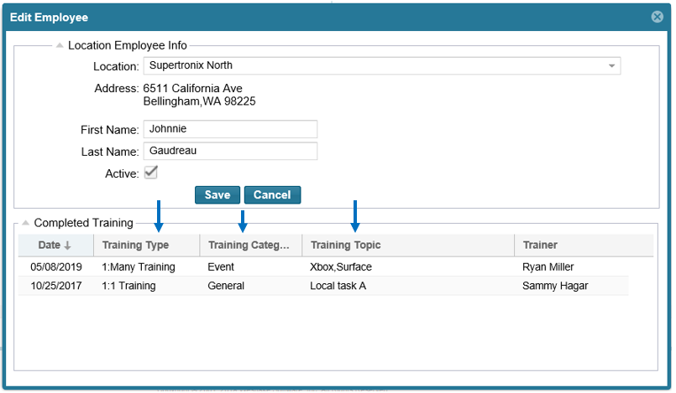
- Dashboards > Retail Pro Training - use the new 1:Many Training Data for viewing Retail Pro details and Check-in data for every 1:many training event; can search for specific transactions and export the data
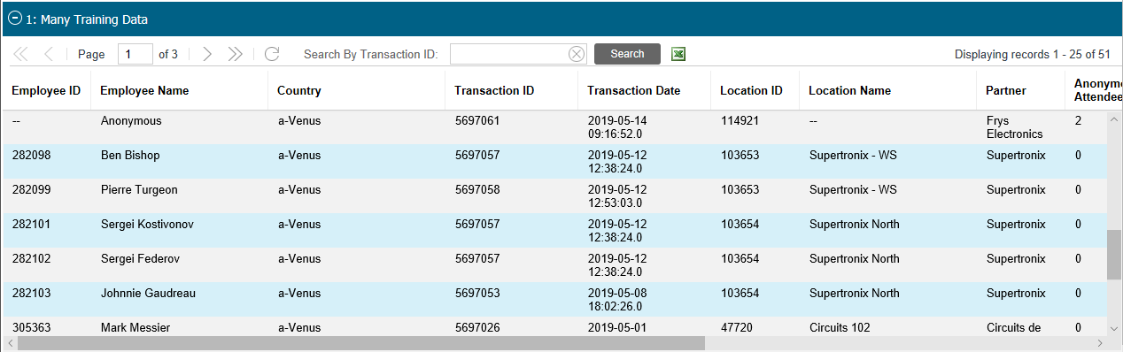

- Expiration of Retail Pro’s – set at 180 days of no activity for expiry, the time period will now use 1:Many training in addition to 1:1 training; previously only checked for 1:1 RP training
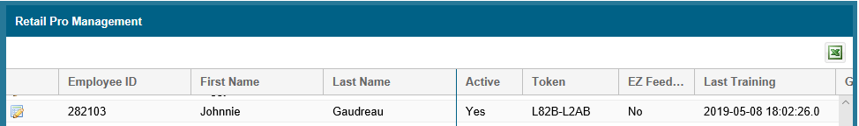
3. Changes to Rep Goals Page
This helpful compliance tool which also links to the Calendar is found in the menu under Users > Rep Goals.
- Managers now have visibility to set Rep’s goals; previously only Admins had permissions
- The Copy From Previous Month feature will allow copying during the current month (once the new month starts); previously if you waited until the new month started to Set Goals, the Copy button was removed
- Filters have been added for more flexibility in setting goals and monitoring Reps’ progress
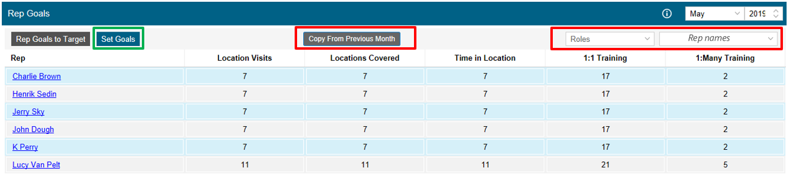

4. Training Tasks with sliders (Proficiencies)
Proficiency Training Tasks have been enabled and can be used at country (Local) level.
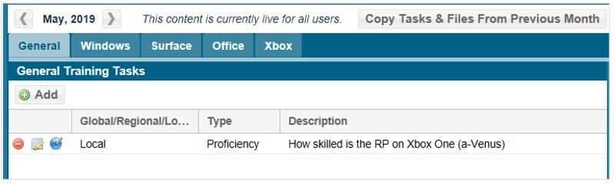
To set one up, the procedure is very similar to creating a Task as before:
- Navigate to Training and Resources > Retail Pro Training Tasks and Files
- Scroll to the desired month to add a Task, select the Product tab to be modified
- Click on Add button which opens the Add (product) Training Task pop-up
- Click on Create Task open a new Task
- Enter the task information and filtering for Rep Type
- Add an Associated file and specify exact start and end dates if needed
- NEW…to add a slider, first check-mark the “Show slider…” checkbox and then select the desired Slider Labels option

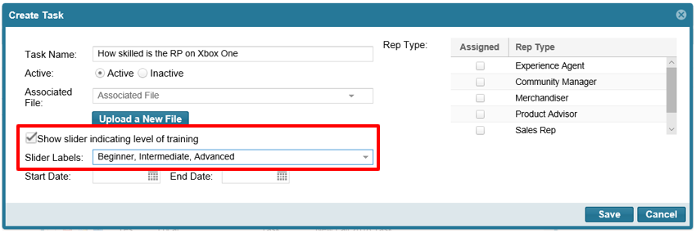
- Save the Task and return to the Add Training Tasks pop-up
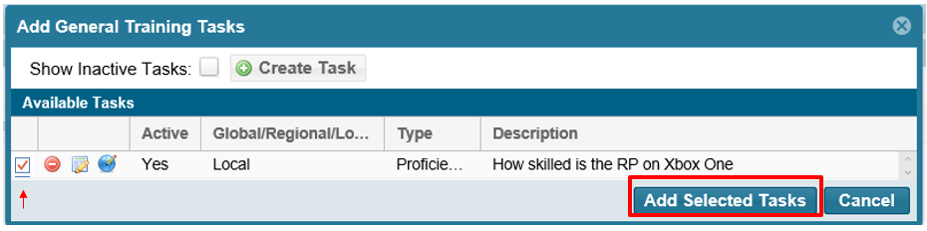

- In the Add Training pop-up select the new Proficiency Task just created and add it to the month’s training task list (Note that it will be live immediately if added to the current month and if no specific dates)
Note: Proficiency Tasks will have priority in the RP Training form and appear at the top of the task list. Global Proficiency Tasks will have priority over all the Local tasks.
Reporting can be found in the same place as before, in Dashboards > Retail Pro Training.

Have questions or comments? Send your inquiry with screenshots to the REP support mailbox at msftreps@westlakesoftware.com.
Revised May 17, 2019.

