Overview
This document contains information on the following changes and features added in the May 2022 release:
- Security update: three incorrect logins result in User lockout (MSFTREPS online and Apps)
- New feature: question Visit Frequency enhancements to add Bimonthly and Biannually
- New feature: Yes / No questions repeat option in the question Filters tab settings
- New feature: Photo Rotation Tool in Transactions and Photo Dashboard
1. Security update
In order to comply with Microsoft SSPA security requirements a change has been made to the user login page, both online at MSFTREPS.com and in the REP apps. If any registered user enters incorrect credentials (username and / or password) three times within a 24 hour period the result will be a lockout. There will be new messages added each time invalid credentials are entered which will specify how many more chances the user has to enter them correctly.
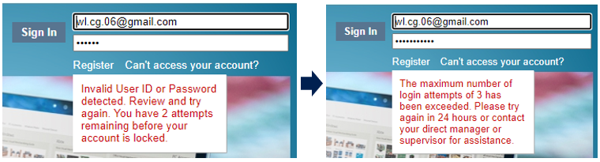
The user will have to wait 24 hours to try logging in again. If still unsuccessful, we suggest using the “Can’t access your account?” link to reset the password. Also, Admins can override the lockout online in User Management. Open the User’s edit window, look for the Account Locked option. Uncheck and Save to remove the lock immediately.
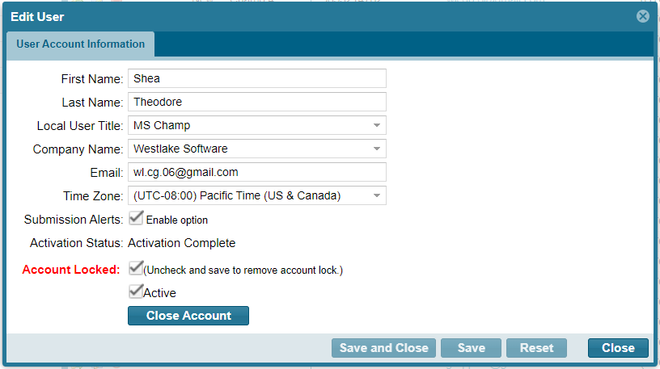

2. Question Visit Frequency enhancements to add Bimonthly and Biannually
The form wizard in the Store Visit Report has been given an upgrade to allow new options for Visit Frequency filter settings. The original options allowed for each visit, weekly, monthly and quarterly. Two new frequencies have been added:
- Bimonthly - defined per month as days 1-14 and then a reset for days 15 - end
- Biannually - defined as January 1 to June 30 and then a reset for July 1 to December 31

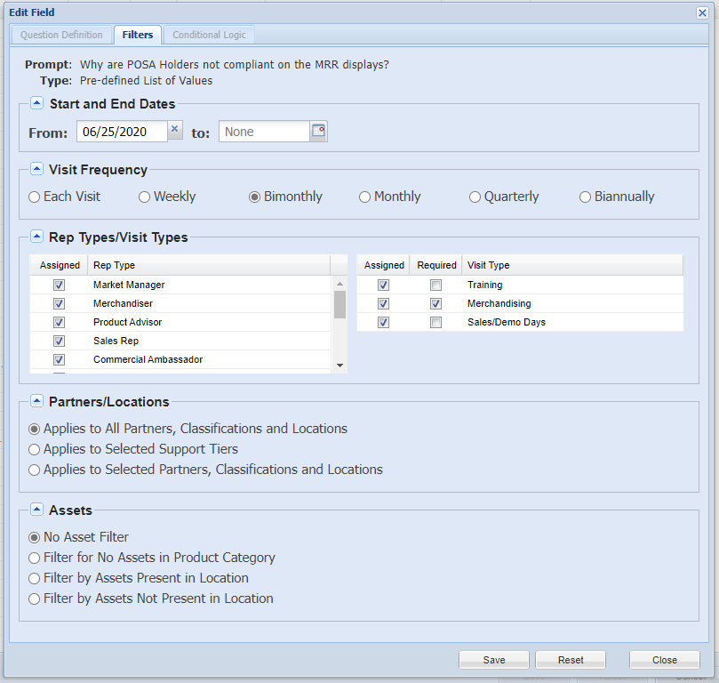
Once the setting has been added, make sure to hit Save for the question and then Save for the full call report.
Note: Future deployments for this new feature may include Special Project forms, but for now only the Store Visit Report is fully implemented.

New Question Frequency icons in the REP Apps
The REP Apps will be updated with revised icons to coincide with the additional question frequencies. See below for examples. All icons except “Weekly” are new.

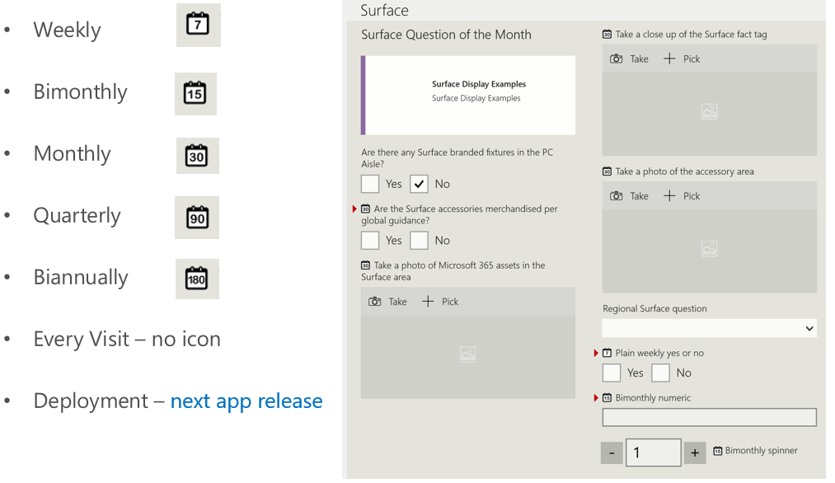

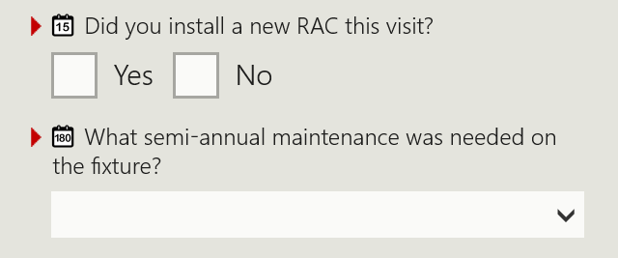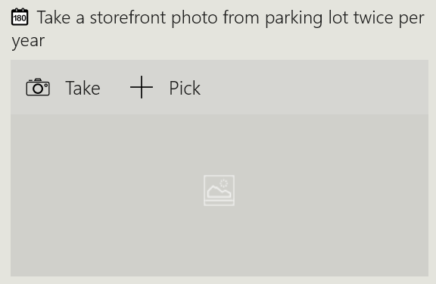
Figure 1 - Example of Biannual and Bimonthly questions

3. Yes or No questions repeat option in the question Filters tab settings
Another addition to the Filters tab is specifically for Yes or No questions. Admins can set the questions to repeat every visit within a Visit Frequency period until a requested Yes or No response is given. In other words, the Admins can specify that the question continues to be visible until the Reps answers a certain way as desired. Only then will the Yes/No question hide in the call report until the next reset point.
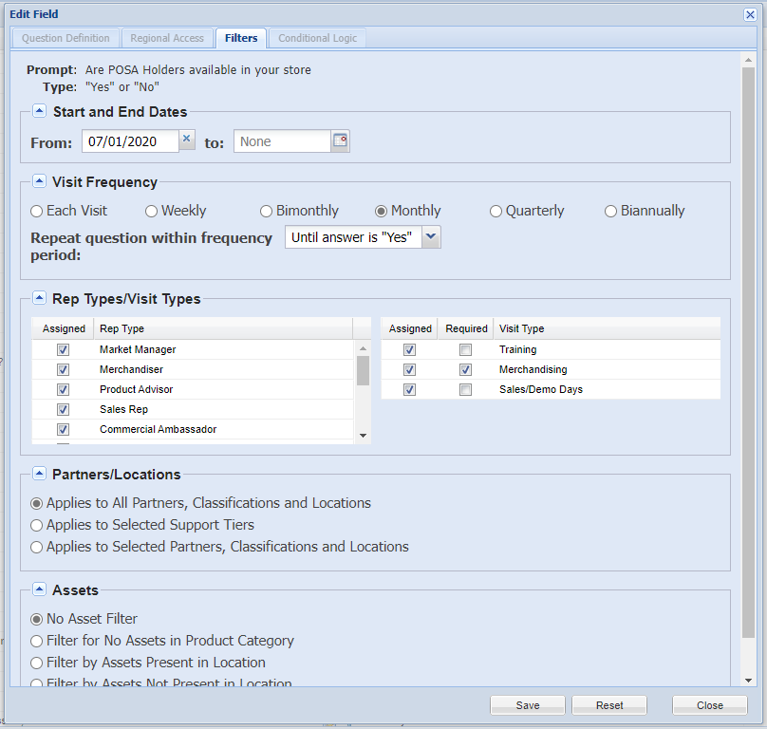
Admins can set the feature with the dropdown: Until answer is “Yes” or answer is “No.” The feature is defaulted to “Never” which means off.
Once the setting has been added, make sure to hit Save for the question and then Save for the full call report.
Yes or No questions that use the Checkbox advanced option are not applicable for this filter option.
Note: Future deployments for this new feature may include Special Project forms, but for now only the Store Visit Report is fully implemented.

4. Photo Rotation Tool in Transactions and Photo Dashboard
When a photo is taken by a cell phone, normally the mercury switch within the phone will determine if the user intended the format to be a portrait orientation (vertical) or a landscape orientation (horizontal). But occasionally that camera process is fooled by tilting the phone a certain way and other factors, resulting in the image being uploaded to the server in an incorrect format. Up until now, there was no way to go in and change the image to the correct orientation.
A photo rotate tool has been added in the Call Reports > Transaction report page and the Photo Dashboard page that will allow a simple correction for any photos that need to be flipped to the correct orientation. This works in a similar manner that you have probably seen in other online photo storage applications such as One Drive and Google Photos.
To adjust, use either button to rotate 90 degrees per click and then Save.
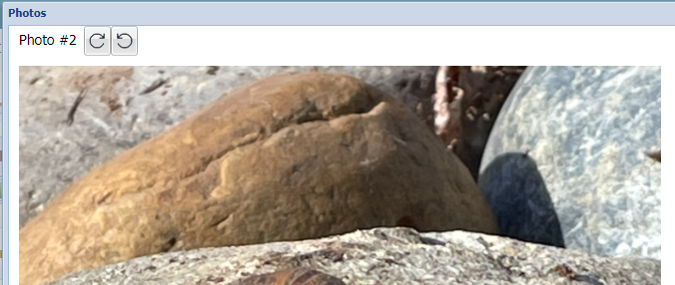
The photo will be stored in the image database with its new orientation which will be reflected in other places such as an exported PDF report.

Have questions or comments? Send with screenshots to the REP support mailbox at msftreps@westlakesoftware.com.
Published May 24, 2019.

