Overview
This document contains information on the following new features added in the May 2018 release:
- Administrator feature to approve several items in Action Center at once
- Call Reports and Direct viewing of Resource File when creating File Link questions
- Chains / Stores “check all” option when filtering for a question in the Store Visit Report
- Source filter added in Retail Pro Training Dashboard for Global/Regional/Local training reporting
1. Action Center Changes
Action Center has been given a major upgrade to allow approvals for multiple items at once, as well as approving a Special Project form as a notification item.
- Navigate to the menu Administration > Action Center
- Use the new filter option for New Forms to see consolidated Special Projects call reports items
- Select the Special Project form in the list and click the option to View/Edit; a pop-up message will appear and then open the form wizard to configure the form and add additional questions
- When finished configuring the Special Project form, the site will navigate to the Call Reports > Manage page
Multiple approvals for items other than New Forms can now be done using the checkboxes on the left. Select all the items with the top checkbox or just the items you want to approve. Then use the Approve button to accept and make them live. The View/Edit and Translate functions will continue to be available for a single action item.
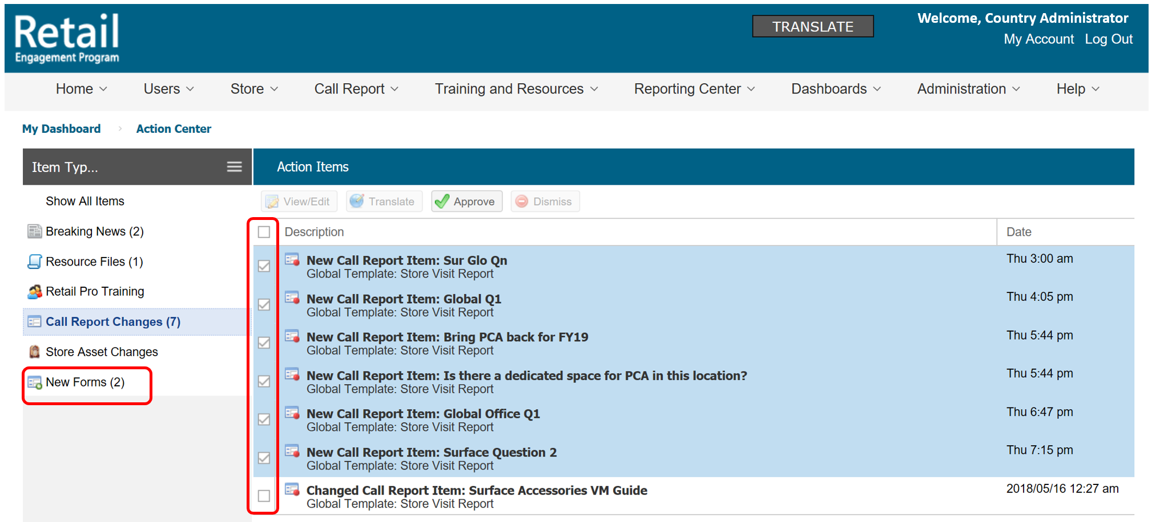

2. Store Visit Report Changes
Several enhancements have been implemented for Admins to help manage call reports questions and visibility.
- Use the new set of view or hide checkboxes at the top of the question list for filtered viewing questions by source as Global / Regional / Local
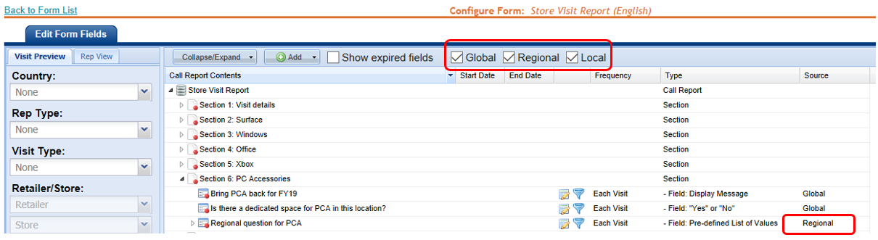
- Direct viewing of Resource File - use the new View File button in File Link questions to preview the file that has been selected in the dropdown, as a convenient way to preview the chosen file

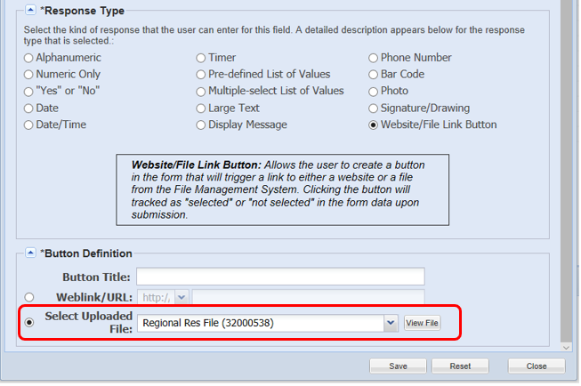
- Chain and Stores check All option in the Store Visit Report – added a simple checkbox option in the questions Filters tab when assigning a question to specific stores; allows the check or un-check of all stores in a chain

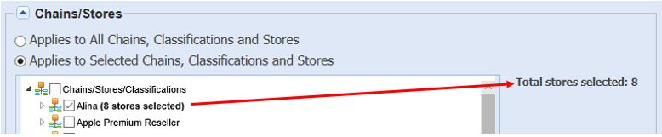

3. Retail Pro Training Dashboard changes
The Retail Pro Training filter panel has been upgraded with a new filter for Task Source and labeling for Global/Regional/Local Tasks and Proficiencies in the reporting. This can be found in the menu Dashboards > Retail Pro Training.
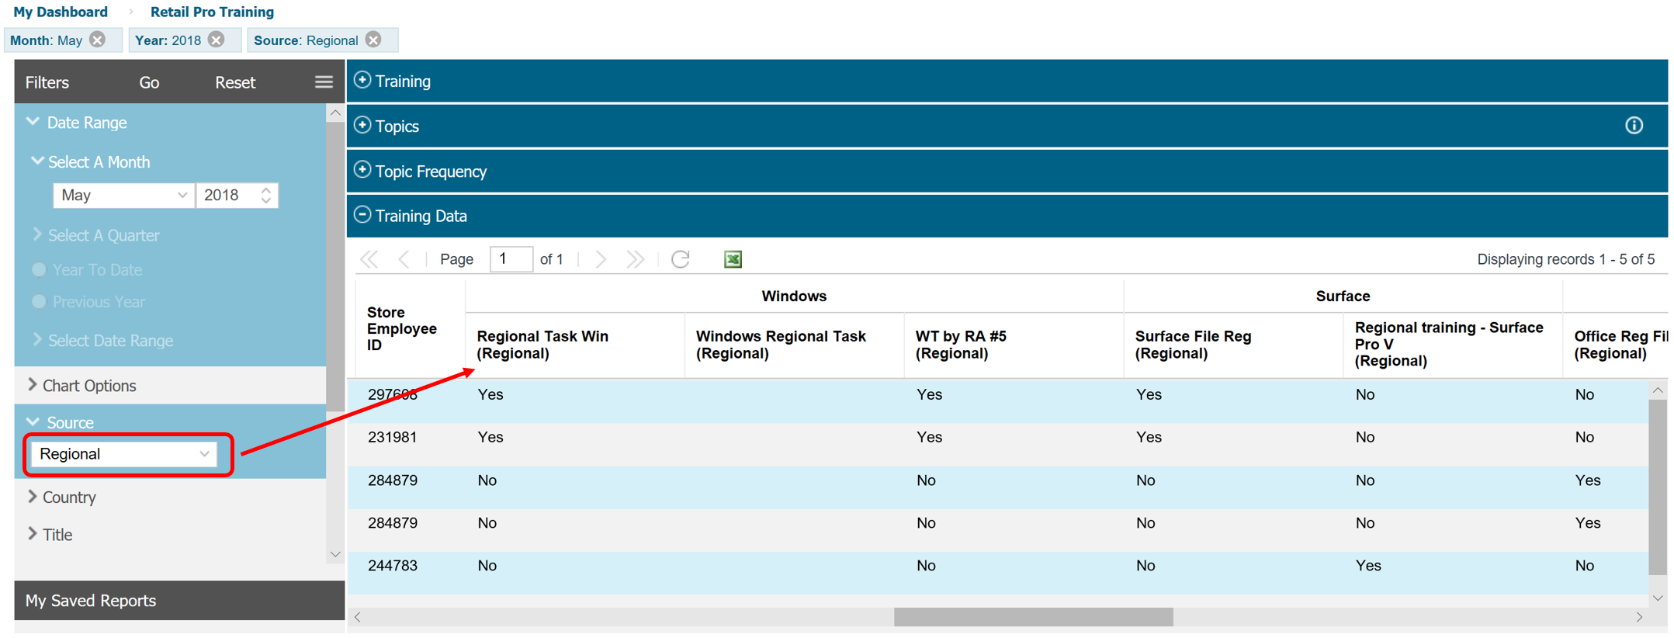

Have questions? Send your inquiry with screenshots to the REP support mailbox at msftreps@westlakesoftware.com.
Revised June 2, 2018.

