Microsoft Translation Integration
Localizing in Action Center, Breaking News, Training and Resources content is now simplified. This enhancement automatically calls up translation for the content in the REP online UI for Country Administrators. Here are some feature highlights:
- You can still load, edit and maintain multiple languages in the translation UI
- The Reset button is there if you make a mistake, or want to clear out what is shown
- The suggested content loads quickly and automatically
- If you make an edit to the suggested translation and Save, the next time you open that language, it will still be there
Note: Language Tools tabs inside of Asset Management and Call Reports > Manage will not have this capability.
Action Center
New Action Items will load into Action Center as previously done, and fall into one of the five Item Type categories. (Figure A)
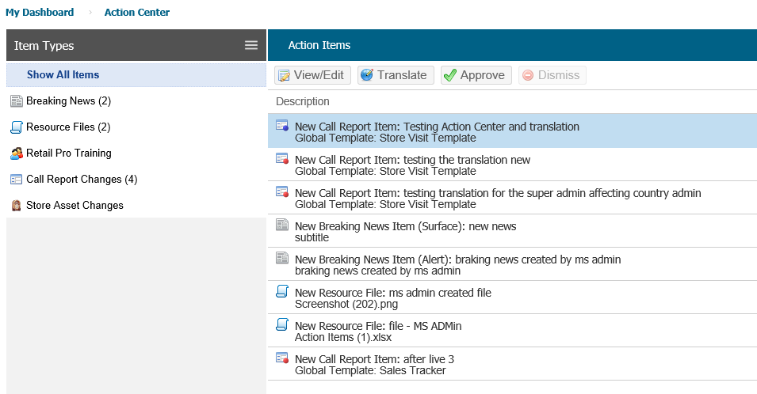
Figure A
Here are the steps to follow to use the suggested translation in the Translate pop-up UI:
- Click the Translate button
- Select the Target Language to work with (adding multiple languages for the same action item is possible)
- The suggested translation from Microsoft Translate will populate in the fields as shown in Figure B
- You now have the following options:
  - Edit the suggested translation text in the Target Language fields by inserting your cursor, making changes and then clicking Save
  - Use the suggested translation text by just clicking Save
  - Clearing out all the suggested translation by clicking Reset
  - Closing the pop-up after Save or Reset of translations you have made by clicking Close
- Once you have finished translating the action item, click Approve to make it active (immediately live) and clear the Action Item from the list.
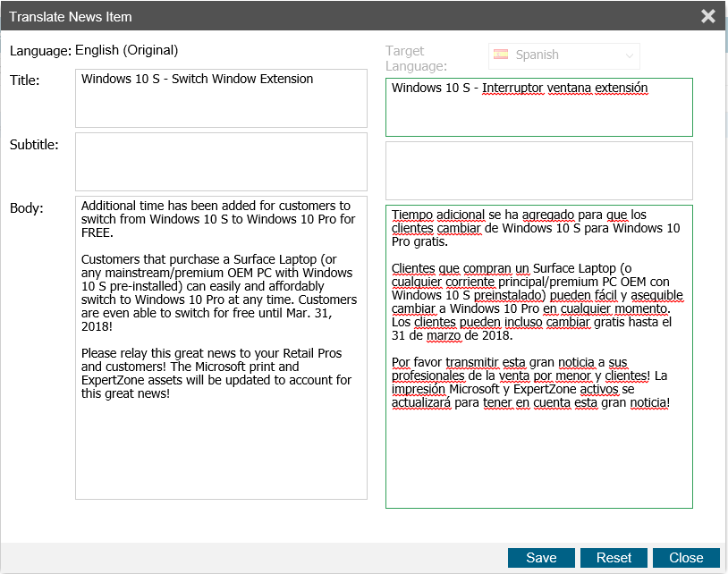
Figure B
Training and Resources
The new auto-translation feature can be used in other places outside of Action Center: Resource File Management, Breaking News, and Retail Pro Training Tasks and Files. The steps are the same as above, just use the blue globe Translate button to initiate the process.

