

Multiple Training Tracking
Admin – Regional - Read Only - Manager

December 9th, 2015

MULTIPLE TRAINING TRACKING
There is a two-phased enhancement happening with Training Tracking:
- Phase 1 - Multiple Training Tracking
- Phase 2 - Tracking degrees of expertise per each training task by the RP
This document covers Phase 1 - Multiple Training Tracking. But soon after (30-60 days) this will be enhanced again tracking some tasks/topics also using sliders. For example, I trained this RP two times; they have moved from Beginner to Novice; but not quite an expert. This will appear as a slider scale.

APP ENHACEMENTS
For the Rep, their RP Training view will change slightly. Note, for the Reps, there is a one-sheet quick overview guide for Reps at www.msftreps.com, Help – Documents. You can hand out or translate and hand this one-pager out.
There is a new “count” under each check box for each Retail Pro (RP). This counts how many times that RP has been trained on that topic. When you check the box, the count will go up. When you submit your record to the server, that count is now stored and analyzed.
Note: The purple color used to show an item was selected for training has now been removed. The only indicator now will be that the count has gone up. You can also de-select a training to make the count go back down.
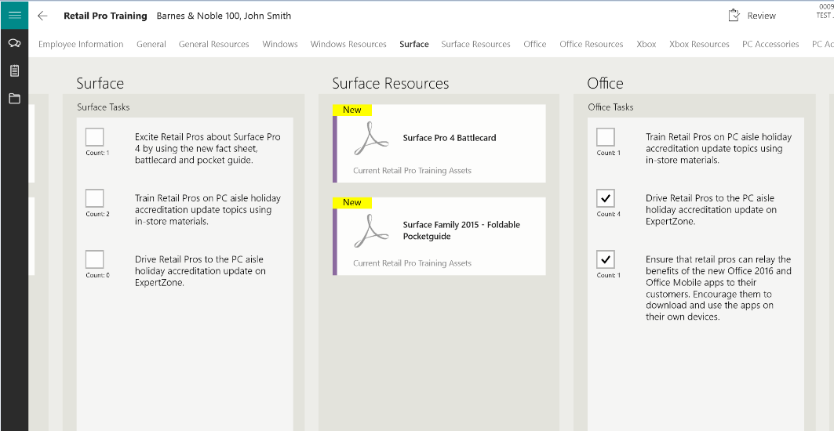

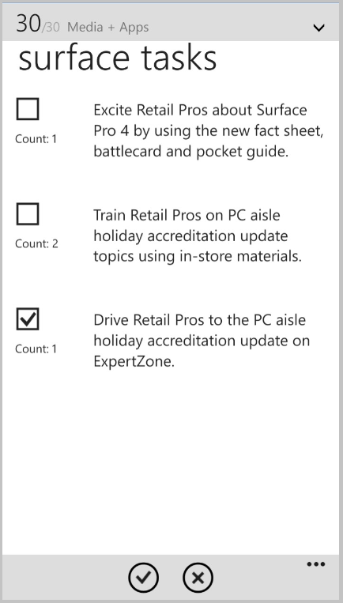
The same functionality changes have also taken place with the Windows Phone version.

Reps will continue to do their training as they have always done; changes are no more purple and now a new counter.

WWW.MSFTREPS.COM
Multiple trainings is tracked in a new report found under Dashboards – RP Training – Topic Frequency (as shown below). There are different starting views for different access levels. Note: This is a highly specialized report designed to show re-trainings. This is not a count of trainings. For a task/topic to show up, a minimum of two trainings (a re-train) needs to occur for a task/topic to register. When it does, the count on the first re-train is ONE (1). The RP has been trained TWO TIMES but they have been re-trained ONCE (1).

Super Admin and Read-Only will start with a list of all countries in view. Regional will start with countries listed within their region:
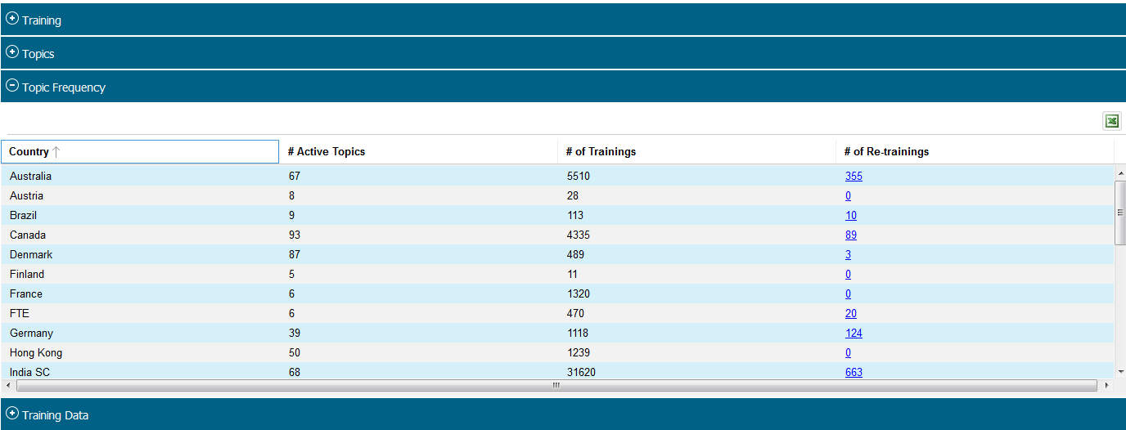
By clicking on the # of Re-trainings numbers (links in blue; see previous page), this will take the Super Admin, Read-Only and Regional to the Country Admin View. If you are a Country Admin, you will see this view:
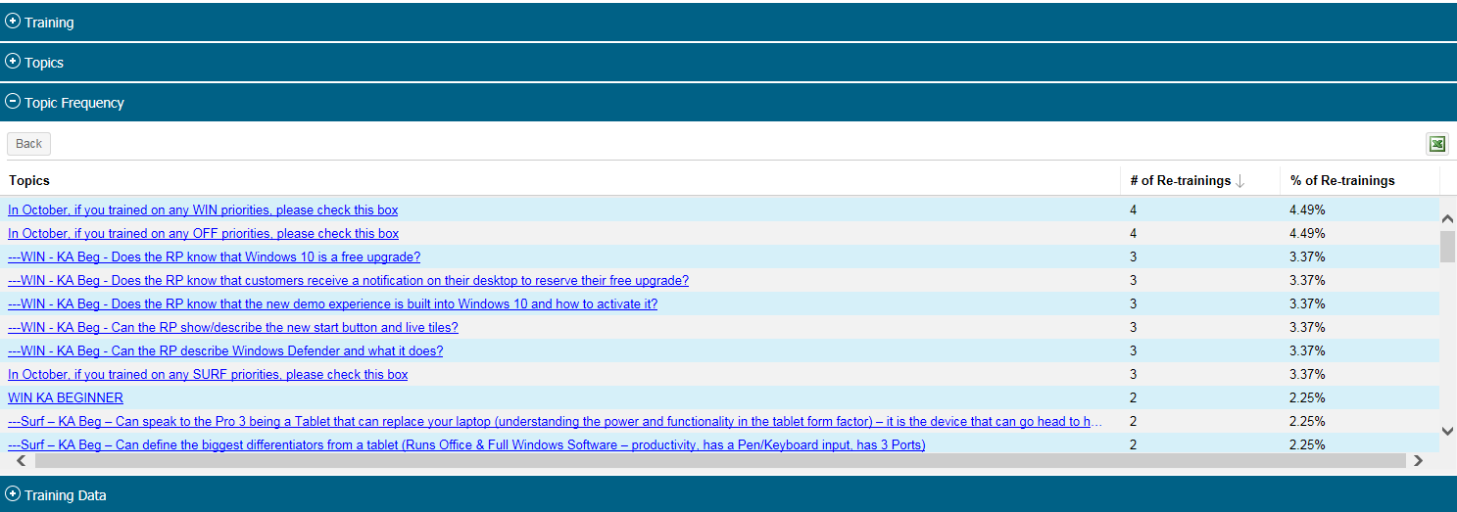
- All tasks/topics within that country that have been re-trained will display in this list.
- If a topic/task has not be trained on at least once, it will not show in this list.
- If a topic/task has been trained on one time, it will not show in this list.
By drilling down into a topic (the topic titles are now links as shown above), the detail of training conducted on that topic/task will display:
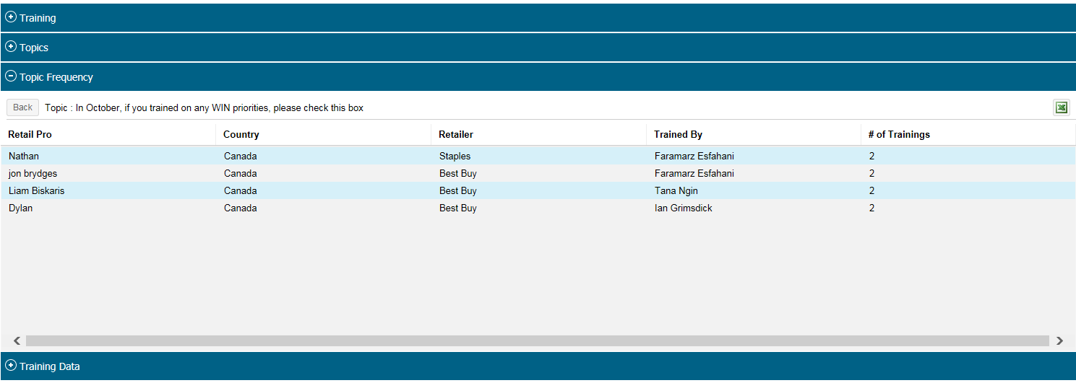
All views offer an export to Microsoft Excel as desired.
As we come online in Jan-March 2016 with associated files and survey/slider type information, the reporting section on re-trainings will become much more detailed. This is a phase 1 transition to the new RP Training section.

