RP TRAINING CHANGES - WINDOWS
There is a new “count” under each check box for each Retail Pro (RP). This counts how many times that RP has been trained on that topic. When you check the box, the count will go up. When you submit your record to the server, that count is now stored and analyzed.
Note: The purple color used to show an item was selected for training has now been removed. The only indicator now will be that the count has gone up. You can also de-select a training to make the count go back down.
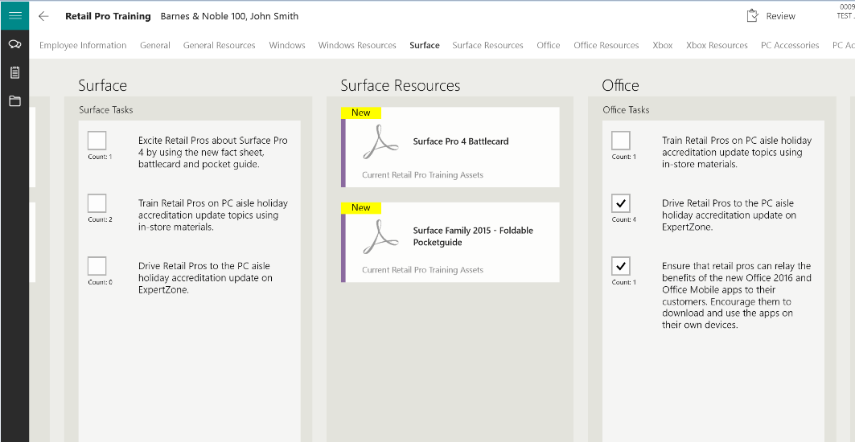
Next generation (2016) will show files associated with each task between the counter and the task; some tasks will support new sliders to show a scaled of 1-5 on how well the RP is progressing on that topic/task.
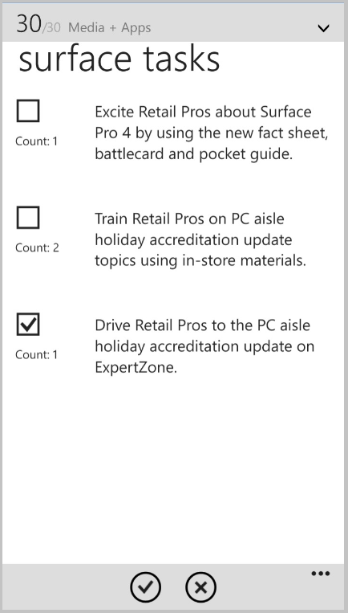
RP TRAINING CHANGES - WINDOWS
There is a new “count” under each check box for each Retail Pro (RP). This counts how many times that RP has been trained on that topic. When you check the box, the count will go up. When you submit your record to the server, that count is now stored and analyzed.
Note: The purple color showing an item was selected for training has now been removed. The only indicator now will be that the count has gone up. You can also de-select a training to make the count go back down.
Next generation (2016) will show files associated with each task between the counter and the task; some tasks will support new sliders to show a scaled of 1-5 on how well the RP is progressing on that topic.

