A new model for training and tracking effectiveness will augment Global Tasks and Files in the REP tool. Global training tasks will be replaced by Global Proficiency Measurements. There will be a shift to assessment and measurement, in addition to checkboxes and counts. Reps will mark progress using a slider that will range from Beginner to Expert on a “1 – 5” scale, designed to measure what the Retail Pros know and have learned from our training. Resource files will be directly associated with the Proficiency with a new button, so Reps can easily click to view them.
New Action Center Screens
The Notifications screen has been updated with indicators to a.) designate a Task as a Proficiency, b.) show if the Proficiency is mandatory, and c.) show the measurement “slider” bar labels included.
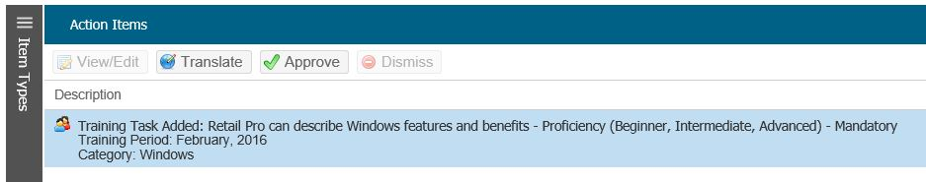
Proficiency Indicators
Click Translate to manage notification
Open the notification using the Translate button. Here you can view any associated files and upload a translated version. A template and instructions for translating the Proficiencies can be found here.
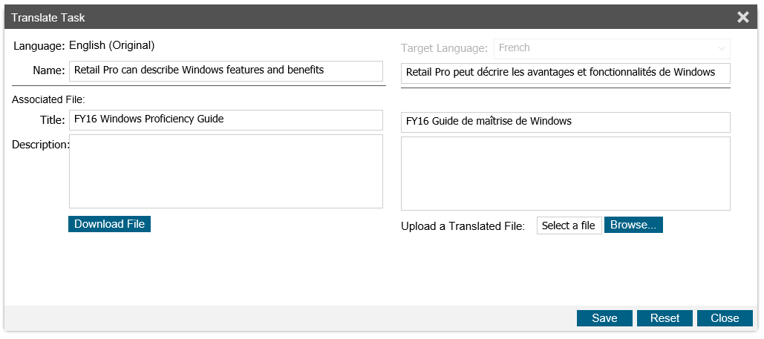
Once the Title and Description are localized, a translated version of the file can be added. Click Save and then Close to complete the localization. Back in the notification list, click Approve to make this item active and visible in the training month, and remove this notification from your Action Center list.
Note: Mandatory Proficiencies cannot be dismissed from the Action Center notification list.
Retail Pro Training Tasks and Files
When Proficiencies are added to the training month, the mandatory Proficiencies will move to the top of the list order automatically, preceding local Tasks. To translate slider values text, use the Language Tools tab. Additional options for localizing associated Proficiency and Training Files in this page can be found at the end of the document.
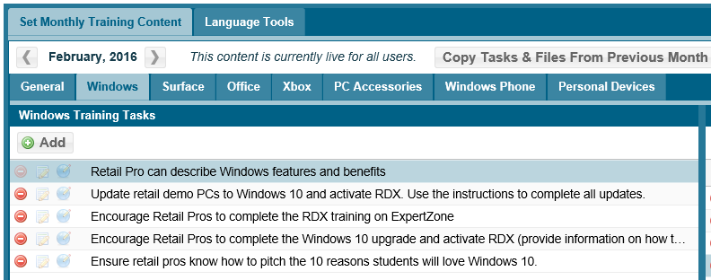
Proficiency at top of list
Custom Reporting Center
To report on Proficiencies, a new option has been added to the dropdown list in the Custom Reporting Center. The steps to create a report will work very similar to the Retail Pro Training functionality.
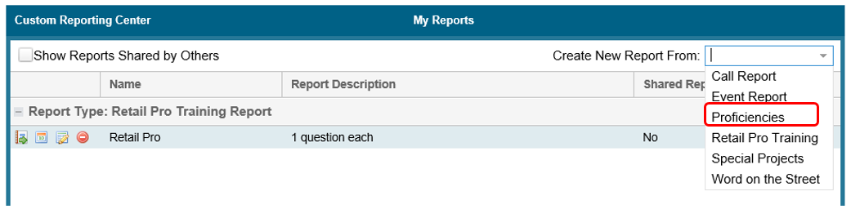In the results display and export, the slider values will be displayed for each Proficiency selected.
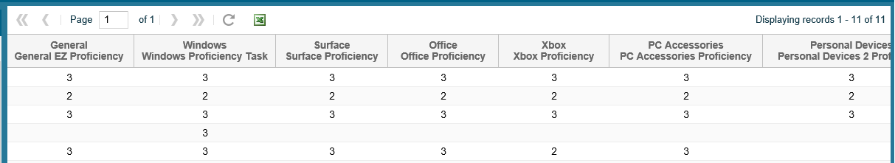

Localizing content without using Action Center
Sometimes it will be necessary to localize or revise the associated proficiency file after the proficiency has been available for a period of time or when regular merchandising cycles end and new cycles start.
The files associated with the proficiencies in the app are ".png" files, so a replacement .png file can only be made from the original Field Labor PowerPoint (English) that is found here: https://microsoft.sharepoint.com/:p:/t/WWRCM_HUB/Field-Labor/EaBYoi469gZCokuJzufQJVkBXzRkdqFnYMwGK1kUOLWWPA?e=Owqi81
Here are the steps:
- Download the PowerPoint from the link above to utilize the original editable version
- Find the corresponding slide with the chart or graphic that you want to localize
- Make the desired localization changes to the slide
- Save that single slide as a “.png” file
- Next, go to Training and Resources > Retail Pro Training Tasks and Files
- Select the tab for the product category to work on
- On the Files (right) side of page click the Add button to see the list of files (see illustrations below)
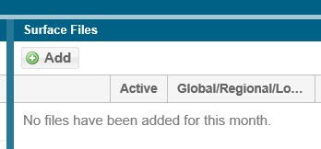
- Find the Global file that corresponds to the Proficiency and use the blue translate button to replace with a local version ".png" file built from your PowerPoint slide
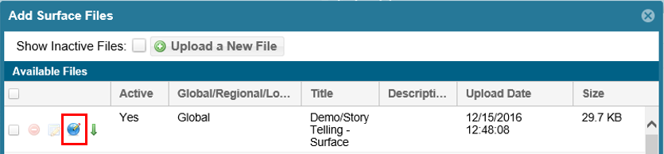

- Note that the English version of the file can be downloaded to confirm that you are working on the right one
- Select the language to localize in on the right and localize the Title
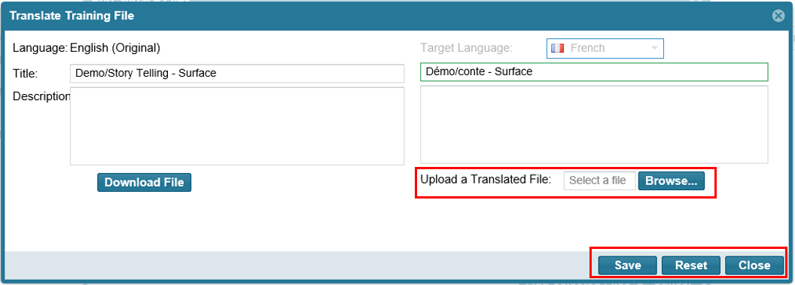
- Upload the translated .png file that you made in previous steps, click Save and then Close
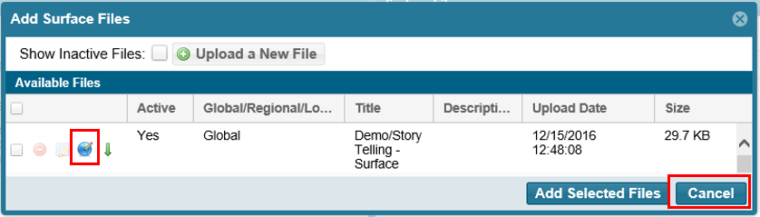
- Final step is to click Cancel to close the Files popup. The localized version of the file is now in place to supplement the English version.
The process above can be repeated with additional languages for countries that need versions in several languages.

Revised 9/10/2018.

