A new model for training and tracking effectiveness is now supported. Global training tasks will now be replaced by (new) Global Proficiency Measurements. Global Proficiency Measurements are similar to how training tasks work today but now offer for example a scale selection from 1-5.
RP TRAINING CHANGES - WINDOWS
There is a new “scale” under the new Global Proficiency Measurements for each Retail Pro (RP). This indicates that a measurement, on a scale of 1-5 (Beginner to Advanced) can be selected. When you change the scale to indicate the level for the RP (touch with your finger), the checkbox will automatically be checked. This now also offers an incremental count of how many times an RP has been trained on an item.
Note: There could also be a file associated with the Proficiency, with a file icon next to the checkbox.
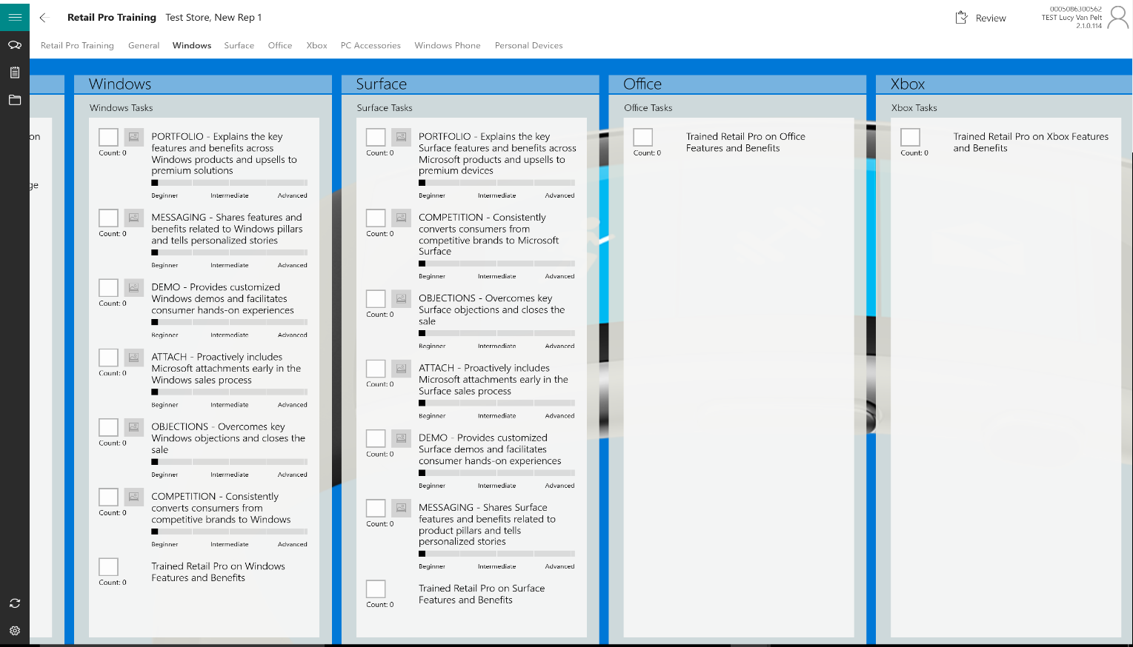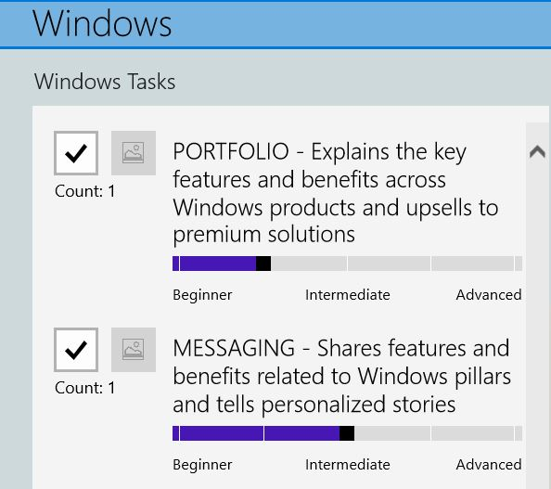
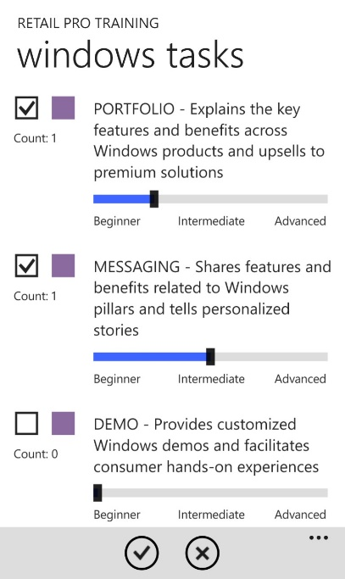
RP TRAINING CHANGES – WINDOWS Phone
There is a new “scale” under the new Global Proficiency Measurements for each Retail Pro (RP). This indicates that a measurement, on a scale of 1-5 (Beginner to Advanced) can be selected. When you change the scale to indicate the level for the RP (touch with your finger), the checkbox will automatically be checked. This also now offers an incremental count of how many times an RP has been trained on an item.
Note: There could also be a file associated with the Proficiency, with a file icon next to the checkbox.

