Last Known Value is a new reporting feature added to the MSFTREPS site. This helps users to find the last known value submitted for a question in call reports. The difference between Last Visit Only and Last Known Value is that, Last Known Value considers all submissions over the period of time selected. Whereas Last Visit Only just isolates and displays the latest submission made. We previously added Last Visit Only in My Dashboard a few months earlier.
LAST KNOWN VALUE FROM CUSTOM REPORTING CENTER
- Go to custom reporting center
- Create a new custom report for call reports/proficiencies
- Add the questions. Click on next

The custom reporting center now displays all the transactions for the selected call reports.
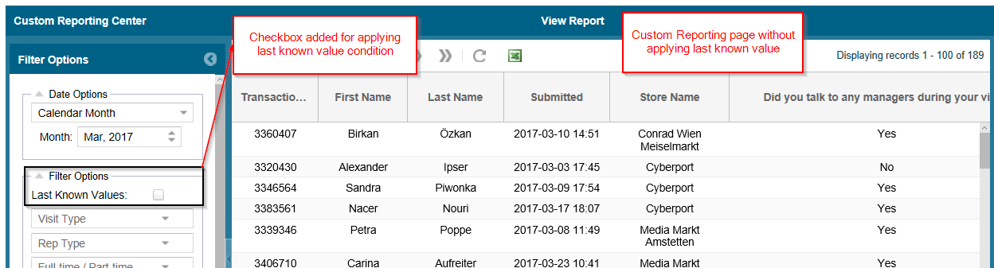A new checkbox named "Last known value" have been added to the filter panel. By ticking this checkbox and applying the GO button, the data is filtered and the last known value for each question per each store which had submissions are displayed. In case of proficiencies, the data is grouped based on individual store employee and is not store based.
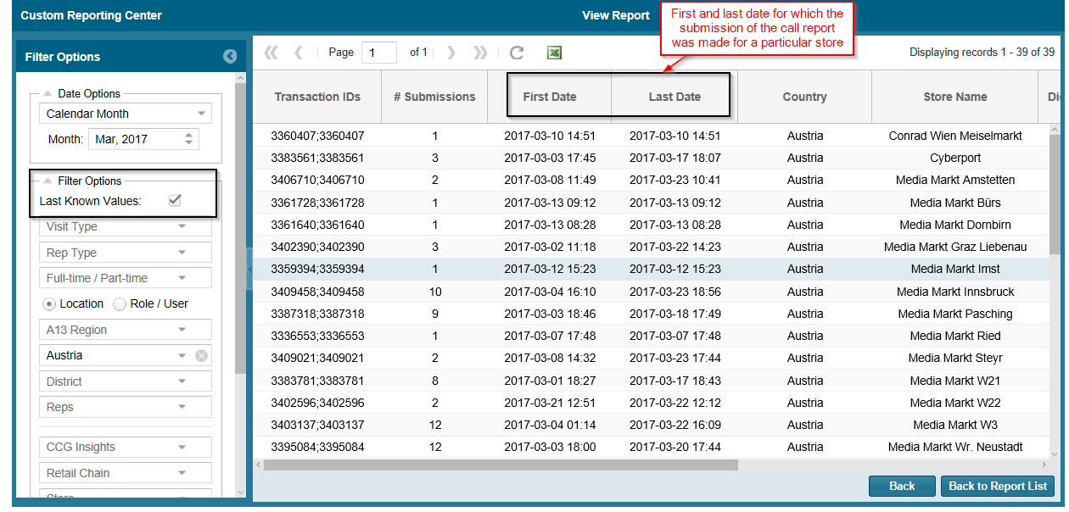
- We can add multiple questions to the report and obtain their last known value altogether.
- The transaction ID column gives the transaction ID of the last known submission.
- In case of multiple questions, more than a single submission of call report may be required to get an entire picture. In such cases, transaction ID column contain the transaction IDs which provide the last known value for each question.

- # submissions column give the total number of submissions made during the selected date range.
- The first and last date indicates the date of first submission and last submission made in the applied date range.
- For each store name, the last known value is displayed against it as seen from the image. The store name is unique in this case. For proficiencies, store employee becomes unique.
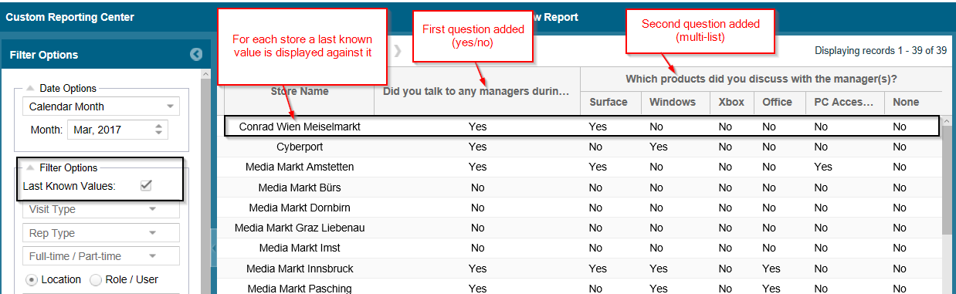
To see the difference between the last known value and last visit, let us consider a small example. In the image given below, we have transaction data for a specific store in a selected date range. As explained before, the last visit considers only the latest submission of a call report for a store. (Last visit is marked in the image)
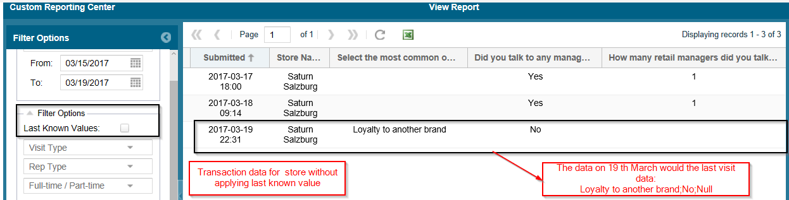
To get the last known value, tick the checkbox and click on Go. The data seen in the image below is the last known value for each question per store.
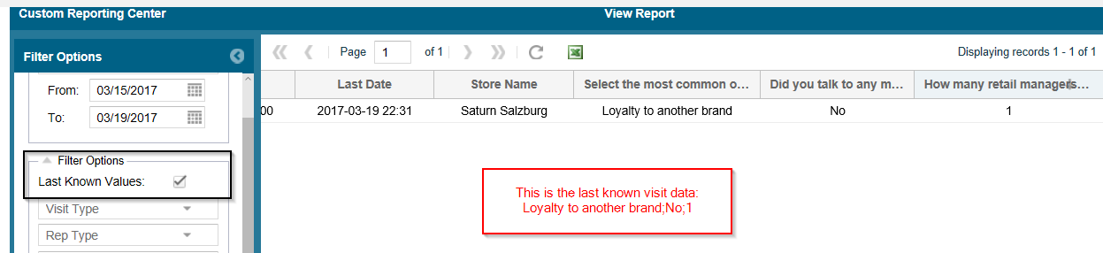

For a simple understanding of the concept, we can see the below scenario. Consider the 3 visits submitted in the below table.

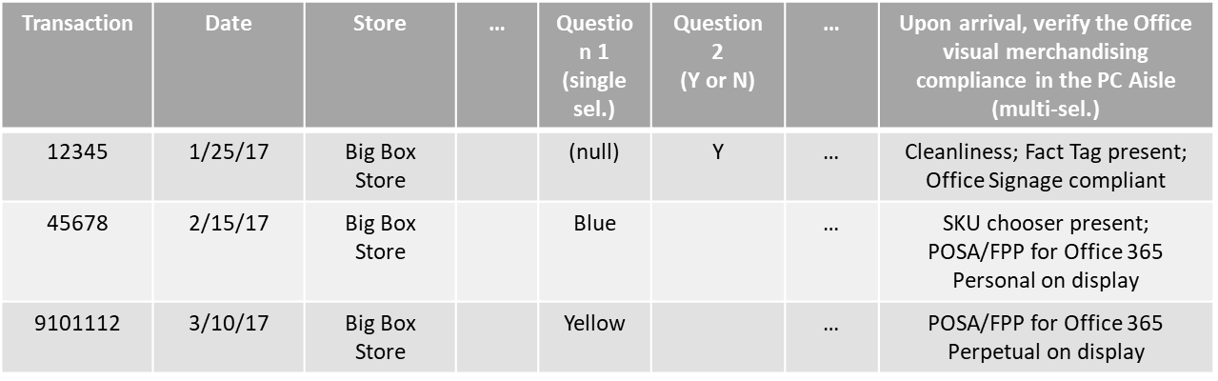

On applying the Last Known Visit filter, only the last submitted value for each question is displayed as in the below table.

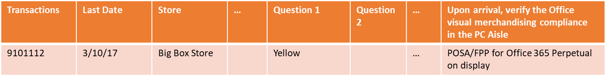

On applying the Last Known Value filter, the last submission which have a known value for that particular question is considered.

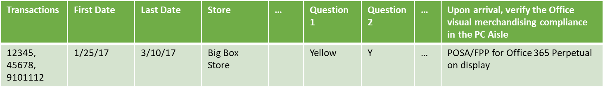

LAST KNOWN VALUE (MY DASHBOARD)
The last known value in My Dashboards has been implemented under My saved items. The implementation is similar to that in the Custom Reporting Center. To get the last known value for the call report questions, following steps are to be followed.
- Expand My Saved Items tab and click on Create New Dashboard Item
- A pop-up comes up with option to add a question and select the mode of display of the chart.
  - Here, a checkbox has been added ‘Show last known values’.
  - Tick the checkbox and click on view.

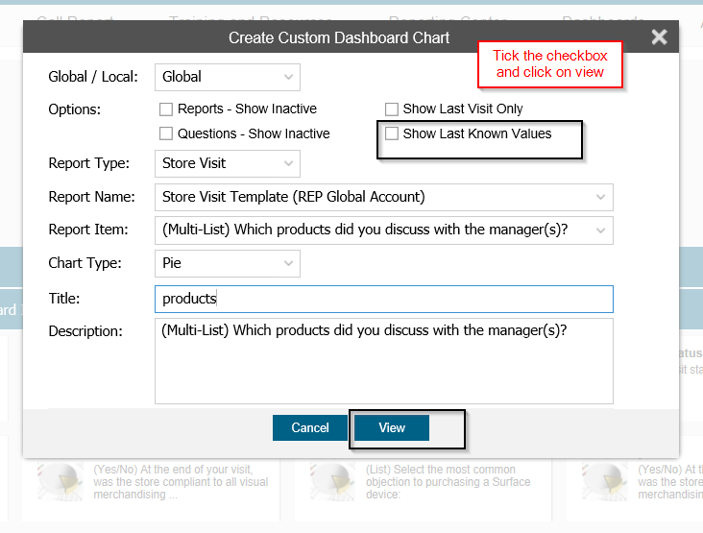
- Save the new dashboard chart
- Now, from the list of saved dashboard charts, select the newly added one.
- Add it to My Dashboard. Apply the necessary filters and click on Go.

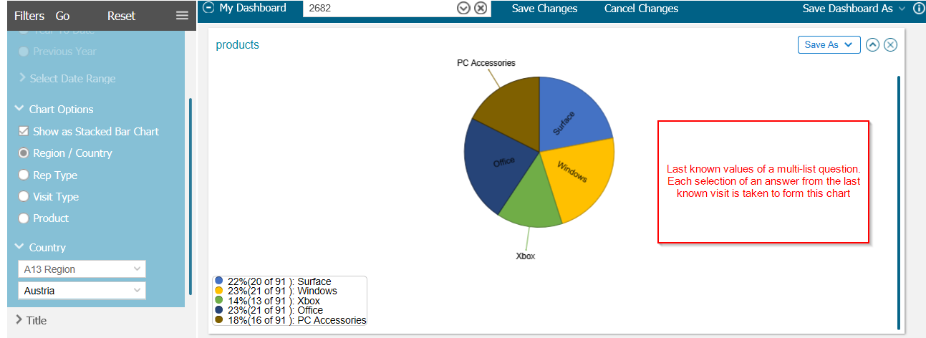
The chart results displayed are last known values for the stores which have submissions in the selected date range. The chart is displayed as a distribution of the options available for the question and the responses they have received based on their last known values.

LAST VISIT (MY DASHBOARD)
Last visit is very much similar to the last known value. The only difference is that it just takes into account the last submission made for a particular question in a store. It does not see if the answer is null or not. The last visit also comes under the My saved items under My Dashboard.
- Navigate to My Dashboard
- Expand My Saved Items tab and click on Create New Dashboard Item
- A pop-up comes up with an option to add a question and select the mode of display of the chart. Here, a checkbox has been added ‘Show Last Visit Only’. Tick the checkbox and click on view.
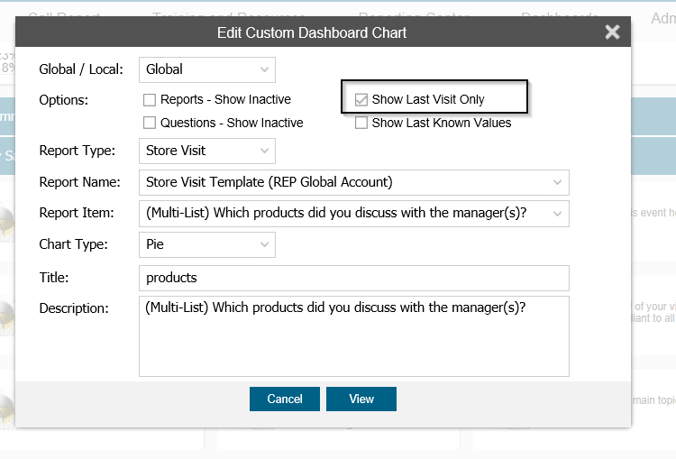
- Save the new dashboard chart
- Now, from the list of saved dashboard charts, select the newly added one.
- Add it to My Dashboard. Apply the necessary filters and click on Go.

