Overview
The Retail Engagement Program (REP) apps have evolved with the October release, now known as “REP 4.0.” Several new features are included with an entirely new design for the app.
- New tile and icon design in the menu system and on some multi-select questions
- Scrolling banner across the top of the app which can be made clickable to open a web page
- Custom theme colors
- Dedicated News page
- Login security using an authenticated email username and password (not your 10-digit REP ID)
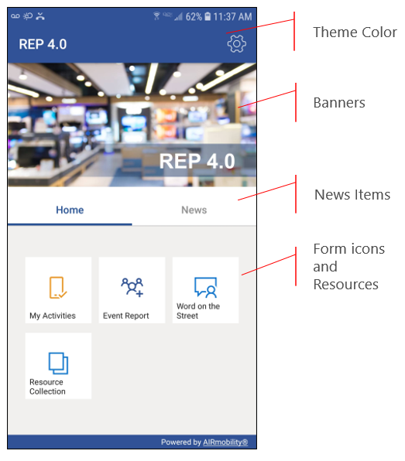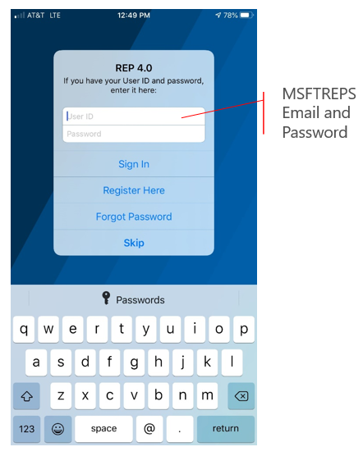
Important Note: Login on REP 4.0 apps requires the same email and password used online at www.MSFTREPS.com. If you have activated your online account through the email authentication process and logged in successfully online with email and password, then you are ready.
If you have not logged in recently online at Msftreps.com we strongly suggest you do that FIRST on your laptop or desktop computer and complete the login security activation process. We have made it possible to do the same activation process from the REP 4.0 app which will open your browser. Use the “Register Here” link on the Account Settings page to check the status or complete the login security process. (Requires stable high-speed Internet access.)

Legacy REP Apps
Previous versions (3.2.46 or 2.0.133) of the REP apps for Windows and Android, using 10-digit REP ID, will still be available for a brief period as a back-up to the new apps. Web Entry is still available as a third option and now uses MSFTREPS email and password to log in.

REP 4.0 App Download:
In the App Stores search for the term “REP 4.0” or “REP v4.0” as opposed to “Retail Engagement Program” as you have done previously.
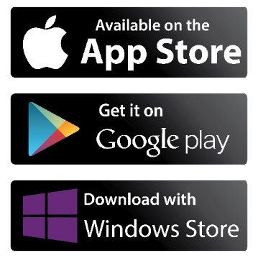
Alternate way to download directly (if viewing this document on the device):
Click here for the iOS app.
Click here for the Android app.
Click here for the Windows app

Using the applicable App Store, download and install REP 4.0 on your Windows, Android or iOS device.
- Make sure you have a strong, highspeed internet connection on Wi-Fi or your cell network
- Close all the browsers and other apps that are currently running
- Open the App Store on your device and search for “REP 4.0” app and then select it
- Follow the steps given on the device to download and install
- Click to open and the Account Settings menu will be visible
- Enter you MSFTREPS email and password
- Click Sign In
- If you cannot remember your MSFTREPS password, there is a Forgot Password link
- After login, in Settings, if you use Submission Confirmations emails (highly recommended) switch that option on

Using the App for the First Time
The general layout of the main page, form structure and submissions has not changed and should look familiar. No special instructions are needed. But if you have questions, direct them to your Manager / Administrator first or see below.
Support
Send any questions or concerns to msftreps@westlakesoftware.com. Please include the following.
- Your name
- MSFTREPS user email or 10-digit ID
- Country
- Device information (Make + Model + OS Version)
- Report Form name and Location name if a store visit (if applicable)
- Description of the issue with any screenshots or error messages
- Diagnostics (found in Settings) copied to a text file and attached to email
Note: The more information you can give us here, the better. Diagnostics are found under Settings. Copy the diagnostics text and then paste it into your email.
Published October 2, 2020.

