Contents
Overview 3
Getting Started 4
REP – Engagement Survey 4
Roll Up File for Retail Engagement Program 4
Website Login 5
Home Screen 7
Welcome and Setup 7
Call Reports 7
Dashboard 7
Administration 8
Call Reports 9
Create Call Reports 10
Call Report Assignments 11
Task maintenance 12
Editing or Removing Questions 14
Hiding/Un-hiding Sections 15
Conditional logic 16
Localization 18
Manage Call Reports 20
Transaction Report 20
Store Notes 21
Export Transaction Reports 21
GPS 23
Escalation 24
Schedule Reports 26
Configure 27
Language Tools 28
Dashboard 29
Compliance Dashboard 29
RSP Training Dashboard 29
Photo Dashboard 29
Misc Dashboard 29
WOTS Dashboard (Word on the Street) 29
Administration 30
General Settings 30
Database Management 31
Store Management 31
User Management 35
Assignments 39
Resource File Management 45
RSP Training Management 48
RSP Tasks and Files 48
RSP Database Manager 52
Breaking News 52
Change Log 52
Appendix 53
Appendix A – Administrator Setup Checklist 53
Appendix B – REP Windows 8 Beta Installation and Setup Instructions 55
Appendix C – Global KPIs tracked in REP 63
Appendix D – Field Types 64

Overview
Welcome to the Retail Engagement Program (REP). This system is designed to provide the tools and resources needed to effectively manage the REP system.
The REP system has two parts: the Windows application and an Administrative Portal.
Information on installation and usage of the Windows application can be found in Appendix B.
This document focuses on the administrative website where country data is managed. The initial data in the REP system is pre-populated from the Roll Up file completed prior to training.
The information in the Roll Up file includes:
- Retail chains and stores
- Field Representatives (Reps) and management team
The web portal manages the above information as well as control:
- Resources used to train Retail Sales Professionals (RSPs)
- Resources for the Reps
  - Plan-o-Grams
  - Kiosk Maintenance
  - Demo Installation
  - Field Rep training resources
- Breaking News – Notification system for new products, calls to action, and other locally relevant news that the Reps need.
The following reports are available:
- Scorecard – KPI statistics view
- Store Visit Compliance
- Training Activities
- Photos
Call report data can also be exported to Excel for further analysis.

Getting Started
Before using the REP portal, the following steps should be completed:

REP – Engagement Survey
This survey requests the following information:
- Country Contact information
- Current reporting capabilities
- Field labor breakdown by rep type as defined in the Field Labor Playbook

Roll Up File for Retail Engagement Program
After completing the survey, a Roll Up file is need to pre-populate the REP system for your country. The roll up file defines:
- Administrator username and temporary password
- Retail Chains
  - Chain names should match Retail-BI for KPI reporting.
  - Chain Classification – used to assign different execution/support levels per stores in the chains. Refer to the Field Labor Playbook for definitions of Good/Better/Best execution.
- Retail Stores
  - Address
  - GPS coordinates
  - Monthly Visit Frequency
- Territory structure
- Field Reps and their managers
Instructions for completing a Roll Up file are included in the spreadsheet.
Once both of these files are complete and entered into the REP system it takes approximately 2 business days after the last completed submission of the Roll Up file before the files can be accessed and maintenance can begin.
Please refer to Appendix A for a checklist of tasks to complete during initial setup.

Website Login
Use the initial username and password designated in the Roll Up file. Send an email to MSFTREP@Microsoft.com, if this information is needed.
Click on the following link, or type the address into your browser: www.msftreps.com
The login page appears:
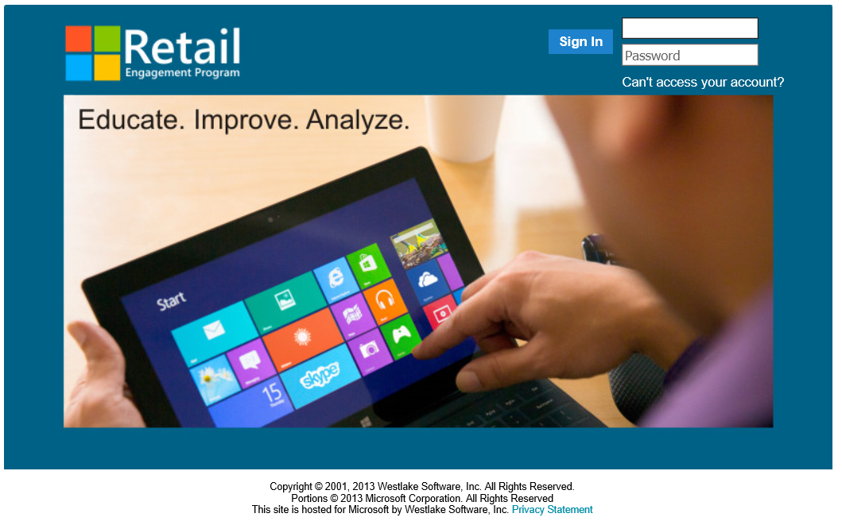

During the first login to the system, a prompt to change the temporary password and security question appears:
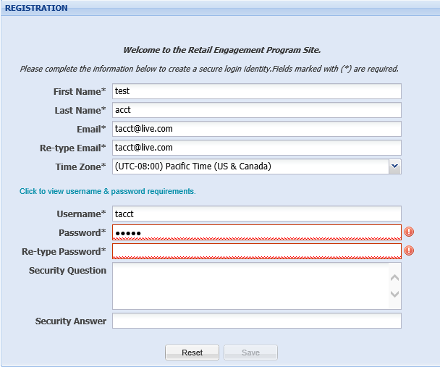

Password Requirements:
- Must be from 8 to 14 characters long.
- Contain at least 1 uppercase character and at least 1 lowercase character.
- Contain at least 1 of the following special characters: -_"!@#$%^&*+=(){}[]<>|\`~,.;:/?
Enter a new Password, Security Question and Security Answer. Click on Save at which point the REP Home screen will appear.

Home Screen

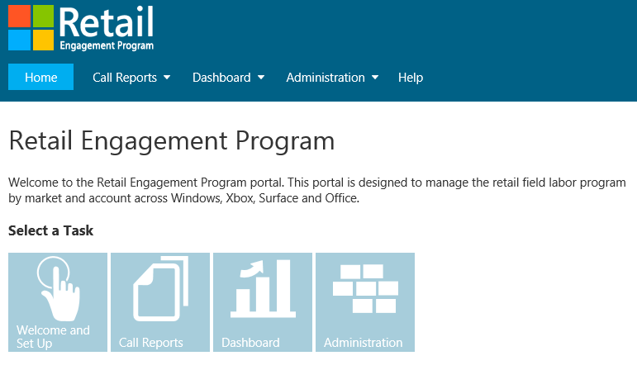

Welcome and Setup
The country welcome message can be changed to include locally relevant items like procedures, holidays, etc. Instructions on installing and setting up the REP application can also be found here.
Note: During the initial deployment of the program, the Windows 8.x application is in Beta status. You will need to load the application following the instructions in Appendix A.

Call Reports
Call reports are forms created to guide the Rep in their activities while visiting their retail stores. A global Store Visit template has been created that includes questions that will map directly back to the Retail-BI KPIs. For a full list of KPIs that are tracked globally, see Appendix C.
The Global Store Visit template is divided into sections by category: Windows, Surface, Office, Xbox and PC Accessories. When creating a call report, select the categories that map directly to the products that are supported by each type of Rep available in country.
There are additional questions/tasks included in the global template that can be modified or deleted as needed. Locally relevant questions and tasks can also be added. See the Call Reports section below for more details.

Dashboard
To see the progress of your field teams and all information gathered in the field, use the standardized reports located in the dashboard. Report details can be found in the Dashboard section below.

Administration
The administrative section is dedicated to maintaining the following items:
- General Settings – Settings for the Welcome page on the website.
- Database Management – Maintenance tasks associated with stores, chains, and users of the REP system.
  - Store Management – Add/Remove/Modify store lists, chains and chain classifications.
  - User Management – Add/Remove/Modify Administrators, Reps and Rep managers.
  - Assignments
    - Store Assignments – Assign Reps to stores
    - Calendar – Assign store visits to Reps
- Resource File Management – Upload localized copies of files used by the Reps in the stores. This can include:
  - Plan-o-grams
  - Kiosk maintenance and setup instructions
  - Demo installation instructions
  - Training resources for the Reps
- RSP Training Management – Maintenance of the Monthly Training Guidance that was previously available as a PowerPoint Presentation.
  - Global monthly templates are pre-populated based on the monthly training guidance and grouped by category.
  - Modifications can be made based on the availability of product in market.
  - Resources from www.MicrosoftRAD.com (US-EN) are pre-populated. If localized versions of the resources are required, they can be downloaded from RAD, localized and uploaded to REP.
- Breaking News – Maintenance of the Breaking News section of the application home screen. Global breaking news will be available to accept, reject or localize based on product availability or relevance in region.
- Change Log – Track changes to the information in the REP system.

Call Reports
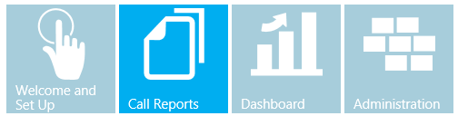
Creating and editing call reports offers the Administrator an extreme amount of flexibility in managing field labor activities across the retail chains in country.
The system offers a variety of response types (large text box, photo capture, drop down list, multiple select list, etc.) to best format data collection needs. Appendix D contains a complete list of field types and their definitions.
Call Reports support basic conditional form logic. For example, creating a drop down menu with 5 items and having a new question appear if one of those items is selected.
The entire interface has over 100 functions and features and will take 15-30 minutes to learn how to use this.
All forms have support for language localization. The client application detects the language setting of the device and if a translation is available (in part or in whole), the translation will display.

Create Call Reports
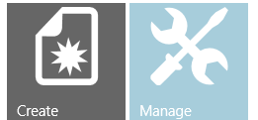


After clicking Create, enter a Form Title and Description. These will display on the Windows application home screen like the tile to the right.

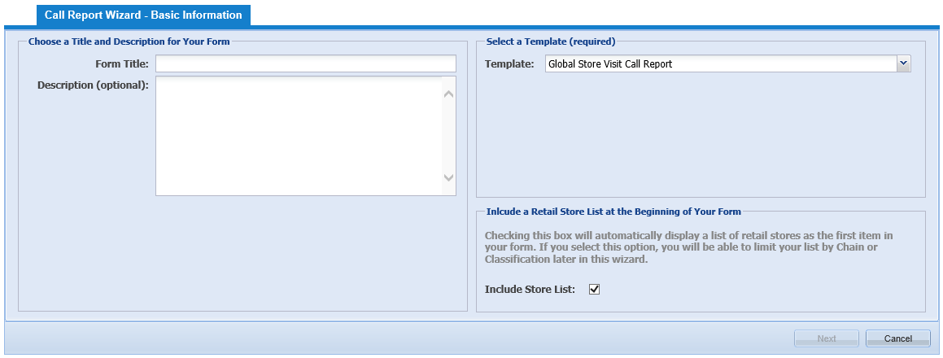
Select a Template from the drop-down list. If no call reports have been created, the only one available will be the Global Store Visit Call Report. This template is divided into sections by category: Windows, Surface, Office, Xbox and PC Accessories. During call report creation, select the categories that map directly to the products that are supported by each type of Rep in country.
There are additional questions/tasks included in the global template that can be modified or deleted as needed. Locally relevant questions and tasks can also be added.
Note: It is reccommended to create a master call report specific for the country. This should include any question that may need to be asked in any retailer. After adding in the country specific information and localizing if needed, this master call report can then be used as a template for all call reports in country without the need to localize each report.
If there are previously created call reports, pick one to copy. All modifications made to the original call report will be copied into the new one, including conditional logic and localization.
Check the Include Store List option and click on Next.

Call Report Assignments
Call reports can be assigned to any combination of Field Rep type, Retail Chain, or Chain Classification.

Assign Reps
By assigning Reps different titles based on job function or responsibilities, the call report can be customized to fit the specific needs. For example: if field reps only support Xbox assign them a title of Gaming Rep and create a call report that only has the relevant questions for the gaming department. For more information on Rep Titles, see the User Management section of this guide.

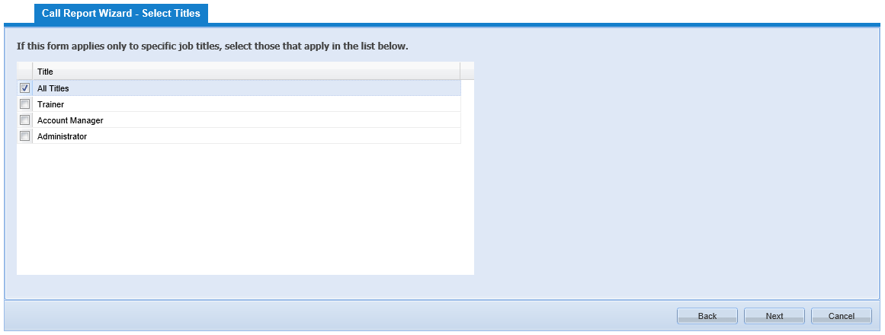
Select the Rep Titles that need to have access to this call report and click the Next button.

Assign Chains and Classifications
Classifications are used to define different support levels for stores in a chain. Following the Field Labor Guidance, the classifications would be Good, Better, and Best. Additional classifications based on the support provided to local retailers can be defined. See the Store Management section of this guide for information and setup of store classifications.

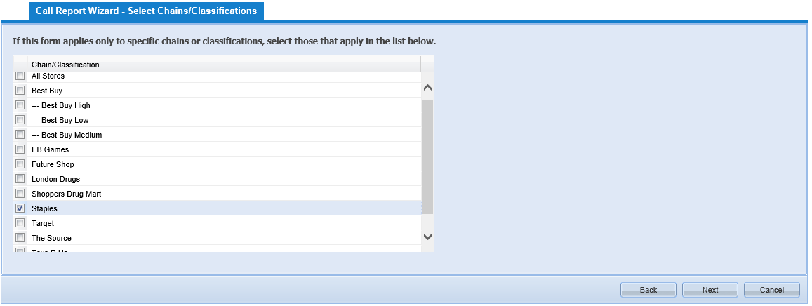
Select the Retail Chains for this form, and click the Next button to continue.

Select Sections
The Global Call Report template has sections for each product category which includes a standard set of tasks. Some of those tasks can be edited or removed, but others will map to global KPIs and cannot be removed.
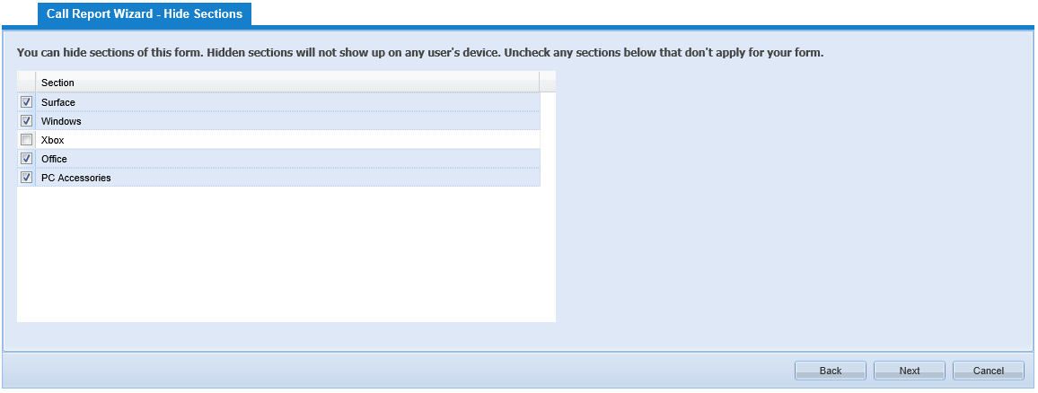
Select any section that should not appear in the call report. Sections without a checkmark will be hidden in the form; however, these sections can be reactivated later if needed. See the Hiding/Un-Hiding Sections in this guide for more information.

Task maintenance
A call report with the default global questions pre-populated has now been created. Changes and locally relevant guidance can now be added into the call report.
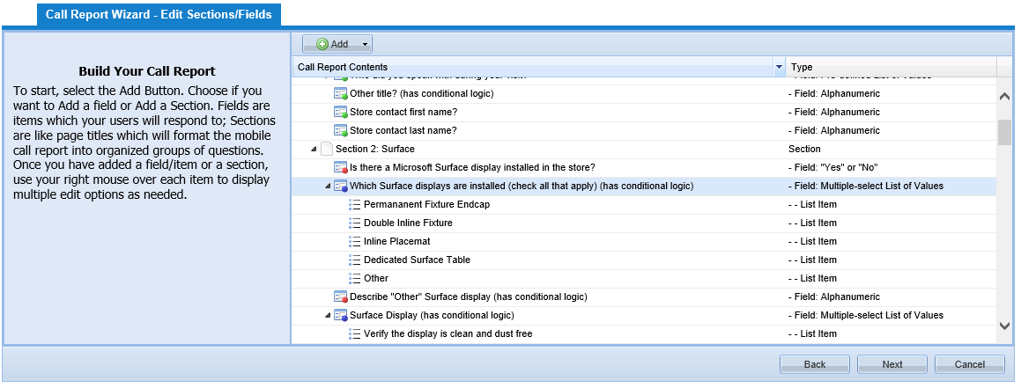

Adding New Tasks/Questions
To add a new task or question (field) click on the Add button on the top of the Call Report Wizard and select the section where a new field should be added. New fields show up at the bottom of the section, but can be moved by dragging and dropping them into the correct location.
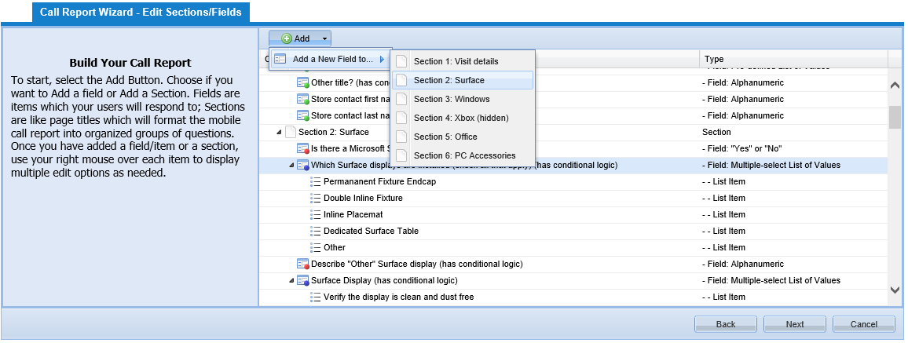
Once a section is selected, the Add a New Field dialog box opens.
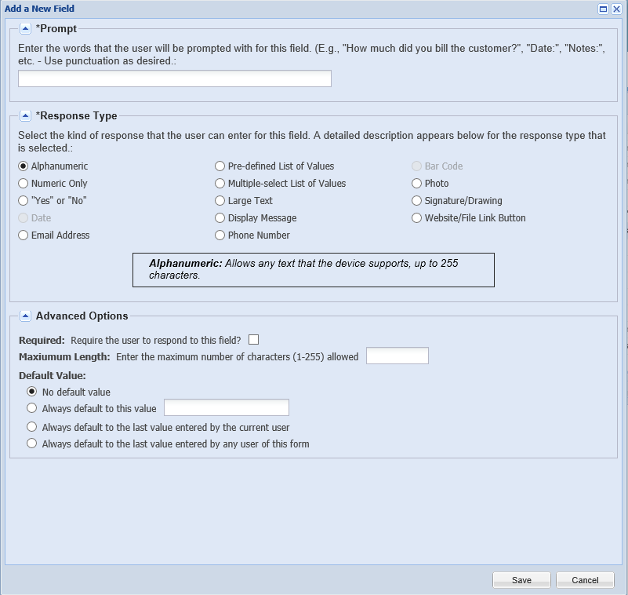
Enter a Prompt. A prompt is the action the user should take to complete a task. For example:
- Take a photo of the front of the store
- Select all that apply to the promotion
- Were there more than 100 people in the store when you were there?

Select the Response Type. The call report builder offers multiple formats such as, Yes or No, drop down menu, multiple select, photo capture, create a button to go to a link on the web or open a file that has been uploaded (and automatically downloaded to the device) to run (graphic, video, Word, Excel, PDF, PPT, etc.). Appendix D contains a complete list of field types and their definitions.
Select the Advanced Options for this field. The options will vary based on the response type.
Click on the Save button when finished.

Editing or Removing Questions
Edit or remove questions in the call report by right clicking on a field and choosing the appropriate option in the pop-up menu.
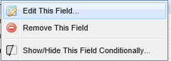
Fields from the global template have the following restrictions:
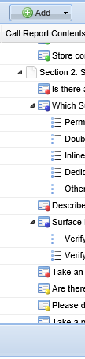

Field can be removed or changed. Fields added will always be marked green.
Field cannot be removed or changed. These questions are required.
Field cannot be removed, contents can be changed. Usually used in drop down select fields. The content of the drop down options can be changed, but not the field name.
Field can be removed but not changed. These are optional fields that can be remove, but not edited.

Hiding/Un-hiding Sections
Sections can be hidden or made visible depending on the products supported in the retailer. For example: A retail chain does not currently assort Surface so those questions can be hidden.
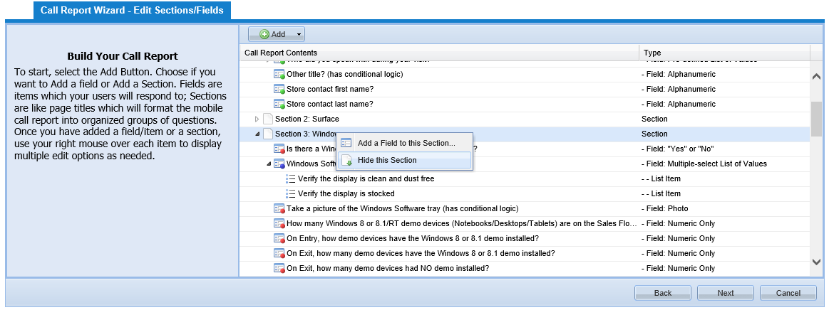
Right click on the section name and select Hide this Section. This section will not appear on the field rep’s device.
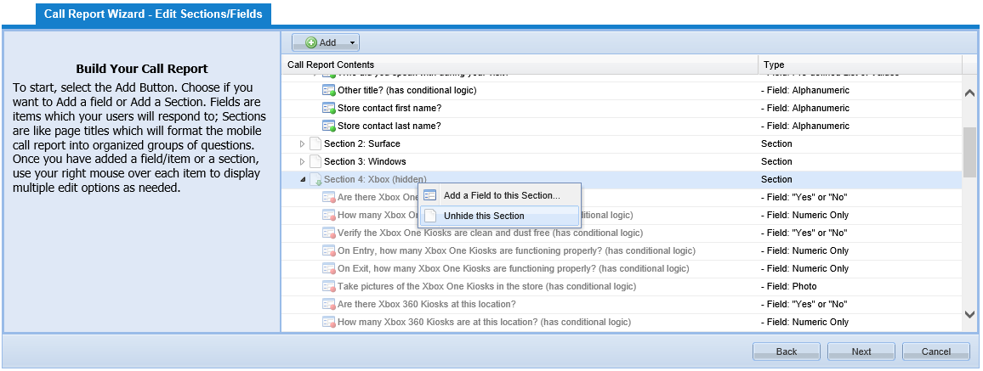
If the retailer eventually assorts Surface devices, the section can be made visible again by right clicking on the section and selecting Unhide this Section.

Conditional logic
Conditional logic allows questions to be hidden or appear based on answers to prior questions in the same section. For example: a question asking if a display is set up properly (to plan-o-gram) is answered as “No”, another can be displayed to ask why the display is not set up properly.
Conditional logic can be triggered by Yes/No, Single Select and Multiple-Select questions. See Appendix D for definition of available field types.
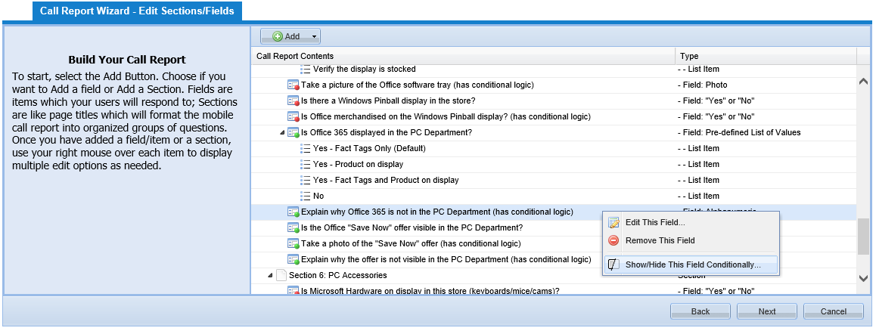
To use conditional logic, right click on the field and select Show/Hide This Field Conditionally
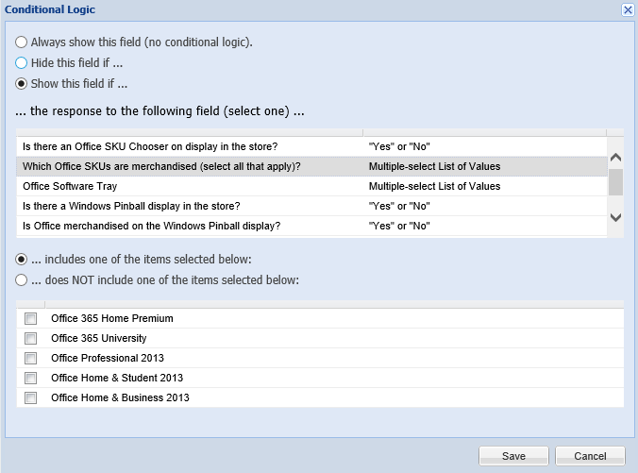
Select the option to Always show the field, Hide or Show, then select the field that this is based on from the list presented.
Select options based on the type of field selected, and click the Save button when complete.

After all changes have been made, click on the Next button.
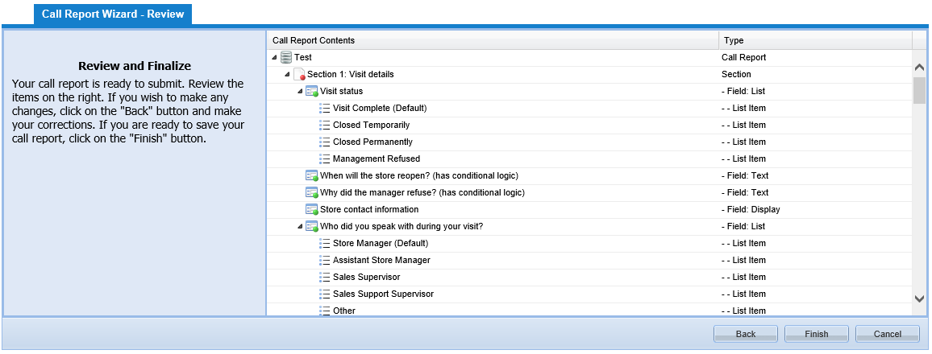
Review the call report then click on the Finish button to save the report.
A prompt to localize the call report will be displayed.
Click the No button if localization is not needed.
To localize the call report, click the Yes button.
Note: If this call report was created from a copy of one that was previously localized, there is only a need to localize any new questions added. If questions were only removed from this call report, there is no need to localize.

Localization
Call Reports can be localized into any language supported by Windows 8.x. Instructions on how to load a language pack onto a Windows PC can be found here: http://support.microsoft.com/kb/2607607/en-us
Localization is currently limited to the fields in a call report. System-wide labels are currently in English and we are looking to incorporate localization of the full application in the next version (H2FY14). Examples of items that will currently display in English are the bottons used for navigation and dialog boxes:
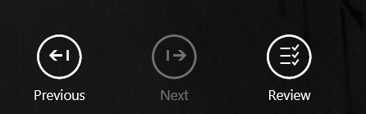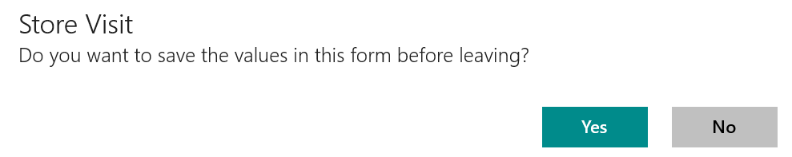

To localize a call report, select the language from the drop-down list.
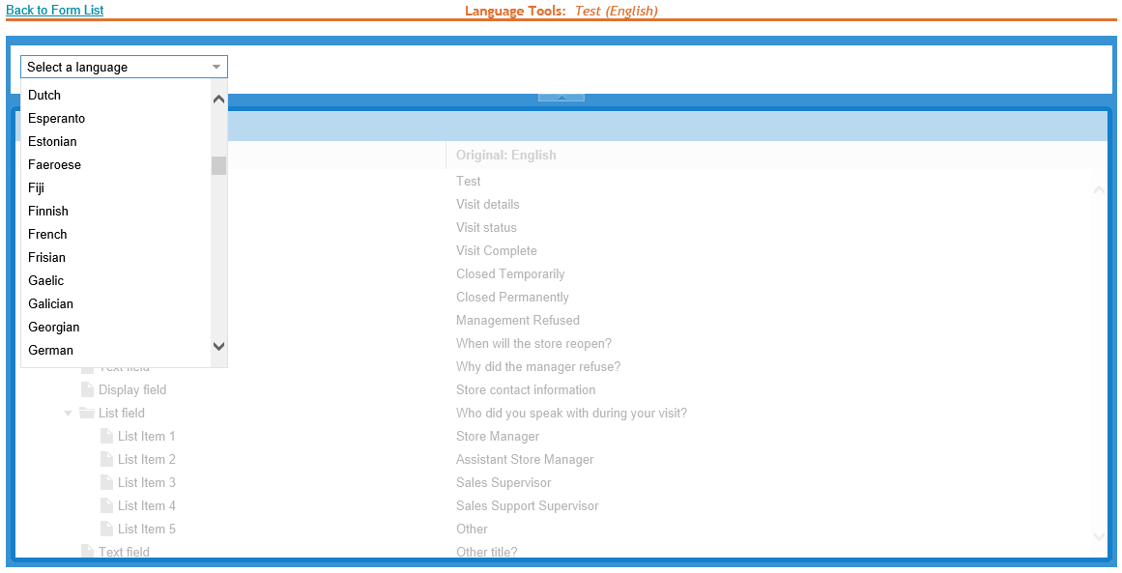
The list of languages is color coded based on translation of the form. If the language is orange, it is partially translated. If the language is green it has been completely translated, otherwise the color is black.
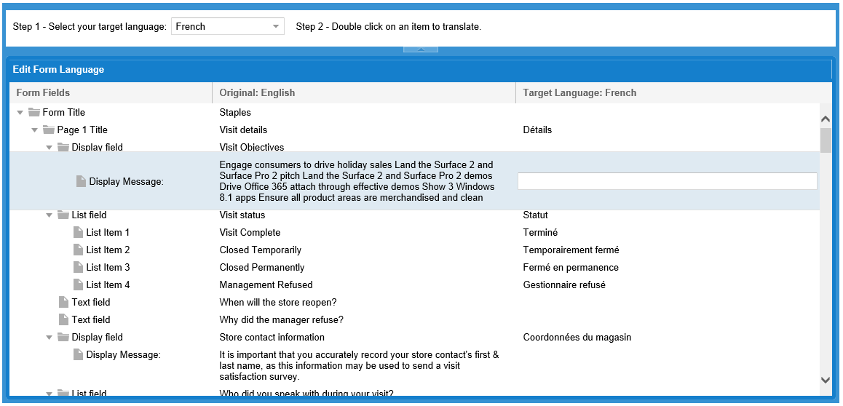
For each field in the call report, double click on it to translate. Type in the translation on the right side and hit enter or click another question to save the changes.
If multiple translations are needed, just select the language from the drop down list and enter those translations as well.
Note: Localization may only need to be done once for the first call report that is created from the global template. Create a new call report as a copy of this one, it will retain the localization already completed. Only new questions added need to be localized.
There is no save option here. All updates are available after exiting the translate field.

Manage Call Reports
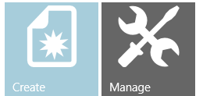
This module provides functions to report on activity for call reports; assign alerts (escalations and scheduled reports); and the ability to modify and localize call reports that have already been created.

Transaction Report
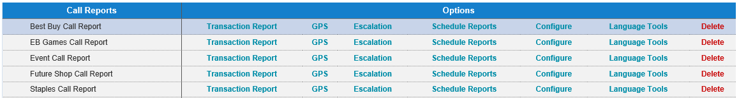
Transaction Reports display all submissions for a call report for a specified date range.
A Rep can view all of their transaction reports, a manager can view all transaction reports from Reps that report to them and an admin for the country can view and modify all transaction reports.
Transaction reports can viewed with all photos as a PDF and can also be exported to Excel. Excel export will also include all photos taken at that store visit.
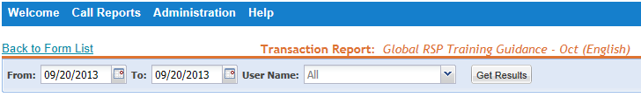
Select a Date Range (defaults to the last report submission date). Managers can also select a single rep or all reps assigned to them. Select the Get Results button.
Click to view and edit store notes
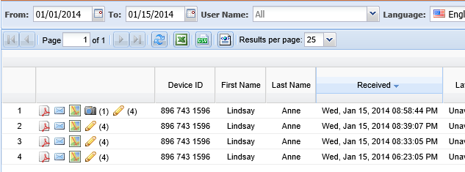
Export records to an Excel spreadsheet.
View photos taken during this store visit.
When Location Coordinates are available with the transaction, map icon will drop out to Bing maps.
Click to view transaction in a formatted PDF Report
Quick email function to submit send report to others.

Store Notes
Store notes are input from the reps while in the stores. These can consist of reminders or helpful hints about the store. Clicking on the pencil icon in a transaction report will open the Store Note editor for editing or deleting of content. These modifications will appear in the application the next time it is synchronized.
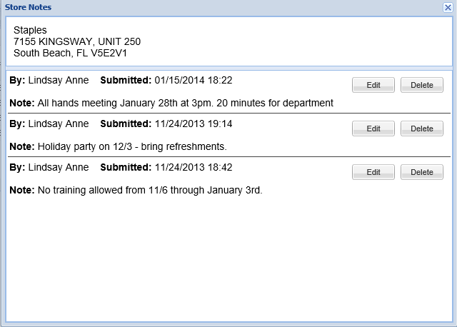

Export Transaction Reports
Basic reporting is contained in the Dashboards. The Download to Excel option allows further analysis of call reports.
Click on the Download to Excel button . Select whether to include photos and the size of the photos, then click Export.
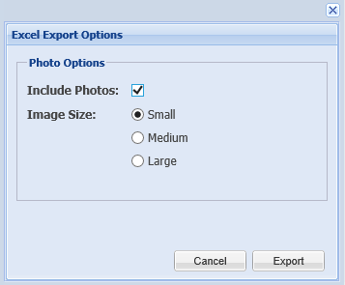
Note: Exporting photos does not download the full resolution photo, only thumbnails of the original photo.

Once the file is opened in Excel, all of the questions included in the call report will be listed as the column headers. Each store visit will be a row in the spreadsheet.
Note: Currently, if photos are included and the data is sorted, the photos will not remain with the correct record. To resolve this, enter titles in the columns that contain pictures before selecting the Filter and Sort options in Excel. A solution to this problem is being investigated.
Before (notice that there are no filer options for the photo columns):
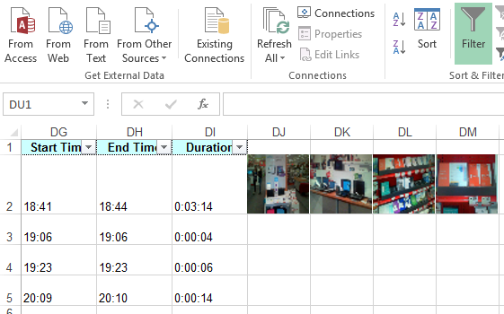
Turn off filtering, add column headers and then turn filtering back on.
After (photos will now sort and stay with the original record):
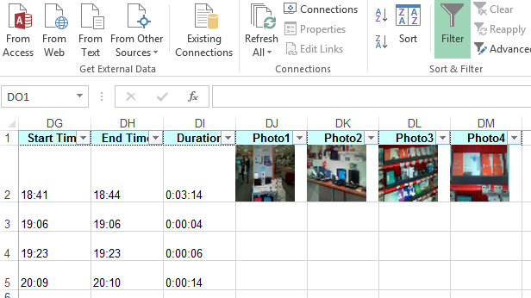

GPS
When this solution is used on a Windows Phone 8.x or Windows 8.x device with built in GPS chipsets, submission to the server of call reports are often real-time and provide a higher accuracy of tracking users.
When tracking users using a non GPS device, location based services are provided by the closest Wi-Fi service in which the device is connected. GPS Tracking using non-GPS enabled devices is not expected to be a highly accurate or timely way of tracking users with the Retail Engagement Program.
Select a Date Range (Managers can also select a single rep or all reps) and select the Get Results Button.
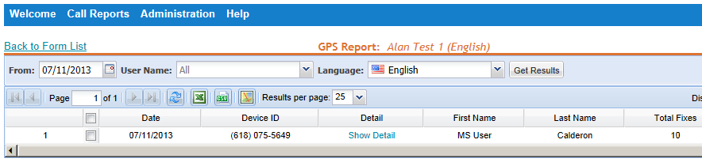
Selecting this link will display the raw detail (LAT, LONG, Date and Time of each GPS coordinate captured).
2. Select the map icon to display all coordinates available for that day on a map.
1. Check this box to map coordinates of this Rep.

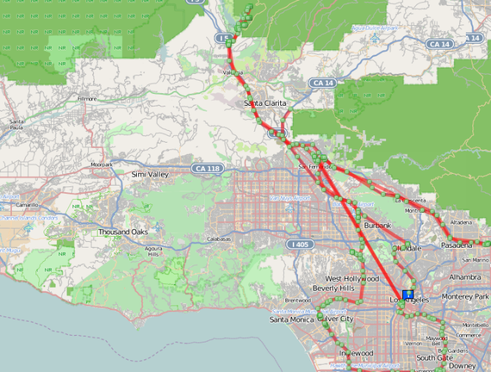

Escalation
Escalations are used to monitor a particular response to a question and email any one person or multiple people that an event/response was met. For example, if a question says “does this store require immediate management assistance?” Yes or No. If the user selects “Yes”, when the record is submitted, that record will send an alert to the denoted manager. This could be an inventory level to an inventory manager, etc. This is highly open-ended where any item in a form can be set up to trigger an escalation.
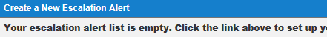
Click on Create a New Escalation Alert
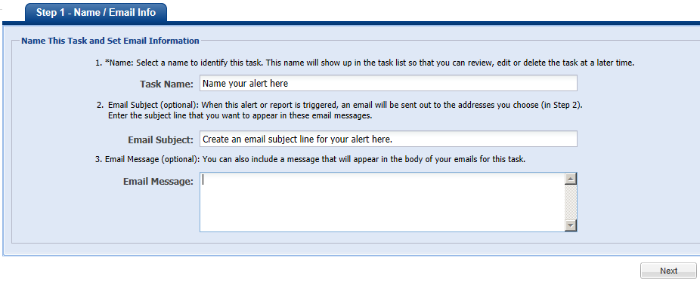
Enter the Task Name, Email Subject, and the Email Message for this escalation. Click the Next button to continue.
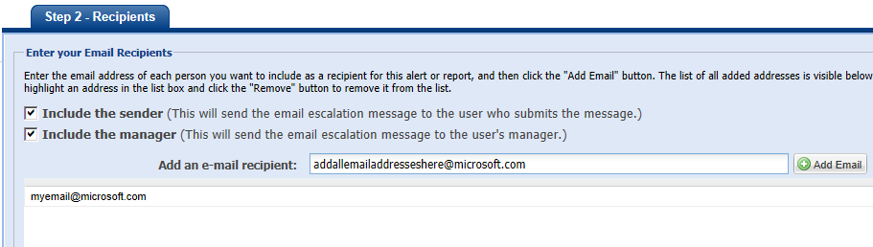
Check the appropriate boxes to include a copy of the message to both the sender (field Rep that submitted the report) and the manager of the Rep.
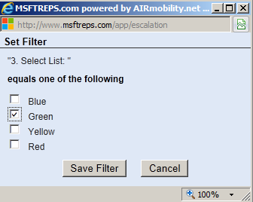
Enter the email addresses of the people to be notified.

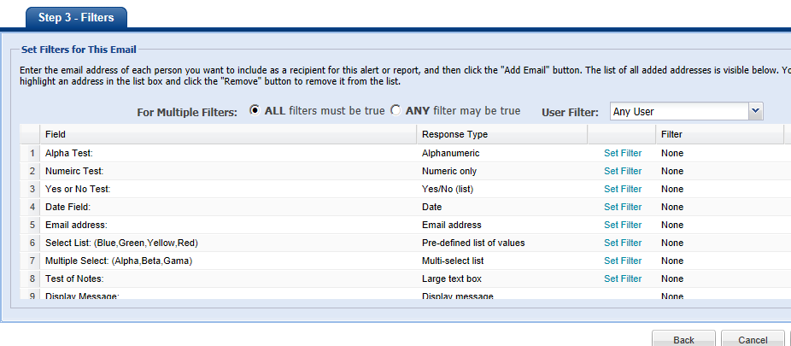
Select the Set Filter link next to the escalation item. A box will pop up to set the detail. Save this information and select Finish to complete.

Schedule Reports
Schedule Reports is very similar to creating an Escalation. See Escalation in this guide for details.
Escalations send a single call report each time the criteria is met. Scheduled reports will group all of the records that meet the criteria and send an Excel attachment containing those records.
In addition to the steps to create an escalation, there is an additional step in the set up wizard:
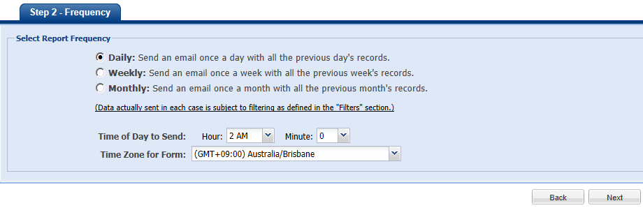
Reports can be scheduled daily, weekly or monthly, denote the time in which they want the reports to come and in what time zone.

Configure
This option is to modify an existing call report. It allows the addition of items, moving items around and modify some items but not all. For example, a pick list cannot be changed to a numeric or photo field (database limitation).
WARNING: Currently, deleting an existing question will delete all data that was collected for that question. A method for deleting questions and retaining historical data is being investigated.
If a question has to be removed and the data needs to be preserved, follow these steps:
- Create a new call report selecting the current call report as a template. See Create Call Reports section for details.
- Modify the new report as needed
- Make the old current call report inactive by unchecking the Active checkbox.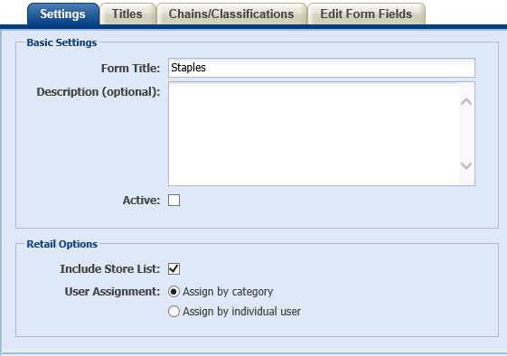

Language Tools
Language tools allow localization of the call report. Refer to the Localization section of this guide for instructions.

Dashboard

Compliance Dashboard

RSP Training Dashboard

Photo Dashboard

Misc Dashboard

WOTS Dashboard (Word on the Street)

Administration

General Settings
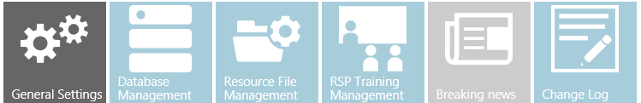
This module is for managing the welcome message for the Reps, and default settings for transaction reports in the REP system.
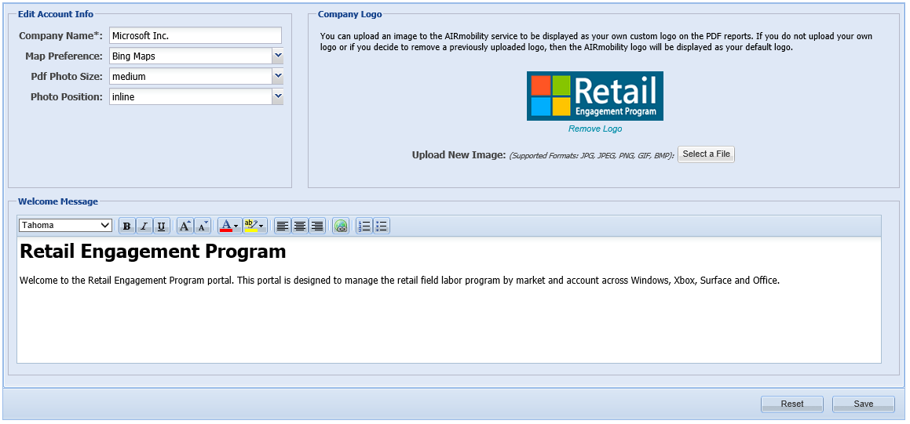
Edit Account Info
Company name: Country
Map Preference: Bing
The following options affect photos in PDF reports:
Pdf Photo Size: Small, Medium, or Large. This is the size of the photos taken in a call report as they appear in a PDF report.
Photo Position: Inline or end. Inline will keep the photos in the same order as the call report questions. Selecting End will put all photos at the end of the report.
Company Logo
The REP system logo appears in the header of PDF reports.
Welcome Message
This is the message reps will see when they click on the Welcome and Setup icon on the home screen. It can be used to customize a message to them. It accepts rich text, so localized content can be placed here.

Database Management
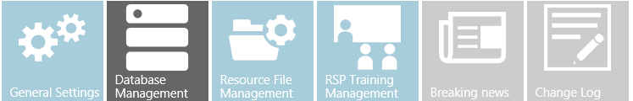
This module is for managing retail stores and chains, users and their store assignments in the REP system.

Store Management
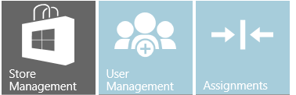
This module allows the maintenance of the regional hierarchy and the retail environment. Each country has a unique structure and all options detailed below may not apply. The initial setup of this data is created from the data contained in the Roll Up file that was submitted.
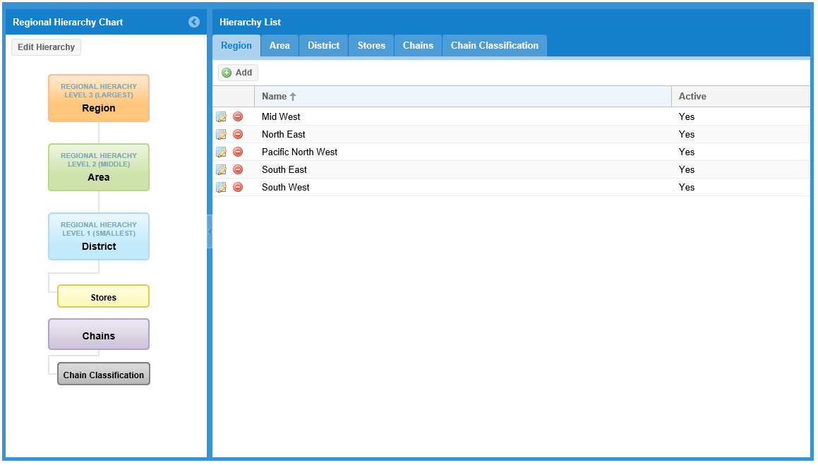

Regional Hierarchy Chart
This hierarchy is dependent on the structure of the field labor team and the requirements for reporting. Currently, there must be at least one region and the maximum is three. Each level in the hierarchy represents another filter in reporting. In the example above, there are 3 levels that represent a District that a rep covers. Then there are Areas that include multiple reps, and final multiple areas are grouped into Regions.
To edit the hierarchy, click on the Edit Hierarchy button on the top left of the screen.
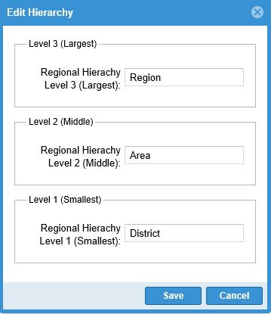
Click Save when finished.

Add/Modify/Delete Stores
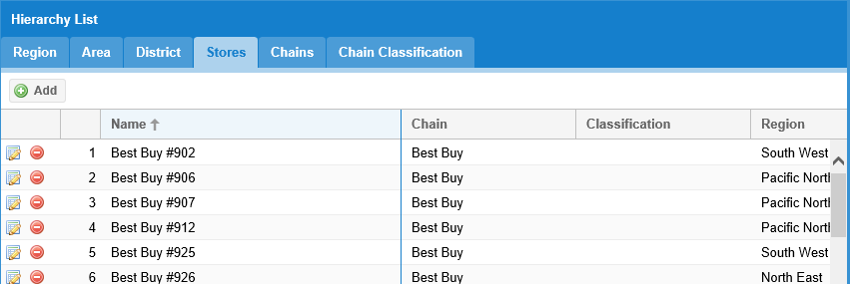
Selecting the Stores tab displays a list of stores loaded into the system from the Roll Up file.

Add a Store
To add a store to the list, click on the Add button.
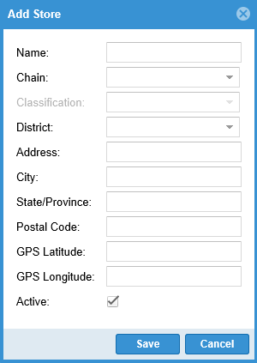
Enter a display name for the store in the Name field. This is how the store name will display both online and as a pick list on each mobile device. This name should be unique and descriptive for the rep. STORENAME #1, STORENAME #2, etc. An example would be to use the Chain and Store Number like: Currys #152, or using the chain and store number with a city: Currys #152 London.
Note: The address of the store will also be listed for further identification in the user application.
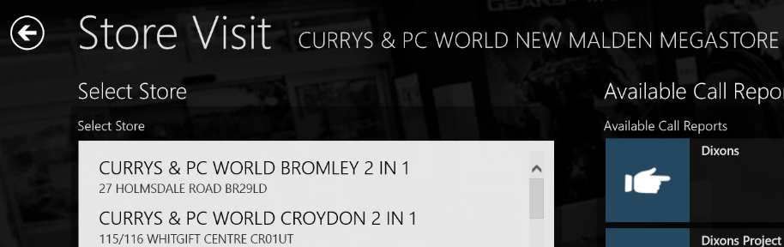
Select the Chain for the store from the drop down list.
Select Classification (if used) from the drop down list.
Select District (this will be customized to your hierarchy, but will always be the lowest level).
Enter in the address information in the appropriate fields. GPS information is not required.
Click on Save when finished.

Modify a Store
To change information about a store or make it inactive, click on the edit button to the left of the store name. Edit information as needed and click on the Save button when complete.

Delete a Store

WARNING: Currently, deleting a store removes any historic data associated with that store. A solution to allow deleting while preserving the historical data is being investigated.
If a store is no longer needed in the system, click on the delete button .
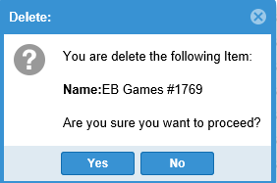
Click Yes to delete the store, or click No to keep the store.
If a store is no longer visited, it is advised to mark them Inactive. Click on the check mark next to Active to clear the box and make the store inactive. At a future date they can be made active again by clicking the blank box.
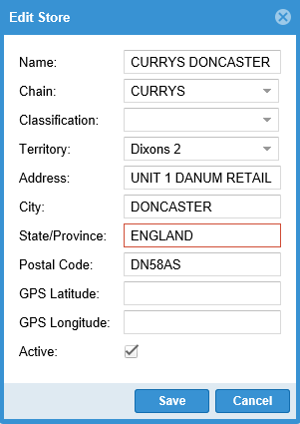

User Management
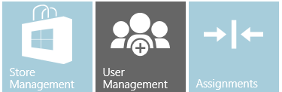
This module allows the maintenance of the management hierarchy and the users of the system. Each country has a unique structure and all options detailed below may not apply. The initial setup of this data is created from the data contained in the Roll Up file that was submitted.
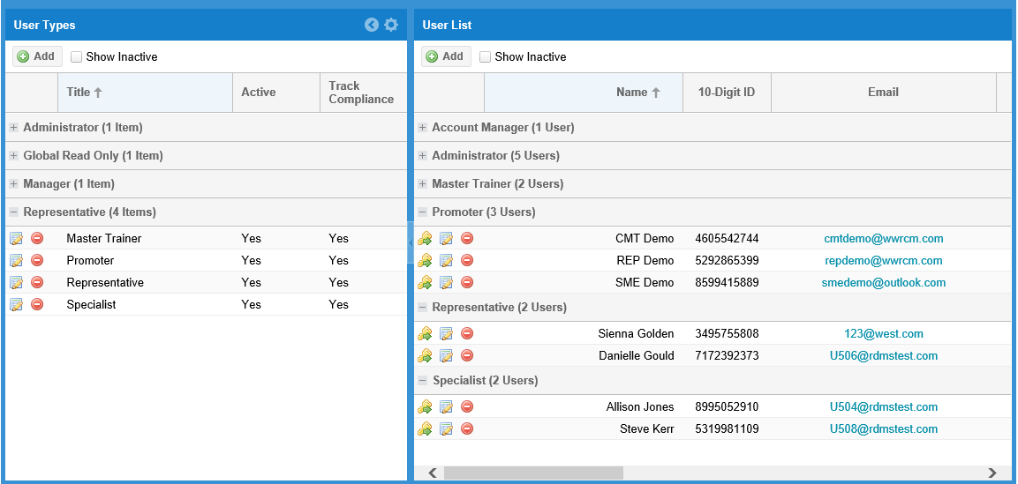

User Types
On the left portion of the screen is the different user types for the country.
- Administrator
  - Full access to all information in the country
- Read Only
  - Guest of the system that can view dashboards only
- Managers
  - Created from the Roll Up file
  - Reps are assigned to managers
  - Managers can view the data submitted by the reps assigned to them
- Representatives
  - Field Reps that visit the stores and conduct training
  - Call reports can be created for different Representative types. Creating multiple rep titles based on their job functions allows call reports to be targeted specifically at the duties of that rep.

Add New User Type
To add a new user type, click on the Add button below User Types.
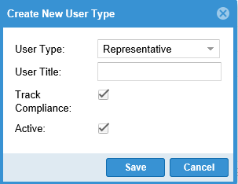
Select the User Type from the drop down list
Enter a name for the User Type.
Track Compliance – if this item is checked then this user type is included compliance tracking. If it is unchecked, they will not see Store Visit Call Reports in the application. Admins, managers and Trainers should not have tracking enabled.
Active – A User Type can be made inactive if they are no longer used. This is useful for temporary user groups (promotion staff, holiday temporary workers, etc.

Add a New User
To add a user to the system, click on the Add button below User List.
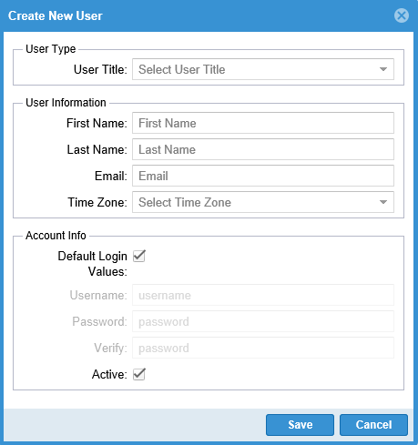
Select the User Title from the drop down list.
Enter the user’s First Name, Last Name and Email address.
Select the Time Zone from the drop down list.
Default log in values are the first initial of their first name, and their full last name. Example: John Doe would be jdoe for both the username and password on the first login to the system. The user will be prompted to change their password and set up a security question.
These can be updated by clicking on the check box next to Default Login Values and changing the information.
Click Save when complete.

Modify a User/Change password
To change information about a user or make them inactive, click on the edit button to the left of the user name. Edit information as needed and click on the Save button when complete.
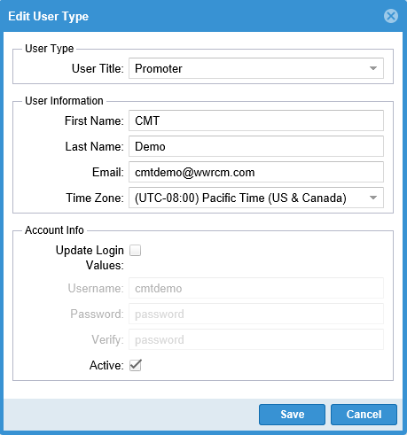
To change their password, click on the check box next to Update Login Values and enter in the new username and password values and click Save.

Delete a User

WARNING: Currently, deleting a user removes any historic data associated with that user. A solution to allow deleting while preserving the historical data is being investigated.
If a user is no longer needed in the system, click on the delete button
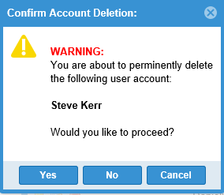
Click Yes to delete the user, or click No or Cancel to keep the store.

Make a user inactive
If a user is no longer working, it is advised to mark them Inactive. Click on the modify button
Click on the check mark next to Active to clear the box and make the user inactive. At a future date they can be made active again by clicking the blank box.

Assignments
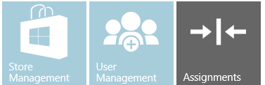
This module includes the functions to assign stores to reps and use a calendar to graphically assign those store to a monthly calendar.

Store Assignments
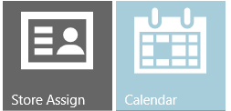
Store assignments define the stores that the reps cover. In the Roll Up file, only one user per store was allowed because the file builds the store and user hierarchy. Once a user is added to the system, they can be assigned to a store that already has coverage.
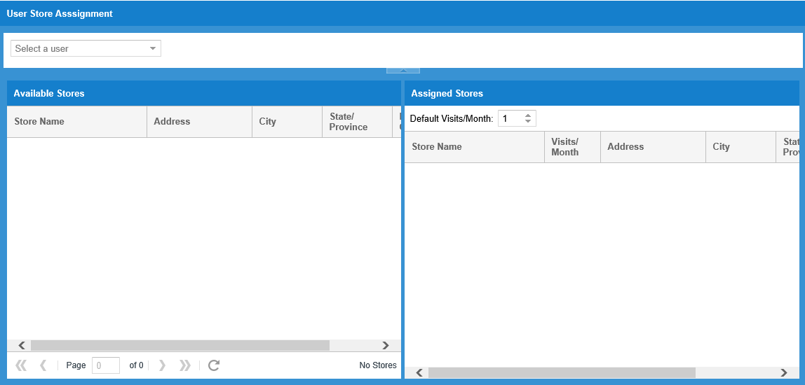
Select a user from the drop down menu.

A list of all stores in country will be listed in the left column. Similar to Excel, the fields can be sorted by clicking the arrow to the right of each field name.
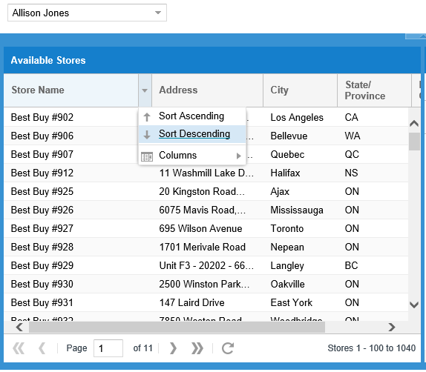
To assign stores to a rep. Select a store by clicking on that store’s line and drag it to the right side of the screen. Multiple stores can be select by holding the Ctrl key while clicking
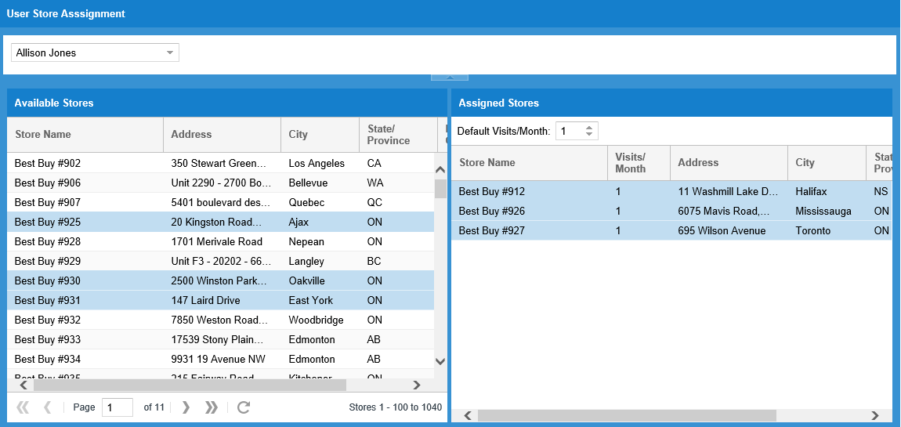
Ranges of stores can be selected by holding the Shift key and clicking on the first store then clicking on the last store in the range needed. Then drag those selections to the right side of the screen.
To remove a store from a rep, click on the store in the Assigned Stores list and drag it back to the Available Stores list. The same select options work with removing assigned stores as with assigning them.
Quick Tip: If stores are being assigned to another rep, after they are selected and slid back to the Available Stores list, they remain highlighted. 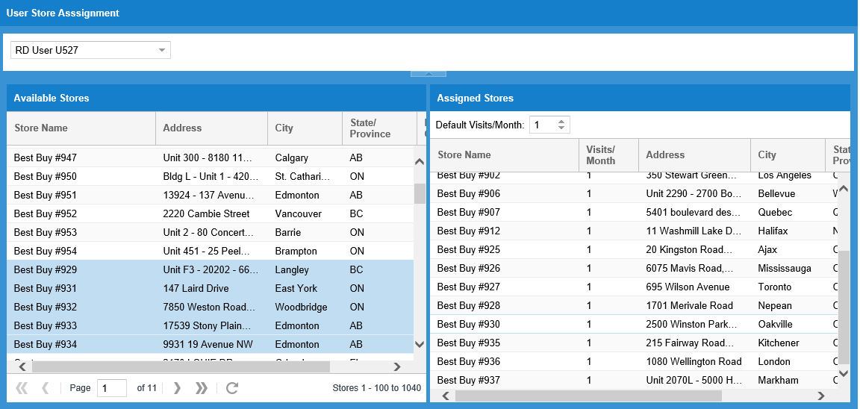
Before clicking on anything else, select the new reps name from the drop down list.
The stores remain highlighted. Click and hold one of the highlighted stores and drag them to the new user’s Assigned Stores list
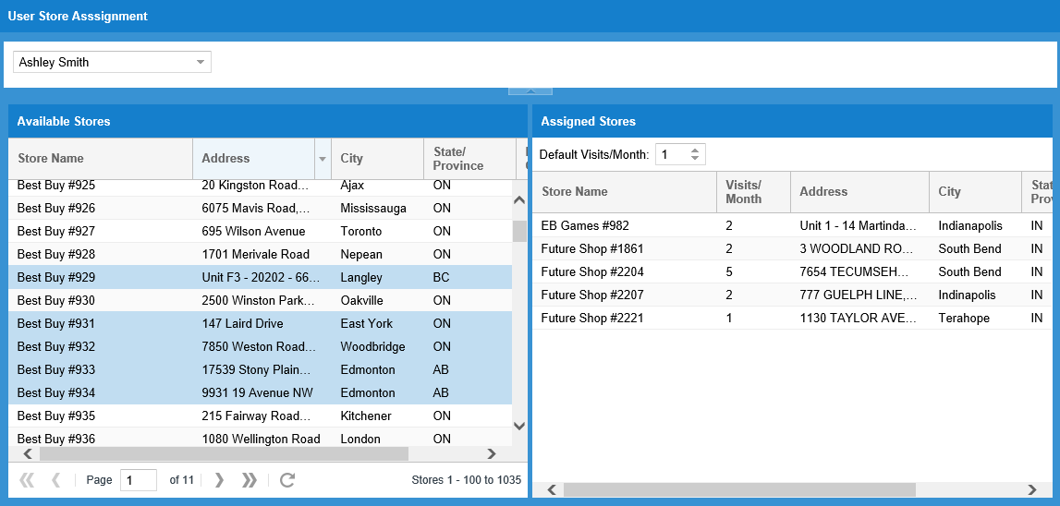

Those stores will now be assigned to the new user.
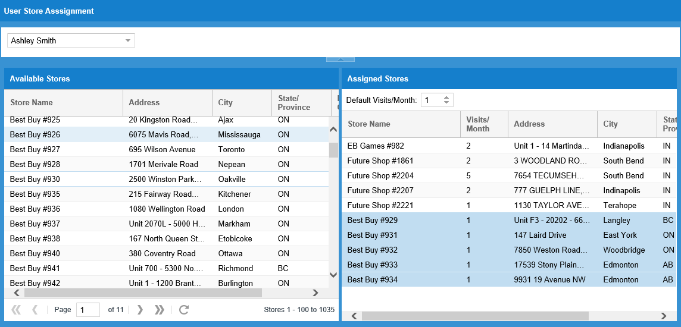

Calendar
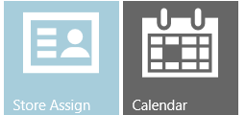
Currently the Calendar function is limited to managing the store list that the rep sees on their device. Additional functionality is being investigated and will be incorporated into future releases.
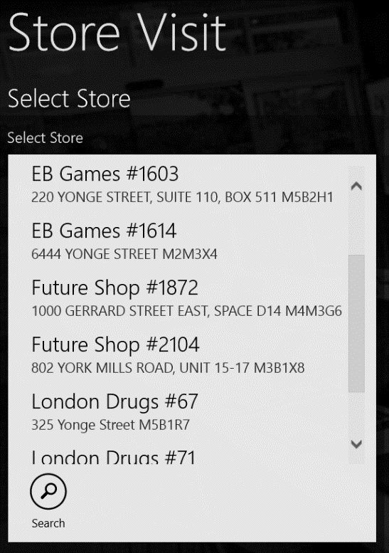
Admins can schedule all reps, managers can scheduled reps assigned to them, and reps can manage their own calendar

If no modifications are using the calendar, then the rep will always see all stores assigned to them in the application.

To have the store list only display the stores to be visited that day, stores can be entered into the monthly calendar.

All stores assigned are listed on the left. If a store is required to be visited more than once in a month, that store will be repeated in the list. For example, if a user is to visit Retail Super Store 4 times in a month, this would list 4 times as:
Retail Super Store 1 of 4
Retail Super Store 2 of 4
Retail Super Store 3 of 4
Retail Super Store 4 of 4
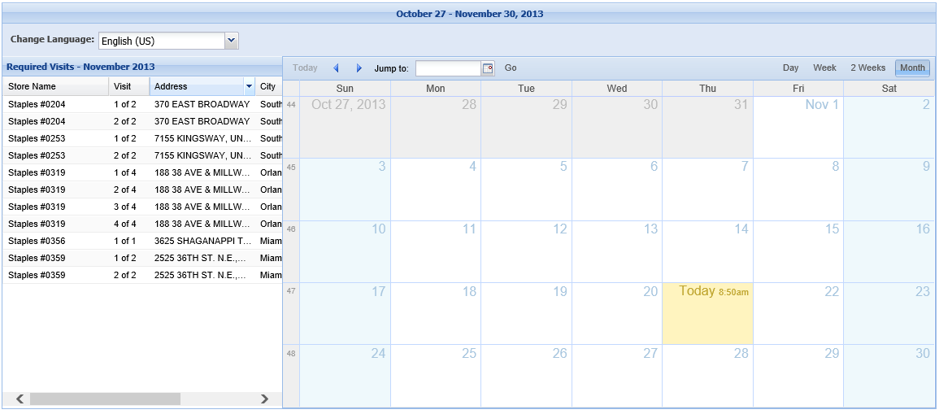
This is a drag and drop interface. Drag all stores assigned onto the calendar days in which they are to be visited. As stores are added to the calendar, they will be removed from the required visits column. To remove a store from the calendar, right-click on the store and select delete. The store will move back to the required visits column.
We default the first visit at 7AM and list all others added at a 30 minute increment. This can be edited to more specific times; but the calendar in this implementation is a daily planner with monthly compliance requirements.

Resource File Management
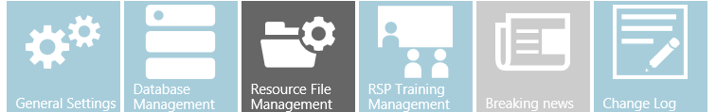
In this module, localized copies of files used by the Reps in the stores can be managed. This can include:
- Plan-o-grams
- Kiosk maintenance and setup instructions
- Demo installation instructions
- Training resources for the Reps
Currently, for the best viewing experience in the REP application it is recommended to utilize PDF, JPG and WMV files. These file types invoke the built-in Windows applications (Reader, Photos and Video respectively) and resize the screen appropriately. This maintains the modern look and feel of the application:

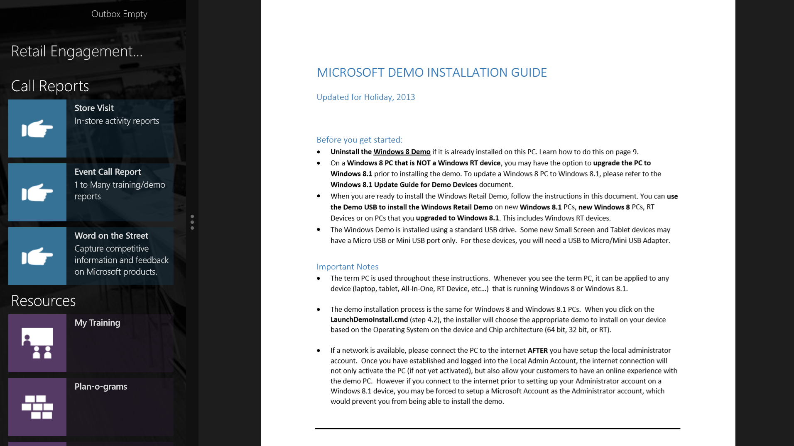
The system can support any file type that the PC can load with an associated application, but it will jump to the desktop application and the user will have to swipe back into the REP application after viewing.

When entering the Resource Manager, a list of files that are locally available to use will be visible. To add a new file, click on the upload button.
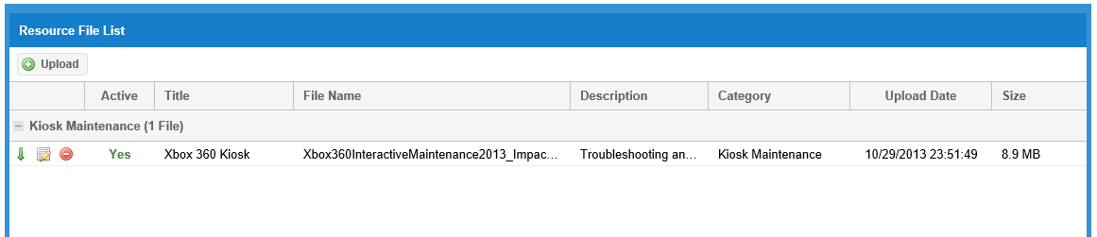

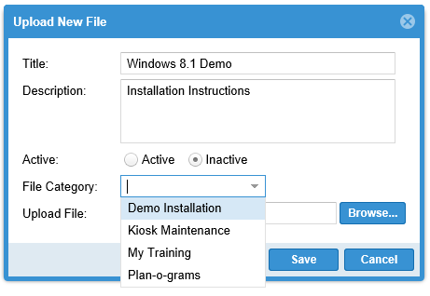
In the Upload New File dialog box, enter the Title and Description.
Then select whether the file is Active or Inactive. If a file is marked as Active, it will download to the Windows Application the next time it synchronizes.

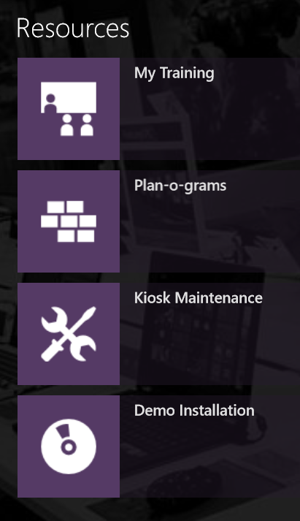

Chose a File Category. These map to the Windows App home screen sections under Resources.

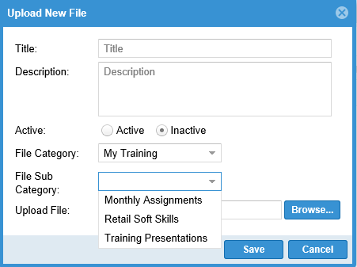
When selecting My Training an additional option to select a File Sub Category is available.
My Training is divided into those sections, plus it contains links to all of the resources that are available for RSP training. This allows the rep to review the RSP Training material without having to be in a call report.

Click on the Browse button and select your file.
Note: Files are limited to 50Mb or less, and your total file uploads cannot exceed 300Mb. For comparison: November 2013’s Training guidance is a total of 135Mb of files.

Click Save when done.

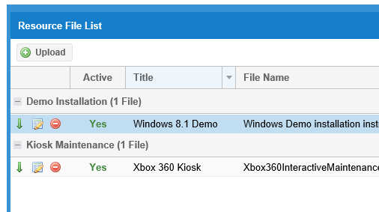
To remove a resource when it is no longer needed, click on the button.
To download a file for viewing, click on the button.
To Edit a file or upload a new copy, click on the button.

RSP Training Management
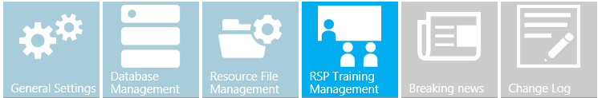

RSP Tasks and Files
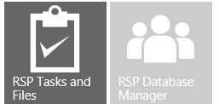
This module allows the maintenance of the Monthly Training Guidance and the resources that will be used to train the RSPs in store. Add and remove training tasks and resource based on the availability locally. Localized content can also be uploaded to replace the default English content. All content included in the monthly guidance can be found on www.microsoftrad.com.
Each month, the training guidance is pre-loaded into the REP system.
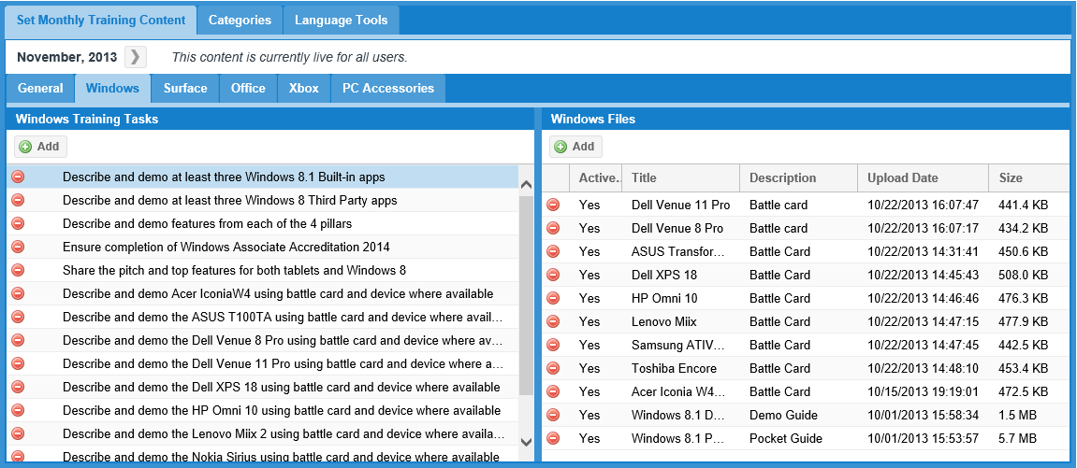
In the left hand column are the training tasks that the field Reps will convey to the RSPs. On the right hand side are resources that facilitate the training tasks. There may not be a 1 to 1 match of training tasks to resources.
To remove items from the training tasks or the associated files, click on the graphic to the left of each item.

Note: Currently, the ability to add new tasks is not available. RSP Training tasks are mapped to Global KPI’s and we are investigating a method to allow additional local training tasks to be added and mapped properly to those KPIs.
If a task was removed and is needs to be restored, click on the Add button on the top left.
When adding tasks, there is list of unused tasks from the monthly training guidance.
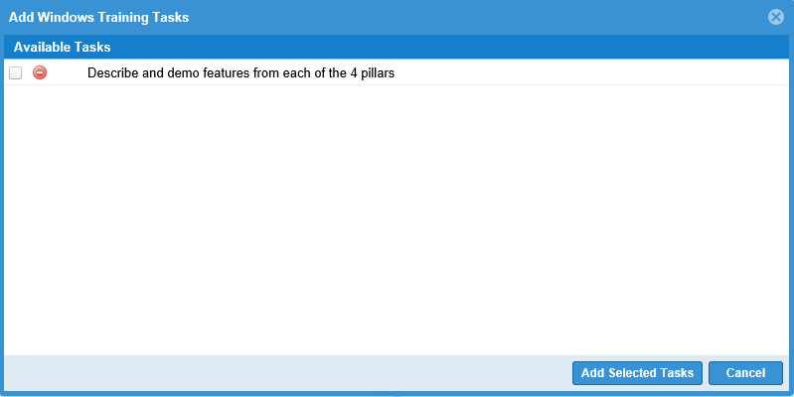
Select the tasks needed by clicking on the box to the left of the available task. When finished click on Add Selected Tasks.

If there are additional resources to upload, or localized resources, add them by clicking on the Add button on the top right.
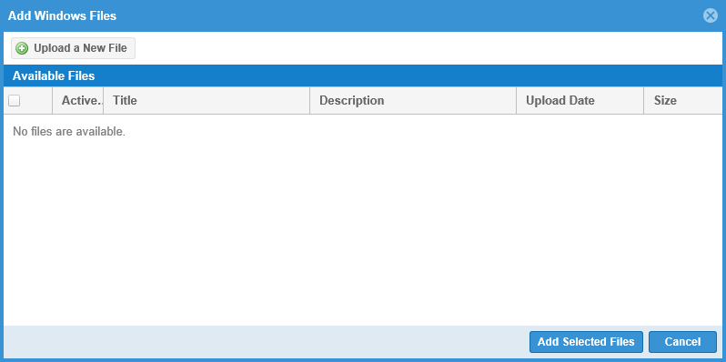
Previously added files will appear in the Available Files list. To add new files, click on Upload a New File button.
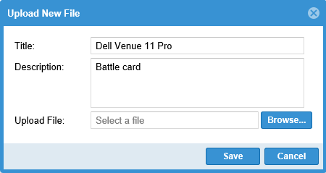
Enter a Title and Description that will appear on the resource tile in the application. Click on the Browse button to select your file. Click Save when finished.

To localize the training tasks, click on the Language Tools tab.
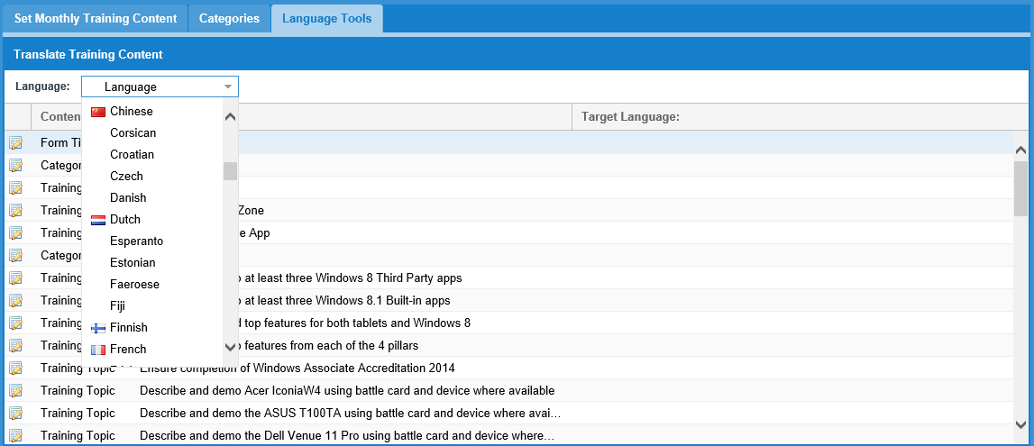
This process is identical to the localizing a call report. Select a language from the drop down list, and double-click on each item and enter the translation. See the Localization section in this guide for more information.

RSP Database Manager

Coming FY14H2
The RSP Database Manager will allow the maintenance of RSP records including removal of RSP names that are no longer working in the retail stores.

Breaking News
Breaking news is used to inform the reps of new product and other locally relevant information. Each country has the ability to create their own Breaking News. Global Breaking News will be available to accept or reject based on product availability or relevance to your region. If needed, the information can be localized before activating it to be displayed on the reps device.
Breaking News displays on the REP application home screen. It is a scrolling list of items sorted by newest first. Items will expire after 90 days, and be removed from the list.
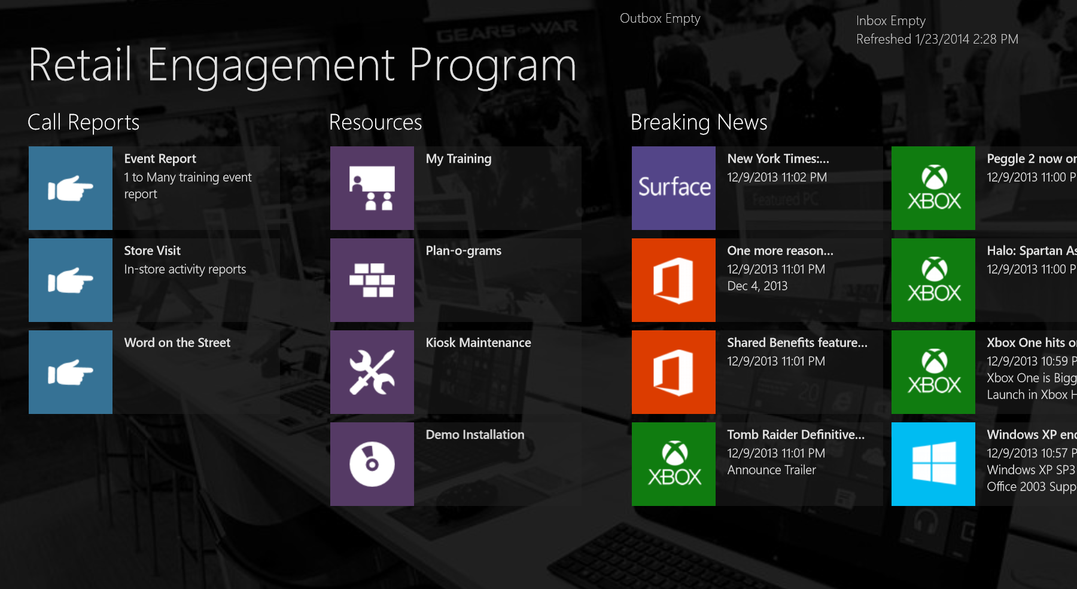

The Breaking News module will list all breaking news created locally and any news items that have been created by the corporate team. Items create by the corporate team will be marked as inactive to allow verification of relevance by each country. This also allows the country administrator to have the item localized and even replace the picture associated with the news item.
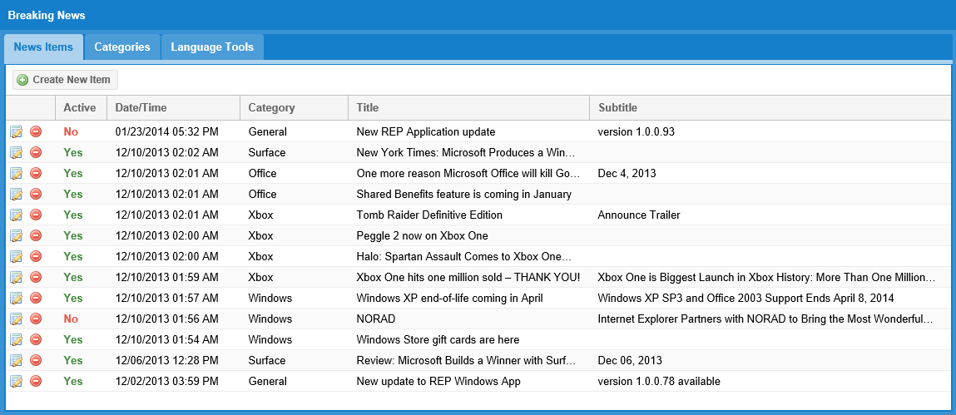

Add Breaking New Item
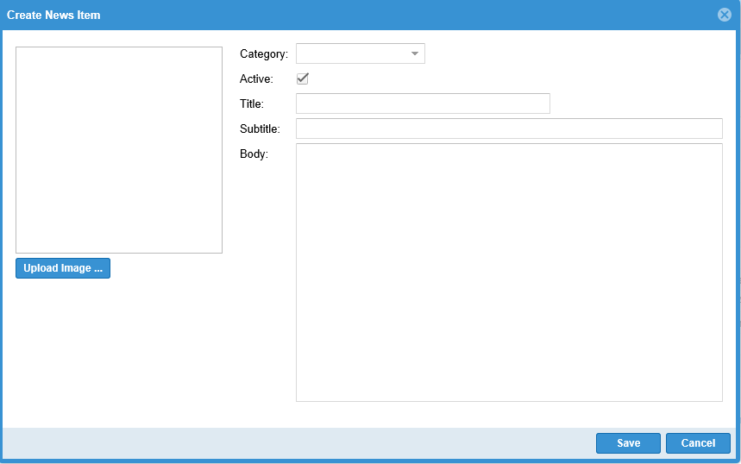
Click the Create New Item button above the news items.
Select the Category from the drop down list.
Fill in a Title, Subtitle, and the body of the message.
To include a picture, click on the Upload Image button and browse for a file to include
If this item should not be active yet, uncheck the Active field.
Click the Save button when complete.

Modify or Delete an News Item

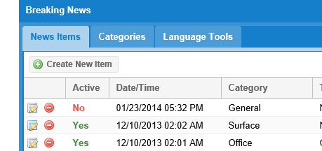
To modify an existing item click on the edit icon to the left of the news item

To delete an item click on the delete icon on the left of the button and answer the confirmation prompt.

Change Log
Coming FY12H2
Track changes to the information in the REP system. Basic tracking of items include additions and deletions of users, call reports, stores, etc. Login data will be tracked as well.

Appendix

Appendix A – Administrator Setup Checklist
  - Website Login & Password
    - Initial login and password change
    - Changing your account information
  - Welcome Page Review
    - Modify the Welcome Page for your region
  - User Management
    - Add additional administrator accounts (if necessary) Note: Admin accounts are the same charge as reps ($40 US/month). Later in November, we will be able to create read-only accounts ($10 US/month). The Viewer accounts can view only (no editing).
    - Limit admin accounts to 5 or less.
    - Review Field Reps and Managers
  - Store Management
    - Review Stores and Chain hierarchy
    - Modify Chain classifications if you need to assign different types of Reps to a store
    - Review Store Assignments and Visit frequency
    - Add/Remove/Reassign stores as needed
      - Initial Roll Up file prepopulated the store assignments for the primary rep
      - For dual coverage of a store, you can now assign additional reps to those stores
  - Calendar
    - Schedule store visits for each rep based on the stores assigned and the frequency of visits per month
  - Call Report Management
  - Tips:
    - Create your “largest” call report first (most Sections and questions)
    - Add logic
    - Localize
    - Use this form when creating your subsequent forms, modifying as needed.
    - Localization and logic will remain from this report and save you the steps of duplicating that effort in each additional call report.
All Global templates provide corporate guidance and can be modified to fit your region and retail specific needs. You can:
- Hide sections that do not apply to the retail chain
- Hide questions that do not apply
- Add Questions for locally relevant information

    - Using the Global Store Visit Call Report
      - Global template for field labor store visits
      - Create call reports based on the needs of the chains in your region
    - Adding tasks/questions
    - Localization of call reports
      - Multiple languages per call report
      - Defaults to English if no translation entered

  - File Uploads
    - Upload Resources used by the Reps
      - My Training = Field Rep training
      - Kiosk Maintenance = setup/ troubleshooting instructions for kiosks
      - Plan-o-grams = store display plan-o-grams
      - Demo Installation = Windows 8/8.1 installation/troubleshooting instructions

  - Monthly Training Guidance
    - Modify monthly training guidance topics
    - Assign resources to training categories
      - RSP Training. Selecting the following categories will allow the resource to automatically appear in the appropriate training section in the RSP Training form on the Windows App
        - General
        - Hardware
        - Office
        - Surface
        - Windows
        - Xbox
  - Call Reports – Escalations
    - Configure email escalations based on call report answers
  - Call Reports – Scheduled
    - Configure automatic Excel reports for each type of call report
      - Can be scheduled Daily, Weekly or Monthly

Appendix B – REP Windows 8 Beta Installation and Setup Instructions
What do you need to get started:
A developer license is required to install and use this beta version of this program. Installation instructions on how to install that license are included below. You will need to start this installation process from the Windows tablet you are planning on using, and you must have a valid Microsoft Account before getting started. You will also need your 10 digit ID number from the Welcome screen of http://www.msftreps.com. If you do not have your ID number, please ask your local administrator for assistance.
If you already have the application installed and are updating to a new version, you must uninstall the existing version first. You can do this by:
1. Locate the Retail Engagement Program tile on your start menu
2. Swiping with your finger in a downward motion on the tile (or right-click with a mouse)
3. Select the Uninstall Icon from the tray
Step 1 — From your Windows browser on your corresponding Windows device, click on the appropriate download button below to retrieve the zip file. (Note: the zip file name will change based on the revision level. The format is w8test2_x.x.x.xx_AnyCPU_REPS_Test.zip)
Please review the installation instructions below prior to downloading the application for your device.
For Windows 8.X | For Windows RT
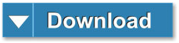
Step 2 — You will be prompted to Open the file on your tablet. Select Open (or the language denoted to open) on your tablet.
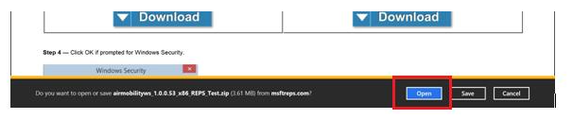
Step 3 — Click OK if prompted for Windows Security.
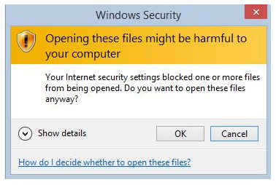
Step 4 — Select the menu item that says extract:
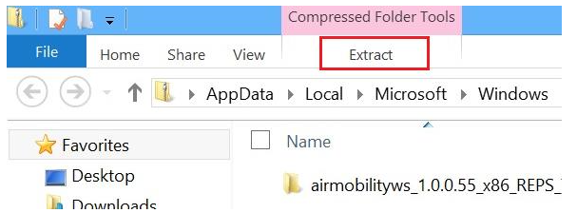
Step 5 — On the Ribbon, click "Extract all".
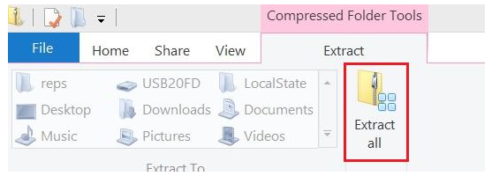

Step 6 — Keep the default options and select the Extract button.
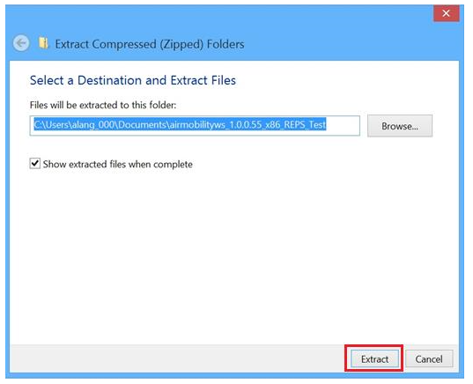
Step 7 — This will display the zip file in the directory. Please click on the zip file to display enclosed files.
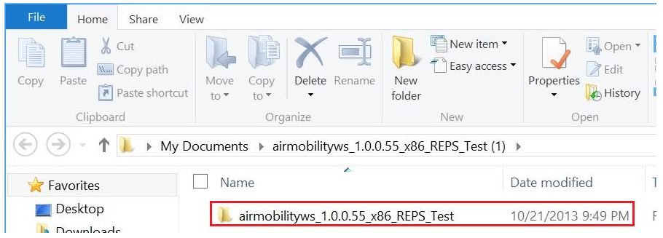

Step 8 — Hold down on the file called: Add-AppDevPackage. This will display the menu shown in the next step.
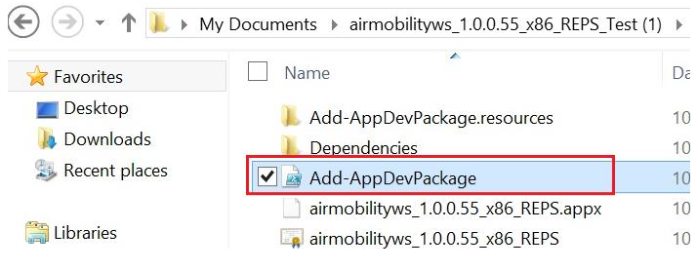
Step 9 — Hover over the file "Add-AppdevPackage.ps1", use your right mouse and select "Run with PowerShell".
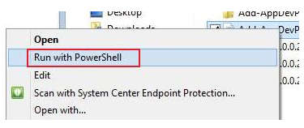
Step 10 — If you are installing for the first time, you will need to register for a developer license. If you have already installed, just press Enter at the first prompt and proceed to "Starting the Program" section below.
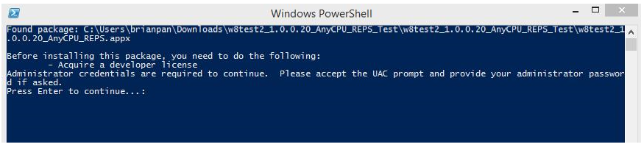
Step 11 — Click "Yes" on User Account Control screen.

Step 12 — Click "I Agree" on the Developer License screen.
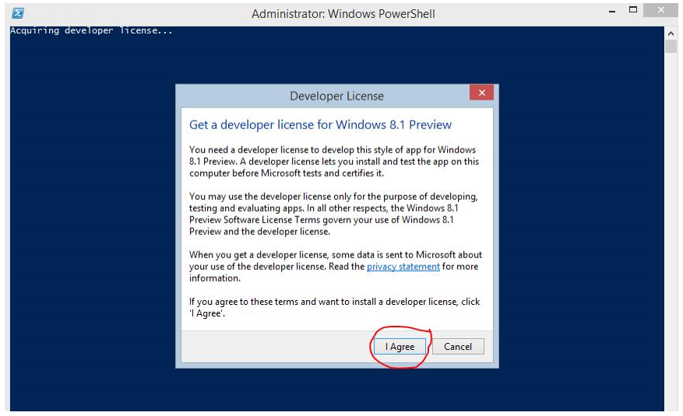
Step 13 — Sign in with your Microsoft Account (not your domain account).
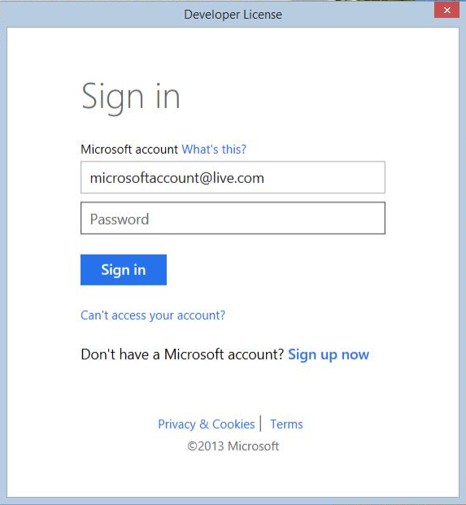
Step 14 — Click on "Close" after confirming you have a Developer License. Note that the license expires and you will have to repeat this process in 30 days or if you install again.
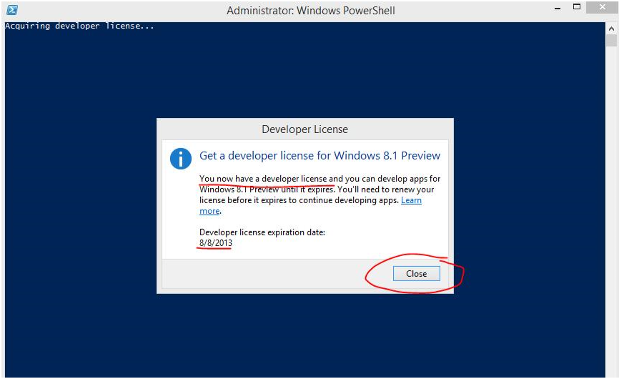
Step 15 — If prompted like below, type "Y" then press "Enter".
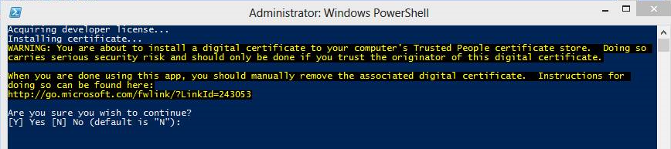

Step 16 — Press "Enter" after verifying the package was installed successfully.
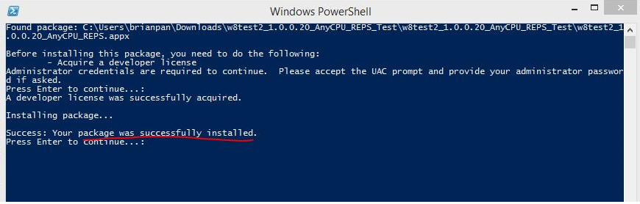
Step 17 — If after installing the developer license you are not taken back to installing the program, simply start on Step 7 and continue.
Starting the Program
If you are using Windows 8, the application icon will appear on the far right of your Start screen:
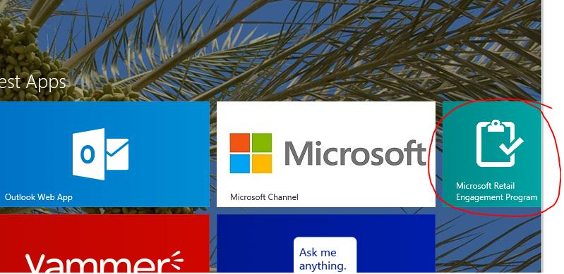

If you are using Windows 8.1, swipe up from the bottom of your Start screen, and you will see the program listed as "Microsoft Retail Engagement Program" with "New" highlighted below it. Right-click on the icon and select "Pin" to start at the bottom. The application will now appear on the far right of your Start screen.
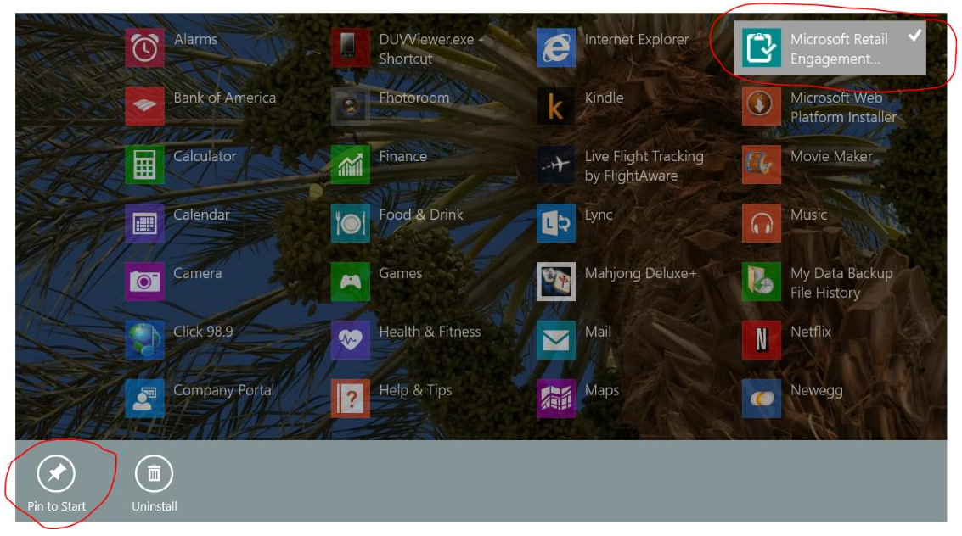
Upon running the application for the first time, you will be asked to enter in a 10-digit ID number. You can find your ID number on the Welcome Page of http://www.msftreps.com. If you do not have access to this site, please ask your administrator for assistance.

Appendix C – Global KPIs tracked in REP

Category | Workstream | Measure Type | Measure Name | Measure Definition
Surface | Labor | KPI | # of stores visited per month | # of unique retail outlets visited by MS hired reps per month.
Surface | Labor | KPI | # of store visits per month | # of total actual store visits including multiple visits to the same store
Surface | Education | KPI | # of 1:many training impressions | # of RSP impressions via 1:many training events (# of "impressions" not # of unique RSPs trained) e.g. 1 RSP may attend 3x 1:M training = 3 impresssions
Surface | Education | KPI | # of 1:1 training impressions | # of RSP impressions via 1:1 training events (# of "impressions" not # of unique RSPs trained) e.g. 1 RSP may attend 3x 1:1 training = 3 impresssions
Windows | Labor | KPI | # of stores visited per month | # of unique retail outlets visited by MS hired reps per month.
Windows | Labor | KPI | # of store visits per month | # of total actual store visits including multiple visits to the same store
Windows | Education | KPI | # of 1:many training impressions | # of RSP impressions via 1:many training events (# of "impressions" not # of unique RSPs trained) e.g. 1 RSP may attend 3x 1:M training = 3 impresssions
Windows | Education | KPI | # of 1:1 training impressions | # of RSP impressions via 1:1 training events (# of "impressions" not # of unique RSPs trained) e.g. 1 RSP may attend 3x 1:1 training = 3 impresssions
Office | Labor | KPI | # of stores visited per month | # of unique retail outlets visited by MS hired reps per month.
Office | Labor | KPI | # of store visits per month | # of total actual store visits including multiple visits to the same store
Office | Education | KPI | # of 1:many training impressions | # of RSP impressions via 1:many training events (# of "impressions" not # of unique RSPs trained) e.g. 1 RSP may attend 3x 1:M training = 3 impresssions
Office | Education | KPI | # of 1:1 training impressions | # of RSP impressions via 1:1 training events (# of "impressions" not # of unique RSPs trained) e.g. 1 RSP may attend 3x 1:1 training = 3 impresssions
Xbox | Labor | KPI | # of stores visited per month | # of unique retail outlets visited by MS hired reps per month.
Xbox | Labor | KPI | # of store visits per month | # of total actual store visits including multiple visits to the same store
Xbox | Education | KPI | # of RSPs trained 1:1 MS Led | How many RSP are being trained face-to-face by Microsoft staff or Microsoft-hired field reps.

Appendix D – Field Types

Alphanumeric – this field support letters and numbers. It is used to enter names, license number, locations and other brief text entry items. Advanced options include making this a required field, supporting a default value, and more.
Numeric Only – used largely with mobile phones (Surface offers a full keyboard where this is less needed). This will default a smaller device keyboard in the numeric pad mode. Advanced features similar to Alphanumeric.
Yes or No – Common option when created forms and call reports. Questions that require a yes or no response also support a set of advanced features for formatting an defaults. Yes or No will translate automatically on the device per the language the device is set to (you may notice this missing in the language tools; it is handled automatically)
Date – phone option only. A date field can be created to default to today’s date and be changed to show some future date like a follow up for example. Note, all records are date and time stamped on our server when submitted. This option is NOT needed to note when a record has been created or submitted.
Email Address – adding email addresses to this section will email a copy of the current call report to that person. It is an easy way to share a report with a store manager or someone else who might want a copy of the work you just performed.
Pre-defined List of Values – Technically a drop down box. When you create a pre-defined list of values, you are setting the user up to only select 1 item from a pick list. Advanced option include items such as selecting one of the items to be a default value, etc.
Multiple-select List of Values – were pre-defined is a single select, this is check off all that apply. Think check boxes; pick more than one. This section also comes with a variety of advance options to choose from.
Large Text Box – typically used for notes or any place in which you want the user to type longer sentences into the form/call report.
Display Message – This feature allows you to put some basic instructional text within your form or call report. Title it but then enter in your text. This is often instructions or reminders, etc. related to that part of the form.
Phone Number – more of a phone option where we are bringing up the phone key pad to enter in a 10 digit based phone number.
Bar Code – supported on the phone and potentially coming soon for the Surface, using the camera function, bar codes and other scan formats are supported.
Photo – Select the photo icon to take a picture. You may take more than one photo. If you take 3 or more, the photos you take will display left and right in a scroll box.
Signature/Drawing – Used largely for a Signature (sign using your finger on the screen), the solution captures signatures and saves them as an image.
Website/File Link Button – Within your call report/form. You can create buttons with words on them. Buttons can either link the user to a website URL or link the user to any number of supported files on the computer. This piece is highly interactive and works in the background with files you loaded in the File Manager. Files that have been uploaded display themselves in a pick list in this section. Title your button, select your file and the user will be able to click on that button on the device side in their form (PDF, JPG, WMV, DOCX, XLSX, PPTX, etc.) Files are then available in Resources on the mobile device as well accessible within each form that uses a button to link to it.

