Overview

The Retail Engagement Program (REP) app is now available in the Google Play Store. Download and install the app on Android devices that meet or exceed the recommendations below. Note that support for the Windows Mobile app will be winding down and is expected to end soon.
Minimum Device Requirements
- Chipset: Snapdragon 630/650 or equivalent, or newer
- Android version: 8.0 (Oreo)
- Memory: 3G RAM or higher
- Storage: 32 GB or higher
Installation
Using the Android Play Store, follow the steps to download and install on your Android mobile device:
- Make sure you have a strong highspeed internet connection on Wi-Fi or your cell network*
- Close all the browsers and other apps that are currently running
- Open the Play Store on your device and search for Retail Engagement app and then select it
- Follow the steps given on the device to download and install the app
- Open and enter your 10-digit REP ID
- The main menu should be visible on the home page once the steps are complete
*Note: the app will offer the option to defer downloading of Resource Files until a Wi-Fi network can be used. This can help save data usage over the cell network.

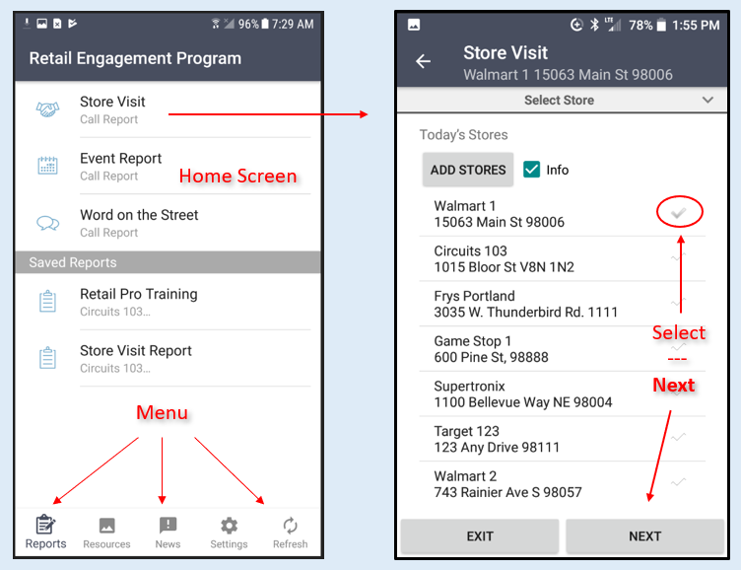
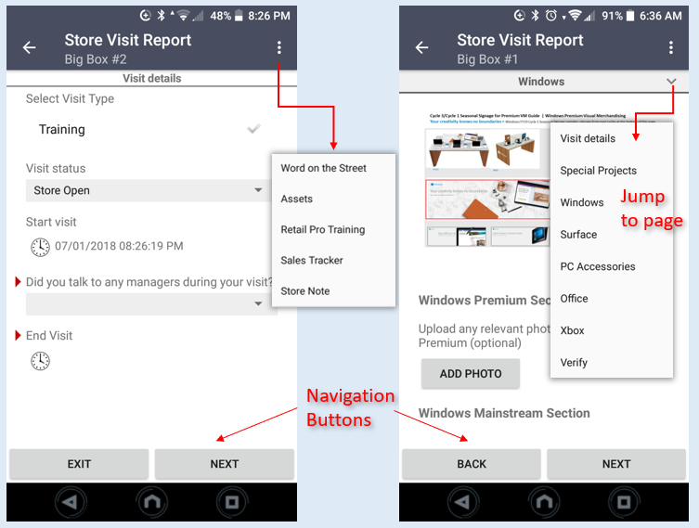
Saving Call Reports. A call report can be saved by backing out or exiting out of the form. The Saved Reports are listed in the bottom part of home screen. Also, the next time you open the same call report for the same store, or from a menu inside a form, the app will ask if you want to restore (resume) or delete the saved version of that form.
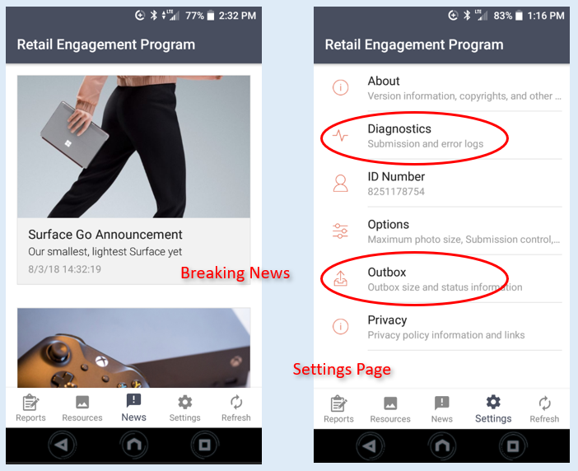

Functional Release Notes
- You will find that the Android version of the app has a slightly different layout from the Windows, Windows Mobile apps and Web Entry
- Some features and navigation controls will work differently on Android than on the other app platforms, but should be intuitive to use (the illustrations below may not exactly match the current version of the app)
- For touchscreen controls, there is no swipe left or swipe right in this beta app; instead use the navigation buttons at the bottom of the page (Exit, Back and Next) or the page jump in the title bar
- Language Preference is set automatically using the preferences set in the device’s own settings menu
- Photo questions will use the camera app on the device, and there is an option to delete and retake the photo. There is no option to upload existing photos from a file folder.
- Word on the Street, Assets, Retail Pro Training, Sales Tracker and Store Note call reports are available to complete inside the Store Visit Report by using the 3-dot (ellipsis) menu in the top right-hand corner of the app
- Event Report and Word on the Street are also available from the main menu
- In the Select Store page, the store Info checkbox can be used to view Store Information, Assets, and Sales Performance pages (some may not be enabled or may not have current data for your country account (just skip them by hitting Next)
- In Settings it is highly recommended to use the Outbox information to verify status of submitted forms.

Support
Send feedback or reports of any issues to msftreps@westlakesoftware.com, with the phrase “Android” in the subject line. Please include the following.
- Your name:
- 10-digit REP ID:
- Country:
- Device information (Make + Model + OS Version):
- Report Form name:
- Store/Location:
- Description of the issue with any screenshots or error messages
- Diagnostics
Note: The more information you can give us here, the better. Diagnostics are found in the main menu under Settings. To copy the Diagnostics, tap and hold on the text. The app will give you a copy option. Select copy and then paste it into your email.

Revised October 30, 2018.

