Overview
The Retail Engagement Program (REP) apps have two enhancements available with the October releases.
- Submission Confirmation Control option added in REP app
- My Activities replaces Store Visit to match Calendar scheduling capability
Submission Confirmation Control
- REP app users can toggle the option on and off as desired to control the amount of submission confirmation emails they are receiving
- Admins use the existing Submission Alerts control in User Management to enable the option on the apps
- Admins must ensure that the Rep’s email address is entered accurately for the process to work
- The new option is available on Windows app, Android app and Web Entry with next updates
App Instructions - Using the applicable App Store, download and install the update on your Windows or Android device.
- Make sure you have a strong, highspeed internet connection on Wi-Fi or your cell network
- Close all the browsers and other apps that are currently running
- Open the App Store on your device and search for Retail Engagement app and then select it
- Follow the steps given on the device to download and install the new update
- The main menu should be visible on the home page
- Click on the Settings gear icon to open the Settings menu
- Windows app - look for Preferences tab and then Submission Confirmation option
- Android app – look for the Submission Confirmation option at the bottom of the list
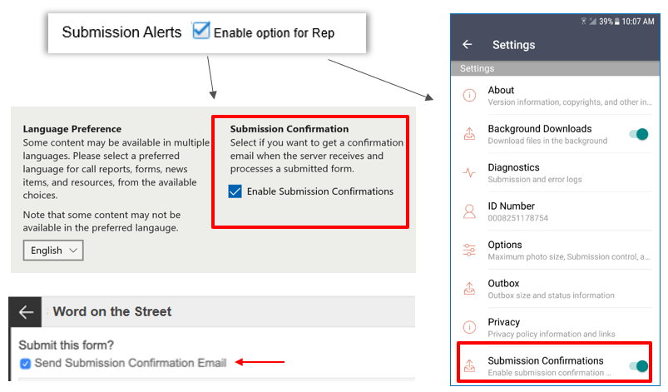
Web Entry (https://www.msftreps.com/rep/) will include a checkbox setting on the Review page before tapping Submit.
My Activities
With the recent enhancement to schedule Events in addition to Location Visits using the online Calendar, the phrases “Store Visits” and “Today’s Store List” have become obsolete. Appropriate label changes have been made in the layout content of the app.
Change on main page of app:
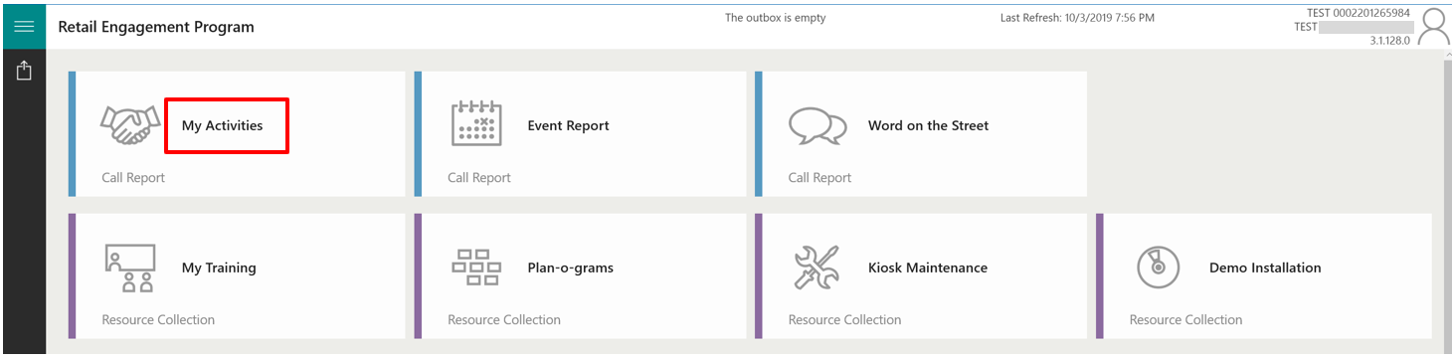
Activity and Call Reports page of app:
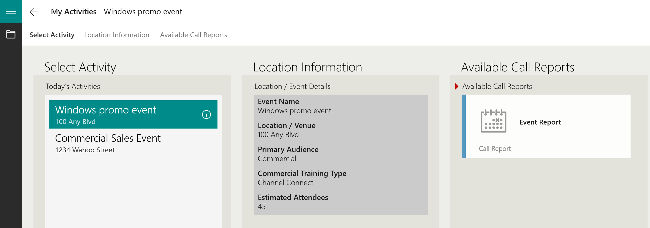
Support
Send feedback or reports of any issues to msftreps@westlakesoftware.com. Please include the following.
- Your name:
- 10-digit REP ID:
- Country:
- Device information (Make + Model + OS Version):
- Report Form name:
- Store/Location:
- Description of the issue with any screenshots or error messages
- Diagnostics
Note: The more information you can give us here, the better. Diagnostics are found under Settings. Copy the diagnostics text and then paste it into your email.
Revised October 3, 2019.

