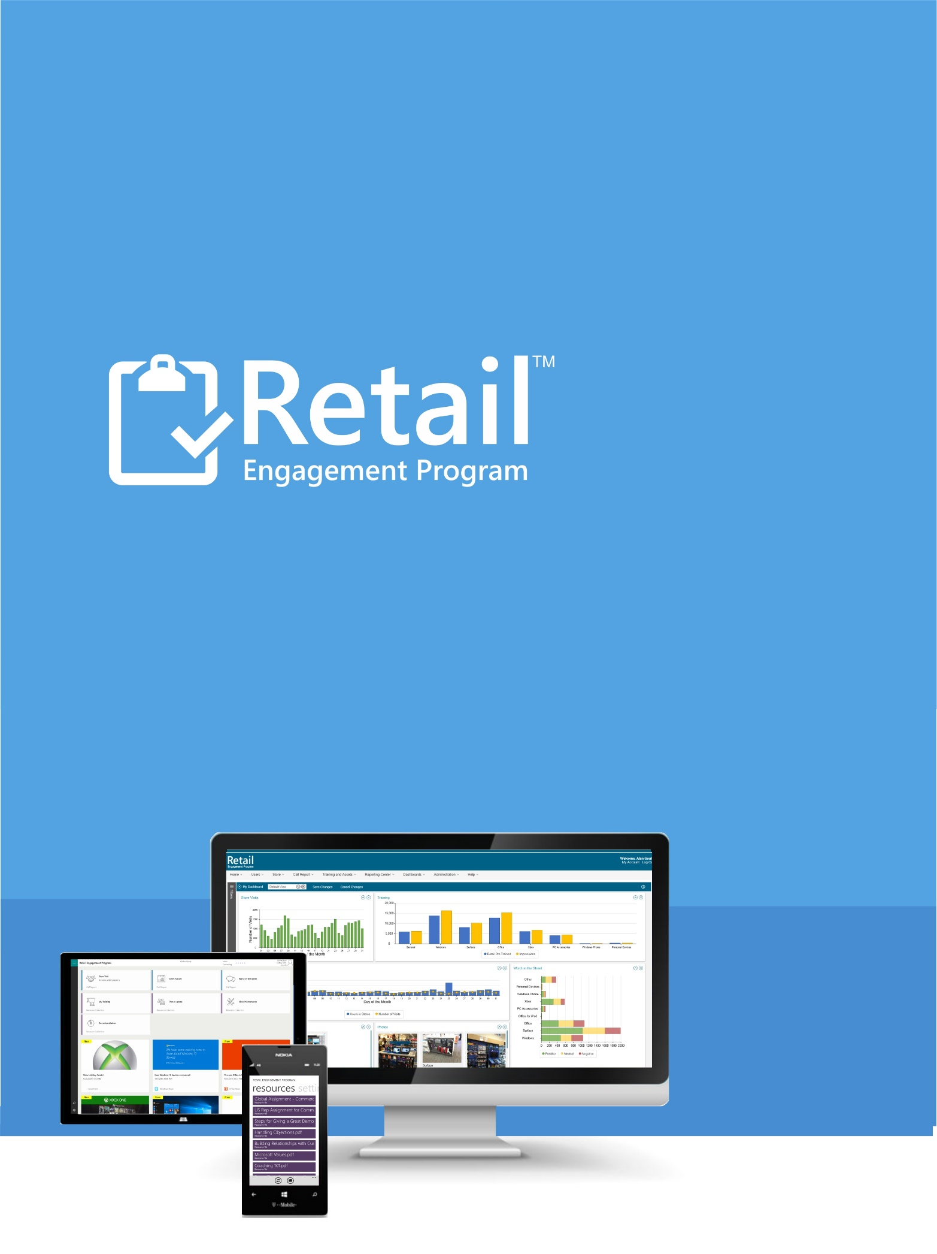

Integrated ExpertZone Guide
Version 21016

Updated February 10, 2016

INTEGRATED REP/ExpertZone QUICK START GUIDE


After reading this document, you should be able to:
Have a general understanding of the new integration between the Retail Engagement Program and ExpertZone.
Know where to find the ExpertZone Token and ways provide this to the denoted Retail Pro
View ExpertZone data within the Retail Engagement Program.

Table of Contents
Overview 4
Tokens in the Retail Engagement Program 5
Troubleshooting 9
Support 11

Overview
The Retail Engagement Program now supports integrated support with ExpertZone. Reps can now view the ExpertZone profile of a Retail Pro within the Retail Pro training section.
The system uses a token based system to synchronize the data.
- Tokens are automatically assigned to each Retail Pro.
- Reps verbally provide that token ID number to the Retail Pro
- The Retail Pro enters that token into ExpertZone
- ExpertZone uses that token to collect ExpertZone information and passes their profile, updated and ongoing, to the MSFTREPS.com website.
- The website passes that synchronized data back down to the Retail Engagement Program App for display and review.

Tokens in the Retail Engagement Program
Initial steps to display a token; go to view a profile of any new or existing Retail Pro:
- Enter the Retail Engagement Program.
- Select from Call Reports: Store Visit.
- Select a Store.
- Select a Call Report and then select Retail Pro Training.
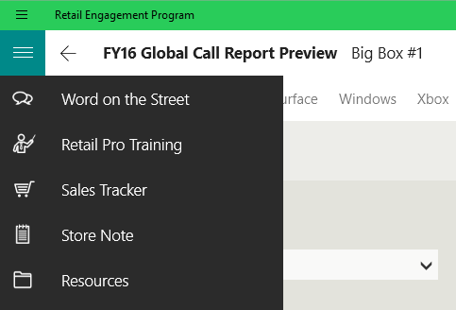
- Select an existing Retail Pro or click to add a new Retail Pro.
- Select Next.
Windows View:
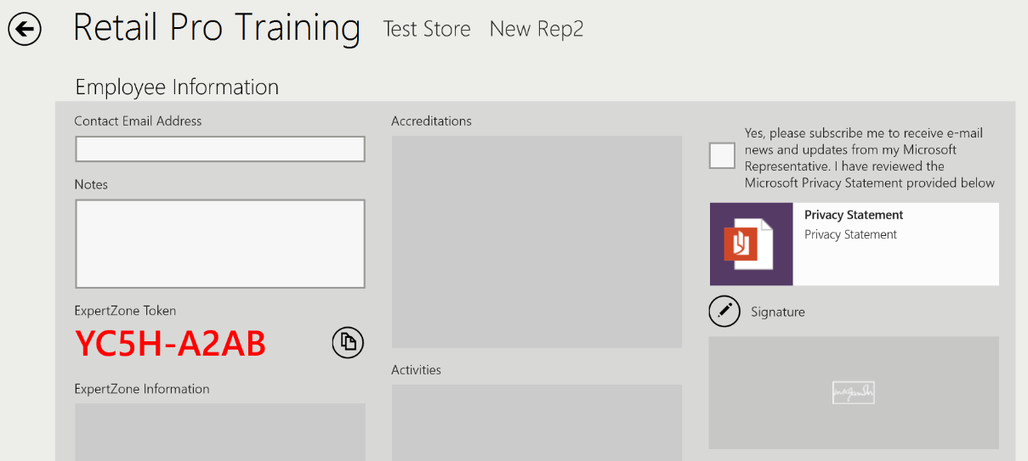
Windows Phone View:
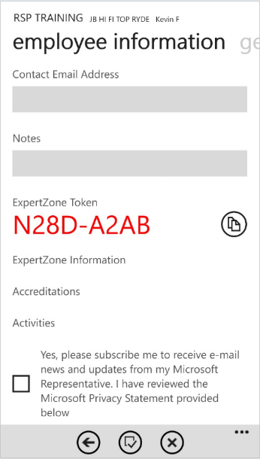

The ExpertZone token will display on the screen in Red as shown above. This will happen with both existing Retail Pros and new ones you may be adding. This is the token in which you want to have the Retail Pro enter into ExpertZone.
The button just to the right of the token copies the token to your clipboard. This can then be pasted into an email or texted to the Retail Pro, or provided to them some other electronic way without having to copy it down. Another good option is to have the Retail Pro take a picture of the token with their camera phone.
What we do not encourage is the Retail Pro writing the token down. This significantly increases the chance of input error when the Retail Pro attempts to add this to ExpertZone at http://ExpertZone.microsoft.com.
Instruct the Retail Pro to enter the token in the Promo Code field either on the registration page for a first time user, or using the menu as shown below. Note, if they attempt to enter in an invalid token, ExpertZone will reject it. It is important they receive and enter their token accurately.
Once the Retail Pro has associated his/her token with their account on the ExpertZone site:
- ExpertZone will send the MSFTREPS.com website the profile of that Retail Pro.
- MSFTREPS.com will synchronize with the Windows Phone and Windows application.
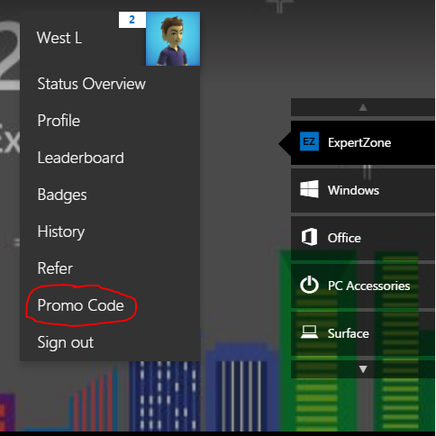

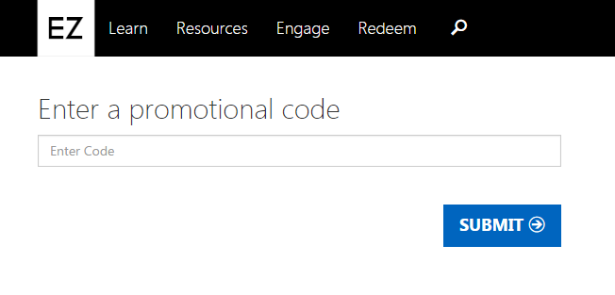
When a profile has been properly synchronized, the following ExpertZone fields will be populated: ExpertZone Information, Accreditations, and Activities.
Windows View:
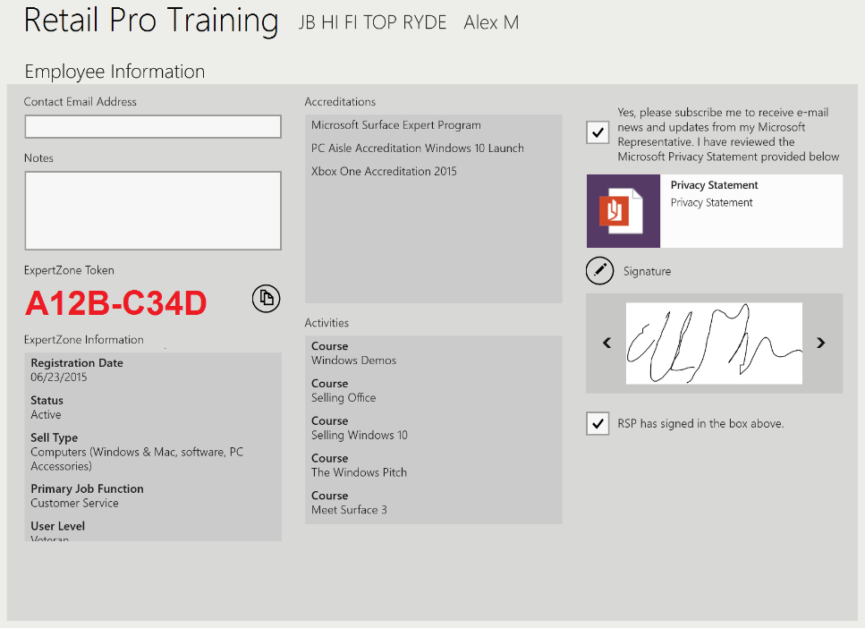
Windows Phone View:
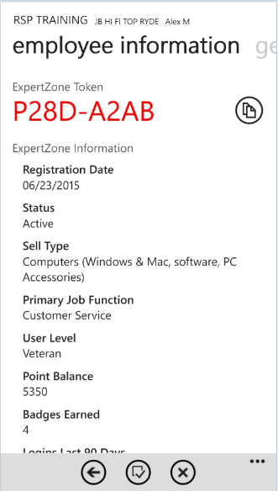

Note: ExpertZone sends the MSFTREPS.com server updates once per day and depending on the timing, it could take up to 3 days for the information to display.

Troubleshooting
If you are looking for an ExpertZone profile in the Retail Engagement Program and it is not there, then the possible causes will be:
- The Retail Pro has not been provided their token yet
- The Retail Pro has not entered their token into ExpertZone yet as a Promo Code. (Note that the Retail Pro must have a Microsoft account to register in ExpertZone.)
- Not enough time has passed from the time in which the Retail Pro entered their token into ExpertZone and for the ExpertZone integration with MSFTREPS.com to have occurred.
- You have not synchronized the Windows device or Windows Phone with the MSFTREPS.com server.

ExpertZone and Token Troubleshooting for Country Admins

Here are some additional steps for Country Admins. Think of the REP – ExpertZone integration as a loop that must be completed from the REP app to the EZ site and back again. The REP app assigns one token to each Retail Pro in the Retail Pro Training call report, and the EZ site uses that token to identify the Retail Pro once entered as a promo code. The token can be entered only once, and at any time in the EZ site.

Step 1 – Admins. In your main menu, check Users > Retail Pro Manager to see the token assigned by REP, if it matches with what the rep is seeing, and if the info is syncing (EZ Feed Live).
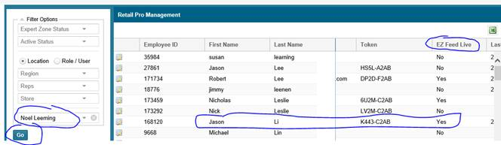

- If EZ Feed Live = Yes, then the loop is already complete and the information will show on the app after the app refreshes and loads the data. Possible issues if not seeing EZ info on the app:
  - Rep has not synchronized the Windows device or Windows Phone with the MSFTREPS.com server.
  - Multiple instances of the same Retail Pro created by the Rep; check the Retail Pro Manager list which can be exported to Excel.

- If EZ Feed Live = No, then the loop has not been completed. One of the following is most likely the reason:
  - The Retail Pro has not been provided their token yet.
  - The Retail Pro has not entered their token into ExpertZone yet as a Promo Code. (Note that the Retail Pro must have a Microsoft account to register in ExpertZone.)
  - Not enough time has passed from the time in which the Retail Pro entered their token into ExpertZone and for the ExpertZone data feed with MSFTREPS.com to happen. This could take as long as 3 days.
  - There is a problem with the token assignment and/or recognition process. This will require opening a trouble ticket online at MSFTReps.com and providing the Retail Pro and token detail, error messages that the EZ site is displaying.

Step 2 - Reps and Retail Pros. The EZ site will return an error message if you try to enter the same token twice. “The Promo code you entered has already been redeemed by maximum number of users.”
That doesn’t mean there is necessarily a problem, just that the site has already accepted it. See the TIP below. But, if the error message says that the token is not valid or can’t find a match, then that is another problem that you should open an online trouble ticket at msftreps.com.

TIP: There is a way for the Retail Pro to confirm the right token code has been entered and see if the token has already been accepted by the EZ site.
In EZ site, go to History > Points (see below).

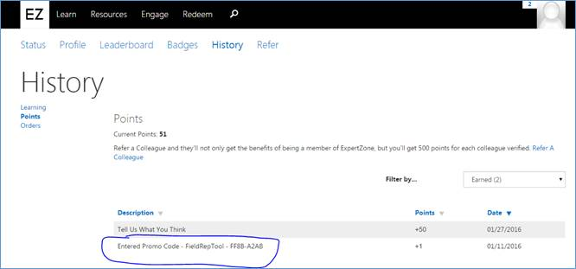

NOTE: Don't "test" a token code for the Retail Pro. If you enter it into a "dummy/test" account in EZ site, and it is accepted, then it can't be used for the real account. Better to check and see what is in Points History in EZ.

Support
There are two ways to contact us for help and support:
Website: https://msftreps.com and then use the Help menu to open a support ticket.
Email: msftreps@westlakesoftware.com

Make sure if you include all necessary detail to describe the issue. Details include:
- Screenshots (if applicable)
- Contact information
- Device model / type
- Every step taken that caused the problem (filter settings, what you clicked on and it what order, can you repeat the process, etc.).
- Expected behavior and behavior you experienced

Thank you
Westlake Support Team

