Contents
Overview 2
Getting Started 2
Website Login 2
REP Website 4
Home Screen 4
Welcome and Setup 5
Call Reports 6
Store Notes 7
Export Transaction Reports 7
Dashboard 9
Calendar 16
REP Application 17
Application Installation 17
Initial Setup 19
Home Screen 19
Using the REP Application without an internet connection 21
Call Reports 22
Store Visit 22
Event Call Report 26
Word on the Street 28
RSP Training 29
Appendix A – Troubleshooting 32

Overview
Welcome to the Retail Engagement Program (REP). This system is designed to provide the tools and resources needed to represent Microsoft in retail stores worldwide.
The REP system has two parts. There is a website Portal that has reporting of completed call reports, training activities and even the photos captured in the stores. The second paert is the Windows Application that contains:
- Training resources to learn about new Microsoft products and services
- Store Visit Call Reports for daily in-store activities
- Event Call Reports to record 1:Many training events
- Word on the Street Call Reports for capturing competitive information, customer and RSP feedback.

Getting Started
Before using the REP application on a Windows device, the REP website must be accessed to obtain a unique 10 digit ID number.

Website Login
An initial username and temporary password will be provided. If the account information is not known, use the “Can’t access your?” account link below the Sign In button.
Click on the following link, or type the address into a web browser: www.msftreps.com
The login page appears:
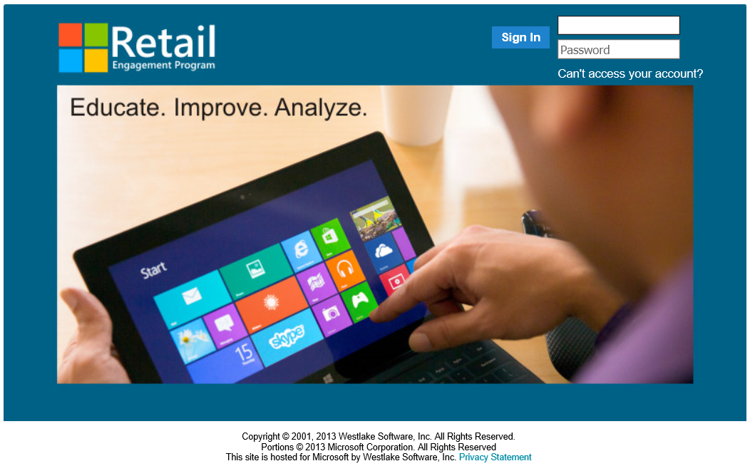
During the first login to the system, a prompt to change the temporary password and security question appears:
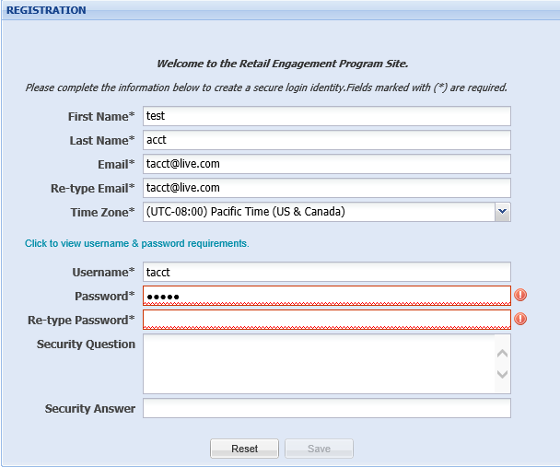
Password Requirements:
- Must be from 6-14 characters long.
- Contain at least 1 uppercase character and at least 1 lowercase character.
- Contain at least 1 of the following special characters: -_"!@#$%^&*+=(){}[]<>|\`~,.;:/?

Enter a new Password, Security Question and Security Answer. Click on Save at which point the REP Home screen will appear:

REP Website

Home Screen
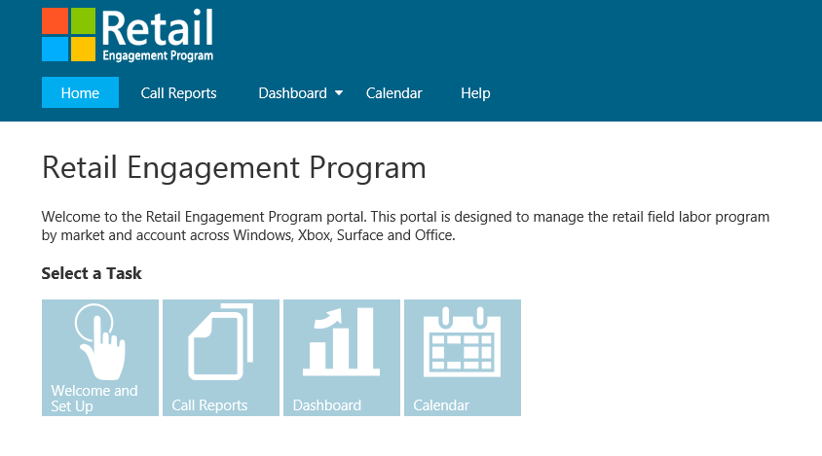
Welcome and Setup
Messages from the local administrator and instructions for installing the REP application on a Windows device are found here.
Call Reports
View completed call reports and export them to Excel.
Dashboard
Visit statistics about Store visits, 1:Many Training Events, Word on the Street submissions and view the photos taken in stores.
Calendar
View and modify the store visit calendar. Use a simple drag and drop interface for scheduling monthly store visits.

Welcome and Setup

This screen will have messages from the local administrator on the right.
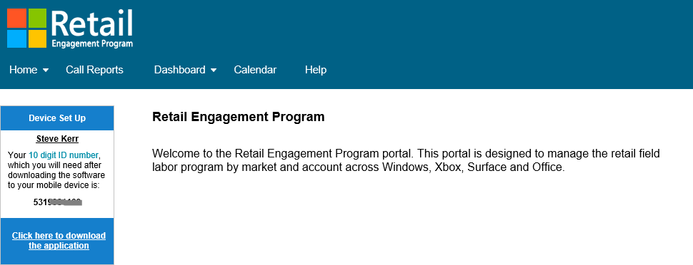
On the left is the unique 10 digit ID needed for the Windows Application. Below that is a link to the application download and installation instructions.

Call Reports

Call Reports can be viewed and exported to Excel. There is also the ability to email the call report and see the photos taken during that store visit.
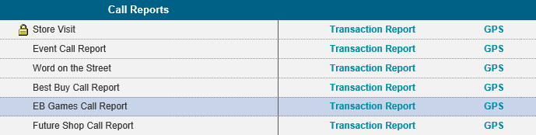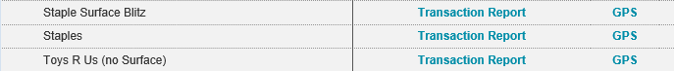
For each type of call report, there is a separate transaction report. Click on the appropriate link to the right of the Call Report name.
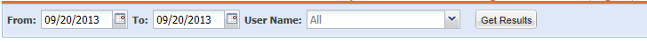
Select a Date Range (defaults to the last report submission date). Managers can also select a single rep or all reps assigned to them. Select the Get Results button.
Click to view and edit store notes
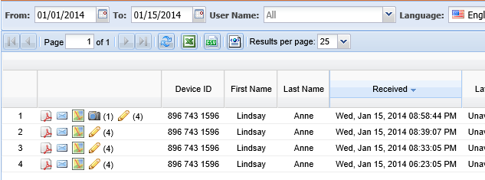
Export records to an Excel spreadsheet.
View photos taken during this store visit.
When Location Coordinates are available with the transaction, map icon will drop out to Bing maps.
Click to view transaction in a formatted PDF Report
Quick email function to submit send report to others.

Store Notes
Store notes are input from inside a store visit call report. These can consist of reminders or helpful hints about the store. Clicking on the pencil icon in a transaction report will open the Store Note editor for editing or deleting of content. These modifications will appear the next time the app synchronizes.
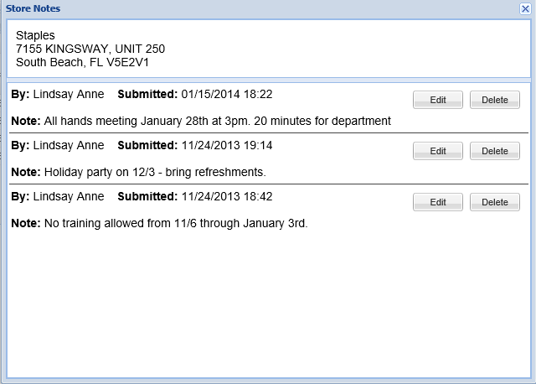

Export Transaction Reports
Basic reporting is contained in the Dashboards. The Download to Excel option allows further analysis of call reports.
Click on the Download to Excel button . Select whether to include photos and the size of the photos, then click Export.
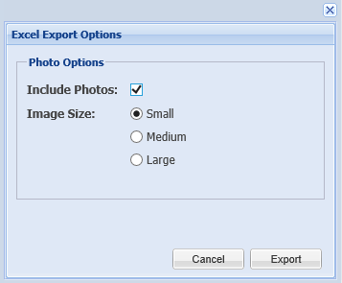
Note: Exporting photos does not download the full resolution photo, only thumbnails of the original photo.

Once the file is opened in Excel, all of the questions included in the call report will be listed as the column headers. Each store visit will be a row in the spreadsheet.
Note: Currently, if photos are included and the data is sorted, the photos will not remain with the correct record. To resolve this, enter titles in the columns that contain pictures before selecting the Filter and Sort options in Excel. A solution to this problem is being investigated.
Before (notice that there are no filer options for the photo columns):
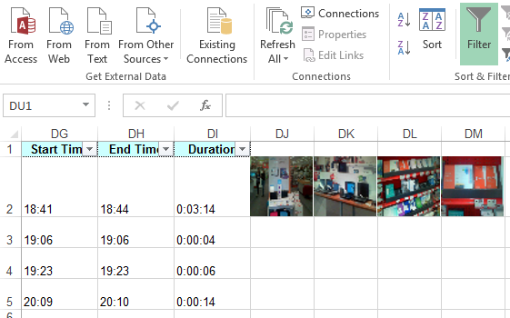
Turn off filtering, add column headers and then turn filtering back on.
After (photos will now sort and stay with the original record):
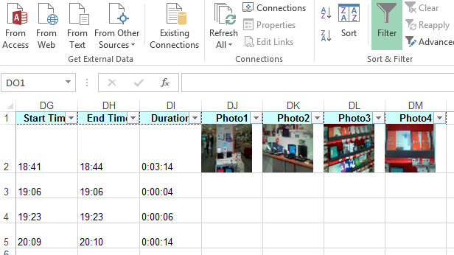

Dashboard
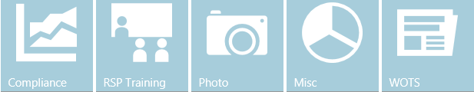
Dashboards are available to view call report information.
- Compliance: monthly store visit progress
- RSP Training: monthly RSP training statistics
- Photo: view pictures taken during store visits
- Misc: Ad-hoc reporting of call report items
- WOTS: Word on the Street
All dashboards have a My Saved Reports option. After filtering any dashboard, select the Save Current Report button to save your changes. Saved views can be edited or deleted by clicking on the Edit button.
Compliance
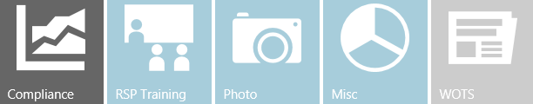
Track monthly store visit progress.
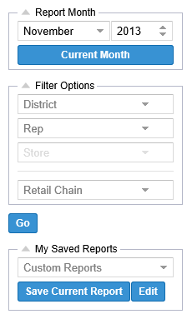
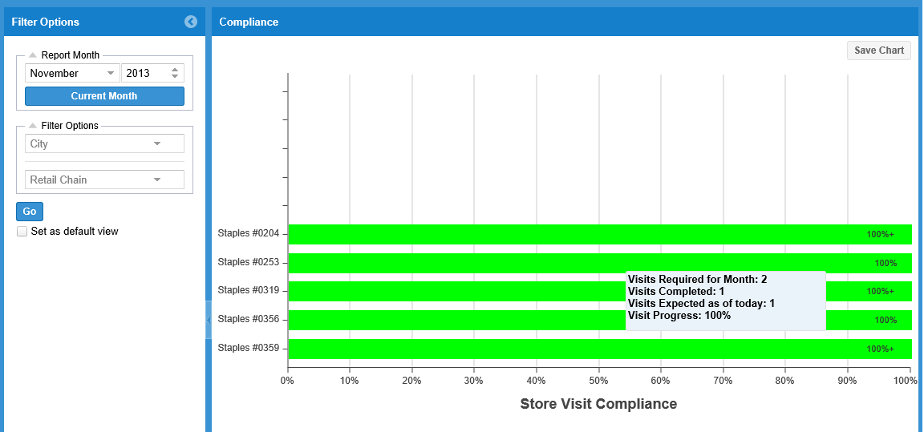
Filter by date, regions and retail chain. Hover on the bar graph to retrieve details.

RSP Training

View monthly statistics for in-store RSP training activities.
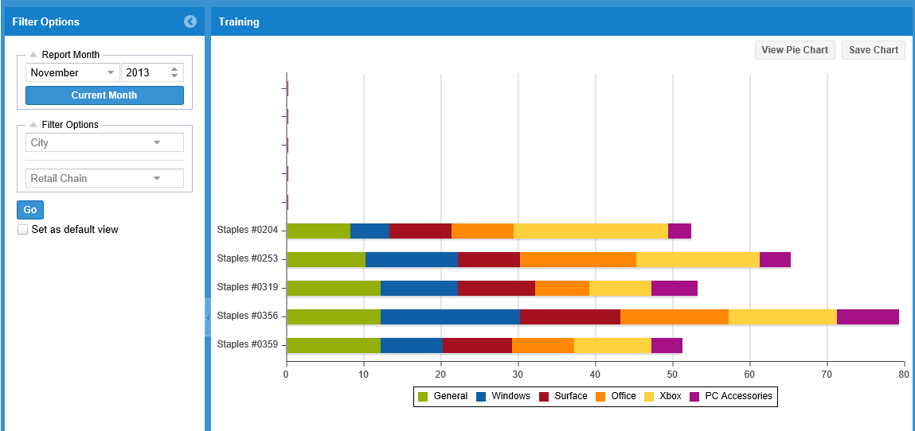
Filter by date, regions and retail chain. Hover on the bar graph to retrieve details.
Click the View Pie Chart button to switch to a pie chart view. 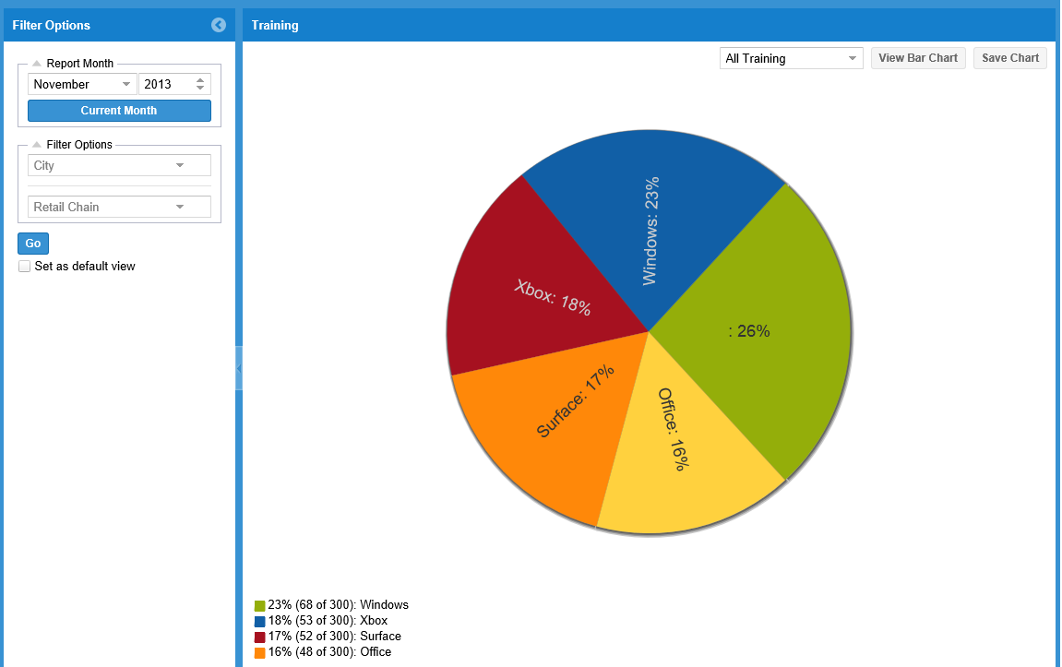
Hovering over a slice of the pie chart shows the detail. Clicking on a slice will select that item and provide the detail for that item (Example: clicking on Windows will show the individual monthly training tasks for Windows.
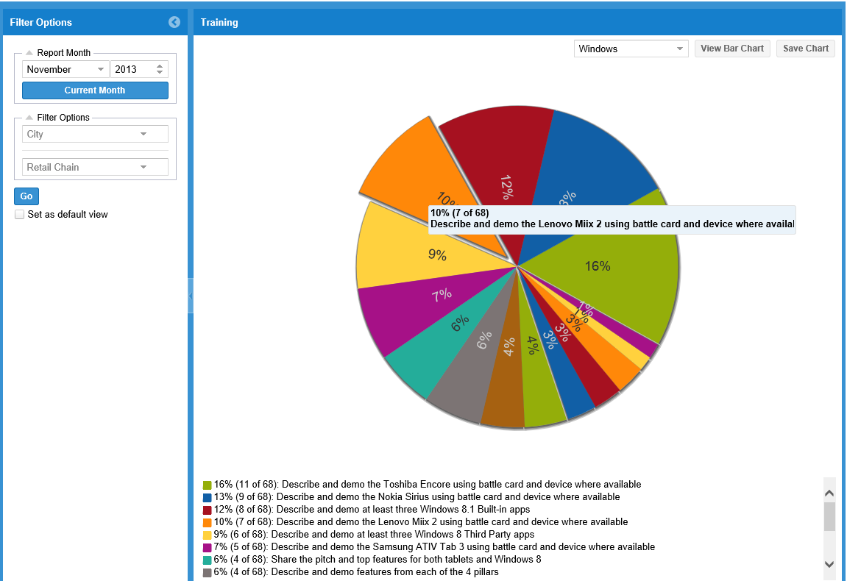

Photo

View the photos taken during store visits.
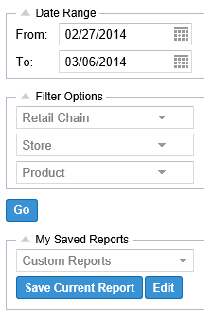
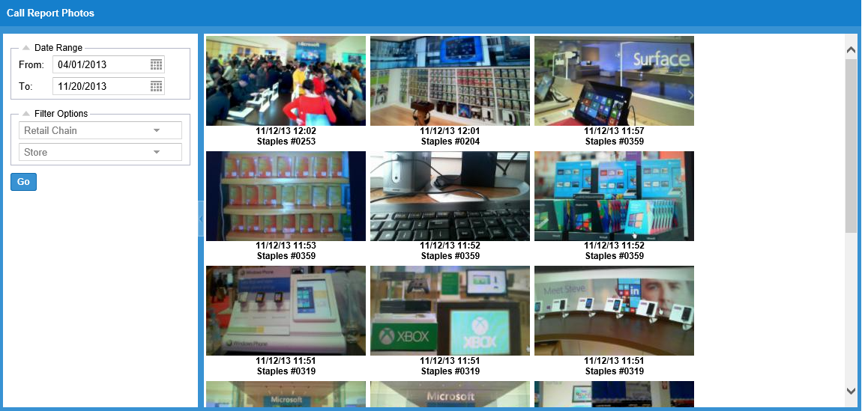
Filter by date range, retail chain, individual store, and product. Photos are displayed newest to oldest. Click on a photo to see a full size image and get the detail of the store visit call report.
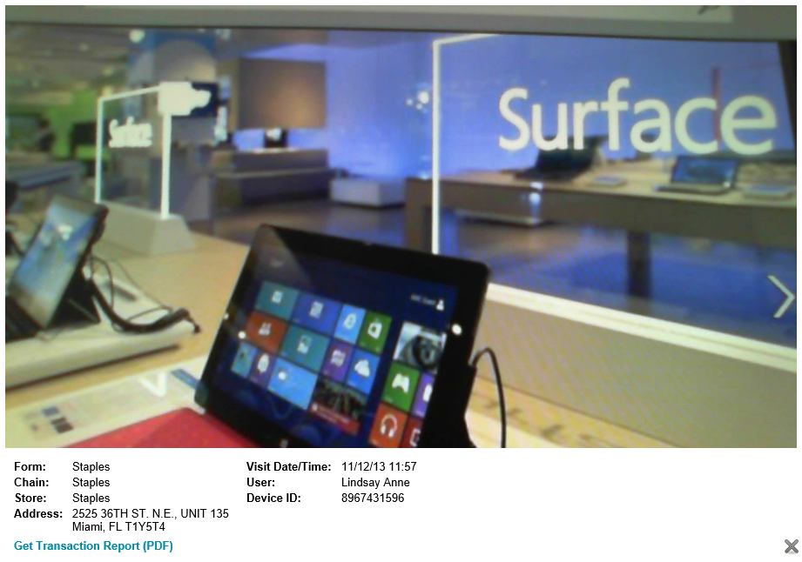
Misc

Display data graphically from any question on a call report.
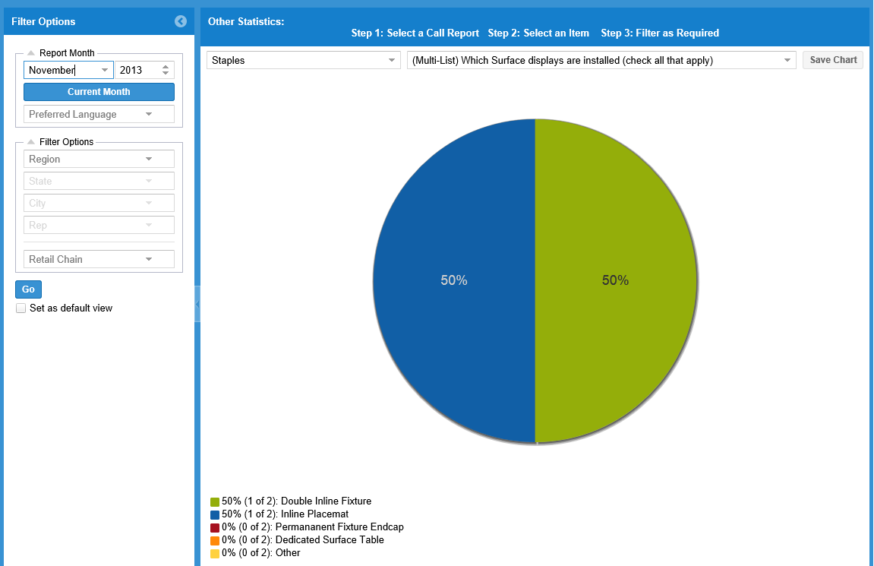
Select the call report and item from the drop down lists. Hovering over a slice of the pie chart shows the detail.

WOTS

Display data collect through the Word on the Street Call report. Word on the Street is used to gather:
- Competitive information
- Customer feedback
- RSP Feedback
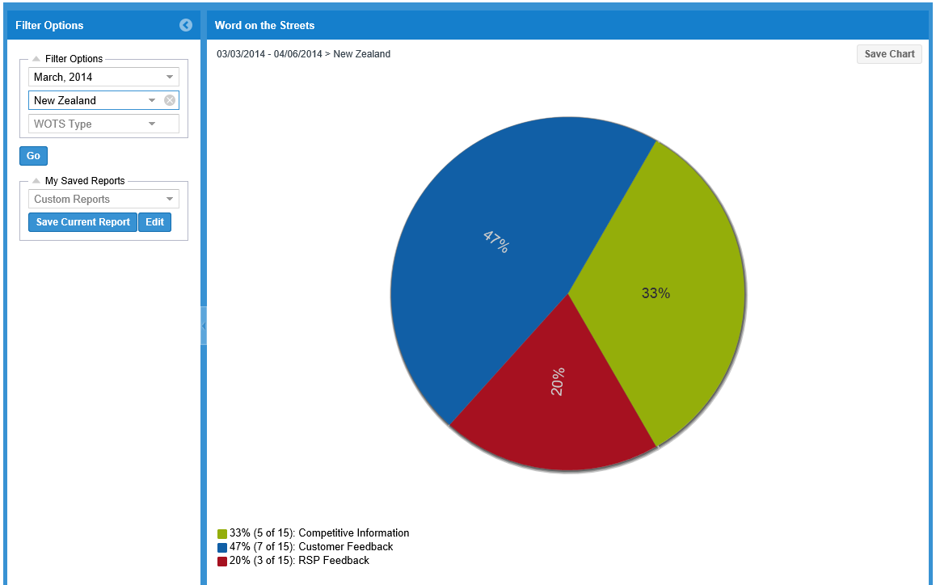
Filter by date, regions and retail chain. Hover on the bar graph to retrieve details. Hovering over a slice of the pie chart shows the detail. Clicking on a slice will select that item and provide the detail for that item.

Calendar

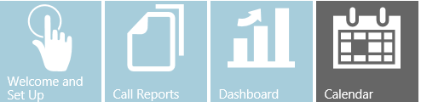
The calendar function is used to schedule store visits for each month. All stores assigned are listed on the left. If a store is required to be visited more than once in a month, that store will be repeated in the list. For example, if a user is to visit Retail Super Store 4 times in a month, this would list 4 times as:
Retail Super Store 1 of 4
Retail Super Store 2 of 4
Retail Super Store 3 of 4
Retail Super Store 4 of 4
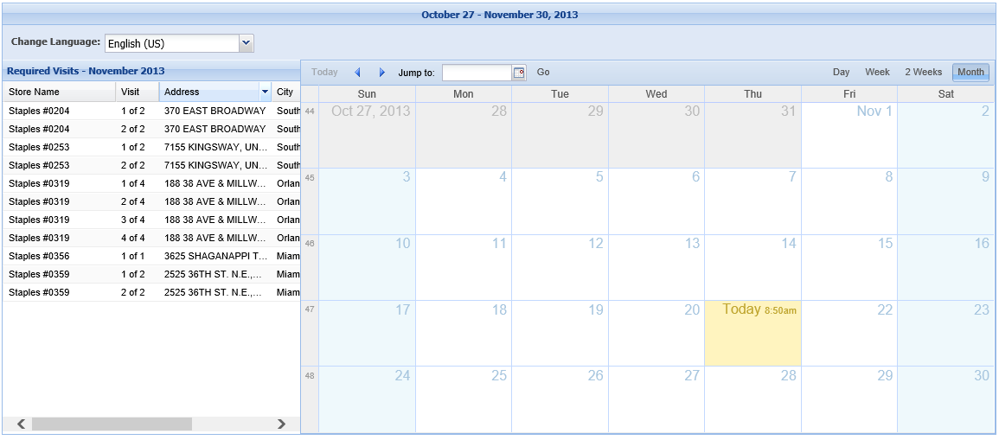
This is a drag and drop interface. Drag all stores assigned onto the calendar days in which they are to be visited. As stores are added to the calendar, they will be removed from the required visits column. To remove a store from the calendar, right-click on the store and select delete. The store will move back to the required visits column.
We default the first visit at 7AM and list all others added at a 30 minute increment. This can be edited to more specific times; but the calendar in this implementation is a daily planner with monthly compliance requirements.

REP Application
The REP application runs on Windows 8.1 and above, with support for both x86 and RT platforms. A unique 10 digit identification number is needed to run the application. See the Welcome and Setup section to obtain an ID.

Application Installation

- Open Windows Store app



- Search for Retail Engagement Program app

- Select the application from the list (it will be the only one listed)

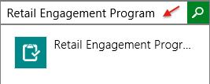

- Select to install

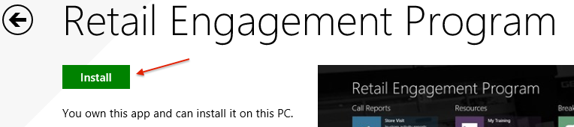

- The installation will happen automatically and Windows will notify when the installation is complete

Starting the Program after installation:

If you are using Windows 8.1, swipe up from the bottom of your Start screen, and you will see the program listed as "Microsoft Retail Engagement Program" with "New" highlighted below it. Right-click on the icon and select "Pin" to start at the bottom. The application will now appear on the far right of your Start screen.
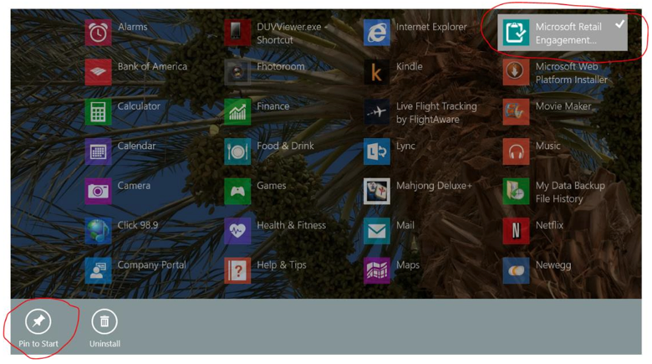

Initial Setup
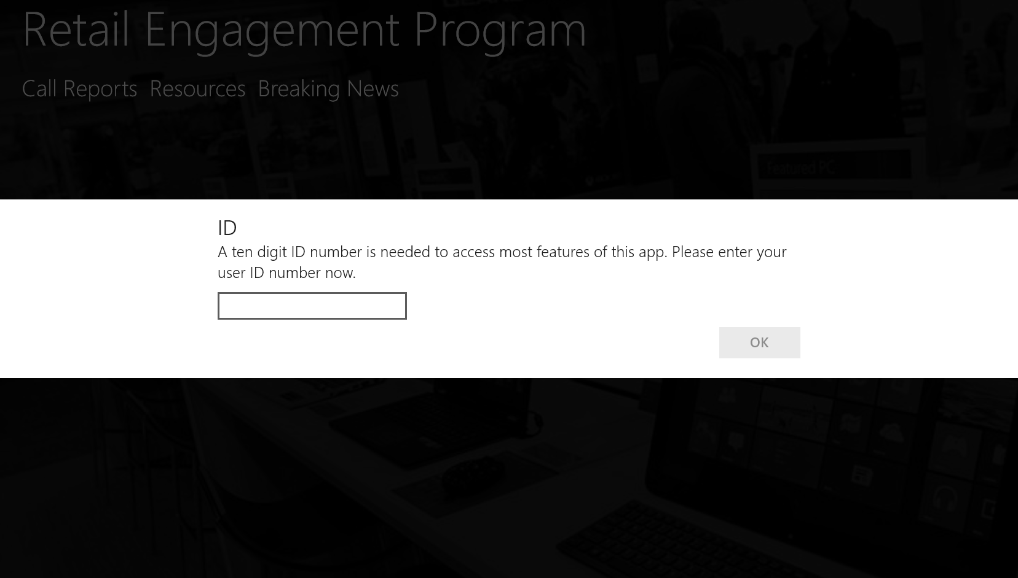

The first time the application is run, a prompt appears requesting an ID. Enter the ID, and press OK.

Home Screen
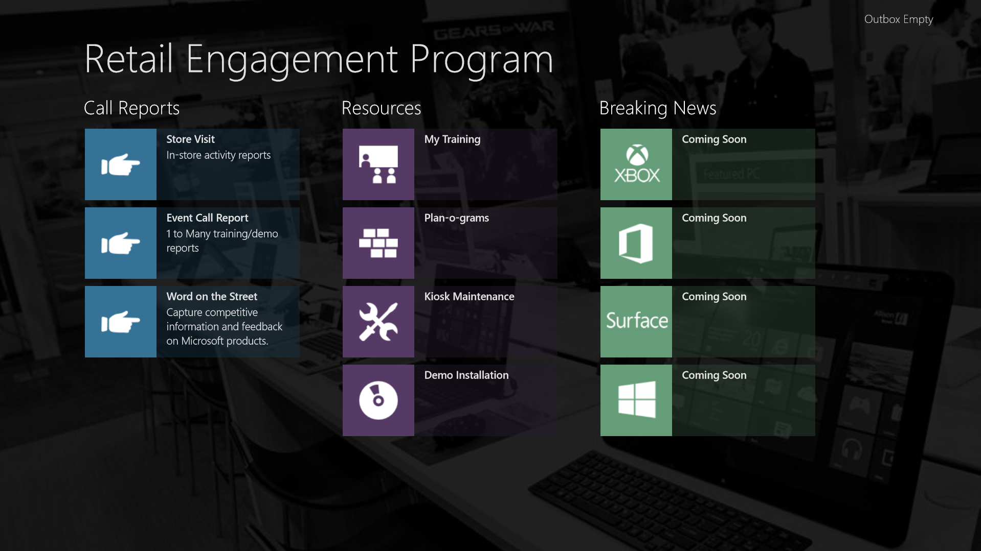
The home screen is divided into the following sections:
- Call Reports
  - Store Visit Call Reports – store visit reporting and RSP training tracking
  - Event Call Report – 1 to Many training report
  - Word on the Street – Capture Competitive information, Customer and RSP Feedback
- Resources
  - My Training – Monthly training assignments and resources
  - Plan-o-grams – store display information
  - Kiosk Maintenance – Interactive display maintenance instructions
  - Demo Installation – Windows Demo instructions
- Breaking News
  - New product information
  - Announcements

Using the REP Application without an internet connection
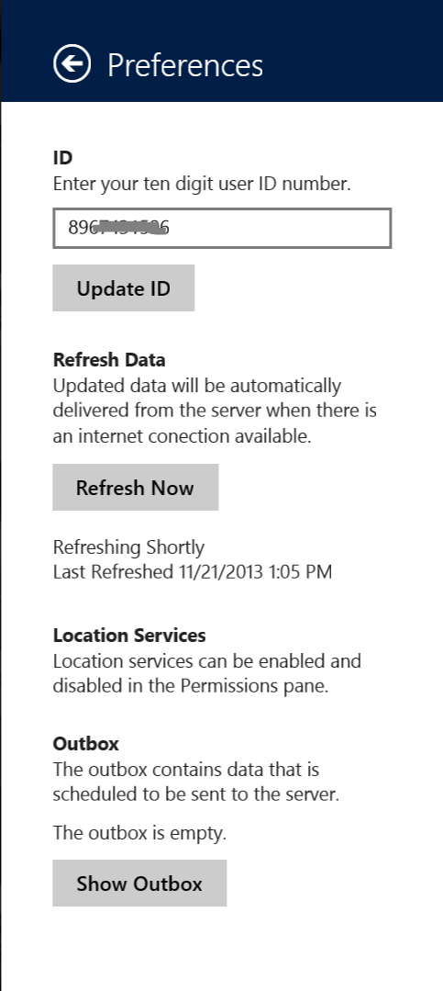
The REP application is designed to work with or without an internet connection. If there is no internet connectivity in the retail stores, syncing the application before the start of the day and at the end of the day is mandatory.
To manually refresh the application:
- Connect to WiFi
- Open the Charm Bar by swiping in from the right side of the screen
- Select Settings
- On the Setting menu, select Preferences
- Select Refresh Now

Call reports and RSP training conducted during the day will be stored in the Outbox until the devices is connected to the internet and a refresh is performed.

At the end of the day, perform the same manual refresh process to send the completed call reports and training to the server.
Notification of pending uploads is displayed in the upper right corner of the application.
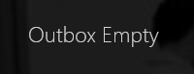
The content of the Outbox can also be displayed in the Preference menu by selecting Show Outbox.

Call Reports

Store Visit
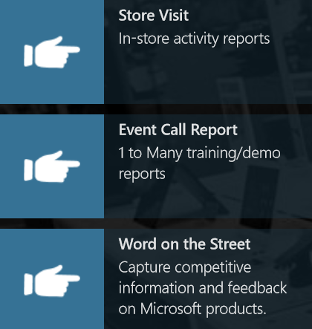
Select the store from the list on the left.
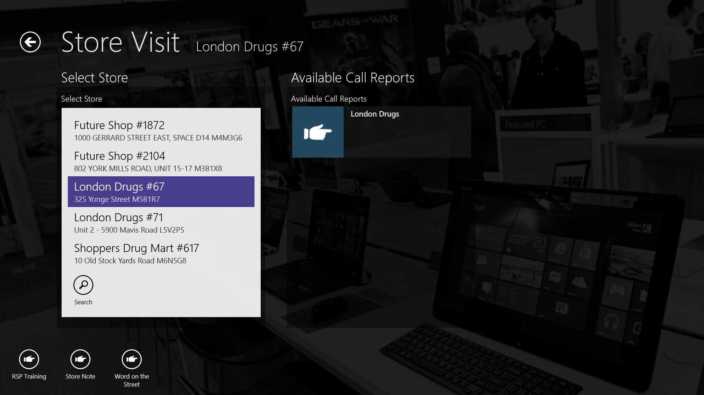
A list of call reports for that store will appear on the right. There may be multiple call reports based on the activities for that store. Contact your manager if you are unsure what report to complete.
Select the appropriate call report on the right.

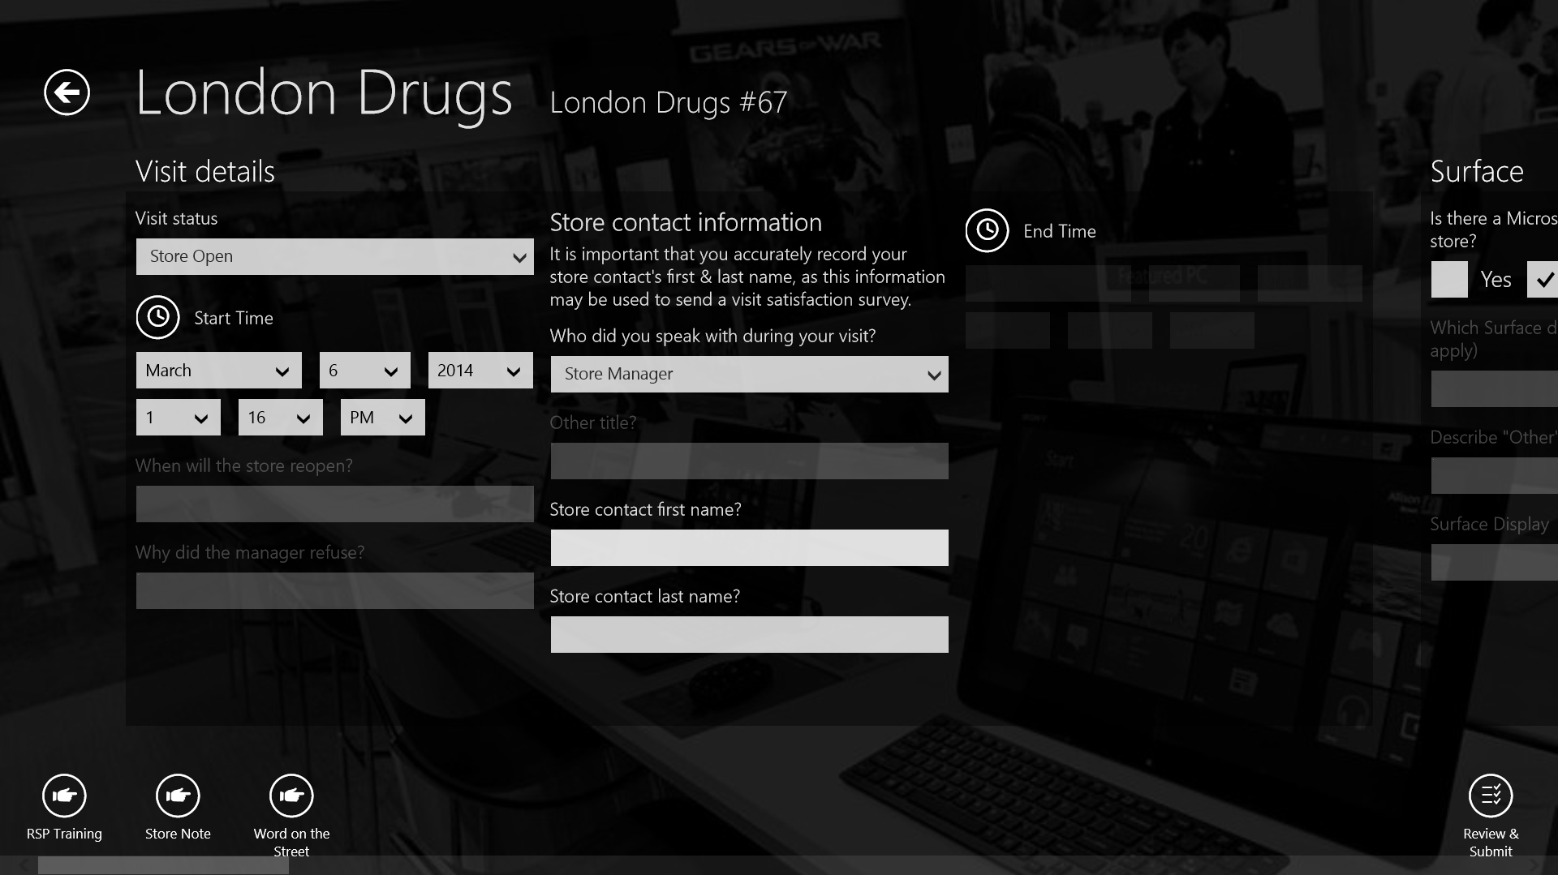
Call reports are grouped into the following sections:
- Visit Details
- Windows
- Surface
- Office
- Xbox
- PC Accessories
Each store may have different sets of items and question within the call report. By panning right and left, all sections for the call report can be easily accessed at any time during the store visit.
Items that are greyed out are not required unless another question is answered first. For example:
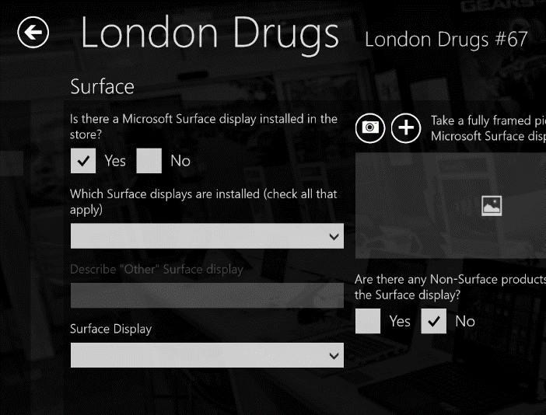
In the screen shot above, the items below the “Is there a Microsoft Surface display installed in the store?” item are grey.
Answering Yes to the item triggers additional items below to be highlight and now must be answered.

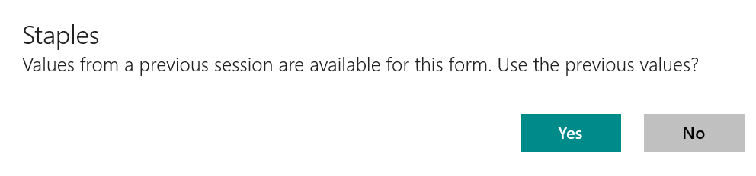
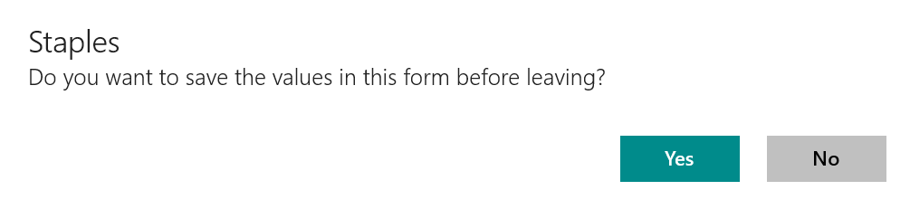
During a store visit there may be a need to return to the application home screen. The system will prompt you to save.

Opening the same call report for that store will prompt to use the previously session.

Photos
Whenever there is a Photo option in a call report, Word on the Street, Event reports, etc. There are two options:
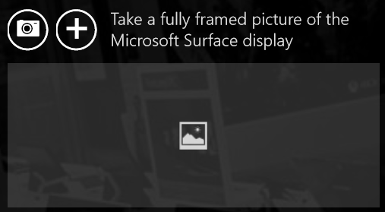
- Take a photo
  - Use the built in camera to capture a picture
  - Click on the camera icon on the left
  - Tap the screen to take the picture
  - There are options to crop the photo save or retake.
  - To take multiple photos, just click on the camera button again.
- Upload a photo (requires version 1.0.0.110 or higher for this option)
  - Upload previously taken photos from a phone, camera, OneDrive, etc.
  - Tap on the plus button to the right of the camera button.
  - Select the location of the pictures using the pull down menu on the top left.
  - Select pictures by dragging down on each one
  - A checkmark will appear on selected photos and a thumbnail list will build on the bottom of the screen.
  - Click on Open to attach the photos
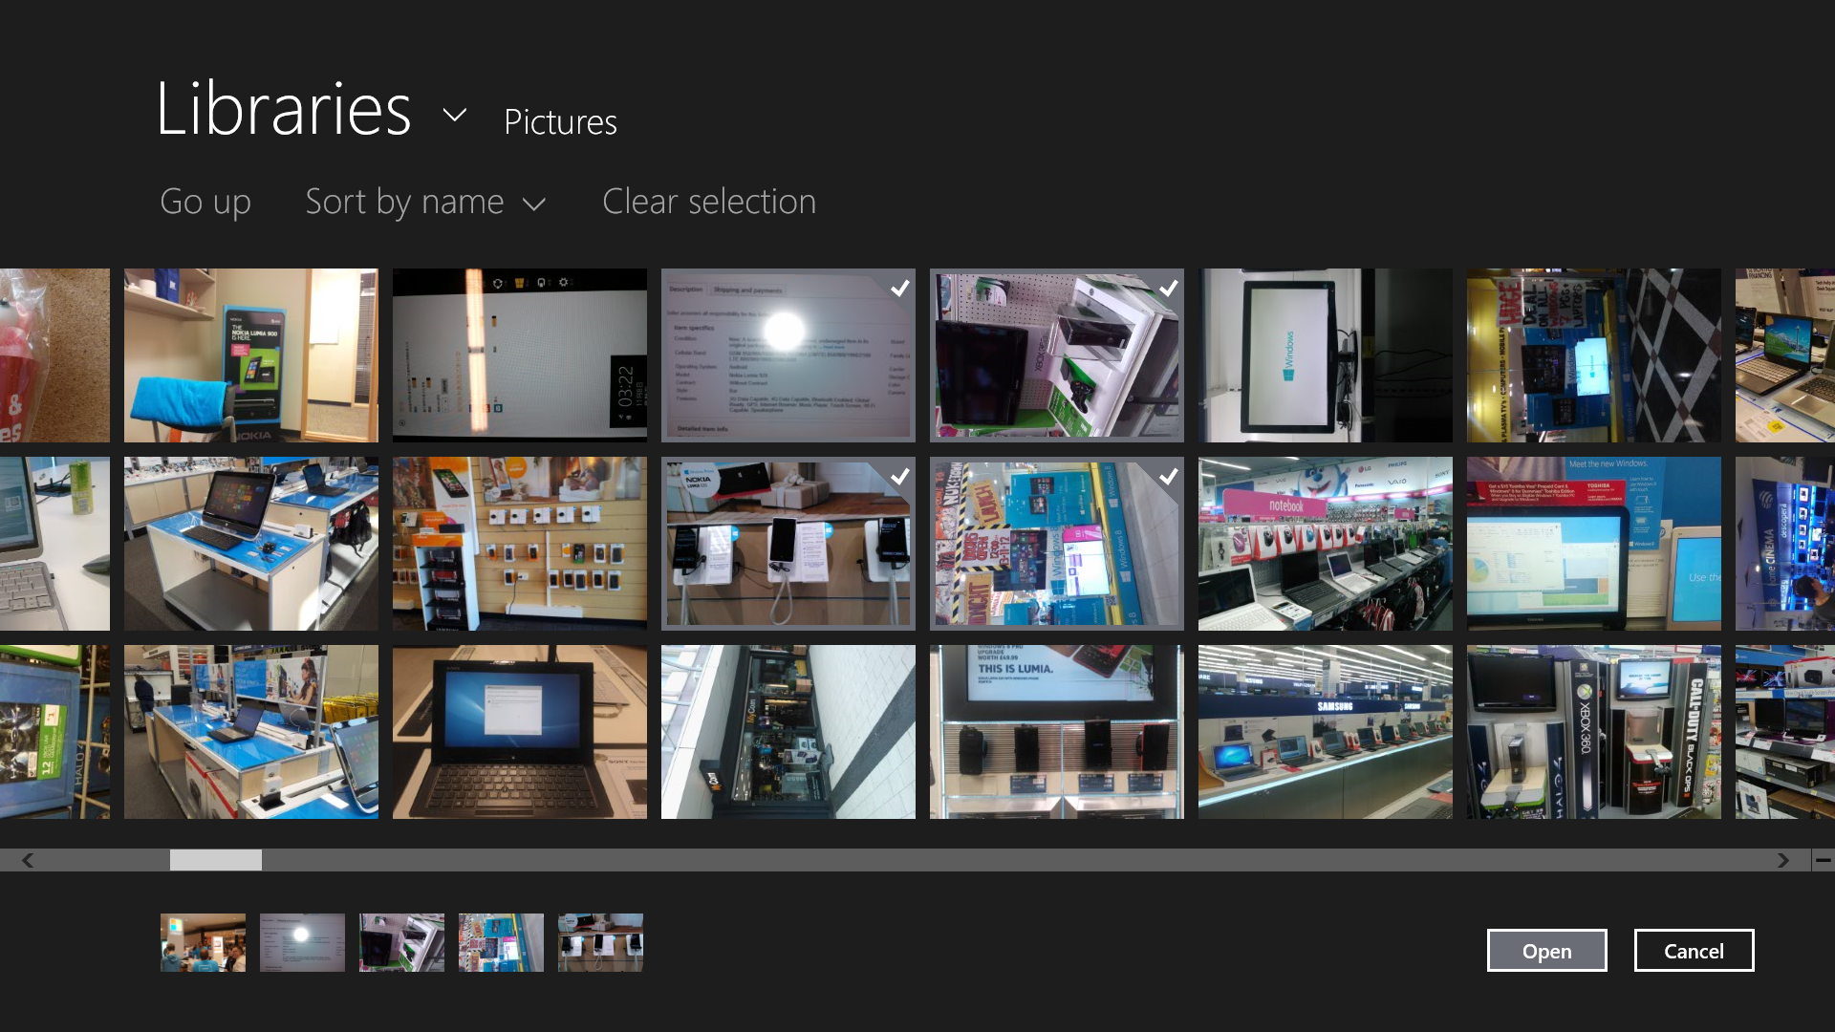
To remove a photo before submitting:
- Click on the thumbnail in the photo section (scroll arrows are available if more than one picture is uploaded)
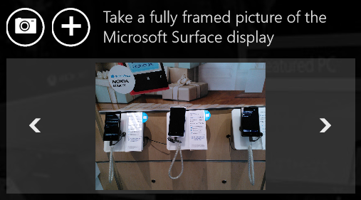
- Click on the trash can on the lower right of the screen to remove the photo.

Submitting a call report
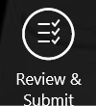
When the store visit is complete, click on the Review & Submit button on the bottom right of the screen.

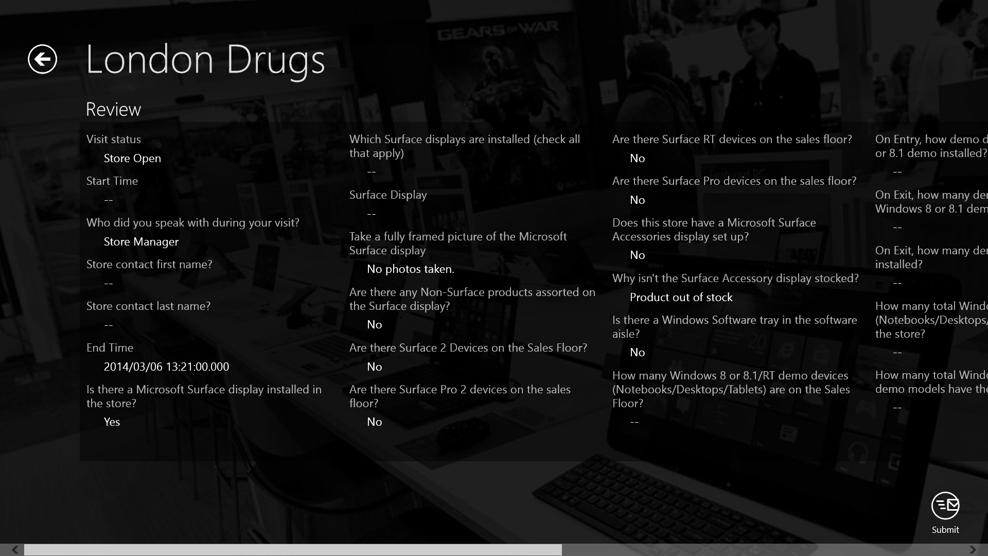
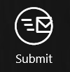
Verify all items have been completed, then press the Submit button in the lower left corner of the screen.

Event Call Report
Event call reports capture the information from one to many training sessions. Below is an example of the layout.
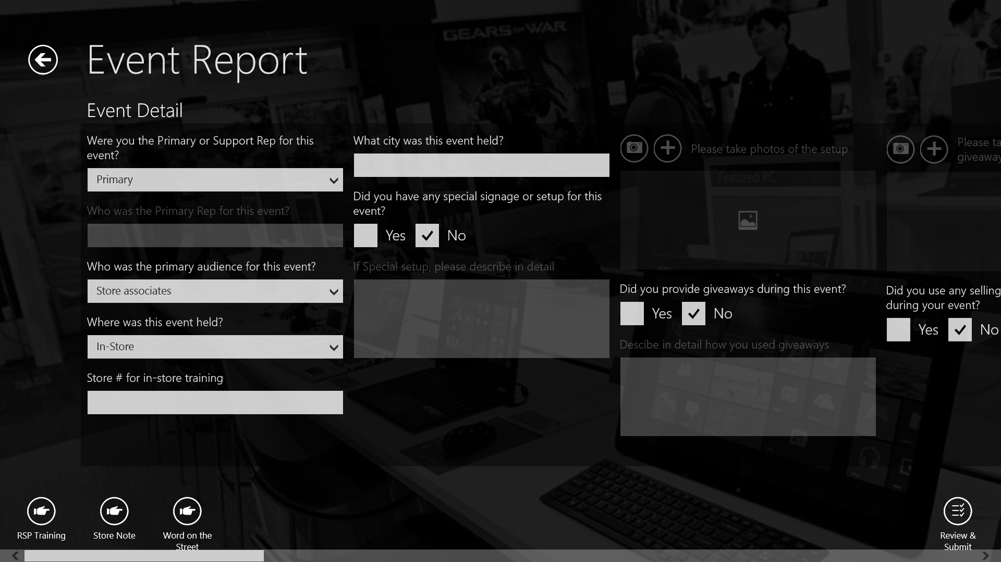
The process for completing and submitting an Event call report is the same as a store visit. See the Store Visit section earlier in this guide for reference.

Word on the Street
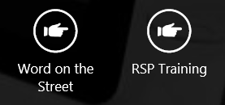
Word on the Street (WOTS) call reports are used to capture competitive information, customer and RSP feedback. During a store visit, there may be multiple instances where a WOTS report would need to be completed. WOTS reports can be accessed while working inside other call reports. A quick launch button is available in the lower left hand corner of the screen.

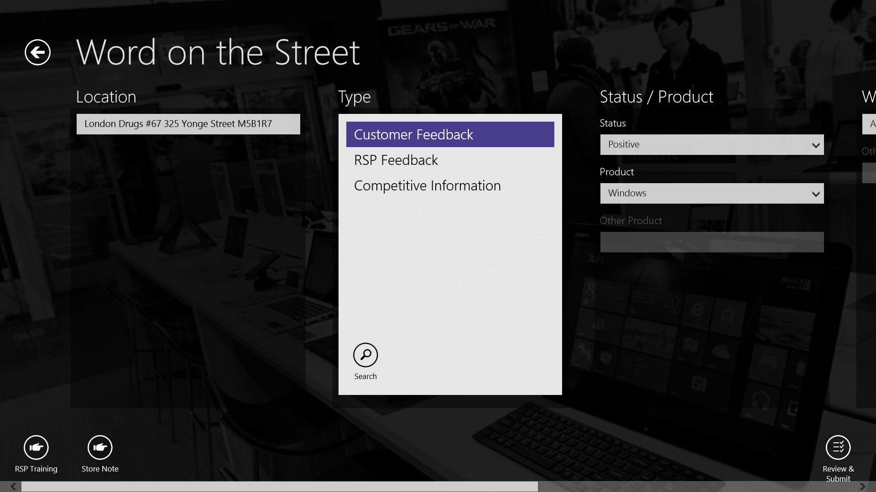
The process for completing and submitting a Word on the Street call report is the same as a store visit. See the Store Visit section earlier in this guide for reference.

RSP Training
Training store employees (RSPs) is an essential part of a store visit. RSP Training can be accessed while working inside of store visit call reports. A quick launch button is available in the lower left hand corner of the screen.
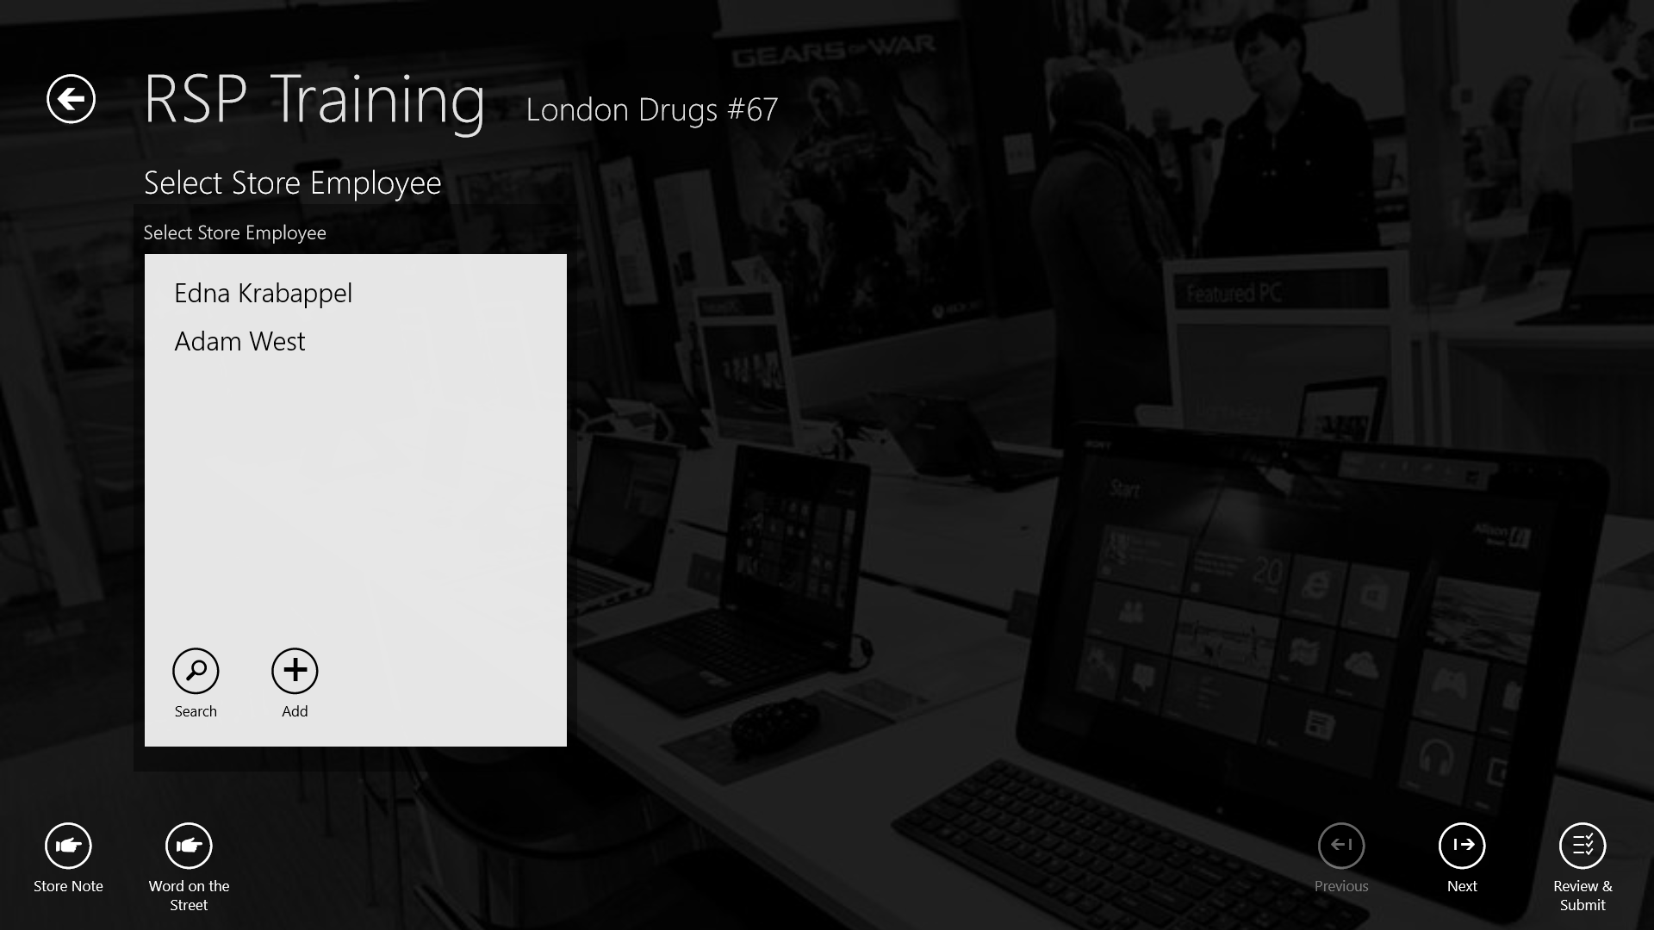
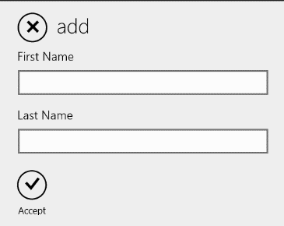
Note: If there are no employees listed on the left, select the Add button and enter the store employees first and last name. Then select Accept to add the employee.
Select an employee from the list on the left, then select Next.

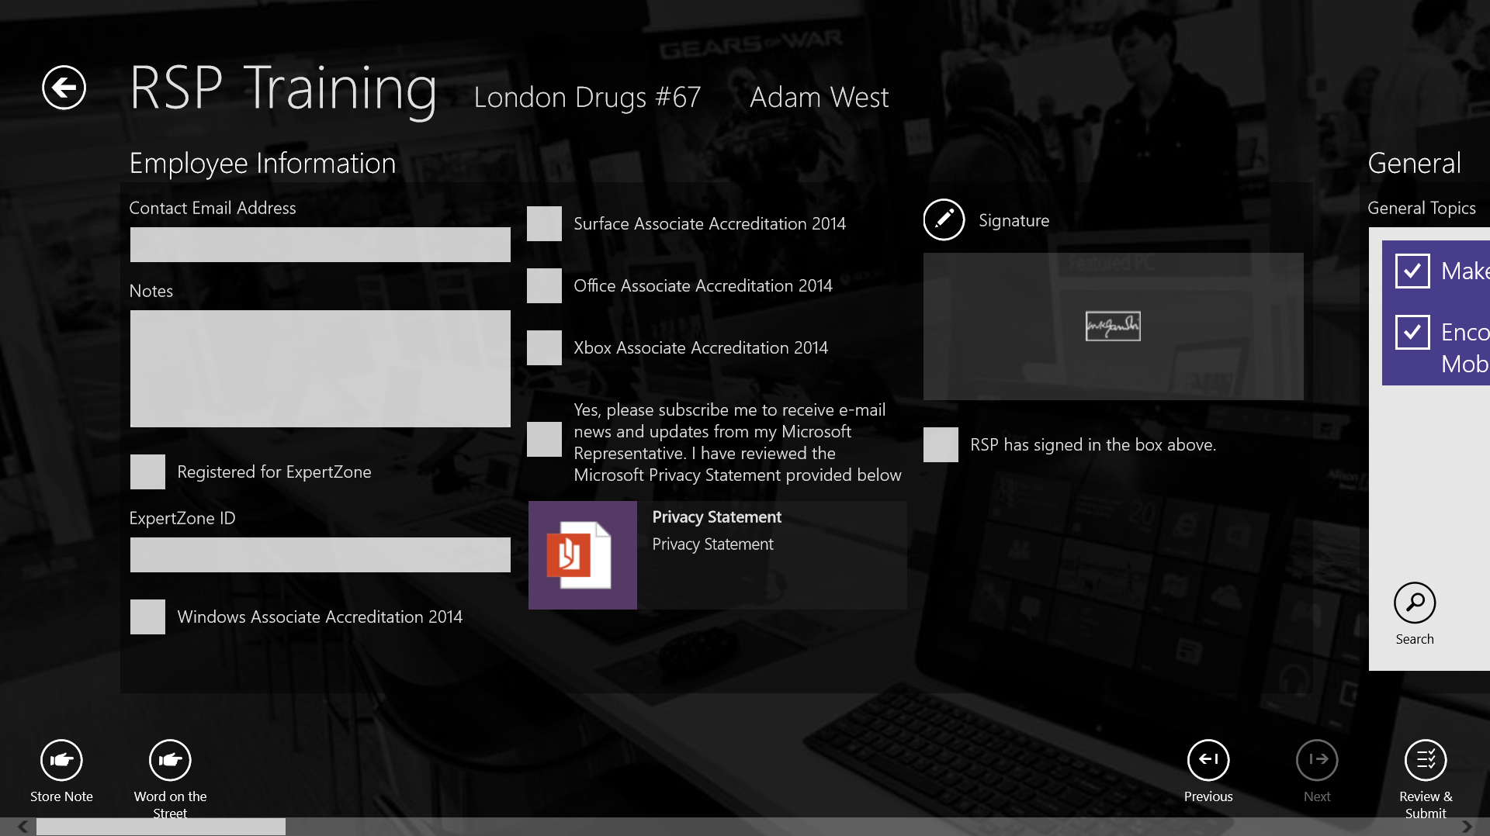

The first section on the left contains details for the store employee. If ExpertZone is available in the country, then enter in the ExpertZone ID. Currently, only manually entered information for ExpertZone accreditations are available. New RSPs should be shown the Privacy Statement, and sign in the Signature field.
Scrolling to the right, there are monthly training items for each category (Windows, Office, Surface, Xbox and PC Accessories). To the right of each section of training topics, there are associated resources that can be used when training the RSP. There may not be a resource for each training topic.

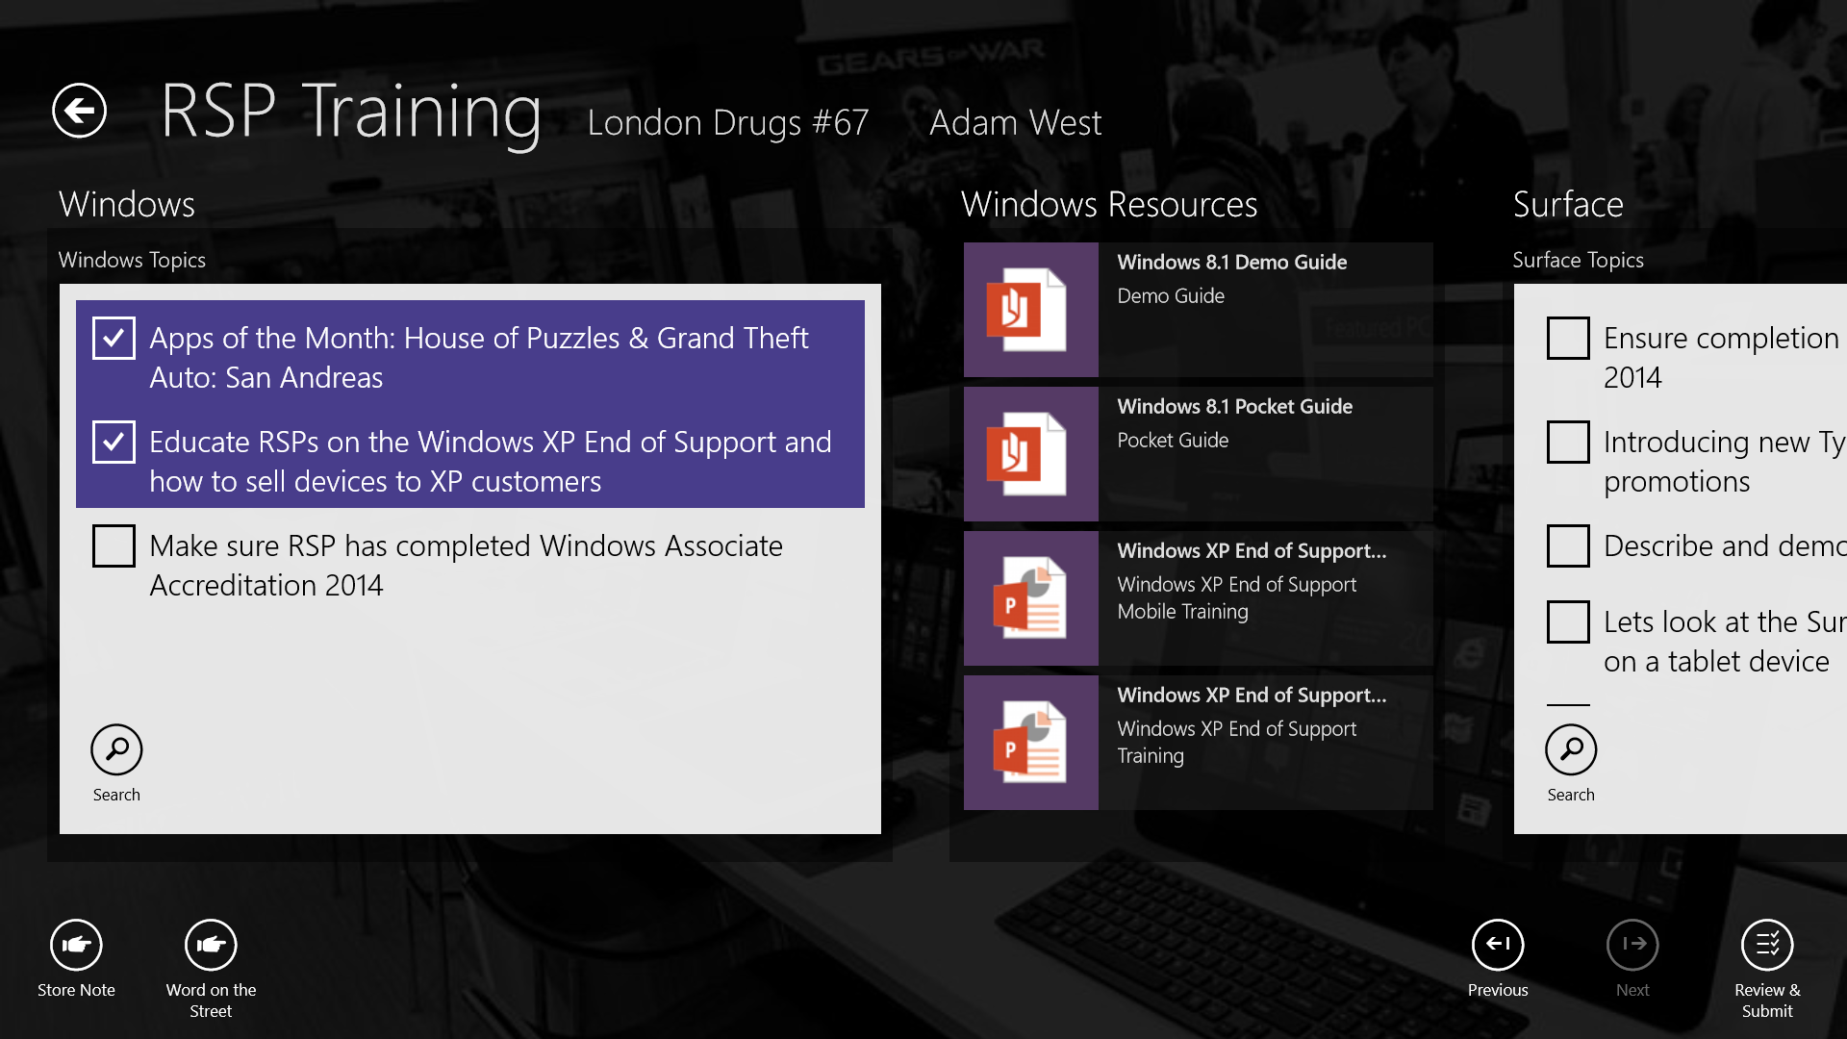
Click the training topics that have been shown to the RSP and select Review & Submit from the bottom right to review the training that was performed. Click Submit to send the training report to the server.
The history of training for the RSP is maintained. On the next visit, they can be trained on any of the remaining topics.

Appendix A – Troubleshooting

For issues with the application: missing call reports, breaking news, etc. Follow the steps below:
- Verify the 10 digit ID (a manager can provide the ID)
  - Open the Settings charm
  - Click on Preferences
  - If the ID is incorrect, click on Update ID the app will refresh after the ID is changed.
- Manually refresh the application
  - Click on the Settings Charm.
  - Click on Preferences.
  - Click on Refresh Now.
- If refreshing doesn’t solve the problem, close the App
  - With a keyboard: press Alt and F4 keys
  - Without a keyboard: drag the app to the bottom of the page and holding it there until the tile flips over.
  - Restart the REP App
- Diagnostic; If closing and reopening the App didn’t fully update
  - Click on the Settings Charm and click on diagnostic and send it
- Website – Verify internet access to the REP server
  - Open internet explorer and open the website (https://www.msftreps.com)
  - If the login page appears internet access is working.
  - If not escalate the issue to a manager.

