Windows – Offline Mode

Reps who want to avoid possible data charges or other internet usage can work offline in the REP app, while preserving wireless communication for other functions on the device. Once selected, the app will be unable to upload any call reports from the Outbox and unable to download any new content from the server, over cellular or Wi-Fi networks. This includes Call Reports, Resource Files, Breaking News and Retail Pro Training Tasks and Files. The feature will be found in Windows app version 2.1.0.224 and higher.

To enable this feature, use the Gear to open Settings, and then select the Work Offline setting in Preferences.
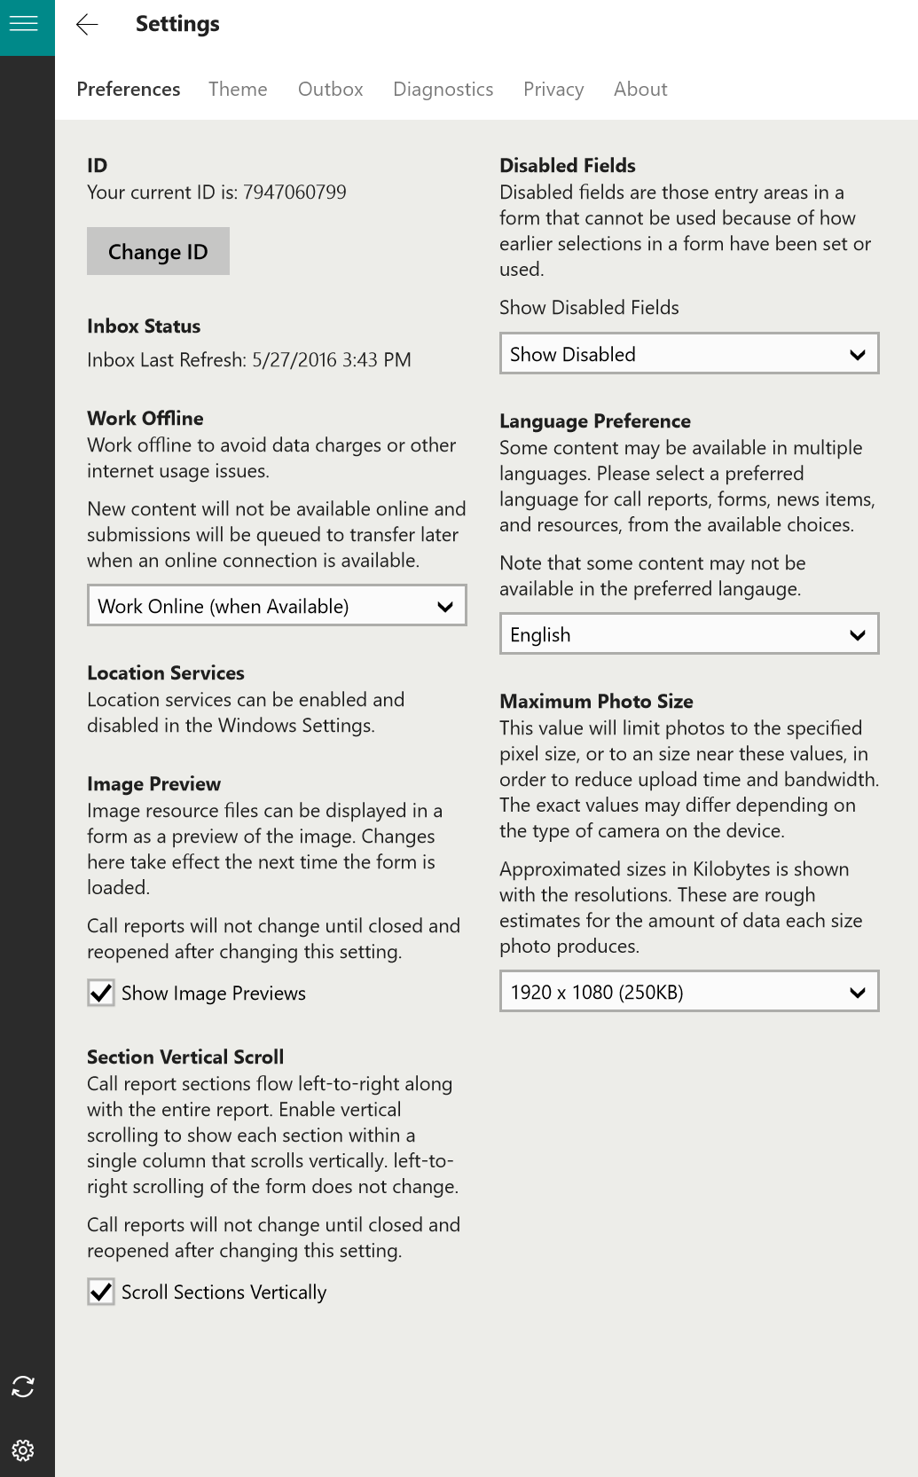
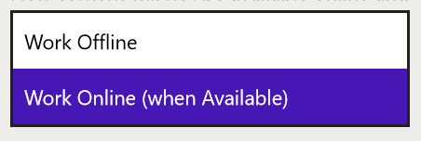
Any call reports completed and submitted will save to the Outbox while in Offline mode. An indicator will appear in the upper right corner of the app to show offline status.
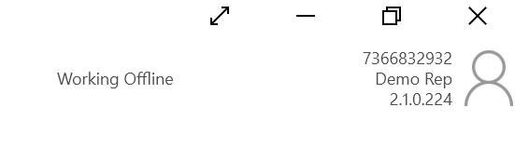
When ready to connect, and in range of strong internet connection, return to Preferences and switch back to Work Online. Your call reports in the Outbox will then upload and any new content will download from the server.

Windows Phone – Offline Mode

Reps who want to avoid possible data charges or other internet usage can work offline in the REP app, while preserving voice and data for other functions on the phone. Once selected, the app will be unable to upload any call reports from the Outbox and unable to download any new content from the server, over cellular or Wi-Fi networks. This includes Call Reports, Resource Files, Breaking News and Retail Pro Training Tasks and Files. The feature will be found in Windows Phone app version 2.8.0.171 and higher.

To enable this feature, swipe to Settings, and then select the Work Offline tile. Once the tile is open, use the dropdown to select Work Offline and then tap the done checkmark at the bottom.
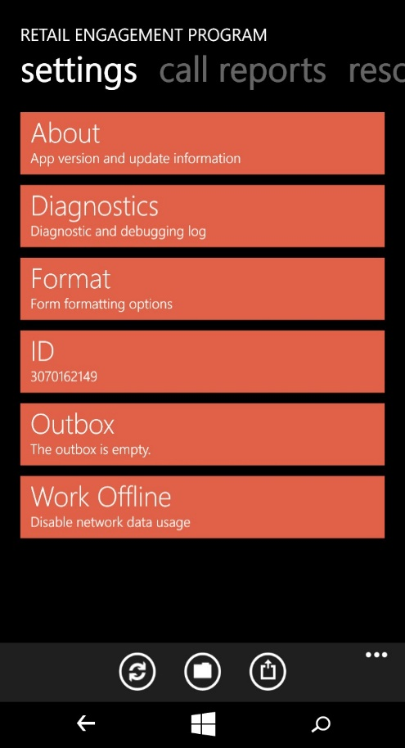
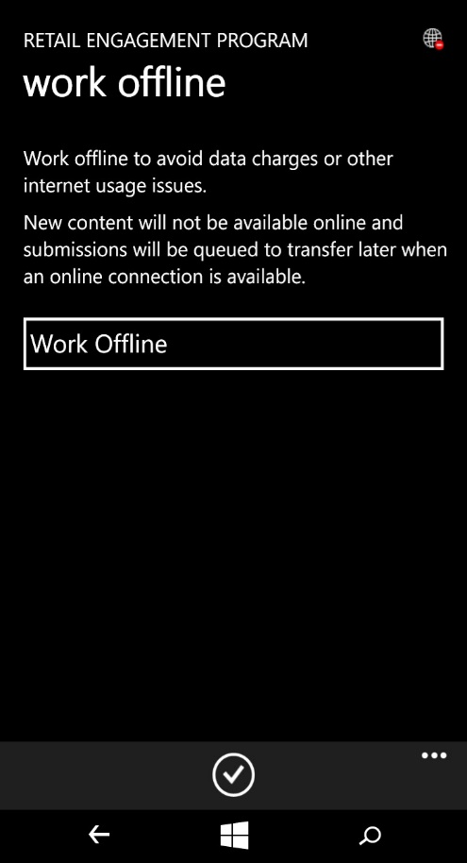
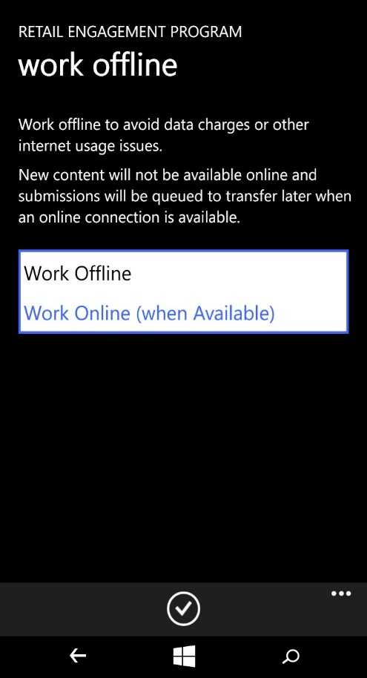
Any call reports completed and submitted will save to the Outbox while in Offline mode. A globe will appear in the upper right corner of the app to indicate your offline status.
When ready to connect, and in range of strong internet connection, return to the Work Offline tile and switch back to Work Online. Your call reports in the Outbox will then upload and any new content will download from the server.

