Windows - Saving and Recovering Call Reports

Saving a Report
Any time a Call Report cannot be finished, it can be saved and then finished later. To save a Call Report, tap the Back button at the upper left corner of the app. The REP app will then ask if the Call Report should be saved, as shown below:
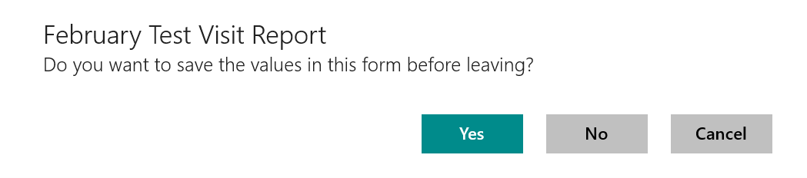
If you select “No” then all of the changes to the Call Report are lost. Select “Yes” to save the report. You will be given the option to enter a name for the report, like this:
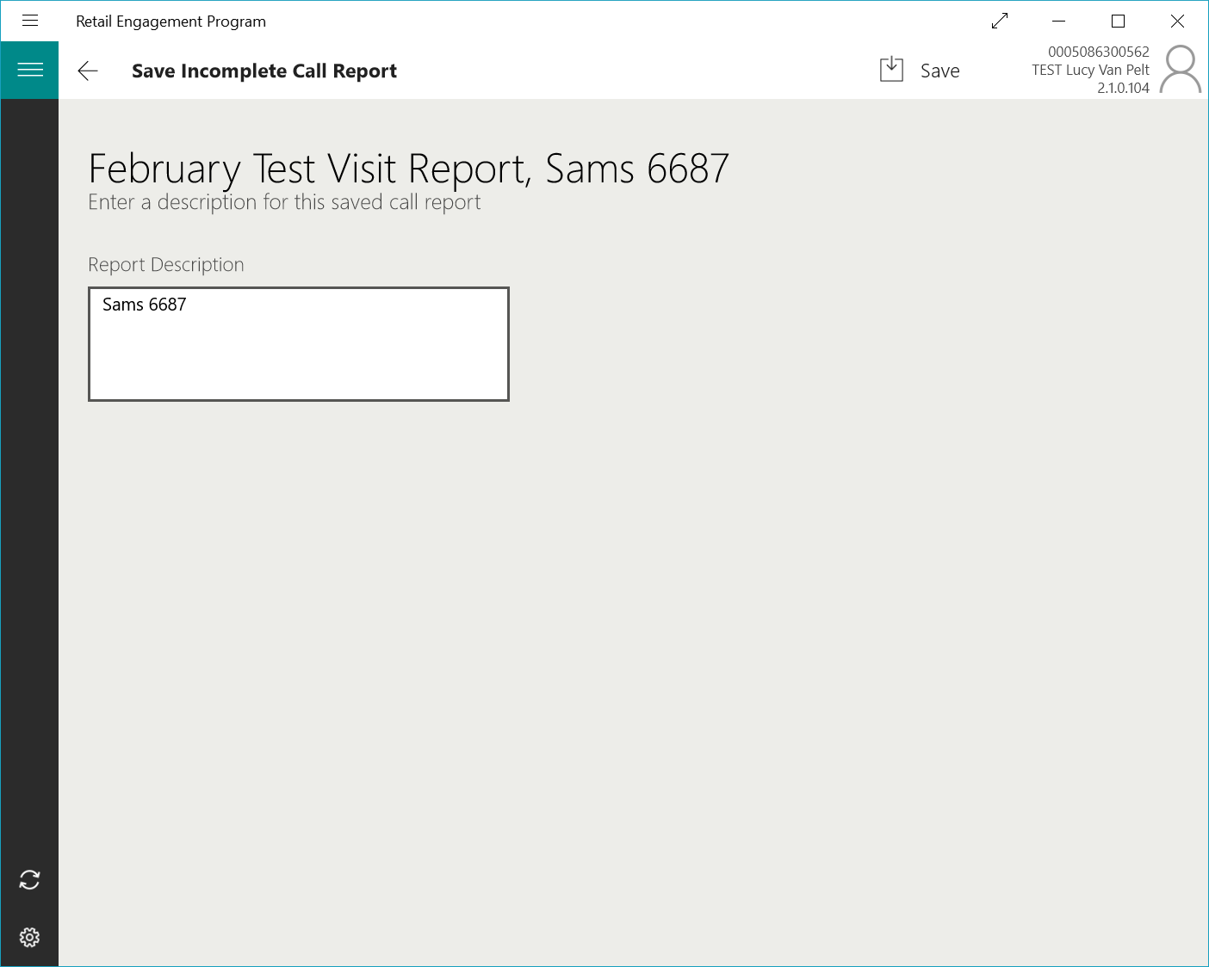
If a store was selected for a store visit, then that store name will be added to the report description. You can use a name other than the store name, keep it, or add to it, as needed. If an employee has been selected in a training form then the store name and the employee name will both be added to the report description for you.
Tap on the Save button at the top-right of the app to go ahead and save the report.
When you are saving a report and there are other reports of the same type, you will see a list of those already saved reports. You can overwrite a saved report by selecting it here – this will copy the description for you and you will later be asked if you want to overwrite the existing report. When the list of existing reports is displayed, you have the option of deleting any or all of them by tapping on them and then tapping on the Delete button at the bottom of the list. Here is what you see when there are already some saved reports of the same type when you try to save a report:
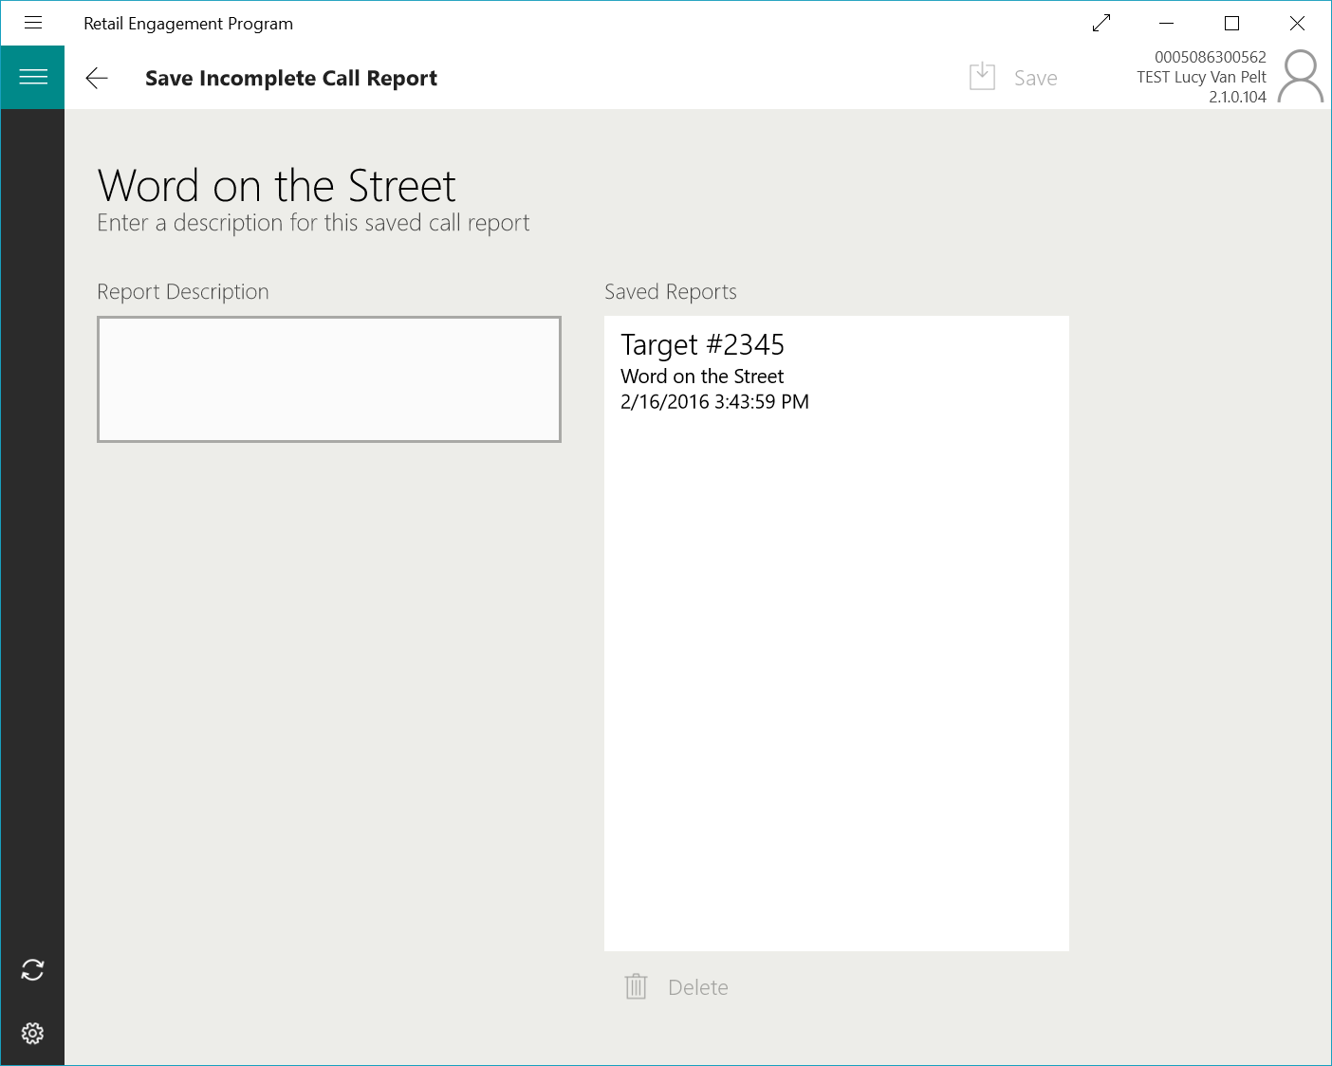

Loading a Report
All saved reports must be opened form the main page of the app. There is a button in the navigation bar on the left side of the app:

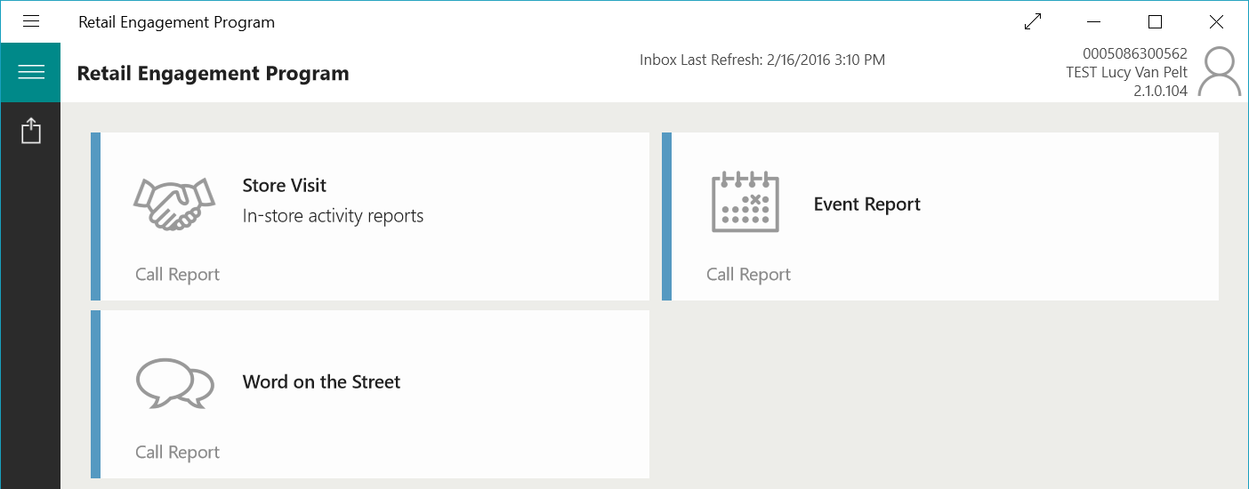
Tap on the button to open the list of saved Call Reports as show here:
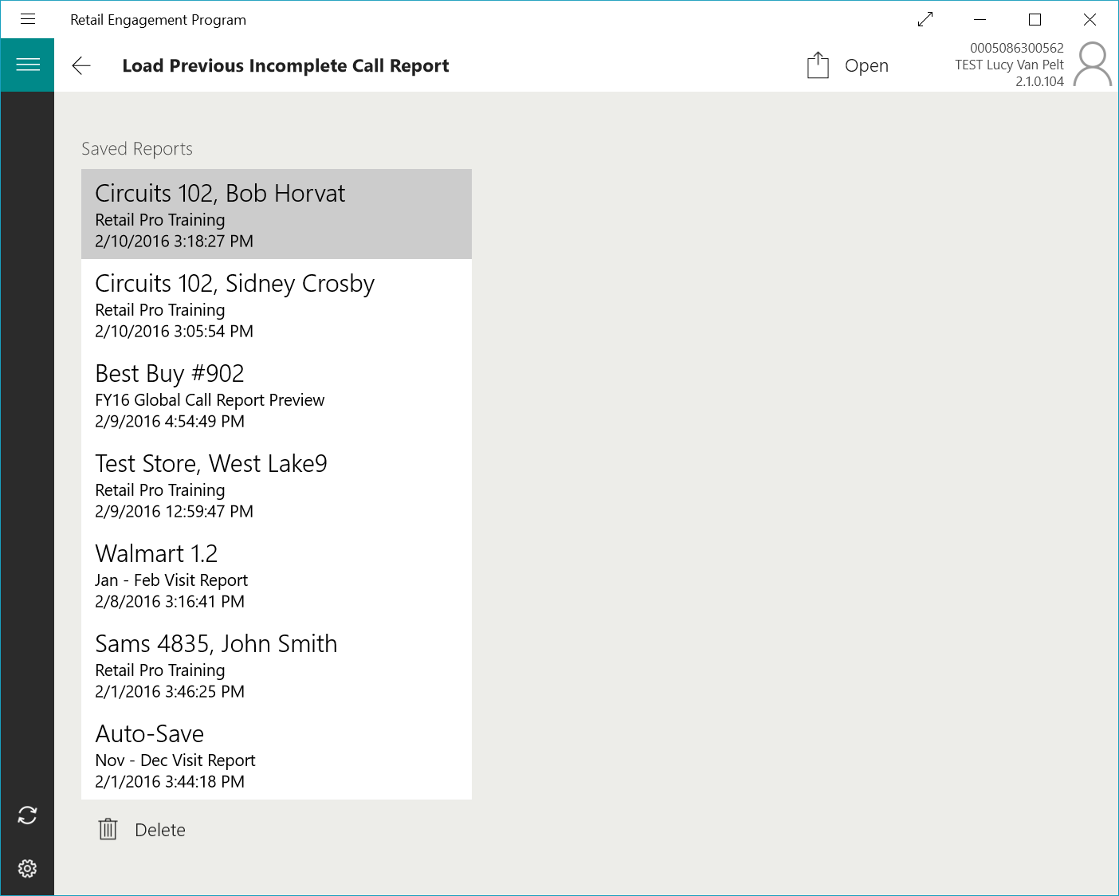
On the Load page, the names of the all saved Call Reports are listed along with the date they were saved and the name of the Call Report. In the list above, you can see a Call Report named “Auto-Save”. This Call Report was being edited when the device battery ran out. Reports are always saved as they are being modified and if something like this goes wrong, the Auto-Save report will show up in the list.
Tap on a Call Report and then tap on the Open button up at the top-right of the app.
You can also delete old and unwanted Call Reports by tapping on a report and then tapping on the Delete button. There is no way to undelete a Call Report so you are asked again if you want to delete it before it is permanently removed.

Automatically Deleted Reports
- When a report is opened, resumed and then submitted, it is automatically deleted from the Saved Reports list.
- When a report is opened, resumed and then saved with a new name, the old report is automatically deleted from the Saved Reports list.
- When an Auto-Save report is opened and resumed, it is immediately deleted from the Saved Reports list. But a new Auto-Save report is created and will show up in the saved reports if the device is powered down or the app is terminated unexpectedly.
Start and End Times – Visit Call Reports
When editing a saved Visit Call Report, it is now possible to adjust the End Time to reflect the true time in store.
Automatically Recovered Call Reports
As mentioned above, call reports named with “Auto-Save” in the title will show up in the Saved Reports list. Another feature has been added to automatically alert the user if a call report has been recovered in the event of a sudden app closure such as manually closing the app in the middle of a call report, app freezing or crashing.
The Recovery alert banner (see photo below) will be presented when the app is re-opened after the previous session ended while a call report was in progress.

After clicking OK, there will be a special Recovered Reports list dedicated to recovered (auto-saved) reports only.
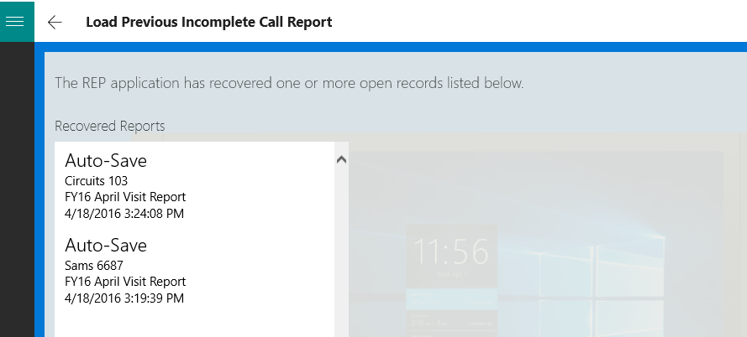
Select a Call Report and then tap on the Open button up at the top-right of the app. Once you resume editing the call report, it will be removed from this list.
You can also delete unwanted auto-saved Call Reports by tapping on a report and then tapping on the Delete button. There is no way to undelete a Call Report so you are asked again if you want to delete it before it is permanently removed.

Windows Phone - Saving and Recovering Call Reports

Saving a Report
Any time a Call Report cannot be finished, it can be saved and then finished later. To save a Call Report, tap the Back button on the phone until asked to save the report. The REP app will ask if the Call Report should be saved, as shown below:
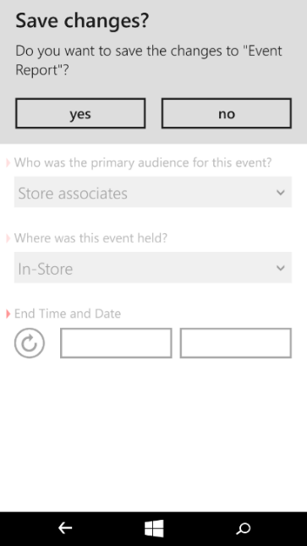
If you select “No” then all of the changes to the Call Report are lost. Select “Yes” to save the report. You will be given the option to enter a name for the report, like this:
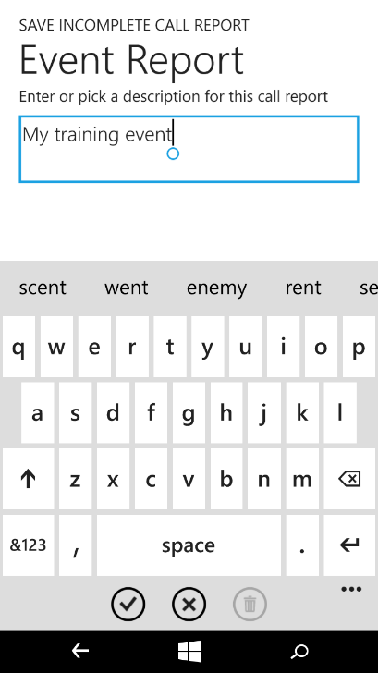
If a store was selected for a store visit, then that store name will be added to the report description. You can use a name other than the store name, keep it, or add to it, as needed. If an employee has been selected in a training form then the store name and the employee name will both be added to the report description for you.
Tap on the Checkmark button at the bottom of the app to go ahead and save the report.
When you are saving a report and there are other reports of the same type, you will see a list of those already saved reports. You can overwrite a saved report by tapping on it – this will copy the description for you and you will later be asked if you want to overwrite the existing report. When the list of existing reports is displayed, you have the option of deleting any or all of them by tapping on them and then tapping on the Delete button at the bottom of the list. Here is what you see when there are already some saved reports of the same type when you try to save a report:
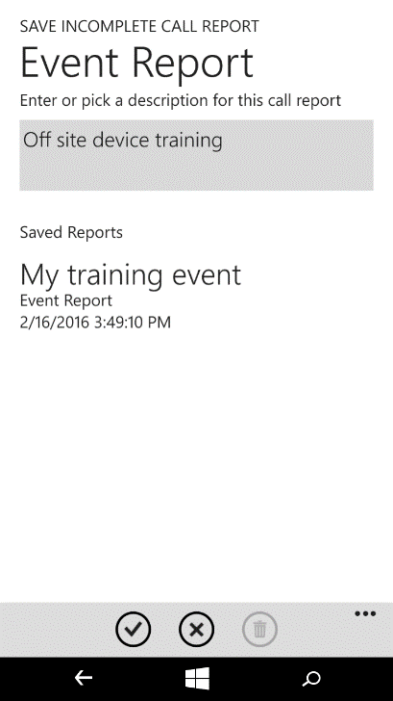

Loading a Report
All saved reports must be opened form the main page of the app. There is a button in the navigation bar on the bottom of the app:
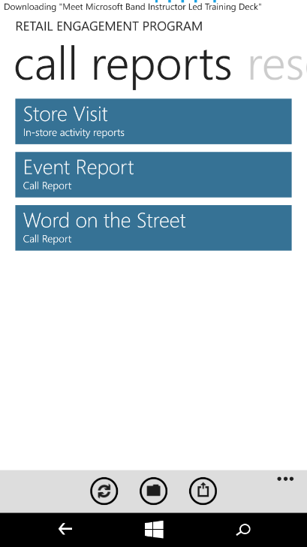
Tap on the button to open the list of saved Call Reports as show here:
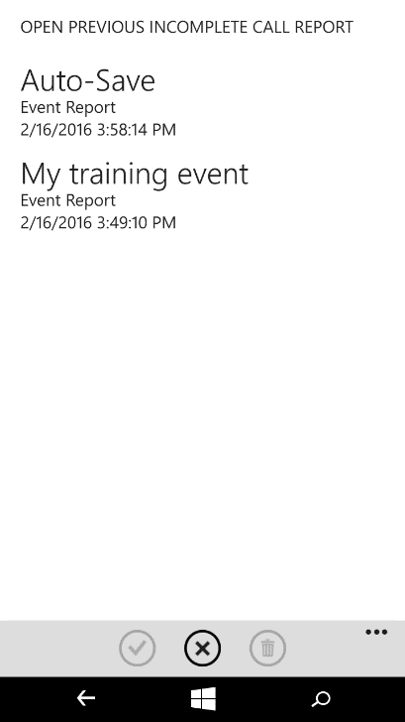
On the Load page, the names of the all saved Call Reports are listed along with the date they were saved and the name of the Call Report. In the list above, you can see a Call Report named “Auto-Save”. This Call Report was being edited when the device battery ran out. Reports are always saved as they are being modified and if something like this goes wrong, the Auto-Save report will show up in the list.
Tap on a Call Report and then tap on the Open (checkmark) button at the bottom of the app.
You can also delete old and unwanted Call Reports by tapping on a report and then tapping on the Delete button. There is no way to undelete a Call Report so you are asked again if you want to delete it before it is permanently removed.

Automatically Deleted Reports
- When a report is opened, resumed and then submitted, it is automatically deleted from the Saved Reports list.
- When a report is opened, resumed and then saved with a new name, the old report is automatically deleted from the Saved Reports list.
- When an Auto-Save report is opened and resumed, it is immediately deleted from the Saved Reports list. But a new Auto-Save report is created and will show up in the saved reports if the device is powered down or the app is terminated unexpectedly.

Start and End Times – Visit Call Reports
When editing a saved Visit Call Report, it is now possible to adjust the End Time to reflect the true time in store.

Automatically Recovered Call Reports
As mentioned above, call reports named with “Auto-Save” in the title will show up in the Saved Reports list. Another feature has been added to automatically alert the user if a call report has been recovered in the event of a sudden app closure such as manually closing the app in the middle of a call report, app freezing or crashing.
The Recovery alert banner (see photo below) will be presented when the app is re-opened, and only if the previous session ended while a call report was in progress. After clicking OK, there will be a special Reports list dedicated to recovered (auto-saved) reports only.
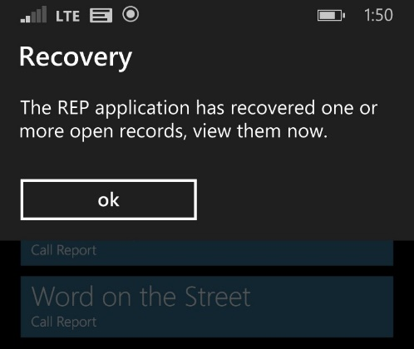

Select a Call Report and then tap on the Open (checkmark) button up at the bottom of the app. Once you resume editing the call report, it will be removed from this list.

You can also delete unwanted auto-saved Call Reports by tapping on a report and then tapping on the Delete button. There is no way to undelete a Call Report so you are asked again if you want to delete it before it is permanently removed.

