

Document: |  | Visit Type Overview - New
For: |  | Microsoft, Inc.
Date: |  | June 30, 2015
Prepared by: |  | Christopher Grupp  v-chgrup@microsoft.com

VISIT TYPE OVERVIEW
Starting for FY16, the Rep Tool will require all call report visits to support a denoted visit type. The types of visits you can denote are determined by Microsoft Corporate. The current types are:
- Training
- Merchandising
- Sales/Demo Days
Over time, these may change and/or expand.
Microsoft will be using these to measure how often each type of visit is being made by each country, by retailer, by rep, etc. Filters have been added to most of the dashboards to now include a drop-down option to filter by visit type.

Getting Started.
Where can I find the new Visit Type controls for a rep? Answer: In the Calendar menu user interface (UI).
Who has access to the new Calendar and Visit Type UI? Answer: Reps, Managers, and Admins.
When should the new Calendar and Visit Type UI be used? Answer: Reps are encouraged to set their schedule up prior to the beginning of the month, but can access the UI during the month as well. This all starts for July, 2015.

Important Administrator Notes
The new calendar controls for visit type are extensive and new. If any Rep, Manager or Admin has trouble with the calendar control, please do the following:
- Report what you were doing in detail and send those notes to msftreps@westlakesoftware.com. Please include your name, country, the Rep and the month in which the trouble occurred; enough for us to replicate what happen.
- Exit www.msftresp.com, log back in a try again
- If you are still having trouble, try a different PC or browser
- If the calendar will not work no matter what you do, the application does allow for users to assign their visit type on-the-fly when using the app. Read further for more detail.
- There is a known issue that is happening intermittently where the box that displays the visit type drop down freezes up. Exit the site, go back in. But please still report this.

SETTING VISIT TYPE USING THE CALANDER
The calendar controls have been enhanced to (1) manage compliance in a new way and (2) to support what visit type is being made to each store visit.
Some rules to note:
- You cannot place a visit on a calendar day that has passed.
- You cannot place the same store on the same day with two visit types.
- You can move forward and prepare future months of work pro-actively (work on August, September now for example).
- There are no copy controls to copy work from one month to another.
- Calendared items MUST be denoted with a visit type in the UI.
- Store visit compliance is now based off of what is placed on the calendar.
  - Once you have set your stores for a month and that month has started, the number of stores you have placed on your calendar is now your compliance number. You can still remove stores, re-assign a visit to a different day and add stores.
  - Example: if you have 20 visits to start with on your calendar for the month of August, you are now being measured at 20 visits. You can add more visits and will show you did more, but it won’t affect compliance percentage. You can do fewer visits but the compliance percentage will diminish.
- Reps can manage their own calendar
- Managers and Admins can enter each Reps calendar
From www.msftreps.com, go to the Calendar option here:
Admin Access:
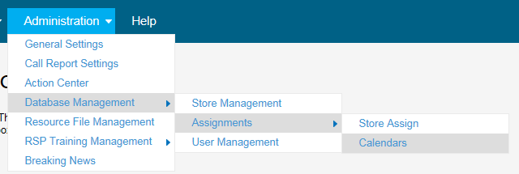
Or:
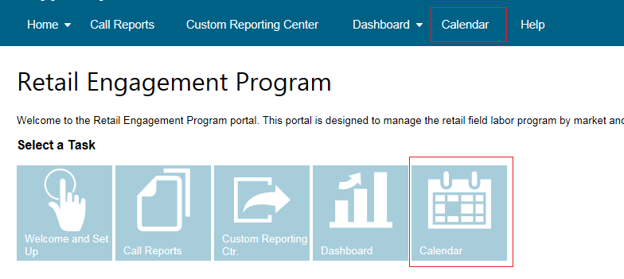

The Calendar user interface has largely remained the same. Stores assigned to each Rep are shown on the left; drag and drop stores to their calendar days on the right.
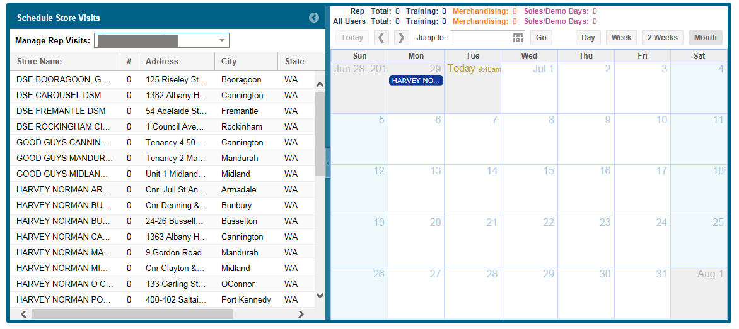
Compliance has now changed.
Before, the Manager or Admin would set compliance in the store assignments for each Rep; that is now not the case. As you drag a store onto the calendar, the # of assignments for that store will now incrementally grow on this page as shown here:
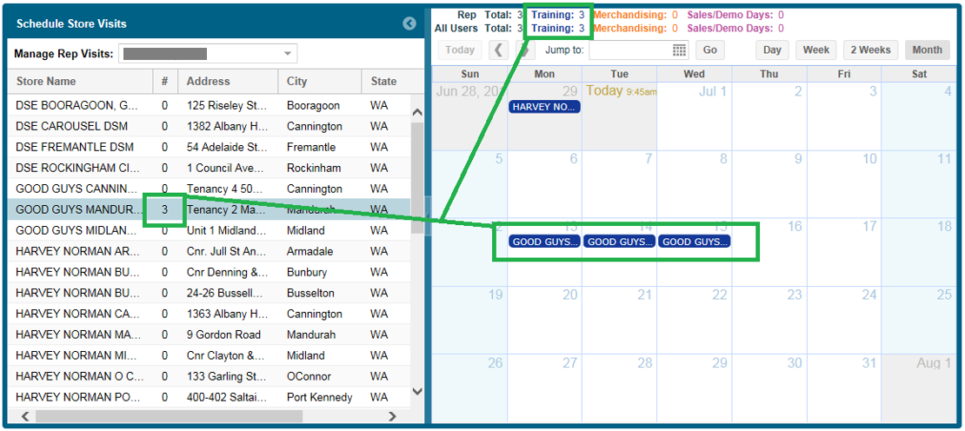
The example above shows the same Good Guys store on the calendar three days in a row. The left list now shows 3, the calendar shows 3 and the stats on top of the calendar shows 3.

At the point in which you drop a store onto the calendar, a pop-up screen displays to allow you to select what type of visit you are making, as shown here:
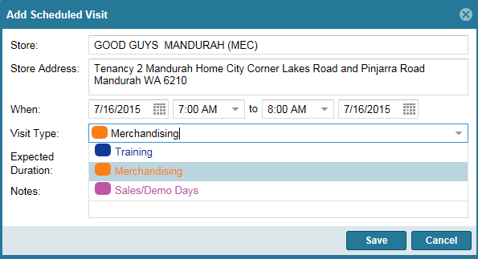

- The store field and address field are NON-EDITABLE. They are there for display only.
- You can use the When time but this is NOT tied to any compliance metric, time in store, etc. They are there only to help a REP better manager their day (at this point in time).
- The main feature/core item here is the Visit Type drop down. You must select one of the items on this drop down to display it on your calendar.
- In early FY16, the Expected Duration option will start to be used to measure time in the store against the actual time in the store. This is also an important field for Reps, Managers and Admins to pay attention to:

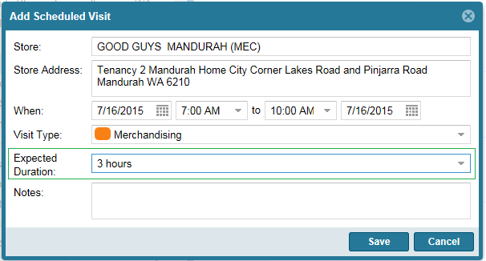
- Expected durations range from 30 Minutes to 10 hours; at half an hour increments.
- Notes field is optional and is only for personal reference, etc.
Select Save.

An example of a calendar with multiple stores assigned with different visit types:
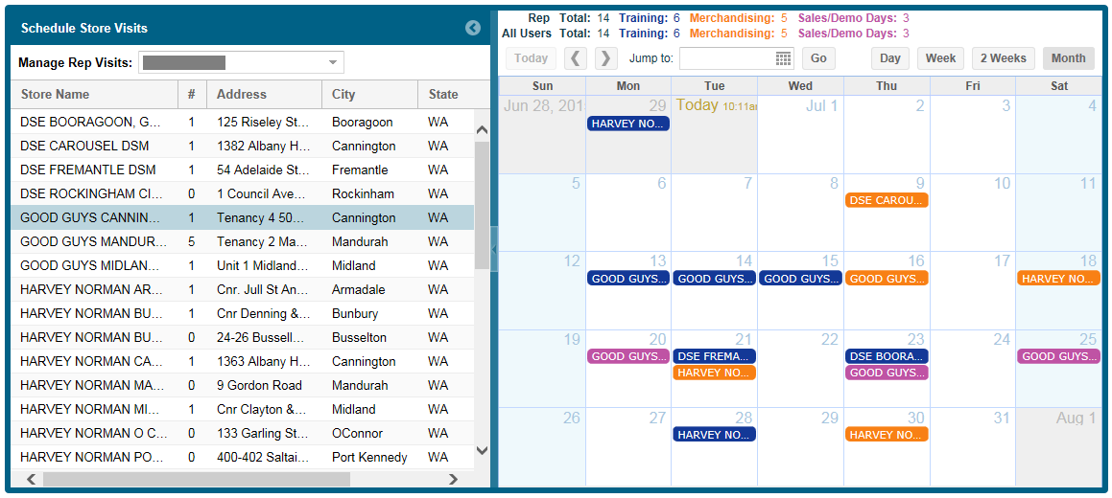
- To remove a record, click on the item on the calendar and select delete. Right mouse with some browser will also offer a delete option.
- For a Rep, the stats on top of the calendar will show their stats
- For an Admin or Manager, the stats will show a line of stats of the rep they are working on AND an overall stat count of the overall number of assignments in your country.
Note for Managers and Admins: there is discussions ongoing about creating a “bigger picture” user interface to show all reps in a list going down a page, their number of monthly assignments and expected totals by visit type and grand totals for all. Then, a way to drill right into the calendar of that rep to make an adjustment. Oct-2015.

WINDOWS AND WINDOWS PHONE
For any rep that was already familiar with using the calendar at www.msftreps.com, the Windows and Windows phone version limit the list of stores for that Rep when they use the app on that calendar day. For example, if you assigned 4 stores for August 15th, just those 4 stores will display on August 15th. However, the app still makes all the stores accessible, as needed, from an expanded pick list (shown below). This capability has existing, remains but now enhanced.
Windows | Phone
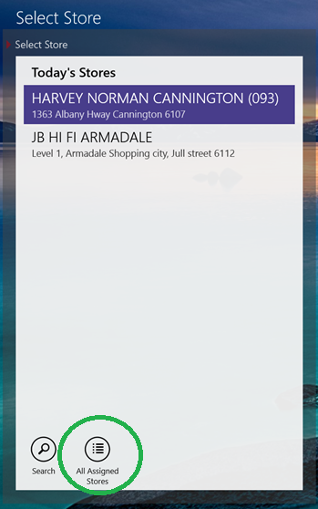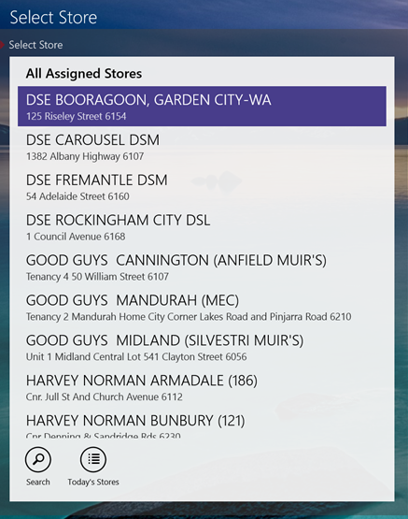 | 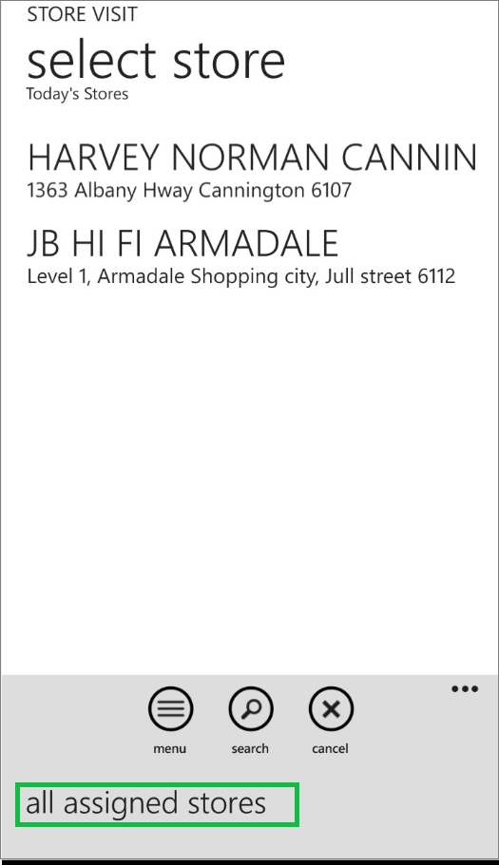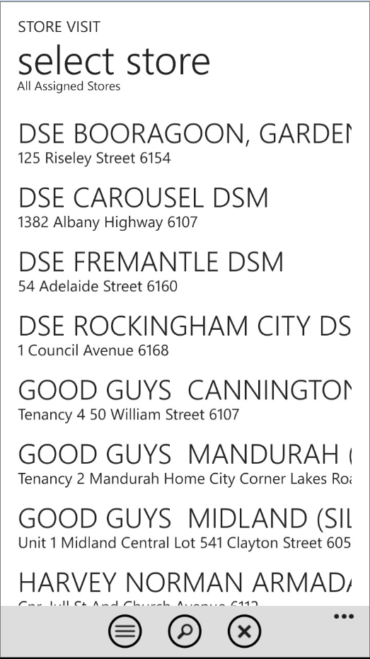

Can you still visit a store that is not on your calendar?
Yes. In these cases where you may need to do a store visit on-the-fly, the call report will allow you to select the visit type from a list:
Windows | Phone
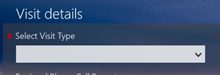  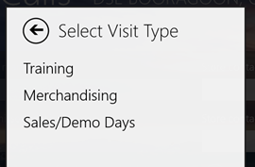  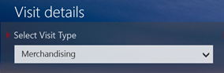 | 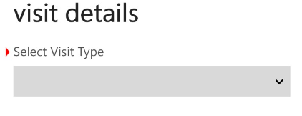  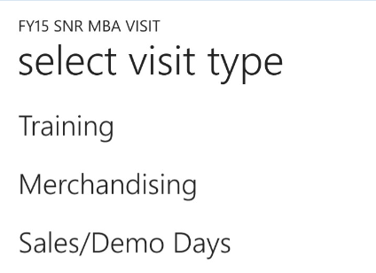  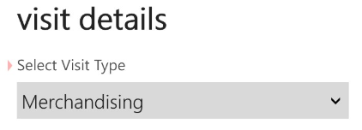

If you are selecting a scheduled visit from the calendar, this field will be (1) pre-populated and (2) not editable.
The visits being made that are NOT on the calendar will:
- Not auto-update the online calendar (at this time)
- But will be added to store visit totals for that country for that month
What if a Rep never uses the Calendar?
- The Rep can denote a visit type every time they visit a store and do this on-the-fly and technically complete all of their monthly visits this way.
- This will possibly cause some issues moving forward with Microsoft’s expectations on compliance requirements, preparing for future months, tracking what they want each country to focus on and will most likely cause a series of global measurements to be off. At some point, this will be flagged. It is important that you become familiar with and start using the calendar controls.

