Overview
The REP app is now available on the web! Point your favorite browser to https://www.msftreps.com/rep/ where you can enter your 10 digit REP ID and password to login and start entering call reports (Figure A below). The password is the same one that you would use for login on the main online site for REP at https://www.msftreps.com/ .
Important things to keep in mind while using web entry
- You must be online and have a strong, stationary connection using hi-speed internet, for the entire entry and submission process. If you try to tether a computer or tablet to a phone with a “hotspot”, it may not work as well.
- Web entry can be used on a variety of devices, such as a mobile phone, tablet, or desktop and with many different browsers. We suggest trying different browsers to determine the best overall experience.
- Don’t use the browser’s back button or refresh button; use only the navigation controls in the web entry site.
- The web entry experience will work very much like the Windows app, with subtle differences in navigation and form controls (button clicks, selectors, dropdowns, etc,).
- There will be slight differences in form controls from device to device and from portrait mode (vertical format) to landscape. For example, when browsing on a tablet in portrait mode you will have to click the right and left arrow buttons at the bottom of the form as you progress from page to page of the call reports.
- Photos: Opening the device camera for a photo question while filling out the form may not be possible on many devices. You may need to take the photo using your camera app and then select it during REP web entry.

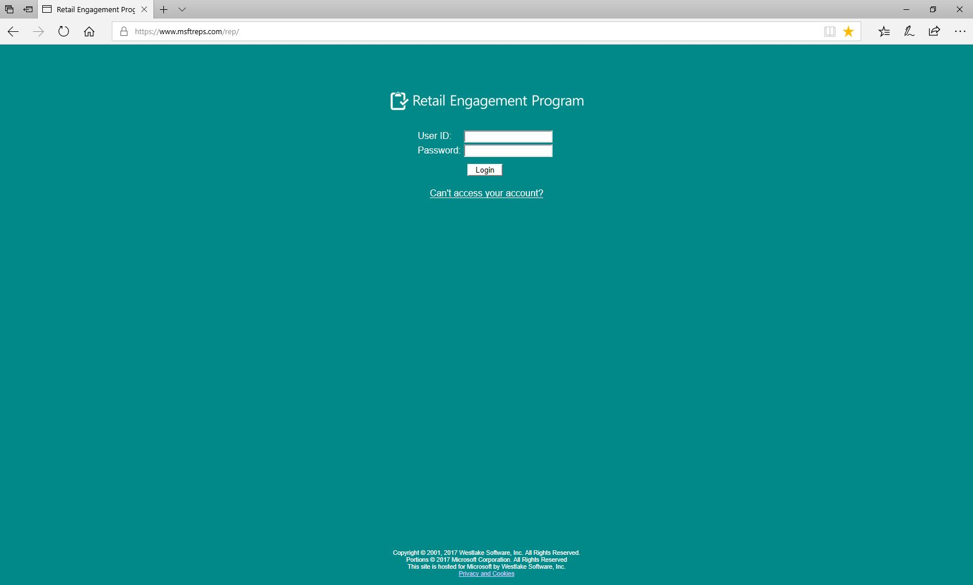
Figure A: Web entry landing page
Submitting, Saving and Resuming Call Reports
The Store Visit Call Report, the Retail Pro Training Report, and other REP forms function and flow in a similar fashion to the Windows and Windows Phone apps. The Review, Submit and Save form navigation buttons have been moved to a new position at the bottom of the page, but the other controls are in a similar place as your use to.
Tip: We recommend that the Country REP Administrator enable the Submission Alerts feature for each of the testing reps, which will send an email confirmation of each submission that arrives at the server. This feature is found in the Admin’s view of the User Management page. There is no Outbox in web entry to view sent items history.
Saving and resuming call reports will work here as well, where you save with the Save button and then close the browser. Then go to the Saved Reports folder when you re-open a browser to find, click it and finish.
Important: There is no (Auto-save) recovery of a partially completed call report or restoring a session if the browser loses internet connectivity or is closed. Also, there is no mixing of app types: a saved call report on the web can’t be retrieved on the Windows Store app or Windows Store phone app and vice versa. For example, with web entry you can start a call report on your computer in the store and save your progress to the Saved Reports folder. Later in the day you can open the web entry site again online, even on another computer, and resume the report and submit it.
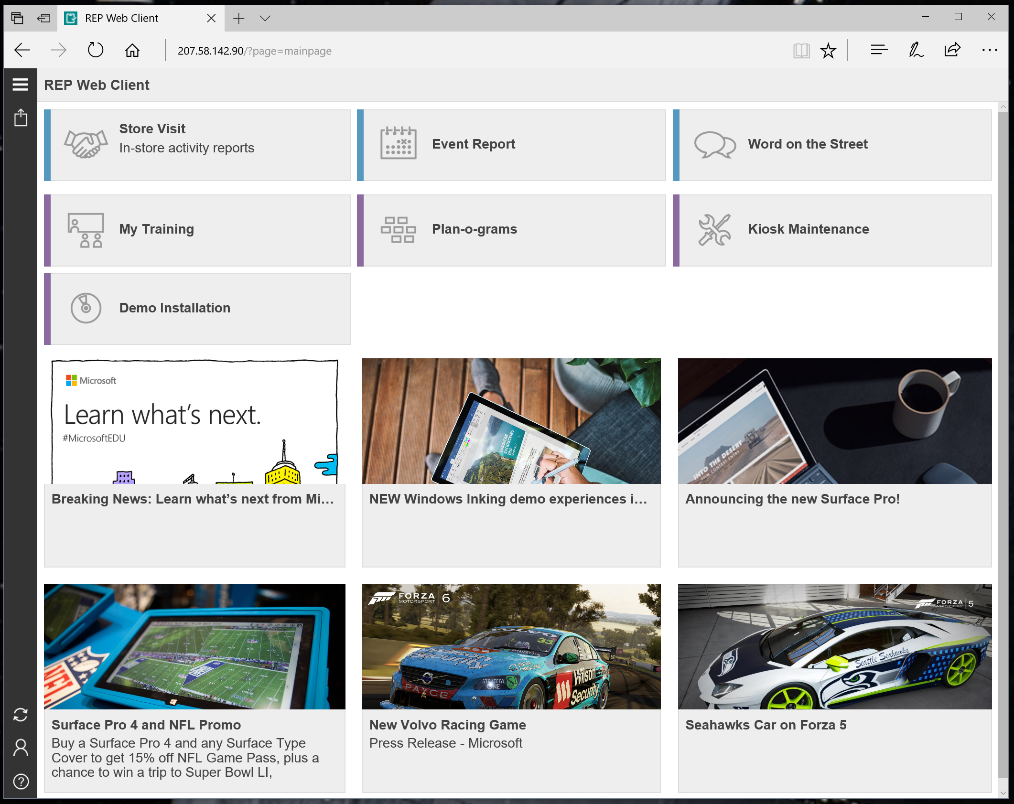
Figure B: Main page of web entry
Note: Do not bookmark or save the web entry site as favorite on any public computer or store computer or device. Also, you cannot bookmark or mark any of the individual pages, such as a call report page, as a favorite. It won’t work as expected and all that will result is the main page bookmarked. Our recommendation is to bookmark or mark the main page as a favorite, after login.
Localization and Settings
The content in the web entry site is English by default, just like the Windows app. If language and culture settings are changed to local settings in the browser, you should see some translated content. The steps may vary slightly by browser, but here are the basic instructions.
- To see local language: If English is the browser’s default setting, then pick a culture setting in the browser like “French (FR)”, etc. which sends that setting to the REP servers. User will then see form content in the requested language.
- If the Country Admin has localized questions and prompts in the main online Msftreps.com site, the web entry user will see the Admin-entered form translations.
- Additionally, using the browser’s built-in translation tool, you can see more, such as the browser page translations. For example, in Chrome just right-click for the option.
There is no Settings button or Settings pages (see Figure B above), but in the lower left there is a Login button where you can re-enter your ID if necessary and an About REP button to check your user name and ID plus other information. Use the Refresh button to get new data from the main server, just like the Windows app.
Support
Send feedback or reports of any issues to msftreps@westlakesoftware.com. Please include the following for the most efficient resolution:
Your name and 10 digit REP ID:
Country:
Device information (Make + Model):
Browser information:
Description of the issue with any screenshots or error messages. Include Call Report name and Store name if necessary.
Note: The more information you can give us here, the better, as there is no Diagnostics page to copy and send.

Other Release Notes
- There is no automatic save feature for form data. Save as often as you feel it is necessary.
- Form pages (sometimes called sections) scroll vertically and never flow across the form horizontally. This is similar to the Windows Phone app and also similar to the Windows app when a setting is set to scroll pages vertically. The option to flow horizontally is not available at this time.
- The list of saved forms on the Load Forms page is shown using form tiles like on the main page. To open a saved form, click or tap on the tile. To delete the form, click or tap on the small circle in the upper right corner of the form and then click the now visible Delete Form button in the button bar at the bottom of the window.
- A photo field in a form may be titled “Take a picture”. The web entry site cannot control a camera and photos must be taken outside of the browser and then the image file imported into the web entry site. Some browsers, like Safari on iOS will let you take a picture when selecting a file in the browser but this functionality is happening outside of our web entry site.
- The signature field is not available at this time and will be invisible or will show a message that it is not available.
- Resource image files cannot be displayed as images within the web entry site. Resource images are all stored on our server and showing all of them could use up a lot of bandwidth. They are shown as tiles in the same way they are shown on the resources page available from the main page.
- There is no copy button for the ExpertZone Token, but the EZ profile and activity information is available.

Revised November 27, 2017.

