MAIN PAGE
Items on the new main page are the same as they were on the 8.1 version: Call Reports, Resource Files and Breaking News. Call Reports, Resource Files and Breaking News are now shown horizontally and work down the page.
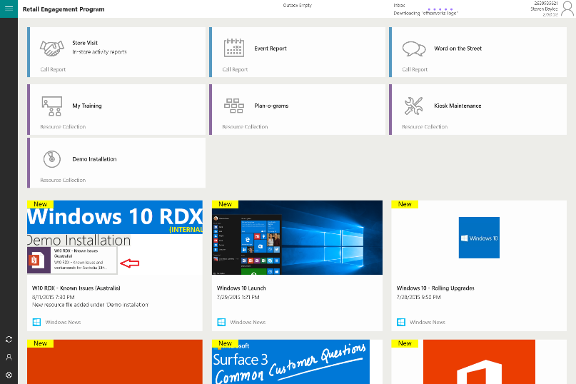

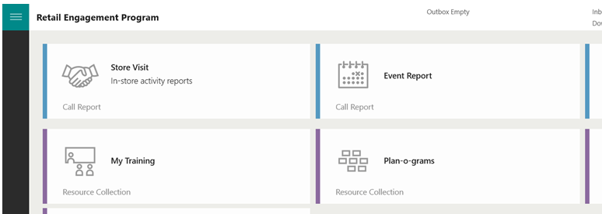

Call Reports remain colored Blue, Resource Files Remain Purple, Breaking New is now graphical. News items are marked with a New indicator. Once they are open and read, the New will disappear.

LEFT SIDE CONTROL BAR – SETTINGS, FORMS & MORE
Settings and access to forms within forms have moved to the left side bar. Items are noted as icons. Select the hamburger icon at the top; this will expand the list to view details of each new icon. Items remain exactly the same as the Windows 8.1 version.

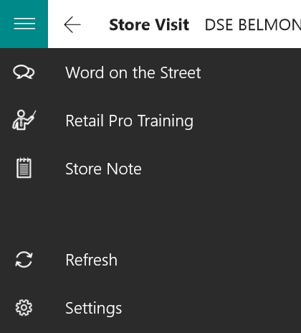

NAVIGATION CONTROLS ARE NOW ON TOP
On all pages, the back function has been moved to be just right of the hamburger icon. This behaves similar to the back options present in the Windows 8.1 version.
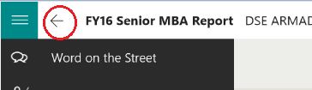

Navigation buttons that moved you Next and Back, Review, etc. have been moved to the top of the application as shown here:
Review and other access items are now in the upper right.
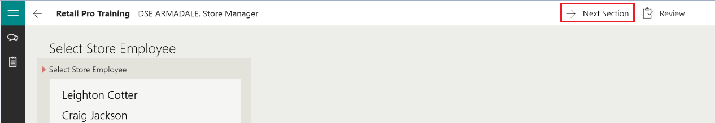

CALL REPORT AND RESOURCE FILE MENUS
When pages support sections, such as a call report or resource files, section titles display across the page (shown below are Visit Details, Windows, Xbox, Office, PC Accessories and Windows Phone).
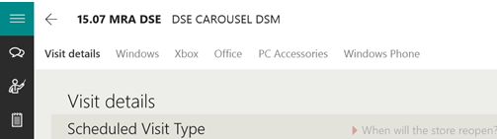

If you were familiar with the swipe down feature of Windows 8.1, this new design places the section jumps now on the page. They are actionable with your finger or mouse to jump to those sections.
PREFERENCES (NEW)
Section Vertical Control
Reps have a preference option to force each item of a call report (Xbox, Surface, Windows) into columns that scroll up and down versus each section wrapping to the right.
Disabled Fields
Reps have an option to see fields that are disabled (grayed out) and now an option to hide them all together until triggered. The benefit of hiding is that if a call report has a large amount of conditional logic (grayed out fields until triggered), this can help limit the display of a very large call report.
Both can be found in the Settings section of the application:

