Read Only User Guide

Contents

Introduction 2
Web Portal Access 2
The Read Only Dashboard 4
Custom Report Center 4
Creating Custom Reports 4
Creating a Custom Call Report 5
Creating Custom Event Report 10
Creating Custom RSP Training Report 12
Saving a Custom Report as favorite 16
Sharing a saved Custom Report 18
The Photo Dashboard 20
Photo View 20
Data view 22
Word on the Street 24
Training Engagements 27
Store Visits 30
Visit and Training Stats 33
Conclusion 34

Introduction
Retail Engagement Program (REP) is a software application that enables all Microsoft retail field labor teams to effectively engage with their retail partners or stores worldwide. The REP application is a single tool that provides directional guidance that is locally relevant to all subsidiaries and the ability to gather and store executional and informational data. Field Labor team directors have the ability to manage and monitor the execution of their programs at retail.

This documentation serves as a guide while you explore various features of REP application web portal. In addition to the navigational guidance, specific call outs have been placed in each section to assist in optimizing the use of the tool for various job profiles.

Web Portal Access
Navigate on your web browser to www.msftreps.com. Once on the landing page (image below) you will enter in your user name and password. I you do not have a user name or password click on “Can’t access your account?”
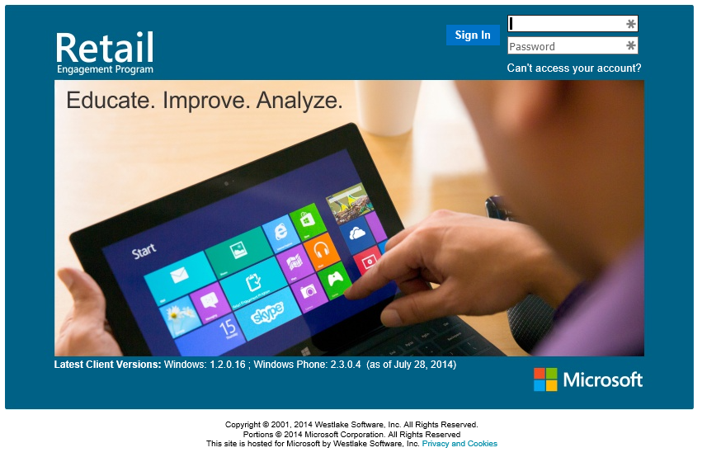

During your first login to the system, you will be asked to change your password and enter a security question and response.

Username Requirements:
- Must be from 4 to 20 characters long.
- Contain only alpha-numeric characters.
- Cannot be presently in use by another user.
Password Requirements:
- Must be from 8 to 14 characters long.
- Contain at least 1 uppercase character and at least 1 lowercase character.
- Contain at least 1 of the following special characters: - _ " ! @ # $ % ^ & * + = ( ) { } [ ] < > | \ ` ~ , . ; : / ?
Enter a new Password, Security Question and Security Answer. Click on Save. You will be directed to the REP Home Screen.

Once registered, users can only change their passwords. Their user names and 10 digit user ID will remain the same. Already registered users who forgot their password can click on the 'Can't access your account?' link on login page. They will have to provide their registered email address. The system will then email them a temporary password, their 10 digit ID and the option to reset their password.

The Read Only Dashboard

This dashboard provides easy access to all of the global data. It is broken into 6 major categories.

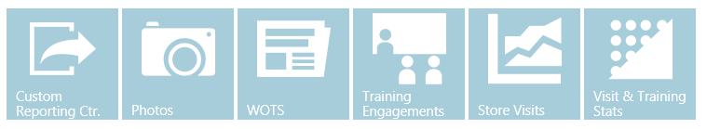

The following sections will provide detailed instructions on viewing and exporting data.
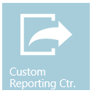

Custom Report Center
The Custom Report Center is a powerful reporting feature that enables users to extract reports across multiple call reports. As the name implies, this feature gives users the option to customize the report structure, i.e. to pick and choose the columns to be displayed in the report. Once the report structure is chosen, filters such as date range, Store Location, User Roles etc. can be applied to further refine the result set. Users will also be able to save their favorite custom reports for future use.

Creating Custom Reports

When you enter the new Custom Report Center the first time, the screen you land on to is largely blank. As you start to create and save reports, they will list here as shown later in this document. Those saved reports will start to list here on the main page. The first step in creating a report is to select a country from the drop down list (as shown in the picture below). A country has to be selected before the various create buttons will be visible.

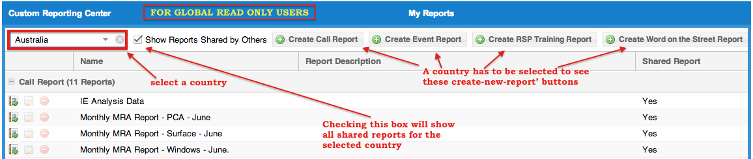

Currently there are four types of custom reports that can be generated. Click on the link to go to respective pages.

  - Custom Call Report
  - Custom Event Report
  - Custom RSP Training Report
  - Custom WOTS Report

Creating a Custom Call Report

Step 1: Click on 'Country’ select menu on the main page to get started.

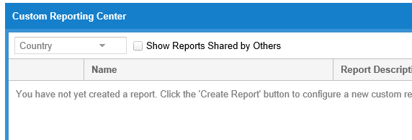

Once the country has been selected the various report buttons will appear

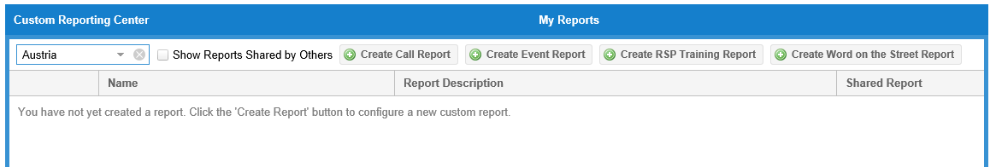

Choose the ‘Create Call Report’ button

Step 2: Choose preferred language and the call report(s) you are looking to generate the report on.

As you can see in the picture below, unless you want to switch to other report types such as Event Report, WOTS report, RSP Training report etc. leave the report type as 'Call Report'. You may also expand the list to also include inactive Call Reports. Tick the check box if you want to consider inactive call reports for the report. For example, if you are interested in generating a report of Manager’s names your reps met with across all call reports, you would use the Select All button shown to quickly select everything. If you were interested in generating a report about Surface Inventory and Surface demos running but do that with only four specific call reports, this is the section in where you would individually pick those call reports (you do this by placing a check box next to the call report or call reports in which you want to create the extract). Last transaction date is displayed to help you better determine a date range (shown on the next page) to pull your reports. This is most useful when also pulling and/or including inactive reports. Click on 'Next' button at the bottom right corner to proceed to the next step.

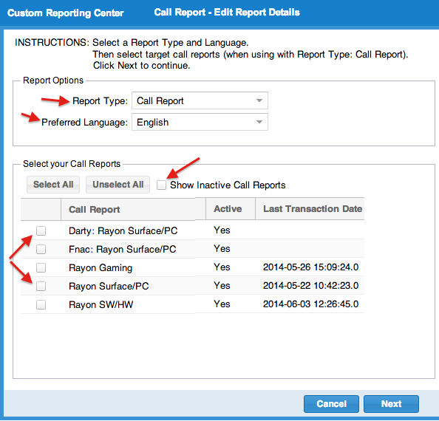

Step 3: Choose the questions / fields from selected call reports

On this page, you will see two horizontally arranged panels. The top panel shows the list of selected fields / questions (in the order of appearance) and the bottom panel shows the list of all available questions / fields for selection (from the call reports you selected in previous step). You will be able to see all the fields / questions available in the call reports you selected in the previous page. All fields are grouped based on products / sections. The collapse / hide button will help you expand / minimize the list. 'Type' refers to the response type of the field / question. 'Applies To' gives the count of how many reports from your selection in previous page contains that particular field.

To add / select a question / field in to the upper panel, Click on the plus button corresponding to the question in the lower panel. You can also drag and drop the questions. As you add / select a question / field, it disappears from the bottom pane.
If you want to remove a selection, just click on the corresponding minus button on the top panel. It will appear back on the bottom pane. You can also drag and drop the questions to the lower panel.

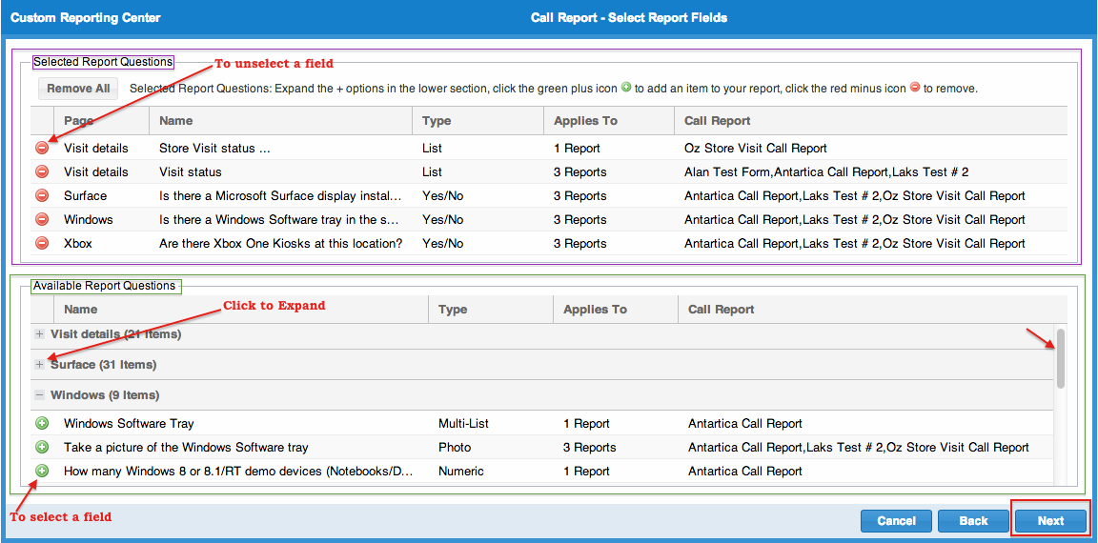

What if the order of the questions matters in your extract? For example, you may be running the data you are extracting in a mathematical formula in Microsoft Excel. And, if the questions are not in a particular order, this could cause disruption to your work flow. The items in the upper section are drag and drop ready. You can grab any question and drag it down or up to allow you to select the desired order of your questions.

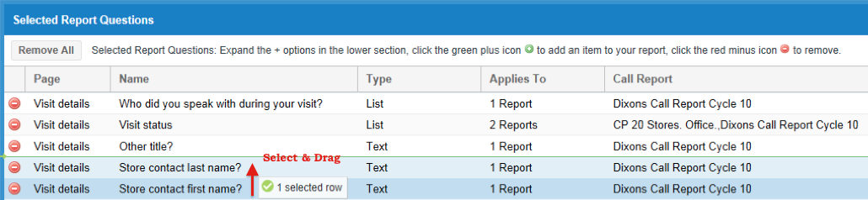

Once your field selection is complete, please proceed to the next page by clicking 'Next' button. You also have the choice of going back to the previous page (form selection) or canceling this activity altogether.

Step 4: Choose Filter Criteria

On this page, you will see two vertical panels. The panel on left side is for filter options and the one on right side is where the report will be displayed.
As shown below, on the left panel, you can select date range specific and/or Store location specific and/or User Role specific filter criteria (just like how you would do in dashboard reports). By default, current week is pre-selected in the date range box. You may click on the date picker to change the date range. Location based filter options allow sub filters based on regions and sub regions as designed in store management page. Role based filters allow sub filters based on various user roles defined in the user management page. For a selected user role, you can further filter down on individual user names and the stores assigned to the user.

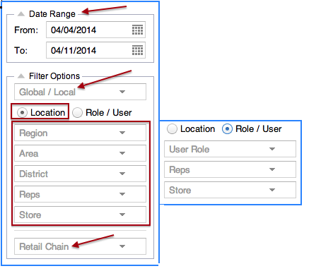

Step 5: Run the Report

Once you have chosen the filters, click on the 'Go' button to view the report on right side panel. Refer to the picture below.

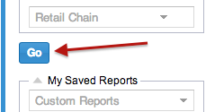

In addition to all the responses to the desired questions in the extraction rules created on the previous two pages and by your filter rules, there will also be the following fields:

• Device ID Number
• First Name of Rep
• Last Name of Rep
• Call Report Name
• Date and Time Received
• Country of Origin
• Chain
• Chain Category
• Store ID Number (when available)
• Store Name
• Store Address
• Store City
• Store State/Province
• Store Postal Code

These fields will help you distinguish the records uniquely.

At a time 100 records are displayed in a page (scroll down). If there are more records satisfying your query and filter conditions, they will be paginated. You can click on the '>' button to move forward to the next page. You have the option to download the entire report as a spreadsheet. Clicking on 'Back to Report List' button at the bottom right will take you to the home page of Custom Report Center. Clicking on the 'Back' button will take you to the previous page (step) where you chose the fields.

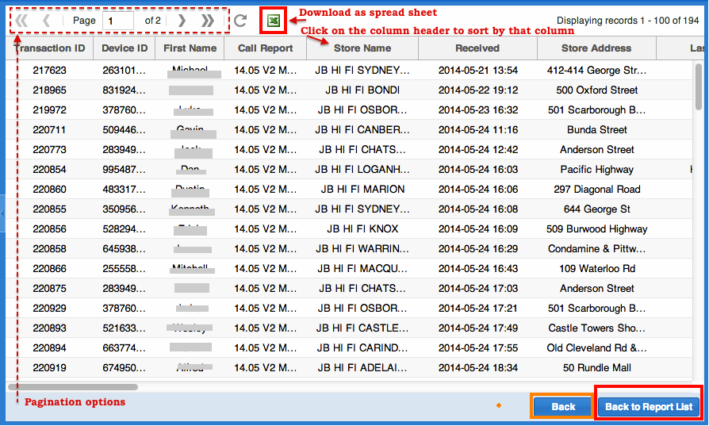

Creating Custom Event Report

Step 1: Click on 'Country’ select menu on the main page to get started.

Once the country has been selected the various report buttons will appear

Choose the ‘Create Event Report’ button

Step 2: Choose the questions / fields from Event Report

On this page, you will see two horizontally arranged panels. The top panel shows the list of selected fields / questions (in the order of appearance) and the bottom panel shows the list of all available questions / fields for selection. You will be able to see all the fields / questions available in the Event Report. All fields are grouped based on sections (e.g. Event Detail, Store Employee Training etc.). The collapse / hide button will help you expand / minimize the list. 'Type' refers to the response type of the field / question.

To add / select a question / field in to the upper panel, Click on the plus button corresponding to the question in the lower panel. You can also drag and drop the questions. As you add / select a question / field, it disappears from the bottom panel.
If you want to remove a selection, just click on the corresponding minus button on the top panel. It will appear back on the bottom pane. You can also drag and drop the questions to the lower panel.

You can grab any question and drag it down or up to allow you to select the desired order of your questions.

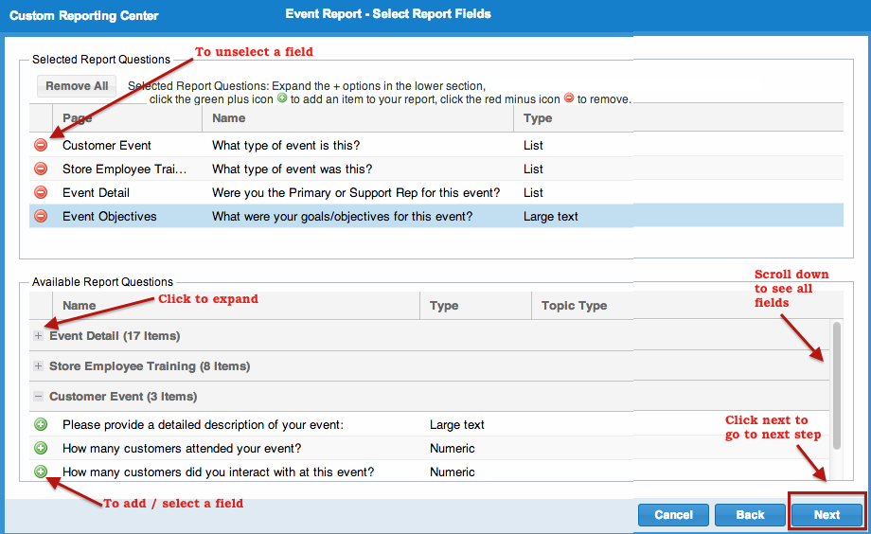

Once your field selection is complete, please proceed to the next page by clicking 'Next' button. You also have the choice of going back to the previous page (form selection) or canceling this activity altogether.

Step 3: Choose Filter Criteria

On this page, you will see two vertical panels. The panel on left side is for filter options and the one on right side is where the report will be displayed.
On the left panel (shown in the picture below), you can select filter conditions based on date range, Store location, User Roles, user names etc. (just like how you would do in dashboard reports). By default, current week is pre-selected in the date range box. You may click on the date picker to change the date range. Market, User Role and User Name filters are in fact sub-filters. That means you have to select a value in the higher filter for the lower filter options to populate.

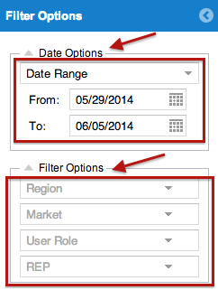
Step 4: Run the Report

Creating Custom RSP Training Report

Step 1: Click on 'Country’ select menu on the main page to get started.

Once the country has been selected the various report buttons will appear

Choose the ‘Create RSP Training Report’ button

Step 2: Leave Report Type as 'RSP Training' and choose preferred language.

As you can see in the picture below, unless you want to switch to other report types such as Event Report, WOTS report or Call report, leave the report type as 'RSP Training'. Then select the date range and proceed. Instead of choosing a specific date range, you can also choose RSP month or Calendar month. Click on 'Next' button at the bottom right corner to proceed to next step.

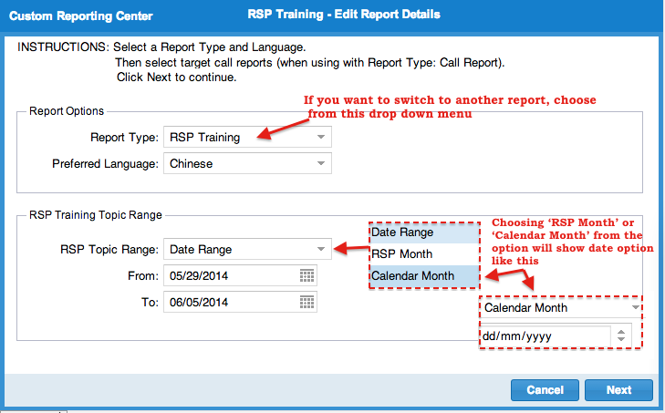

Step 3: Choose the questions / fields from RSP Training Report

On this page, you will see two horizontally arranged panels. The top panel shows the list of selected fields / questions (in the order of appearance) and the bottom panel shows the list of all available questions / fields for selection. You will be able to see all the fields / questions available in the Event Report. All fields are grouped based on sections (e.g. Event Detail, Store Employee Training etc.). The collapse / hide button will help you expand / minimize the list. 'Type' refers to the response type of the field / question.

To add / select a question / field in to the upper panel, Click on the plus button corresponding to the question in the lower panel. You can also drag and drop the questions. As you add / select a question / field, it disappears from the bottom panel.
If you want to remove a selection, just click on the corresponding minus button on the top panel. It will appear back on the bottom pane. You can also drag and drop the questions to the lower panel.

You can grab any question and drag it down or up to allow you to select the desired order of your questions.

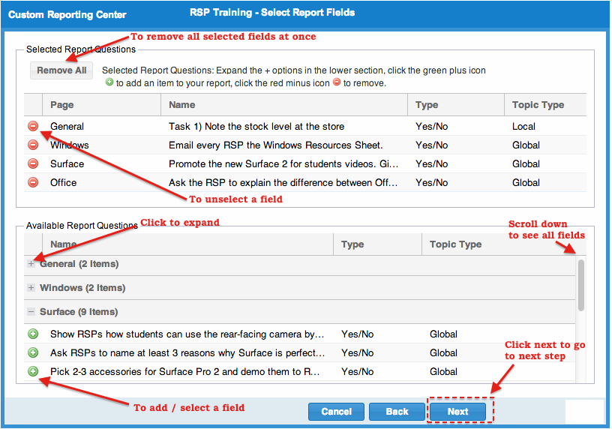

Once your field selection is complete, please proceed to the next page by clicking 'Next' button. You also have the choice of going back to the previous page (form selection) or canceling this activity altogether.

Step 4: Choose Filter Criteria

On this page, you will see two vertical panels. The panel on left side is for filter options and the one on right side is where the report will be displayed.
As shown below, on the left panel, you can select date range specific and/or Store location specific and/or User Role specific filter criteria (just like how you would do in dashboard reports). By default, current week is pre-selected in the date range box. You may click on the date picker to change the date range. Location based filter options allow sub filters based on regions and sub regions as designed in store management page. Role based filters allow sub filters based on various user roles defined in the user management page. For a selected user role, you can further filter down on individual user names and the stores assigned to the user.

Step 5: Run the Report

Creating Custom WOTS Report

Step 1: Click on 'Country’ select menu on the main page to get started.

Once the country has been selected the various report buttons will appear

Choose the ‘Create Word on the Street Report’ button

Step 2: Choose Filter Criteria

On this page, you will see two horizontal panels. The panel on left side is for filter options and the one on right side is where the report will be displayed.
As shown below, on the left panel, you can select date range and the type of WOTS report. By default, current week is pre-selected in the date range box. You may click on the date picker to change the date range.

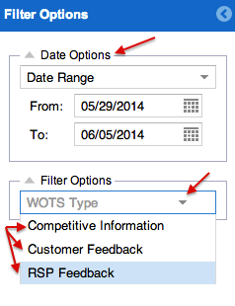

Step 3: Run the Report

Saving a Custom Report as favorite

You can save as favorite, the criteria / filters of your custom report by clicking on the "Save Current Report" button at the bottom on left pane (refer to the 1st picture below). It opens a pop up windows (2nd picture below) where you can enter your preferred title for the query and a description. The "Edit" button beside 'Save Current Report' button lets you choose and edit one of the previously saved report queries (3rd picture below).
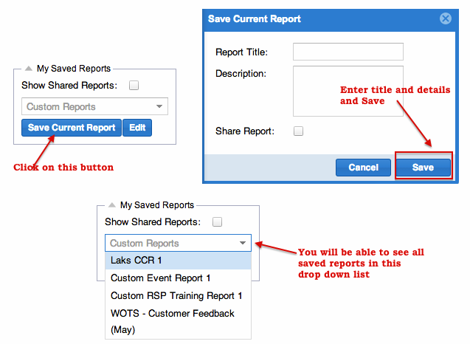

Saved reports will be listed down on the main page of Custom Report Center (like shown below).

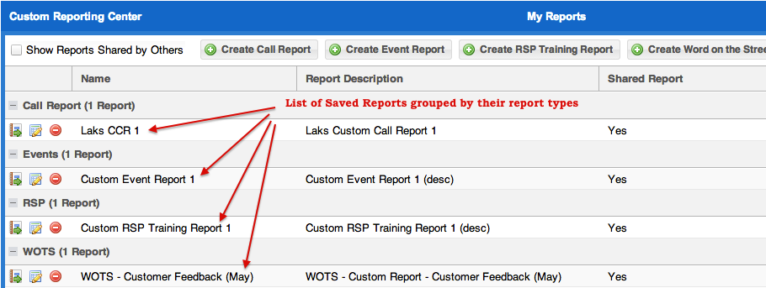

There are three options available to you with a saved custom report:

View Report
Edit Report
Delete Report

'View Report' will directly take you to the page where you can set filters and execute the report. 'Edit Report' will allow you to reselect the call reports and questions (fields). 'Delete Report' allows you to remove that saved report from the list. A confirmation box will be shown before you delete.

Sharing a saved Custom Report

You can share your saved reports with other users in your country. To do this, please check the option 'Share Report' while saving a report as your favorite (as shown below).

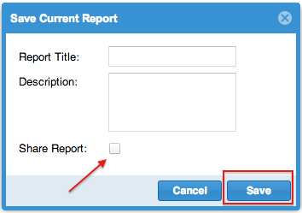

You can also edit an already saved report and share it at a later point in time. For that, go to the main page of custom reporting center, click on the 'Edit' button of the relevant saved report. This will open a small pop up window like shown below, where you can check the 'Share Report' check box and Save. To un-share a report, un-check this box and save.

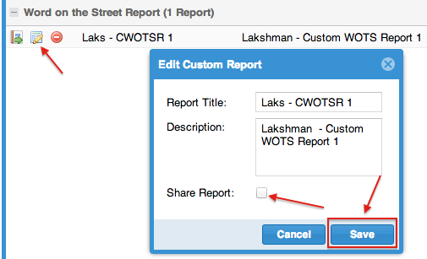

To view reports saved and shared by others in your country, tick the check box 'Show Shared Reports' (refer to the picture below). You will not be able to remove or edit reports shared by others.

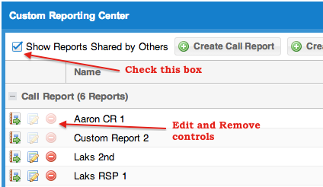

…………………………….



The Photo Dashboard

Photo dashboard report shows the photos uploaded to REP system through various report submissions.

Once you are on photo dashboard page (as shown below), select a date range and other filters as applicable from the left panel and hit on the 'Go' button to view the list of photos on the right panel. By default, current day is selected as date range. There is no limit on the date range selection but the larger the range, the more photos will be downloaded which could affect download times. There are 2 views (2 tabs) of photo report. Photo View and Transaction view.

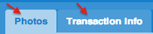

Photo View

Photo view or 'Photos' tab is the default view. As shown below, this view displays all photos from different reports that satisfy the filter condition. Click on the photo to enlarge. This view also offers photo size adjustment control and pagination control.

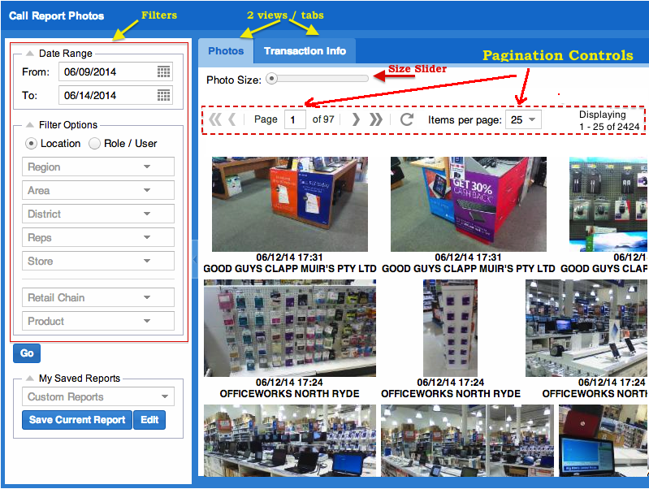

Photo Size
The photo size slider / adjuster offers three levels of thumbnail photo sizes; small, medium and large. By sliding the indicator to the desired size, the photos below with adjust accordingly.

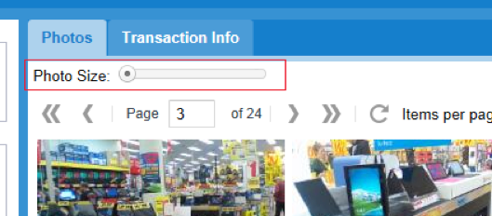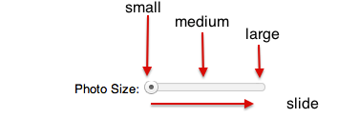

Paging Feature
Paging feature (Pagination) controls the number of photos that will display on the screen at the same time. We have set the default of the number of photos shown per page to 25. This will help create a faster experience when re-sizing and re-loading photos over the Internet. You can increase the number of photos per page. However, the more you display on a single page, the longer the load time will be per photos set by your filters. The best quality and largest display of photos remains to be by clicking directly on the photo for a fuller screen display.

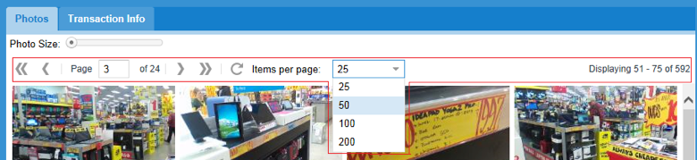

The number of pages is determined by how many photos are driven from the filter options on the left and by the number of items per page in which you set. The total number of photos available per your filter set options is displayed on the far right.

Data view

As shown below, data view displays the details of various transactions (call report submissions) that contained a photo. As you can see in the picture below, it shows the date/time, user name, form name, store name, device used to capture the picture etc.

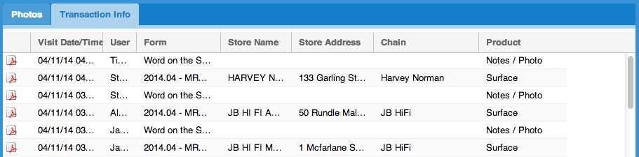

Clicking on the pdf file icon (for each record) will generate a full printable report of that transaction with the photo embedded in it. This can be handy to communicate / share with others through emails or hand over as print outs. An example is shown below:

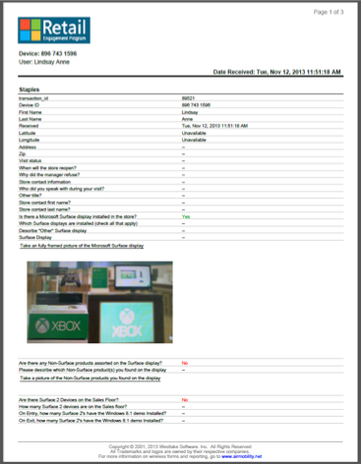

Filter Options and Save option are very similar to those in RSP training dashboard. Please refer to Filtering Options in RSP Training Dashboard page for details.

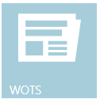

Word on the Street

The WOTS dashboard report shows the statistics (pie charts) based on the data from Word on the Street reports submitted. Click "Word on the Street" from menu to produce the WOTS report view.

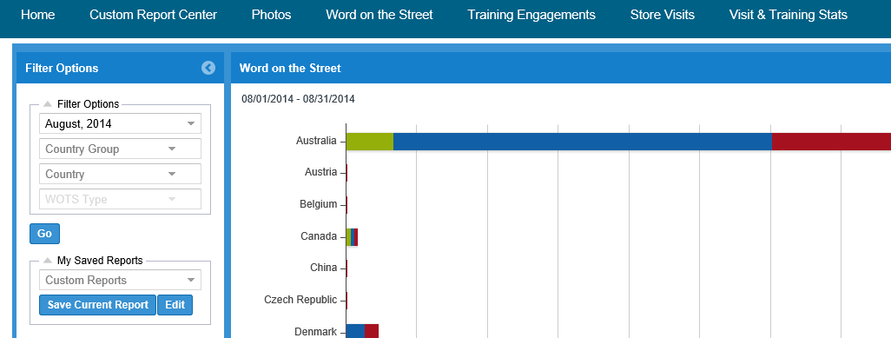

Various filter options and the option to save any report views are located on the left side of the page.

Filter Options:

Basically there are 4 top level filter options. They are 'Month, Year', ‘Country Group’, ‘Country’ and 'WOTS Type'. Once selected ‘WOTS Type’ has 3 options: 'Competitive Information', 'Customer Feedback', 'RSP Feedback'. Choosing one of these three options will expose associated sub-filters as shown in the pictures below. Data selection / filtration of these filters are based on the semantics of various questions and response types in WOTS form.
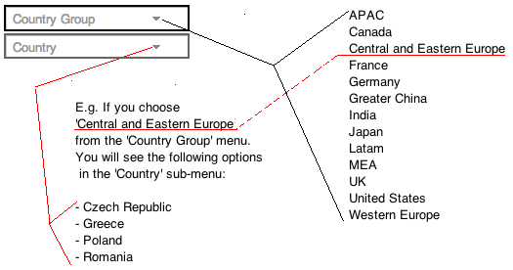
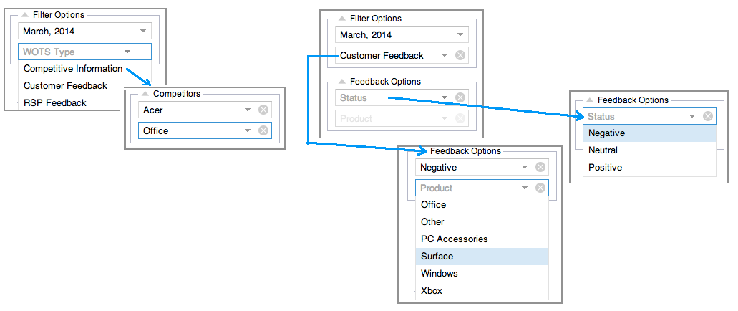

My Saved Reports:

You can also save the current query/filters by clicking on the "Save Current Report" button at the bottom on left pane. It opens a pop up windows where you can enter your preferred title for the query. Checking the 'Set as default view' box will ensure this query is run by default the next time you come to this report. "Edit" button beside 'Save Current Report' button lets you choose and edit one of the previously saved report queries.

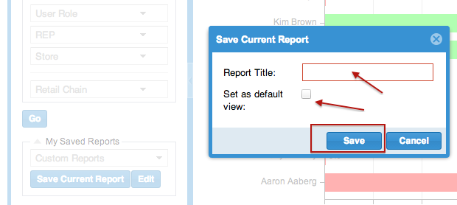

On the bar graph, you can drill into more details double clicking on the bars (E.g. To view the individual visits to a store). Corresponding filter condition is automatically set on the left pane. You can also hover your mouse cursor over the bars to get more details.

Saving / Downloading the Chart:

The "Save Chart" button in the upper right hand corner of the chart area allows you to save / download the chart as a PNG file image. You can use this image in email correspondence, reports and presentations.

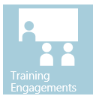

Training Engagements

When you click on "RSP Training" from Dashboard sub menus, you will be able to view monthly RSP training progress.

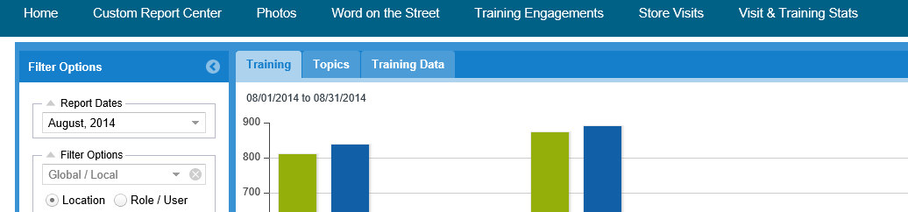

There are three views (tabs) in this report as shown. The Training view (default) and Topics give graphical views, whereas Training data gives tabular data. You can generate histograms (default) or pie charts in graphical Topics view. Data view shows the result on the page as well as give the option to download the report as excel spreadsheet.

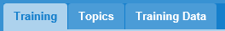
Graphical View:

By default, graphical chart is shown based on filters selected. Legends are shown at the bottom.

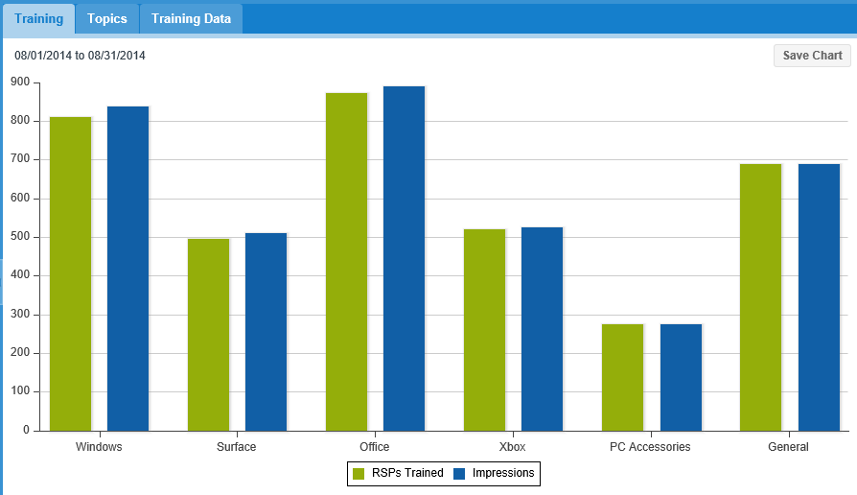

Filter Options:

Basically there are 4 top level filter options. They are 'Month, Year', ‘Country Group’, ‘Country’, followed by the organizational breakdown for that country.

Default report view considers all global and local data. Various report-months can be chosen, current month being the default. Under Location category, you can apply sub-filters based on regions and sub regions as designed in store management page. Role based filters allow sub filters based on various user roles defined in user management page. For a selected user role, you can further filter on individual user names and the stores the user is assigned to. Results can also be filtered based on Retain chain names.

Data View:

A typical date view appears like shown below:

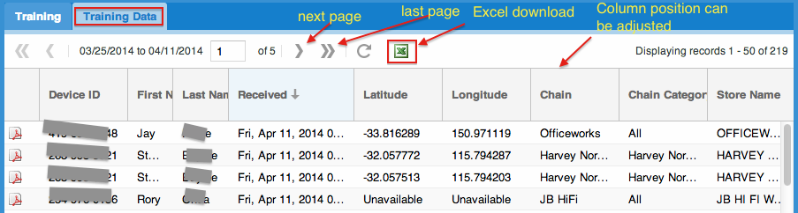

Each record can be downloaded as a .pdf file. The entire report can be downloaded in excel format. Various columns displayed include user details, device details, form fields, location details, form submission start time, end time, duration, trainer signature etc. If there are more data than one page can display, records are paginated. You can navigate across the pages using the controls shown in the picture above. Clicking on the columns will sort the report based on that column values.

For Data view, the following are the various filter options:

The "Save Chart" button in the upper right hand corner of the chart area allows you to save / download the chart as a PNG file image. You can use this image in email correspondence, reports and presentations.

You can save the current query/filters by clicking on the "Save Current Report" button at the bottom on left pane. It opens a pop up windows where you can enter your preferred title for the query. Checking the 'Set as default view' box will ensure this query is run by default the next time you come to this report. "Edit" button beside 'Save Current Report' button lets you choose and edit one of the previously saved report queries. On the graph, you can drill into more details double clicking on the bars or pies. Corresponding filter condition is automatically set on the left pane.

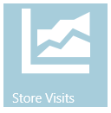

Store Visits

The Store Visits data is extremely useful for managing and monitoring the field teams. It can also provide valuable insights on the visit frequency of individual retail locations. The default view will show global monthly performance to date. The filter options described below will allow the viewer to view specific data groups.

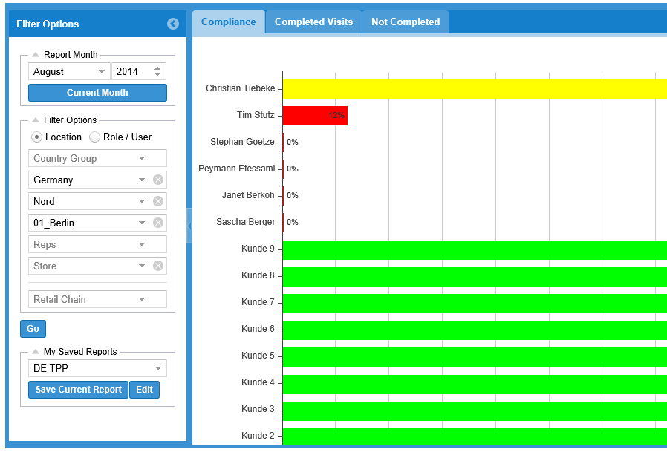

On the left panel, you can use Filter Options based on location or user roles or month. You can just press "Current Month" to return to the present month. Location based filter options allow sub filters based on Country Group, regions and sub regions as designed by subsidiary. Role based filters allow sub filters based on various user roles defined in user management page. For a selected user role, you can further filter down on individual user names and the stores assigned to the user. Once you have chosen the filters, click on the 'Go' button to view the report (horizontal bar graph) on right panel.
The bar graph is color coded based on compliance level effective on the day when the report is generated. If a representative has done more store visits than required to meet his/her compliance level, the percentage figure will be shown as 100+%. For incomplete current months, all figures are prorated (calculated for the portion of the month completed). That is, if the frequency of store visit is set to 8 for a user and if we're only halfway through the month, the number of visits expected up to that point in the month would be taken as 4. If the rep is ahead of schedule and has already completed 5 visits to that store, then the report would show 5/4 100+%. However, the system does not allow the number of visits completed figure to ever be higher than the full frequency number for the month, which in this example would be 8.

You can also save the current query/filters by clicking on the "Save Current Report" button at the bottom on left pane. It opens a pop up windows where you can enter your preferred title for the query. Checking the 'Set as default view' box will ensure this query is run by default the next time you come to this report. "Edit" button beside 'Save Current Report' button lets you choose and edit one of the previously saved report queries.

On the bar graph, you can drill into more details double clicking on the bars (E.g. To view the individual visits to a store). Corresponding filter condition is automatically set on the left pane. You can also hover your mouse cursor over the bars to get more details.

The "Save Chart" button in the upper right hand corner of the chart area allows you to save / download the chart as a PNG file image. You can use this image in email correspondence, reports and presentations.

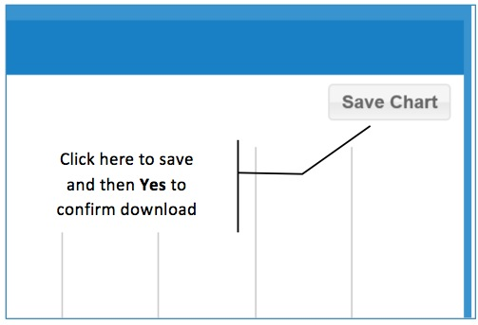

Click Yes in the confirmation pop up to save the file.

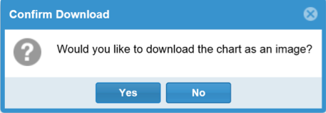

On the right panel, to the right of 'Compliance' chart tab, there are two more tabs: Completed Visits & Non Completed (visits)

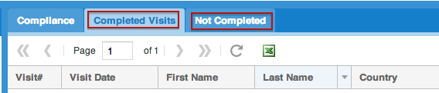

'Completed Visits' will display every store visit that your reps have completed in the month denoted on the filter options on the left. 'Not Completed' will display every store visit that your reps have not completed in the month denoted on the filter options on the left.

The number of store visits is determined by how you set the frequency in how often a rep needs to visit a store. For example, if you have set a rep visit the same store 5 times in a month, and that rep has only completed 2 of those visits, you should expect to see it twice in Completed Visits and that same store listed 3 times in Not Completed. At the beginning of each month, you should expect to see most of the stores in the Not Completed tab and few in the Completed Visits tab. At the end of the month, you would expect to see the reverse: most stores in the Completed Visits tab and less in the Not Completed tab. The benefit here is as you get to the end of the month, a Manager or Administrator could view and export what is left as it relates to store visit compliance.

You can use any of the existing filter options (as mentioned above) to maximize or limit your view as desired (controls on the left). Select the Go button to update your list.

Lists for both Completed Visits and Not Completed tabs include:

• Visit # (if a store needs to be visited 4 times, this will list as the 1 of 4, 2 of 4, etc.)
• Visit Date
• First Name (of rep)
• Last Name (of rep)
• Country
• Chain
• Chain Category
• Store Name
• Store Address
• Store State/Province/Country
• Store Postal Code

Once you have displayed the data in which you want using the filters in the right, you can easily export this information using the MS Excel icon export button.
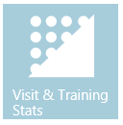

Visit and Training Stats
Unlike other dashboard reports, these are data reports (without graphs) specific to Store Visits and RSP Training. These reports can be used to view numerical / tabular data and download in to excel spreadsheet.

There are two tabs. One for Store Visit Stats and other for RSP Training Stats.

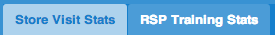

Filter Options:

Both Store Visit Stats and other for RSP Training Stats can be filtered based on report-month, the Country Group, the Country and the name of the user. If no user is selected, the total for the country is shown. After choosing the filters, click on 'Go' button to generate reports.

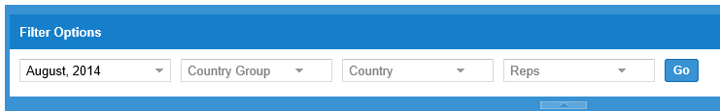

Store Visit Stats:

This report shows data collected through store visit call reports. Each record gives store wise split. Grand total for the month is the bottom most record.

Typical View:

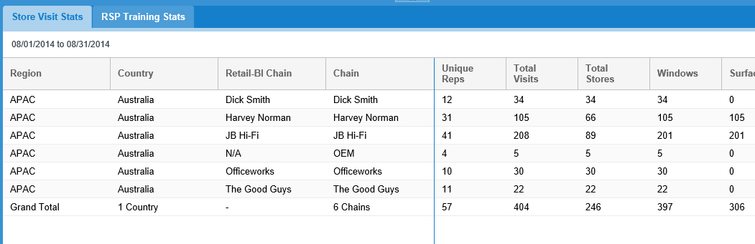

RSP Training Stats:

This report shows data collected through RSP Training forms. Each record gives store wise split. Grand total for the month is the bottom most record.

Typical View:

Note: #RSPs = Unique individuals, # Impressions = Face to face meetings

All of this information is transferred directly to the Retail BI tool (with sub approval)

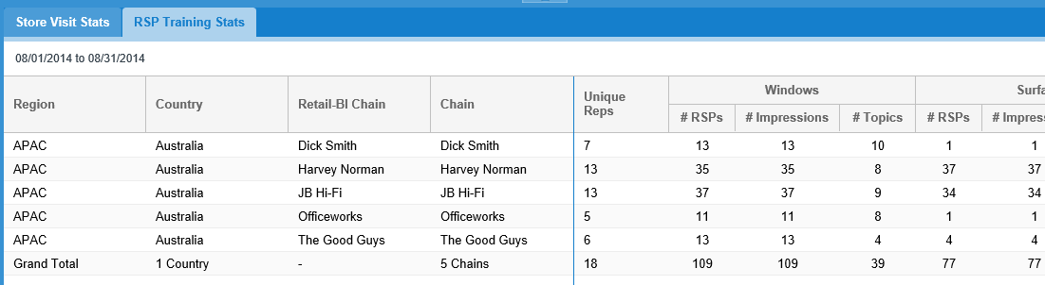

Conclusion

As you can see the Retail Engagement Program (REP tool) has a vast amount of information that can be readily viewed online or easily downloaded for custom analysis. While this guide will assist in navigating the program it is best to peruse its features and drill into data points to best familiarize yourself with its capabilities.

