RECORD SUBMISSION NOTIFICATION FEATURE – TROUBLESHOOTING TOOL
Enter into User Management and click to edit a User, check the box as shown to enable Submission Alerts back to the User/Rep in the field by Email.
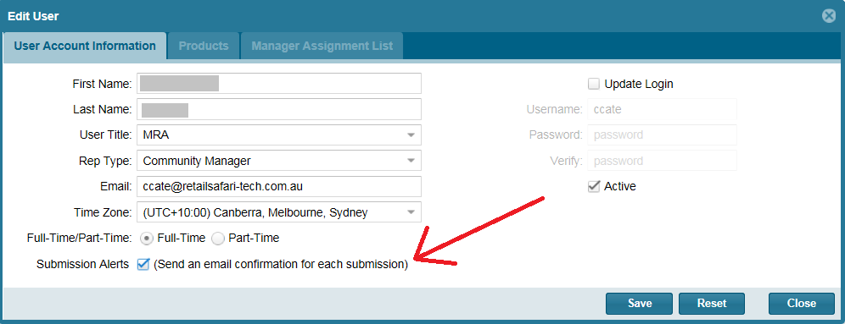

By checking this item to be active, all submissions to the MSFTREPS.com server by this Rep will generate an email acknowledgement back to this user that it was received by the server.
What is this for?
- This is an option to be used as a troubleshooting tool for a Rep claiming missing records or intermittency of records received. For example, a Rep gets to the end of the month and they stated a few records they believe they submitted were not showing on the MSFTREPS.com website. By turning this on, a Rep can now closely monitor all of their activity moving forward, every day, in near real time and report on a missing record immediately versus waiting until the end of the month.
What is this not for?
- Turning this on for all Reps all the time. Technically this can be done but this is a data-intensive function and we are asking this to be used more as a troubleshooting tool for a Rep claiming missing records from month to month.

Important:
- Make sure the email address of the Rep is correct and current. If the email address is wrong, they will receive no notices.
- If a Rep has this feature on, sends in 5 records (for example) and only receives 4 email notices (i.e. 1 missing) or is receiving no notifications on any records submitted, see the next page for Troubleshooting.

TROUBLESHOOTING AND REPORTING A MISSING RECORD
Review the issues and find the one that best matches your experience:

Issue 1 – My Rep is not getting any notifications but records are showing up on the MSFTREPS.com server
Log in at www.msftreps.com and verify that the missing record is missing. It is possible the server has not sent the email to the Rep and the servers in which we are sending to on the side of the Rep are slow or down. If the record(s) are/is on the server:
- Please wait 24 hours for the email to arrive.
- If NOTHING is sending but all the records are showing up on the server, please contact msftreps@westlakesoftware.com and send the following:
I am ________ in country _______. My Rep ________ is sending in records; they are showing up at www.msftreps.com but they are not receiving a notification email back. I double checked to ensure the box is checked for sending notifications and I have verified the email address of the Rep.

Issue 2 – My Rep is not getting any notifications and the records are not showing up on the MSFTREPS.com server
You have gone to www.msftreps.com and were unable to find the record or records in which the Rep is stating is missing. This indicates something is wrong with the client side (app side). From the Windows device or Windows Phone, enter into Settings and Diagnostic Report. From the Diagnostic Report Page, click Copy Diagnostic Report. This places the report on the Windows Clipboard. Paste the report into an email and send the following to msftreps@westlakesoftware.com
I am ___________ in country __________. My Rep _______ is submitting records. I am not finding the records on the MSFTREPS.com server and the Rep is set up to receive notifications and is receiving no notifications. I have attached their most current diagnostic report here: [paste diagnostic report here].

Issue 2 – My Rep is receiving notifications but did not receive every record they submitted today (last few days). Notifications are intermittent; records received on the server are intermittent.
You have verified that some of the records in which the Rep is stating they sent are not on the server; Rep is also stating notifications or records are intermittent. Please send the following along with the diagnostic report (see Issue 2) to msftreps@westlakesoftware.com
I am ___________ in country __________. My Rep _______ is submitting records. Some of the Records are received and notifications sent; others are not showing up on MSFTREPS.com and notification of submission is not being received by the Rep. For example, on the date of ___________ they visited store ____________. There is no record of this anywhere. I have attached their most current diagnostic report here: [paste diagnostic report here].

