Overview
This document covers the expanded functionality for a new role, Regional Administrators. These changes allow a more seamless, multi-country administration of the major functions in REP Tool. The new features include (click to shortcut to the section):
- User Management, Location Management, and Retail Pro Manager
- Creating and deploying Special Project (SP) Call Report Templates and Forms
- Manage Call Reports
- Enhanced Breaking News UI
- Enhanced Resource Files Management
- Custom Reporting Center
- Retail Pro Training Tasks and Files
- Training Dashboards
- Action Center
- Miscellaneous other changes and fixes:
- Support
The term "Regional" in this document simply means that the Administrator has access to create or modify content for multiple countries. Requests to be set up as a Regional Administrator must be sent to Microsoft at msftreps@microsoft.com.

1. User Management, Location Management, and Retail Pro Manager
Content for User Management, Location Management and Retail Pro Manager has been consolidated into one Regional view, which eliminates the need for logging in and out of separate Admin accounts.
In case of store management and user management:
- No changes can be made to the data when multiple countries are selected from the country list dropdown. In short, it changes to a view only mode. However, regional admins can login as the user of any of these countries even in this view only mode.
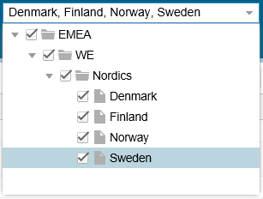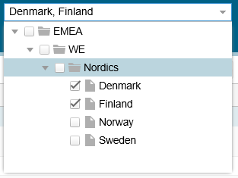
- For changing the data, adding, removing a location/user, a single country must be selected at a time. This rule applies to the User Types section as well in User Management.
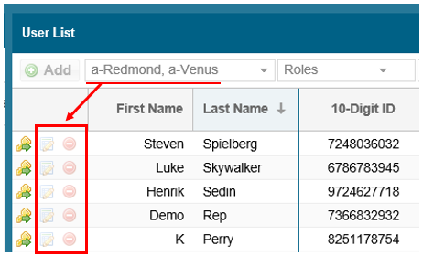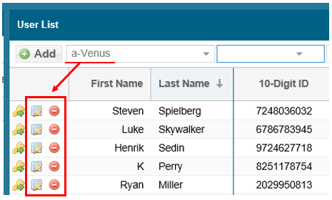
Exception: In the Retail Pro Manager page, you can edit the RP details even when multiple countries are selected in the filter panel.
2. Creating and deploying Special Project (SP) Call Report Templates and Forms
The new functionality allows RA to create a new Special Project template to be available for selected countries. Or you can create a Special Project form for a single country based on a global/regional template. The general steps are as follows.
- After login as the RA, navigate to the menu Call Reports > Create. This will open the Call Report Wizard for building a Special Project template or form.
- Choose your template (existing or blank)
Notes: Global: Special Projects Template has start and end timers. This allows capturing time of specific projects. If there is no need to track time, use the Global: Special Projects – Blank.
- If building a SP template, pick what countries the SP will be applicable.
- Enter in the name of the template, the description and other settings as you have done with SP’s in the past.
- Click Next to continue building the SP by adding prompts, questions, and display messages as usual.
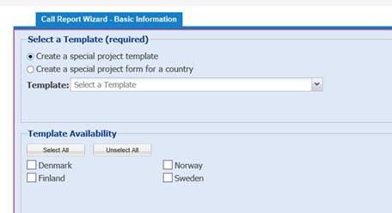
Once a SP template has been created, it will show in the RA’s form list (Call Reports > Manage>> Manage >> Regional View from dropdown in upper right). This will also trigger an Action center item under a new section new forms in Action Center (More on this later in the doc).
The SP template is stored in the list of available templates ready to use in the country’s template list. In the example below, the RA is building a country SP form from a template (also created by the RA). A standard Country Admin could also build a SP form from the same template in a similar manner.
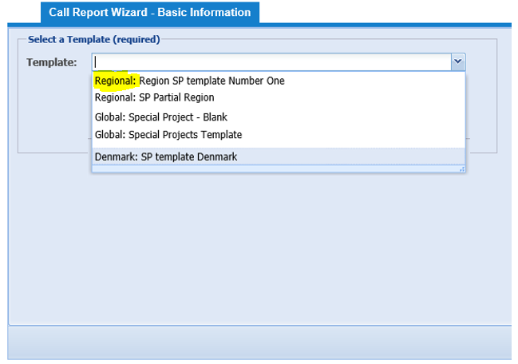
New SP forms created by an RA will show in the country’s form list (Call Reports > Manage >> pick country from dropdown in upper right).
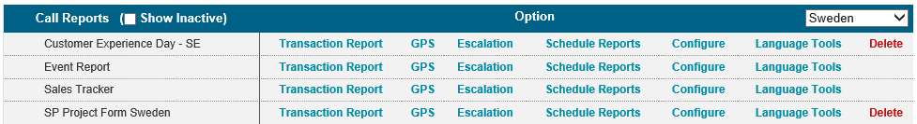
Note: any changes made by the Regional Admin to the SP template once it has been deployed and adopted to use, will trigger an Action Center notification.
The changes made to the start/end date, required special project and active functionalities in the setting tab for the special project templates will reflect on the special projects created based on this template.
3. Manage Call Reports
The Call Reports list will have a new regional copy of the Location Visit Report/Event Report/Word on the Street when country filter is set to Regional View. When configuring any of these call reports, the Regional Admin can now add truly regional level questions.
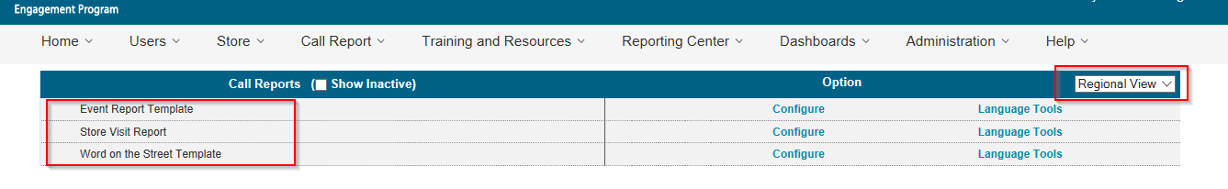
- Select Regional View from the dropdown on the right (the default)
- Click on Configure to open the regional copy of the Location Visit Report form
- Add and edit questions in the usual manner as before. The source of the question added in this manner will be ‘Regional’.
- To select countries which the regional questions apply to, use the Regional Access tab (default is all)
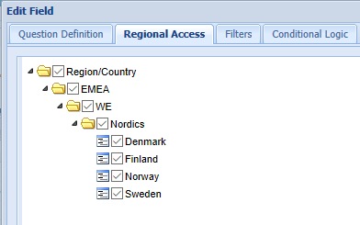
- Use the new set of view or hide checkboxes at the top of the question list for filtered viewing of questions by source as Global/Regional/Local. These checkboxes have been installed for all of the call reports.
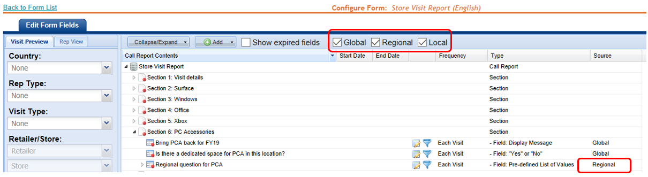
Note – In the Regional View of these call reports, there will be no Local questions shown. To see Local questions, select a country in step “a” above.
4. Enhanced Breaking News UI
The new functionality allows RA to create Breaking News articles for some or all of their countries. The general steps are as follows.
- After login as the RA, navigate to the menu Training and Resources > Breaking News.
- Notice the source of the article can be denoted as Regional now.
- Click Create New Item, which opens the popup.

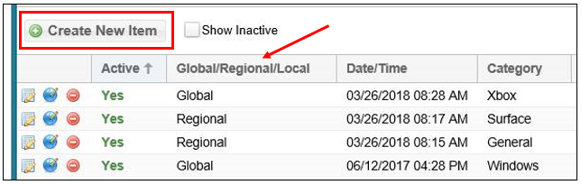
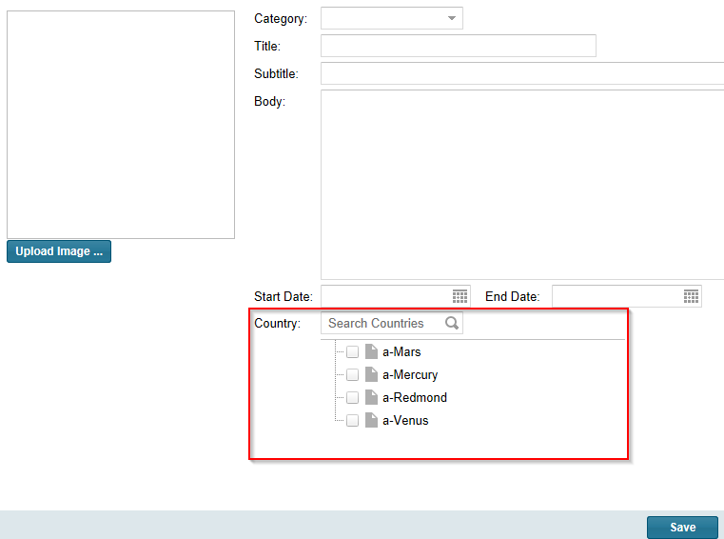
- Add the required elements as previously done and then chose the countries to deploy the article. Once saved, the article will trigger a notification in the Action Center for each country where you can translate and approve as needed.
5. Enhanced Resource Files Management
Content has been consolidated into one Regional view, similar to Breaking News above. The general steps are as follows.
- Navigate to the menu Training and Resources > Resource File Management.
- Notice the source of the file can be denoted as Regional now.
- Click Upload, which opens the popup.
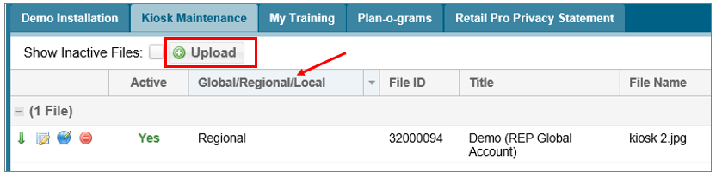
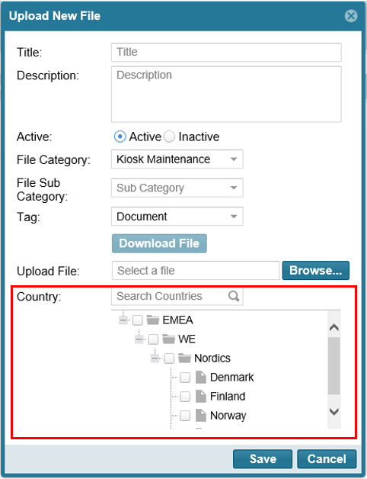

- Add the required elements as previously done and then chose the countries to deploy the file. Once saved, the article will trigger a notification in the Action Center for each country where you can translate as needed.
- Important note: If you intend to link the file to a call report question in the Location Visit Report or a Special Project call report, make sure to select the applicable countries here to avoid an error in Action Center.

6. Custom Reporting Center
Custom Reporting Center has been modified to choose and then see the source of the questions: Local, Global, and Regional.
- Navigate to the menu Reporting > Custom Reporting Center.
- Select the Region (“All”) or country from the dropdown on the upper left.
- Select the report type from the dropdown on the upper right.
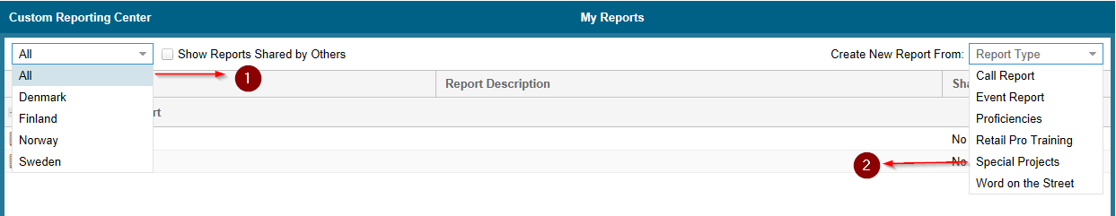
- Continue to build the report as done previously.
- Note here that the questions available to select will be determined by the country dropdown in step b.
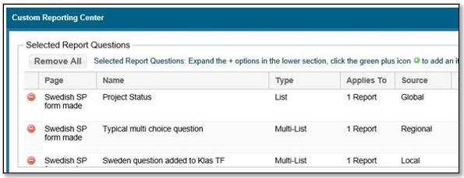
PS: The source will be displayed in both the report page and excel file exported where the source will be given next to the prompt.
A new feature has been implemented for regional admin users. The regional admin can see all the questions added by country admins to the Special projects (Local Questions) which were created based on the special project template created by the regional admin.
- Navigate to the menu Reporting > Custom Reporting Center.
- Select the Region (“All”) or country from the dropdown on the upper left.
- Select the report type(special projects) from the dropdown on the upper right and click on special projects
- Select the special project template added by regional admin and continue
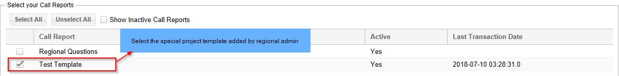
The country name will be given along with the local questions added by country admins as seen from the image below. The respective special project name created based on regional template can be seen here.
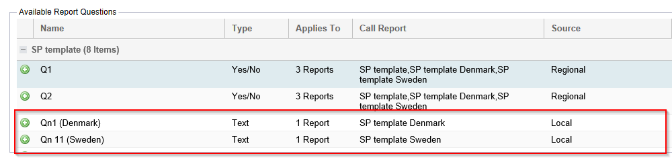

7. Retail Pro Training Tasks and Files
Content has been consolidated into one Regional view, similar to Resource Files. The general steps are as follows.
- Navigate to the menu Training and Resources > Retail Pro Training Tasks and Files.
- The view can be adjusted with the Country dropdown in the upper right corner of the page.
- Notice the source of the file can now be denoted as Regional.
- Click Add in the month-by-month content view, which opens a popup window.
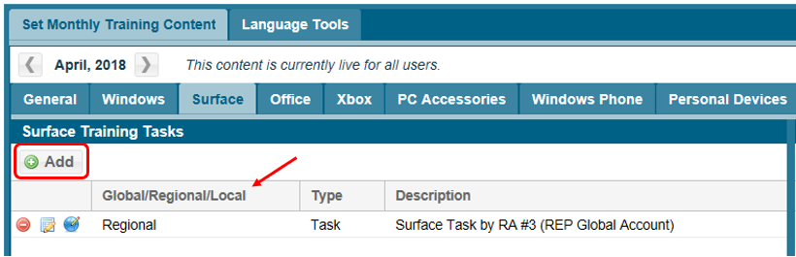
- Click Create Task (or Upload File if working on a training file) in the popup.
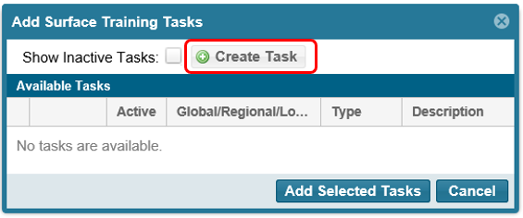
- Configure the Task as needed and then Save:
  - Enter Task name that your Reps will see in the Retail Pro Training form
  - Add a file to guide what is to be accomplished (optional)
  - Select which countries in the region will receive the Task, with an Action Center approval
  - Checkmark to not allow the country admin to dismiss the Task in Action Center (optional)
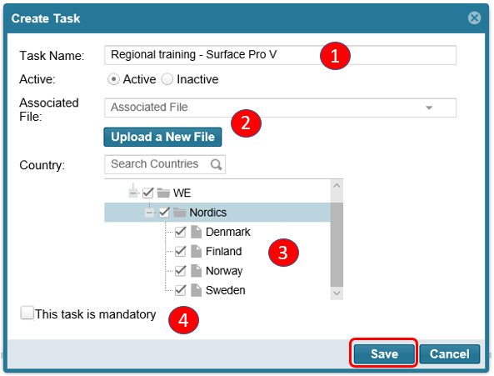
- The new regional Task will appear the Add Category Training Tasks assignment popup ready to be check-marked and assigned into the month-by-month view.
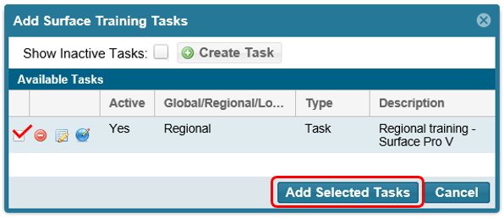
- Adding the Task to a training month will trigger a notification in the Action Center for each country where it can be translated and approved. (Example below where the new Task was added to April.)
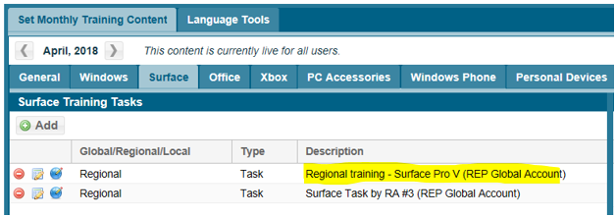
- Important note: If you added an associated training file in the Task, make sure to add that to the same month as the task, similar to step f above.

8. Training Dashboards
Retail Pro Training filter panel has been modified to use the new filter style for country selection and report on any Regional Tasks that have been added. Navigate to the menu Dashboards > Retail Pro Training.
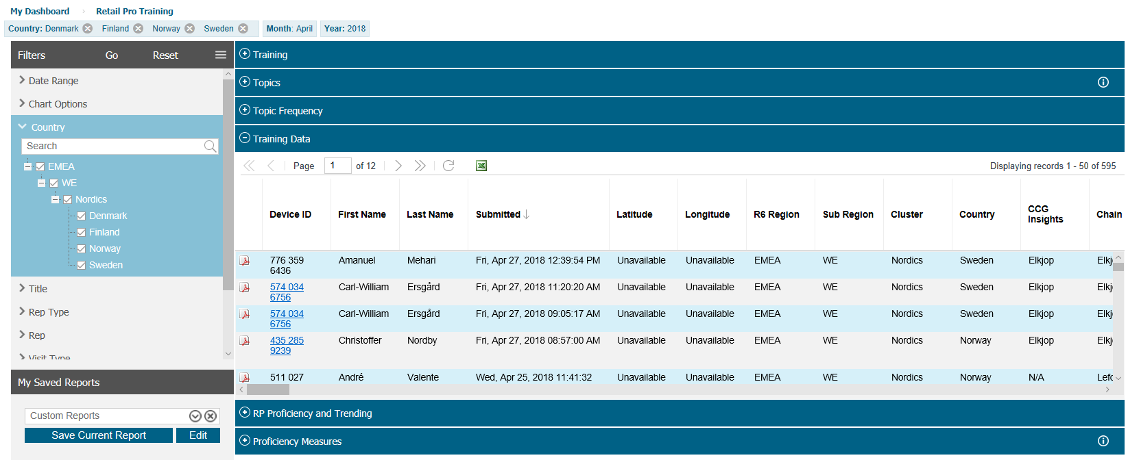
The Retail Pro Training filter panel has been upgraded with a new filter for Task Source and labeling for Global/Regional/Local Tasks and Proficiencies in the reporting. This can be found in the menu Dashboards > Retail Pro Training.
The data available in the whole Retail Pro Training dashboard gets filtered based on the source filter selected in the filter panel.
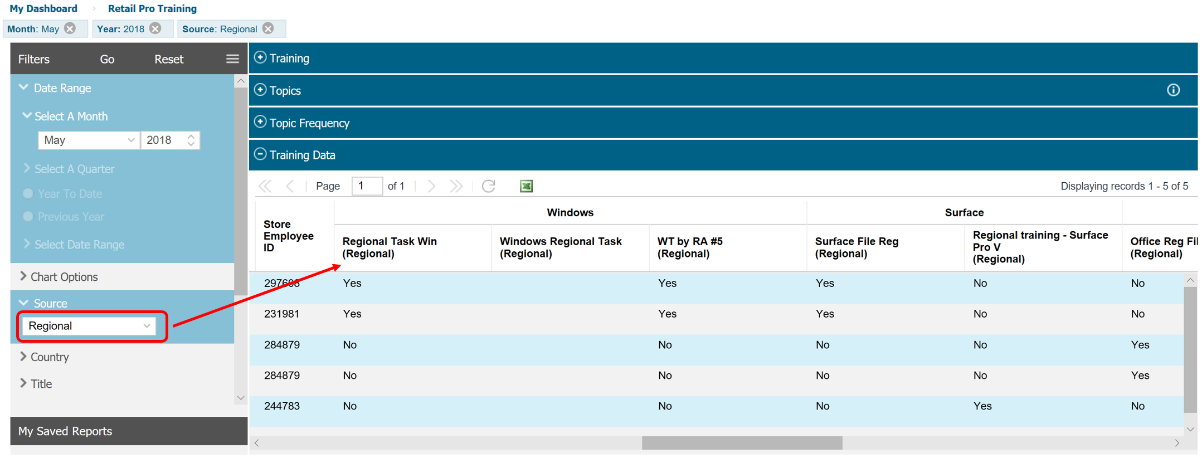

9. Action Center
Action Center has been given a major upgrade to view items for multiple countries and allow approvals for multiple items at once. The new Toggle Grouping button will offer a new item-by-item list. The general steps are as follows.
- Navigate to the menu Administration > Action Center
- The page can be adjusted to either a Report View or an Approval View with a new selection option in the upper right corner
- Click Approval View to use the Country dropdown in the upper right corner to select countries; you can filter by notification type as done before and then approve Action Center items
- Use the new filter option for New Forms to see consolidated Special Projects call reports notification items
- Click Report View and use the filter panel to select countries to view Action Center status for the region
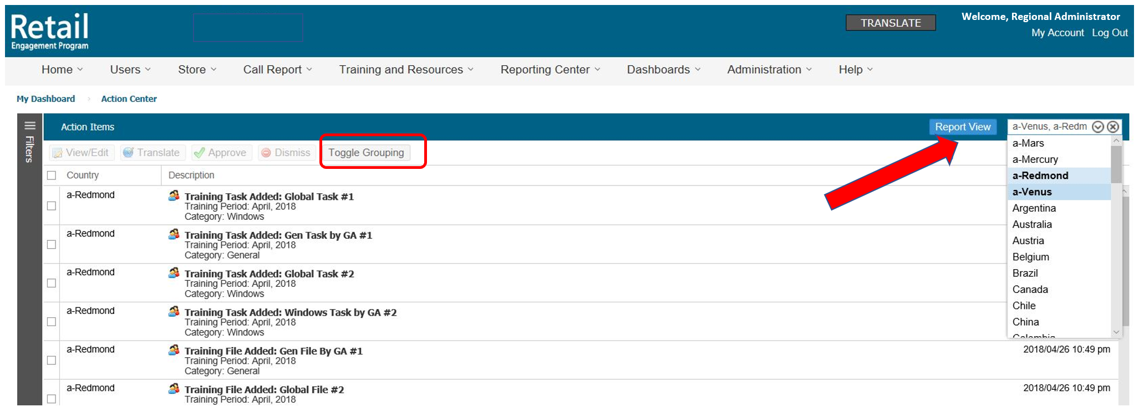
- When using the New Forms item approval, select the Special Project form in the list and click the option to View/Edit; a pop-up confirmation message will appear and then open the form wizard to configure the form with regional questions
- Configure the Special Project form for the region countries, localizing each country one at a time; after completing the form, the site will navigate to the Call Reports > Manage page, and the action center notification for the new form is removed for the corresponding country
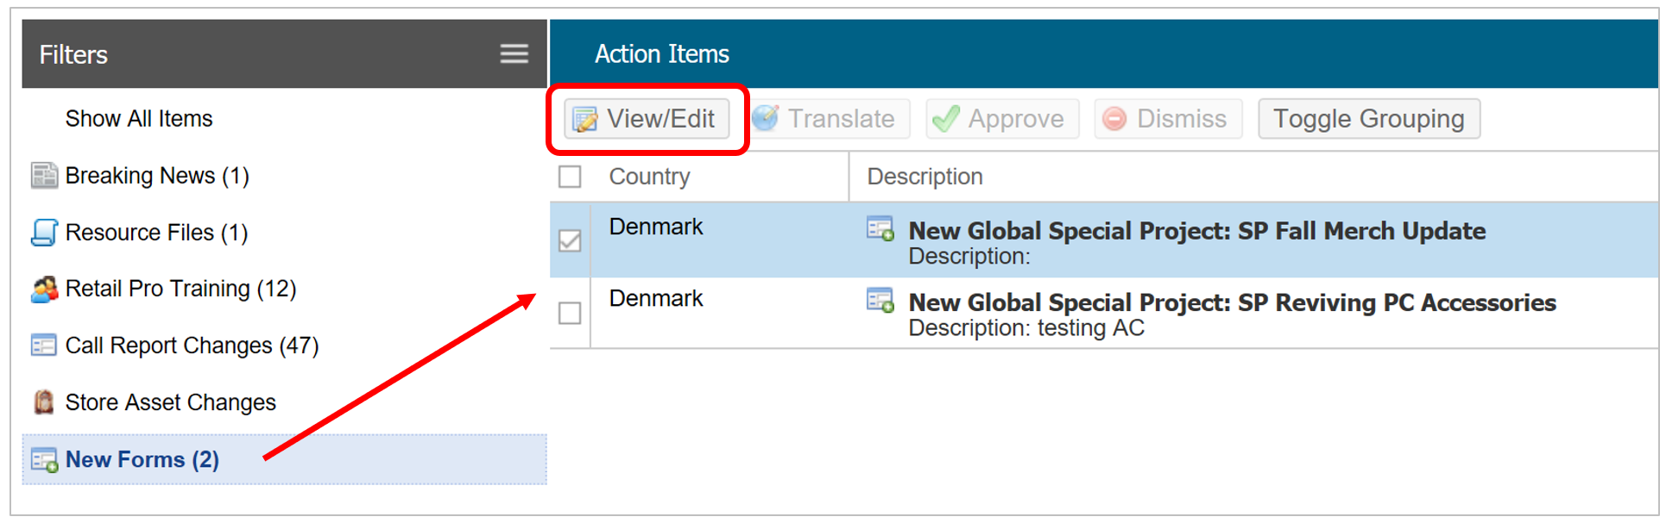
Multiple approvals for items other than New Forms can now be done using the checkboxes on the left. Select all the items with the top checkbox or just the items you want to approve. Then use the Translate or Approve buttons.
Multiple approvals work only if the action items are same but the countries are different. Multiple approvals of different action items (say a resource file and call report item or different resource files) are not possible.
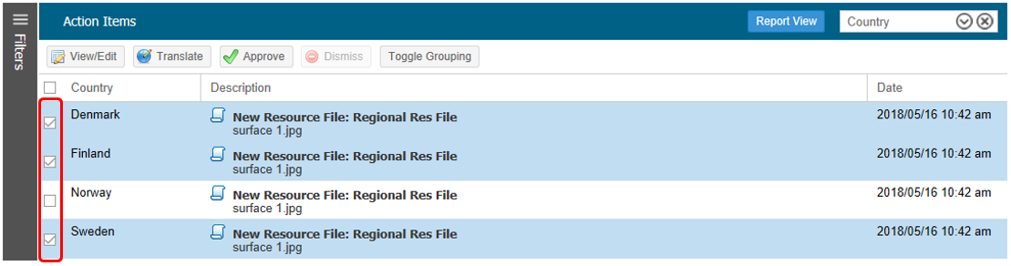
10. Miscellaneous other changes and fixes:
- Direct viewing of Resource File - use the new View File button in File Link questions to preview the file that has been selected in the dropdown, as a convenient way to preview the chosen file
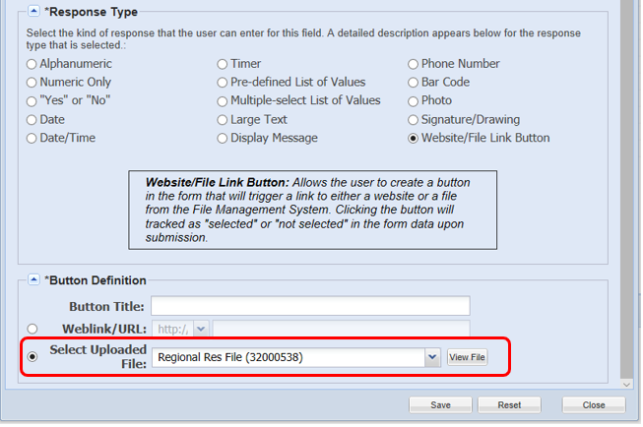

- Check All option in the Location Visit Report – added a simple checkbox option in the questions Filters tab when assigning a question to specific stores; allows the check or un-check of all stores in a Partner chain
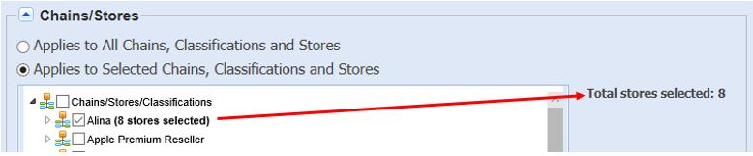

Partial Search – The search functionality has been optimized throughout the site with the implementation of partial search. There are two parts to this:
a.) Additional search functionality in various places of the UI
Example in System Users Report. Enter part of a name, or user ID and click Get Results. See the results actually listed, not just in the search dropdown.
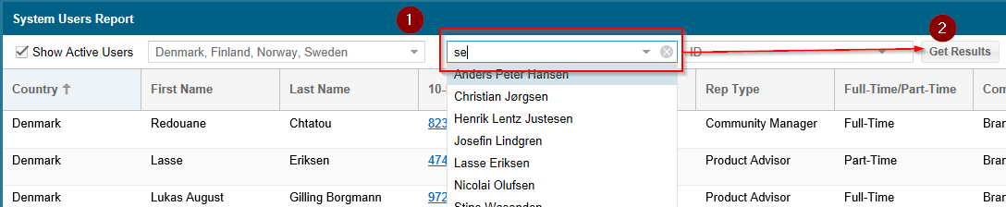
Partial search results in Location Management, User Management:
Example, if the user wants to see the results for all store names with the word “Stockholm”, enter “Stockholm” and click on Get Results button. This will fetch you all the stores names which include the term “Stockholm”. Same for other “Filter By” search options (Global store ID, etc.). This feature has been also enabled in stores tab for call report settings, store assignments, calendar, reps field in Retail Pro Manager page
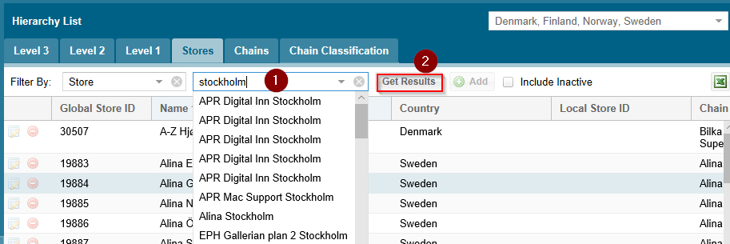
Add Search by Token in RP Manager: Search by token is the new field added in Retail Pro Manager to make the search for Reps simpler and more efficient.
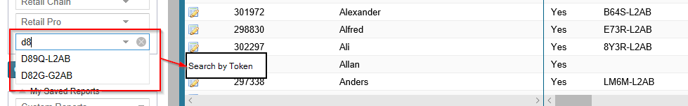

b.) Additional search functionality for stores in call reports
Partial Search enables the user to enter some search text which results in the tree conforming to the text entered. The stores can be check marked after the list shortens to the matched stores. Then the steps could be repeated to add an additional set of stores.
The search should be allowed to reset by pressing the “X” as shown in the right mockup.
The Total stores selected count increases or decreases with each additional selection. This feature can also be seen with the country list on the regional access tab of a regional question added from regional view.
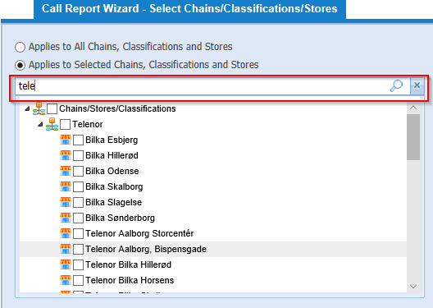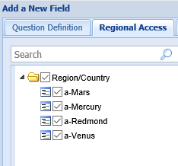
Warning message that multiple admin users in REP Tool are editing the same UI
With the implementation of this feature, only one admin can make changes to a call report at a time. If any other admin tries to access the same time, he will receive a warning message. On clicking the cancel button in the warning message, the user will be redirected back to the form list.
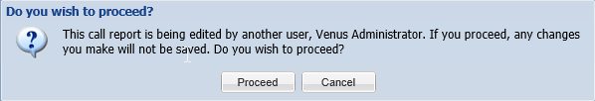
The admin can continue to the configure page by clicking the proceed button, but any changes made when the other admin is on this page will not be saved. There will be another warning message which will inform the admins to try after some time.
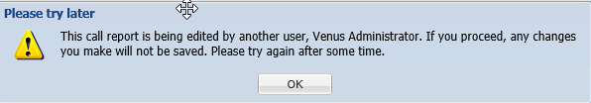

11. Support:
If you encounter any issues, please use the Msftreps.com online support request found at Help > Technical Support. If there are screenshots or other text included in a language other than English, please offer the translation.
You can also send reports of any issues to msftreps@westlakesoftware.com. Include the following (cut and paste this into your email):

Region / Country:
Your computer’s Windows version (Windows 10, 8, 7, XP):
Browser information:
Menu name, Call Report name, User name, and Location name with the issue:
Description of the issue with any screenshots or error messages:

Note: The more information you can give us here, with steps to duplicate how it happens, the better we will be able to address.

