Rep Goals Dashboard
The Rep Goals dashboard provides a more effective and convenient way to create and track visit and training goals down to the Rep Level. Admins can set goals for each month individually or copy them from month to month.
The new dashboard can be accessed by Admins, Managers, and Reps in the menu system: between My Dashboard and Compliance under Dashboards.
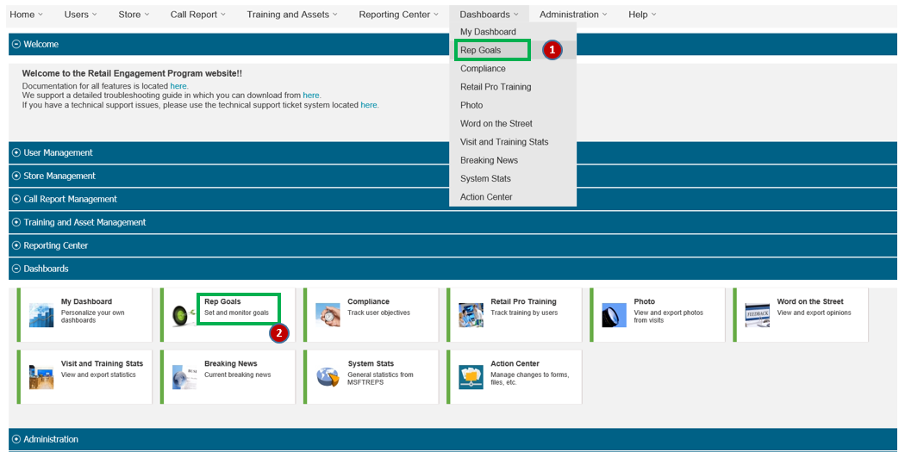
Figure 1
The default view for the Rep dashboard will be with ‘Rep Goals to Target’ tab as shown in Figure 2. This has the name of the Rep down the left and 5 goal categories across to the right.
- Store Visits – Number of unique store visits done by the rep
- Stores Covered – Number of stores covered by the rep
- Time in Store – Time spend by the rep in stores for completing store visits
- 1: 1 Training – Number of unique Retail Pro trained by the rep
- 1: Many Training – Number of event report submitted by the rep
Each cell is marked in a different color based on the progress made by that rep towards the target assigned.
- Not Set – Admin has not yet assigned a target for that particular rep.
- Red – The progress made by the rep towards assigned target is less than 84%.
- Yellow – The progress made by the rep towards assigned target is between 84% - 99%.
- Green – The progress made by the rep towards assigned target is greater than 99%, the rep has attained the expected target.

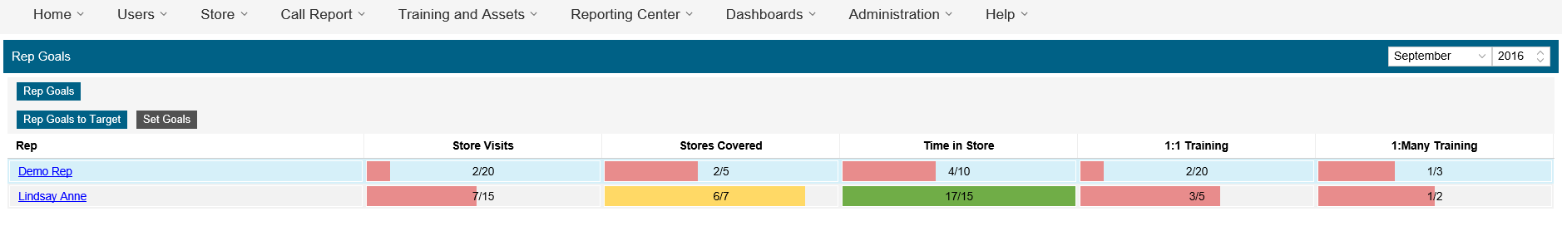
Figure 2
Assigning Goals
Goals for the individual rep can be assigned through the ‘Set Goals’ tab. (The new tab design now uses buttons as shown in green or gray and only available for the Admins to use.) This shows the name of the Rep down the left and 5 goals assigned across to the right. Each field under each goal is editable (click on them). Changes are saved as entered (on-the-fly). See Figure 3.
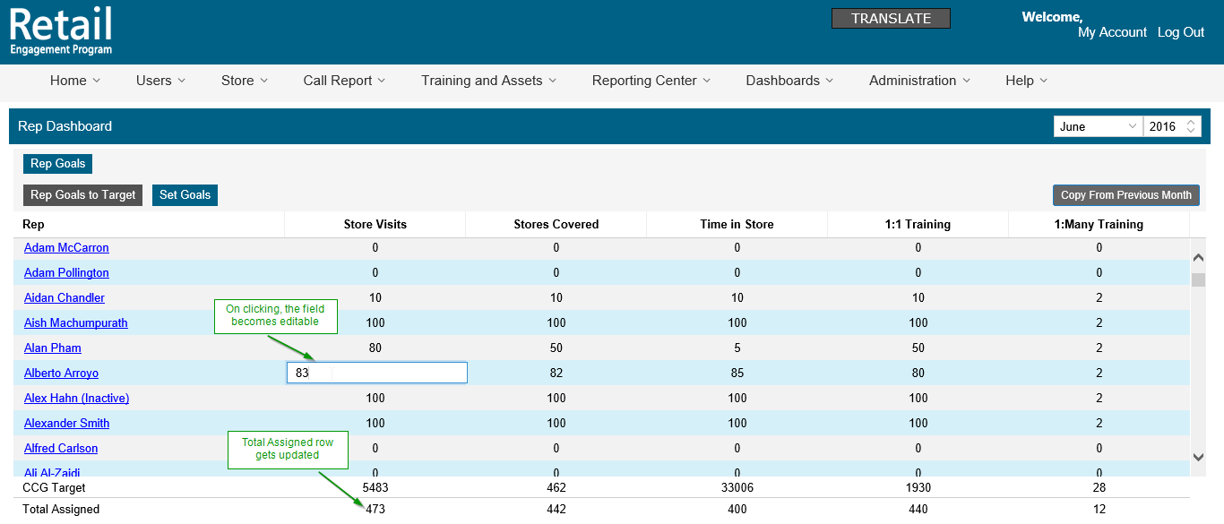
Figure 3
The ‘Total Assigned’ row provides the sum of the goals you assigned to your Reps. Whenever the goal for a particular rep is updated, count in the Total assigned column also gets updated.
Month Controls:
- There is a drop down provided in the top right-hand side which will help in selecting a different month. By default, current month will be selected.
- There is a ‘Copy from Previous Month’ button provided on the top. This will help in copying Goals for the reps, from the previous month. If most of the targets for a month or a previous month is expected to be the same or close to the same, you can now click this button and the goals will be updated from the previous month.

Rep Goal Detail
The rep names in Figure 2 are links which will drill into the Rep Goal detail in Figure 3. This page is a more detailed graphical view of the progress each rep is making. These graphs are similar to the monthly and quarterly goals in My Dashboard, broken down to Rep level.
Figure 3
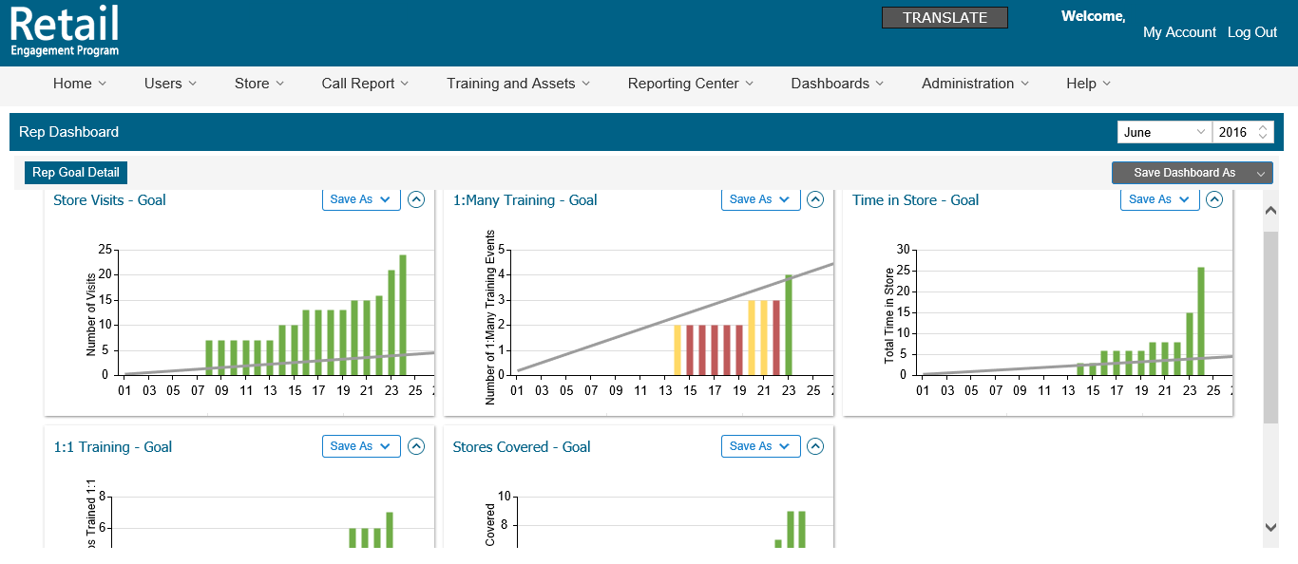
These graphs can be exported individually or as a whole into Image, Excel and PPT. The graphs can be moved, collapsed and resized. The graphs are plotted in different colors based on the progress made by that rep towards the target assigned within the selected month.
- Red – The progress made by the rep towards assigned target is less than 84%.
- Yellow – The progress made by the rep towards assigned target is between 84% - 99%.
- Green – The progress made by the rep towards assigned target is greater than 99%, the rep is maintaining or has attained the expected target.

