

Representative User Guide
Version 112415

November 24, 2015

WELCOME TO THE RETAIL ENAGEMENT PROGRAM!


After reading this document, you should be able to:
Find your personal REP ID number.
Install the software on your Windows Phone or Windows 8.1+ Device
Use the REP tool on your mobile device.
View your statistics online at www.msftreps.com.

This document includes:
- Quick Setup Guide: Windows
- Quick Setup Guide: Windows Phone
- Detailed Manual on Windows, Windows Phone and www.msftreps.com.

Table of Contents
Welcome 5
What is the Retail Engagement Program? 5
Quick Setup Guide: Windows 8.1/10 6
Quick Setup Guide: Windows Phone 8
Get Started 11
Get Your Personal REP 10 Digit ID Number 11
Mobile Devices 13
Windows 8.1 + 14
Windows 8.1+ Set Up/Installation 14
Getting to Know the Windows App 17
Windows 8.1+ Settings 18
Breaking News, Resource Files, Call Reports 21
Windows Phone 32
Windows Phone Set Up 32
Windows Phone Usage Instructions 35
Settings 35
Breaking News 36
Resource Files 37
Call Reports 38
Word on the Street 39
Event Report 40
Store Visit Report 41
Retail Pro Training 42
MSFTREPS.com - Viewing Your Information Online 45
Welcome and Set Up 46
Call Reports 46
GPS/Mapping 47
Custom Reporting Center 49
Scheduling Custom Reports 51
Dashboards 53
Common Controls 53
Compliance 54
Retail Pro Training 56
Photo Dashboard 58
Word on the Street 60
Visit and Training Stats 62
Breaking News 63
System Stats 64
Calendar 65
Frequently Asked Questions 66
Technical Support 67


Welcome
Welcome and thank you for participating in our global retail initiatives!
This manual includes:
- Quick Setup Guide – Windows 8.1/10 (Page 6)
- Quick Setup Guide – Window Phone (Page 8)
- User’s Guide (Page 11 – Get Started)


What is the Retail Engagement Program?
The Retail Engagement Program, often referred to as “The REP Tool,” is an application for Windows Phone and Windows that tracks your activity when visiting a retail location. It combines:
- A Breaking News feed from both Microsoft Corporate and the company you work for.
- Resource files in which can be PDFs, power point documents, video files; any supported files that are designed to make you more productive.
- Call Reports or forms in which are put together by both Microsoft and the company you work for in which you will complete each time you visit a retail location.
The REP Tool also has a server side component as well. This is located online at www.msftreps.com. MSFTREPS.com is a location in where you can log in and review the work in which you have submitted. This includes a calendar, reporting tools and dashboards to view your data. It also includes your personal REP ID number. You will need to login online first to get your ID number. This will be used when setting up your device. This manual is in the following order:
- Go online to get your ID number
- Step-by-step on how to set up and use REP on both Windows 8.1+ and Windows Phone
- Detail in how to use all features accessible by a Rep on the server

Quick Setup Guide: Windows 8.1/10
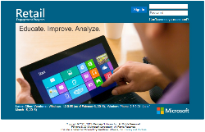
Step 1 - Get Your 10 Digit ID number
- Go to: www.msftreps.com

- Login to the website using the first initial of your first name and your last name together, all lower case. If your name is John Smith for example, you would use jsmith and jsmith as both the user name and password.
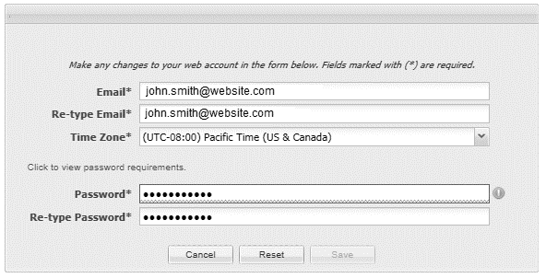
- You will be prompted to change your password. Passwords require you use at least one of the following characters: !@#$%^&*+=()[]{}|\’~,.;:/?

- Enter your password twice and select Save.

- This will take you to the main page of the site. Your 10 digit ID number will be located on the screen in the upper-right by your name.
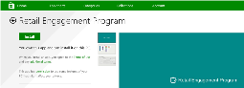
Step 2 – Download and Install the Application from the Store
- Enter the Windows Store from your device

- Search the store for: Retail Engagement Program

- Initiate the download process: select Install.
Step 3- Setting up the Program for the First Time
- Click on the tile called Retail Engagement Program

- Accept or Reject the Location Question

- Enter in your 10 Digit ID number and select OK
Step 4 – Running the Application for the first time
- After you enter in your 10 Digit ID number, the app will synchronize with the server and start to download your call reports and all associated files.

- Associated files can take 2 minutes to 20 minutes to load when using the application for the very first time.

- It is recommended you wait until the files finish loading. Status is indicated at the top right of the screen under the Inbox indicator.
Step 5- Call Reports, Resources, Breaking News
- Call Reports are with Blue tiles and on the top. Resources are with Purple tiles and are in the middle. Breaking News items are on the bottom and support a wide variety of colored tiles.

- Click each tile to view its contents.

- Detail of each section can be found in the longer User Guide in this document.
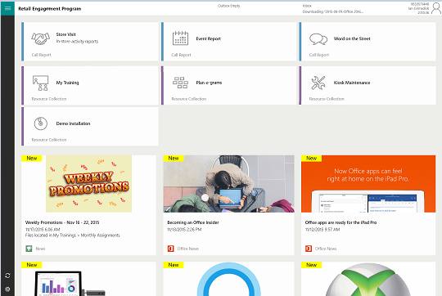

Quick Setup Guide: Windows Phone
Step 1 - Get Your 10 Digit ID number
- Go to: www.msftreps.com

- Login to the website using the first initial of your first name and your last name together, all lower case. If you name is John Smith (for example), you would use jsmith and jsmith as both the user name and password.
- You will be prompted to change your password. Passwords require you use at least one of these characters: !@#$%^&*+=()[]{}|\’~,.;:/?

- Enter your password twice and select Save.

- This will take you to the main page of the site. Your 10 digit ID number will be located on the screen in the upper right by your name.
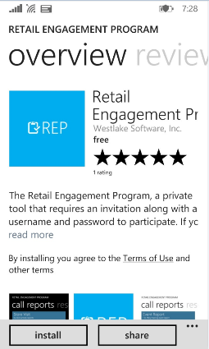
Step 2 – Download and Install the Application from the Store
- Enter the Windows Phone Store from your phone.

- Search for Retail Engagement Program

- Select Install

Step 3- Setting up the Program for the First Time
- For the initial setup, please turn off cellular and conduct Step 3 and Step 4 using Wifi.
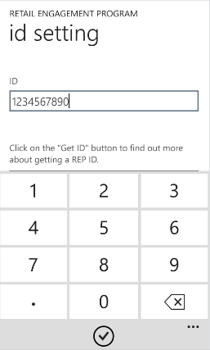
- Enter your Apps directory and click on Retail Engagement Program.

- Enter in ID number on ID Setting page

- Select the check box at the bottom of the page
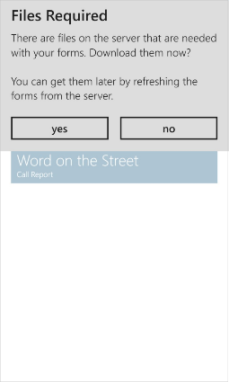
Step 4 – Running the Application for the first time
- The application will prompt you about Files Required.

- Select Yes if you are using Wifi, select No if you are on Cellular service.

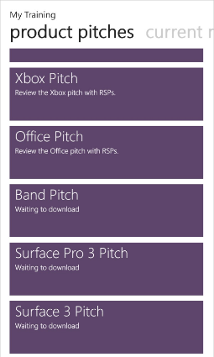
- It is recommended that you wait until all files have downloaded before using the application. This can take a few minutes to as much as 30 minutes depending on the volume of files, etc. your company is supporting. How do you know when it is done downloading? Enter into Resources (purple tiles) and view the status of the last item in this list. When all the status lines stop saying Waiting for Download; everything will have downloaded.

Step 5- Call Reports, Resources, Breaking News
- Once on the main screen, swipe left and right to see Call Reports (blue), Resources (purple) and Breaking New (green) (note, Settings are in Orange).

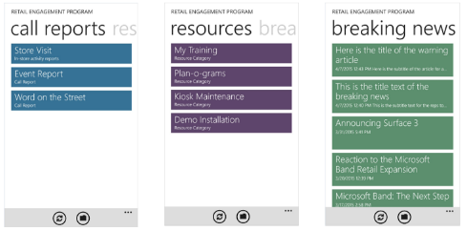

- Click on each section to use.

- For more detail on how to use the application, see detail on Windows Phone usage in this manual.


Get Started
To get started, make sure you have:

- A fully charged Windows Phone or a Windows Device running 8.1+ with Internet Service active.
- A Personal Computer with Internet Access (this can be the same computer in #1 running Windows 8.1+ – Surface, etc.).

Get Your Personal REP 10 Digit ID Number
Your ID number is used to synchronize your store lists and call reports, back and forth between the online servers. Every Rep has their own unique 10 Digit ID number; this is how you get yours:

STEP 1 - From your computer, point your browser to www.msftreps.com
This will take you to the Username and Password page:

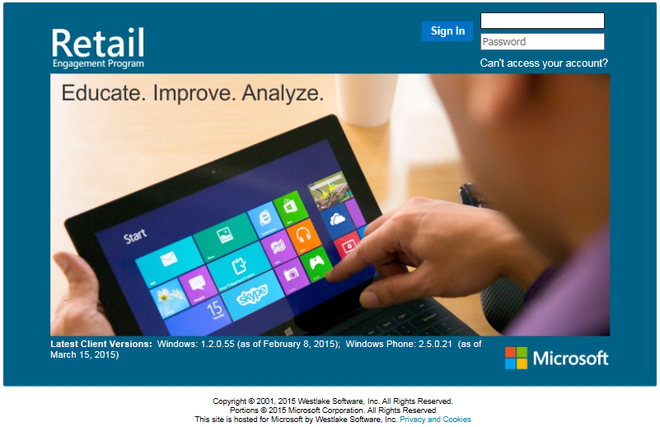

STEP 2 - Your starting username and password is the first letter of your first name and your last name together; all lower case. For example, if your name was John Smith, your initial user name and your initial password are both: jsmith.
What do I do if this did not work?
Please contact the Administrator at your company to ensure they have set up your account.
STEP 3 - You will be prompted to change your password (as shown below) before you can enter the site for the first time. Change your password and select the Save button.
Note: Passwords must contain at least one of the following special characters: -_!@#$%^&*+=()[]{}|\’~,.;:/?
STEP 4 - Once you are on the main page (shown below), your 10 digit ID number is located in the upper right of the page:
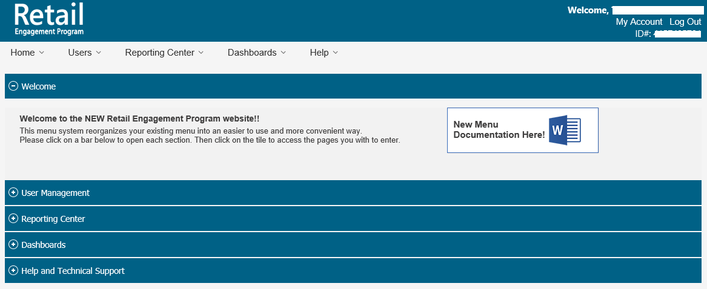
STEP 5 – Write your ID number down. This is will be used in the next section when setting up your mobile device.
For more information on the online features, please see section called: Viewing Your Online Information.

Mobile Devices
Note: If you have not retrieved your 10 digit ID number as noted from the previous section, this is required when setting up your mobile device.
Windows 8.1+ and Windows Phone support different instructions. Windows Phone Set Up and Usage Instructions follows the Windows 8.1+ instructions below.

Windows 8.1 +

Windows 8.1+ Set Up/Installation
The Retail Engagement Program is an app in the Windows Store.
STEP 1 – Locate the Store tile in your Metro interface. It is often depicted as a green tile and a shopping back icon with the Microsoft Logo on it:
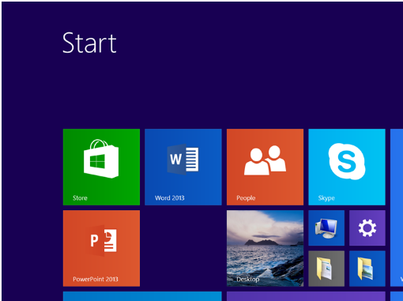
- Every device running Windows 8.1/10 can be different. The icon may not be included on your main page, or it may be a different size, etc. You can also select the Windows logo on your keyboard and just start typing the word: Store
- If you have not set up Store access on your device, you will need to do this as your first step.
STEP 2- Enter the Store and search for: Retail Engagement Program (not Rep or Rep Tool). As you type, the application will become available as a selection:

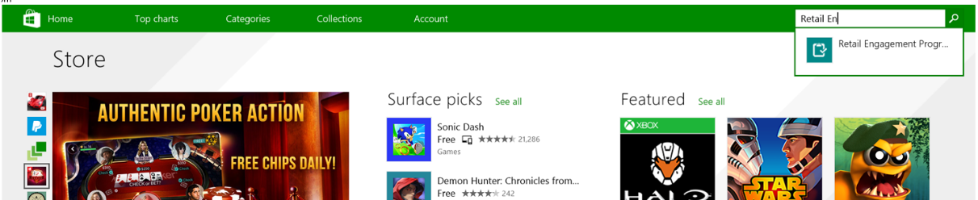
Step 3 – Select in the Install button to install the application.
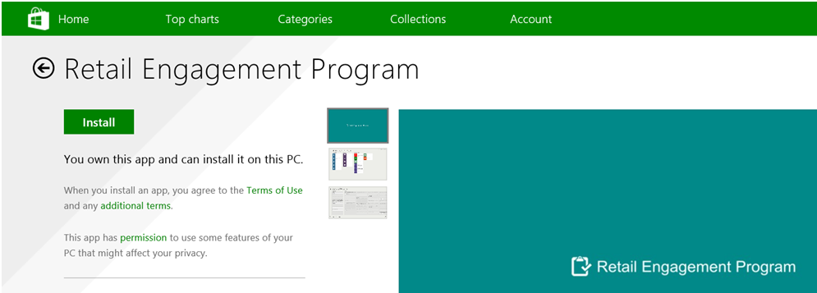
Step 4 – Find the Application Icon in the Metro interface. The REP icon and tile look like this:

Step 5 – Click on this tile to run the application for the first time. The application will load and take you to an Allow screen:
Step 6 – Select to either Allow or Block the Retail Engagement Program to use your location. Allow is recommended.

Step 7 – The application will ask you to enter in your 10 digit ID number. Enter your ID number and select the OK button. The OK button will become active once you have entered in your ID number. 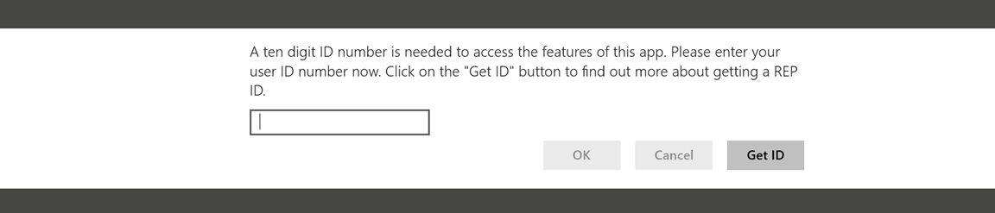
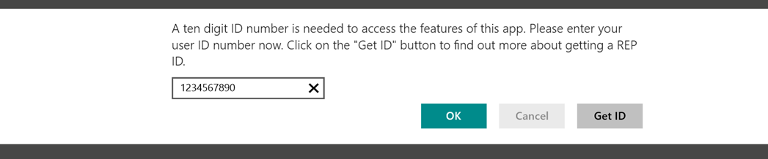
This will take you to the Main Page of the Retail Engagement Program. The program will start to download support materials associated with your account. You can see this activity labeled as the Inbox in the upper right of the screen.
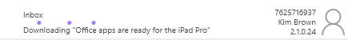
Please wait until the main page has completed download all of the associated files. This can take a few seconds or many minutes depending on the size and number of files associated with your account.
Does the screen now look like the one shown on the next page or does it look like you are missing all call report tiles, no resources and no breaking news items?
It is possible you have mistyped your ID number. Swipe in from the right to left (8.1) or Select Settings icon in the very lower left (Windows 10), select Settings and then Preferences, change your ID number and select Change ID. If the Change ID field is not in an active state, exit the program, re-enter and try again.

Getting to Know the Windows App
ID Number
Name
Version Number
Outbox
Inbox

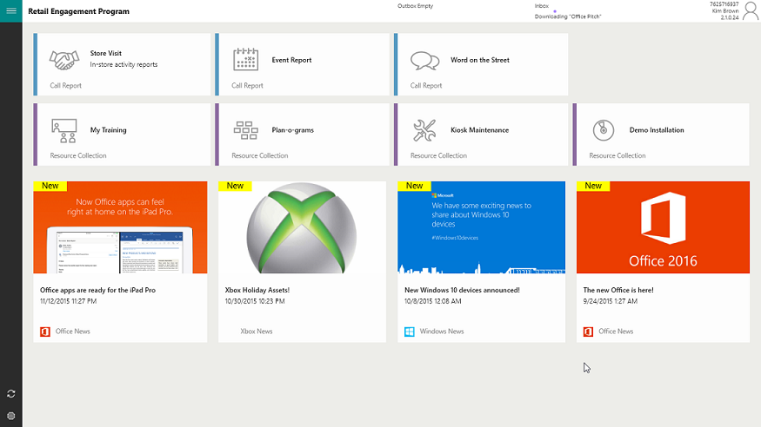
Call Reports/ Forms to be completed
Breaking News Feed
Resource Files (document management)

Outbox | The Outbox displays records that are pending that have not been sent to the server (working out of wireless coverage).
Inbox | The inbox shows the status of support materials downloading.
ID Number | Your REP ID number
Name | Your Name
Version Number | Version number of the current app.
Call Reports | Tiles to select all required call reports to send in information.
Resource Files | Supporting resources, documents, video, training materials.
Breaking News Feed | News from Microsoft Corporate and your Company.

Windows 8.1+ Settings
By clicking on the Settings icon provided in the bottom left corner you can enter into Settings. The following is an overview of the main/important controls when using the application.

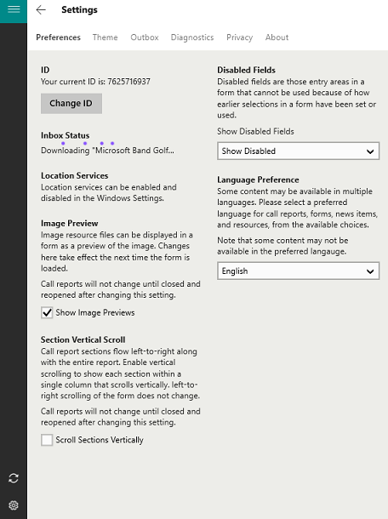
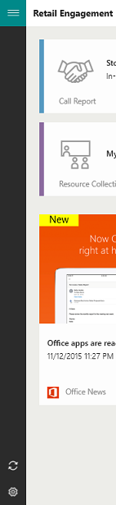
The main controls in Settings are the following: Preferences, Outbox, and Diagnostics. These are detailed along with all items on the following page.
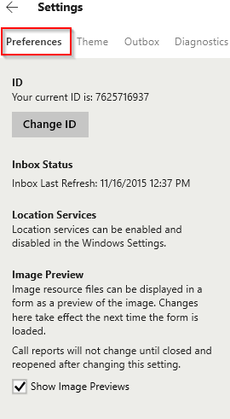 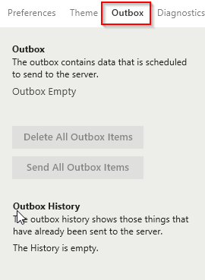
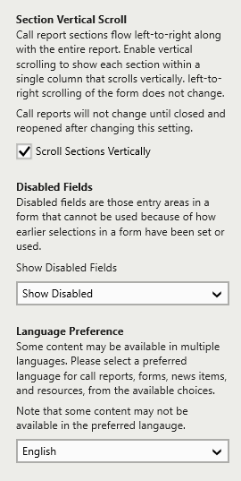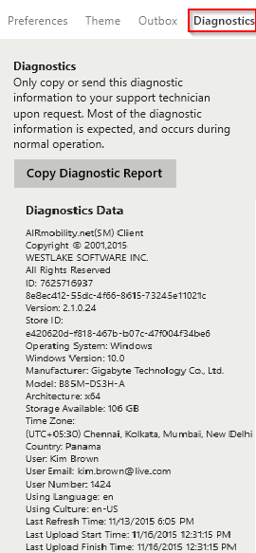
Outbox | - If you wish to delete all current Outbox items, select the Delete button. Those records are now non-recoverable.  - Send all Outbox Items is most often used when asked to do so by technical support when you might be having a problem. Outbox items are sent automatically when you have internet coverage. This is a manual push option.
Preferences | - ID – where you enter/change your ID number  - Inbox – You can force a synchronization with the server with this button.  - Location Services – Refer to Permissions section.  - Image Preview – If a resource file is a graphic like a JPG, you can opt in your call reports to display that image (personal preference).  - Section Vertical Scroll – Enables vertical scrolling to show each section within a single column that scrolls vertically.  - Outbox – Option to display records in the Outbox.  - Disabled Fields – The program uses skip logic. You can either show non relevant questions in a deactivated state (dithered) or choose to hide them all together.  - Language Preferences – If and only if your Admin has translated your call reports, call reports can be displayed in any language in the world.
Theme | - This allows you to add a pre-loaded background picture to the main application or choose one of your own throughout and then set either a light or dark theme.
Diagnostics | - For our technical support services. By copying and pasting your diagnostic report into an email or support ticket, you provide our team a complete snap shot of all your settings, information about your device and diagnostic information for about your last 25 submissions.
Privacy Statement | - Detail on required disclosures
About | - About Westlake Software, Inc.


Breaking News, Resource Files, Call Reports
Breaking News are new items created by Microsoft Corporate and approved by your company; they can also include locally created announcements and news by your company.
Breaking News provides you near real-time information about Microsoft products and services directly from Microsoft.
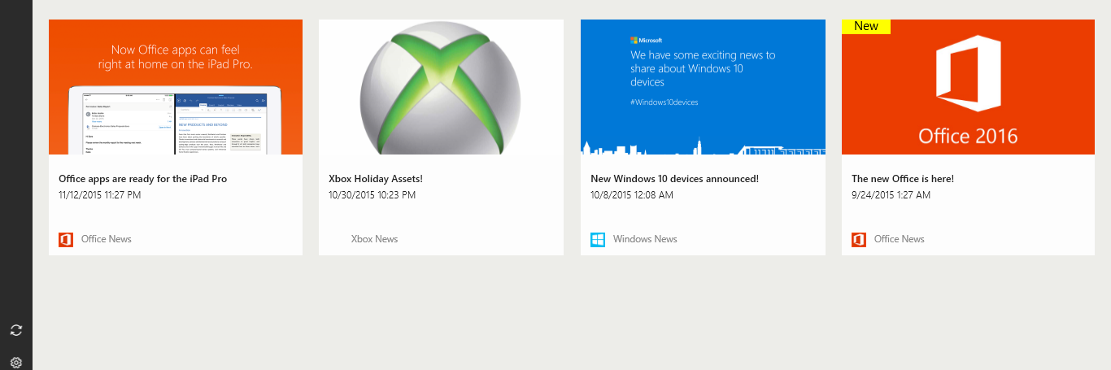
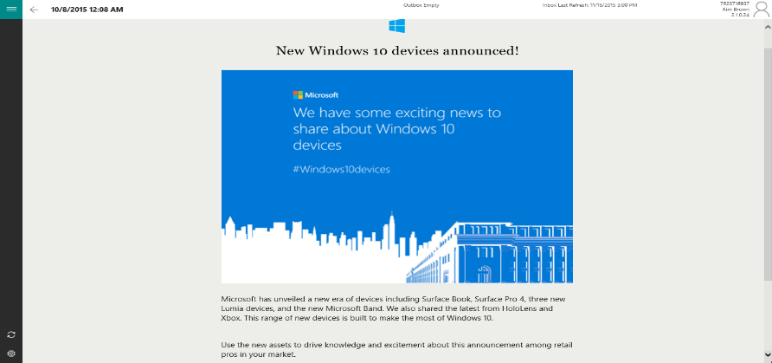
By clicking on a Breaking News Item, Breaking News items can support:
- A graphic
- Title
- Sub Title
- Body/message
- Web hyperlinks

Resource Files are a collection of brochures, diagrams, training materials, videos, etc.; anything Microsoft Corporate or your company wants you to have in the field to do your job.
For example, some training materials are for your own learning; other materials are for the training of Retail Pros. This is a single location in where all of these files reside, are well organized into sections and are always available for quick and easy access.
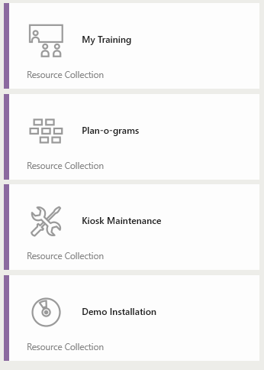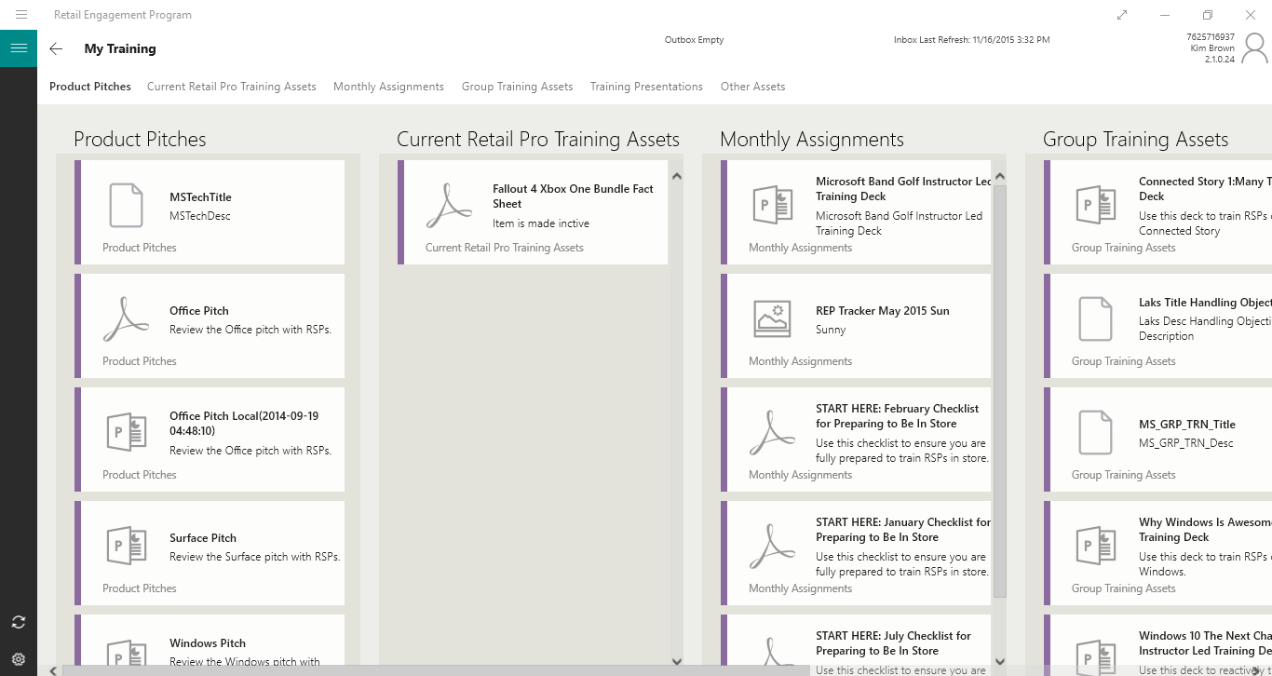

You can swipe to close the document (example of Windows 8.1 below).

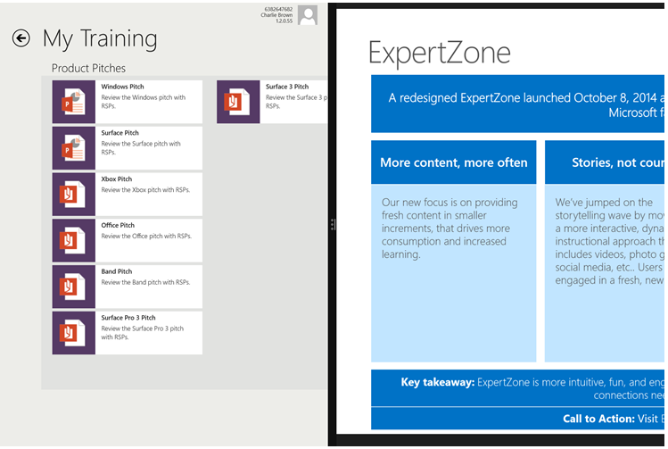

Call Reports are different for every country and company around the world. The following is a generic overview of the Call Report system. Your experience will be similar but not exactly as the following.
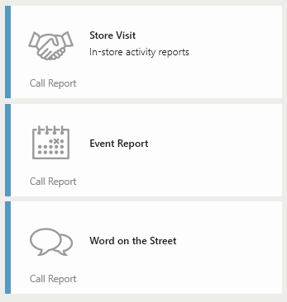
There are four main call reports today (Nov/2015):
- Store Visit
- Retail Pro Training (found within the Store Visit Form)
- Event Report (1 to Many Trainings)
- Word on the Street (capture opinions)
It is expected, over time, the system will include a larger variety of call reports to support. You may also see Special Projects and Sales Tracker depending on your country.
Special Features:
- As you enter into any call report, you may see small red carrots (triangles) next to items. This denotes that the item is mandatory to compete the record.
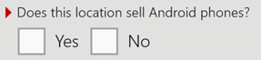
- Call Reports with multiple sections have a list of sections along the top (Windows) which you can click on to jump to different sections.
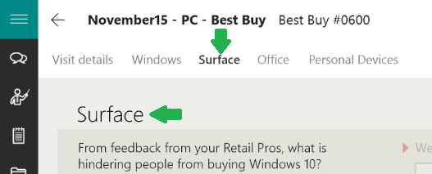
Word on the Street is a call report which enables you to help Microsoft track product sentiment from Customers, Retail Pros as well as Competitive information.
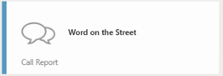
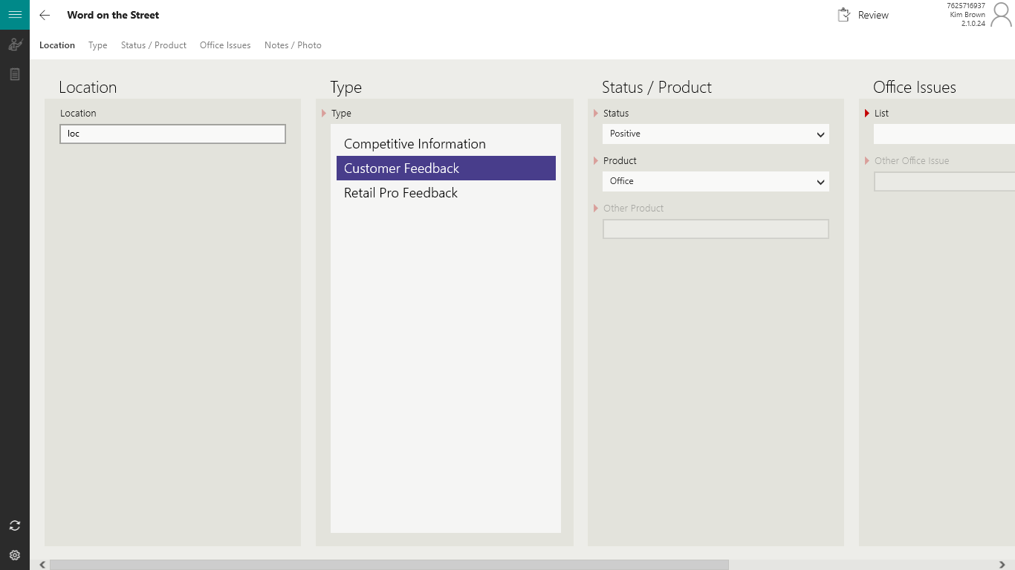

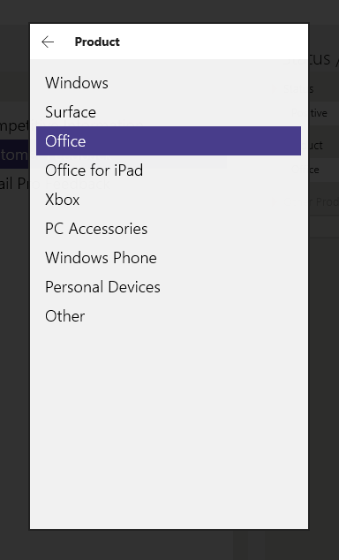

Enter a location if you are starting Word on the Street form from the Main Screen. If you access Word in the Street from inside a store visit, this field will populate with that store location information automatically.
Select a Type: Competitive Information, Customer Feedback or Retail Pro Feedback. If you select Competitive Information, an option to select which competitor will display (not shown).
Select Status: Positive, Negative or Neutral
Select a Product: (note, all selection options display as pop-ups to show pick lists; select one).
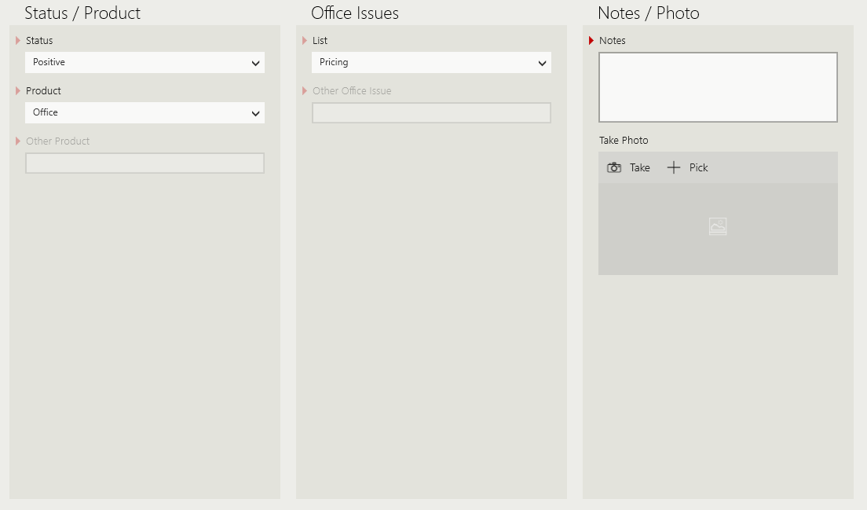
Issues: Select from a list of pre-defined issues.
Notes: Add typed notes
Photo: Take a photo
Review and Submit: Select the Review and Submit icon in the lower right of the page to review and then submit.
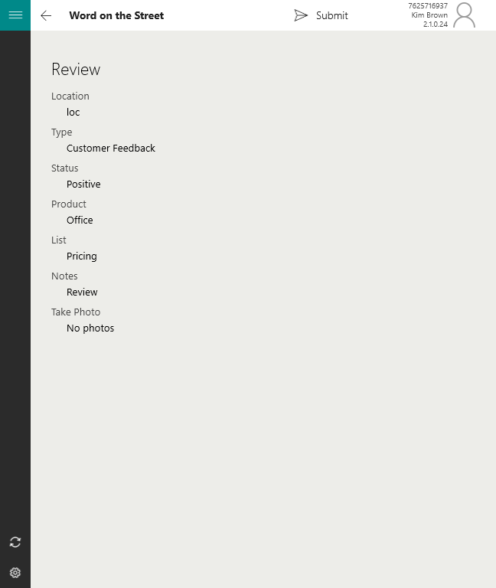
The Word on the Street submission moves into the Outbox. If you have Internet connectivity at this moment, the form will transmit right away. If you do not, you will see on the main page and the Outbox will say, “Outbox: 1. Records will stack in your Outbox until you are back with internet connectivity.”
Event Report is where 1:Many training is accounted for. The call report works similar to Word on the Street but there are more fields to complete.
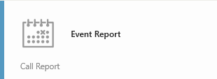
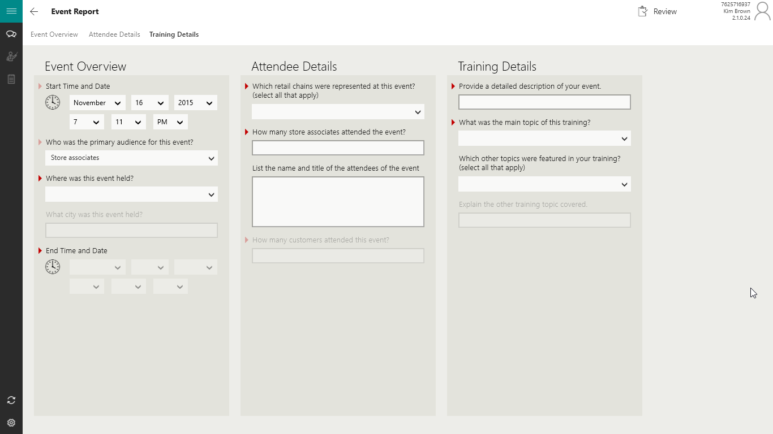
By clicking on each section header provided on the top, you can navigate to the corresponding section.
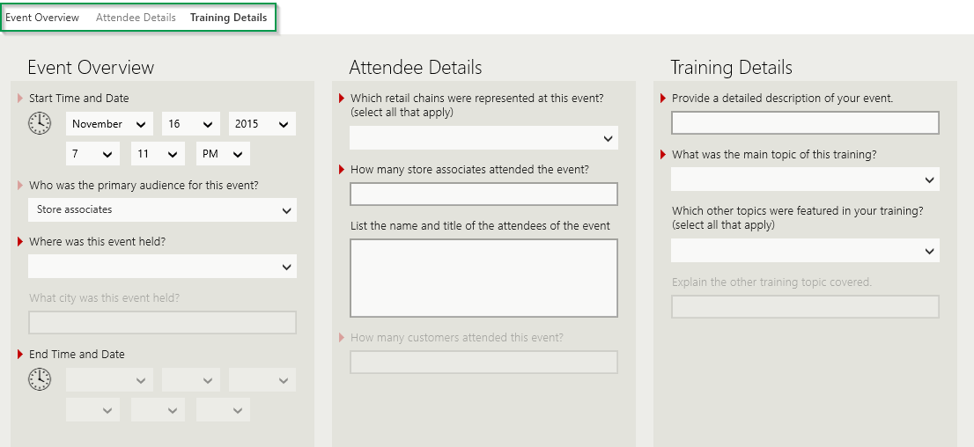
Similar to Word on the Street, select the Review and Submit button when complete. Then tap Submit.
Store Visit call report supports the most detail. Depending on your country, you can have 20 questions to hundreds of questions to complete on a store visit. This is determined by Microsoft as well as the company you work for.
After clicking on Store Visit, a list of stores in which are assigned to you will display.
- Some Reps have one store in which they visit many times each month; others have a long list of stores and move around in their territory often.
- If you use our online Calendar, the app will pre-filter to the stores in which you are assigned; but you will always have access to your entire store list. See Calendar section for more detail.
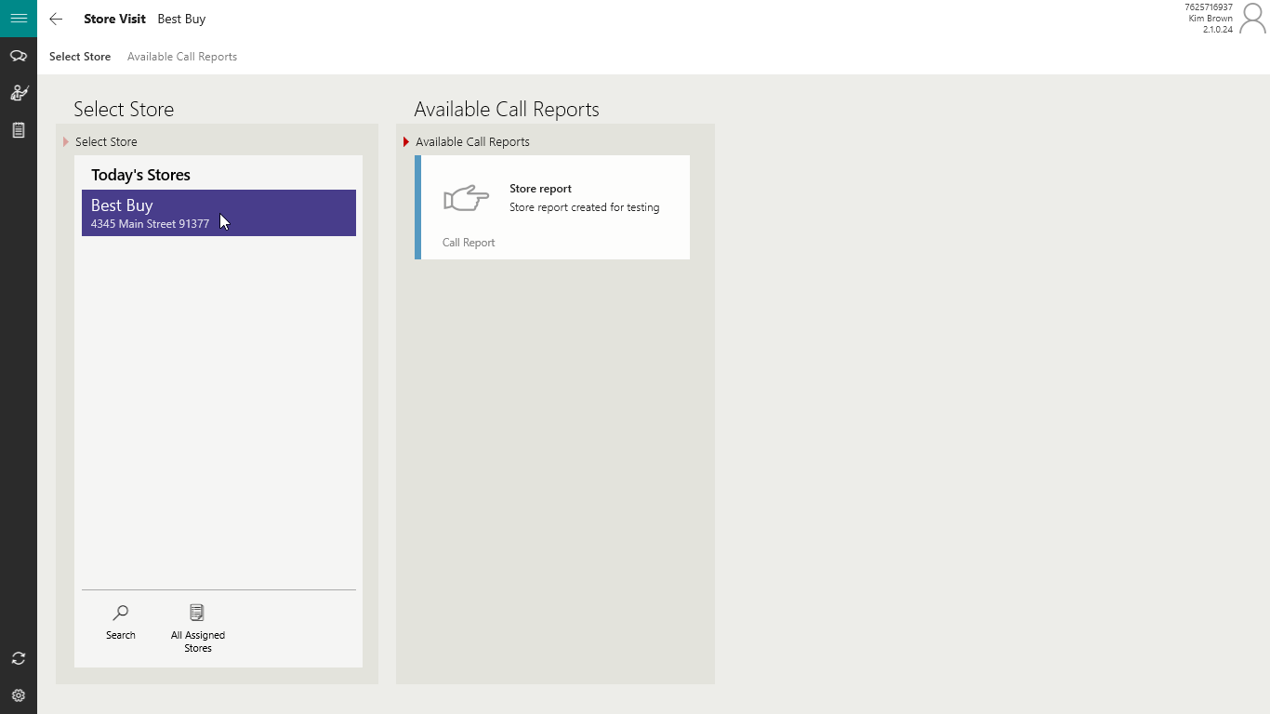
Select a store from the list on the left (only one shown here), and select the Call Report in which you are required to complete (sometimes one; sometimes more than one) on the right.
By selecting the call report on the right, this will take you directly into the call report to start your visit.
The app supports a variety of question types. Some are yes or no, others ask for start and end times, photos, etc. You may see graphics displayed as well as links to websites and links to resource files.
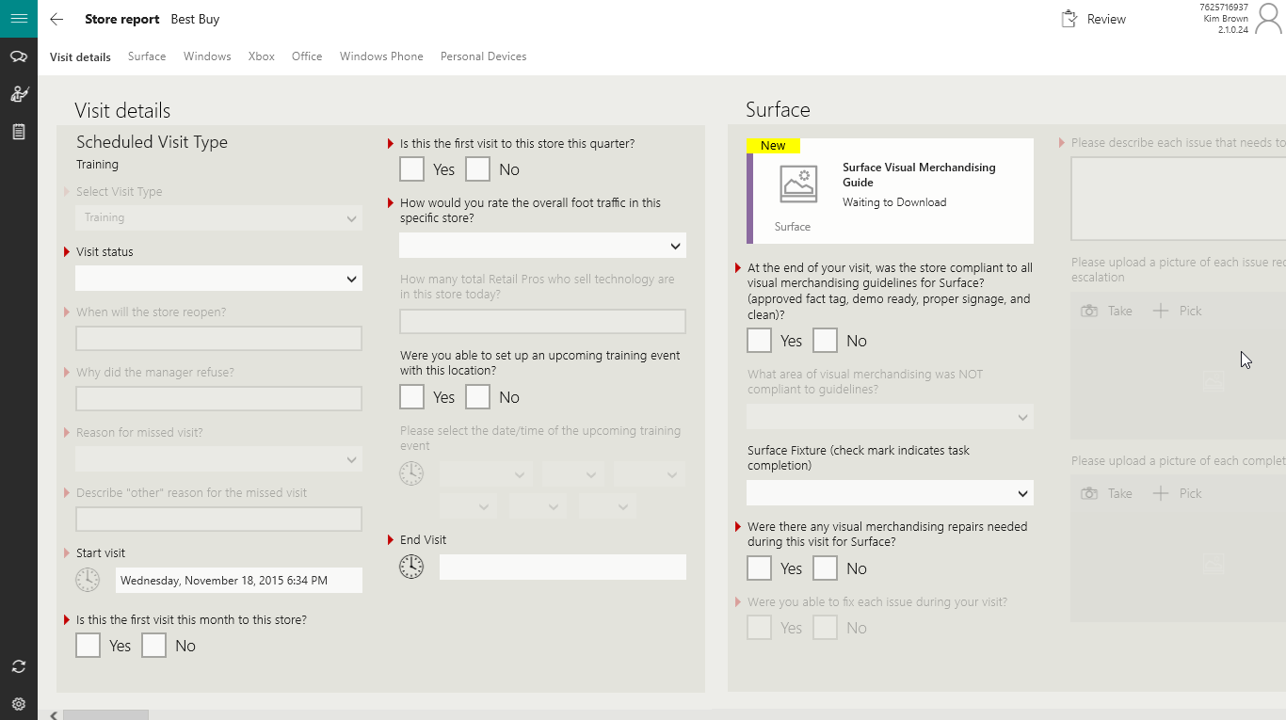
These are managed just like the call reports in which were described earlier.
Along the left side rest a set of icons. They are Word on the Street, Retail Pro Training and Store Notes.
Word on the Street - has already been documented in an earlier section. But in this case, you can stay in your core call report, open Word on the Street, complete a record, submit and go back to your open Store Visit call report.
Store Notes - By clicking on Store Notes, you can take some notes on the store. Those notes become part of the record of the store and will keep a running log in the app of the notes taken on the store over time.


Retail Pro Training – This is where you add Retail Pros to the system, add their profile and track their training.
Global Community We collect from Reps like you, all over the world, approximately 200,000 topics trained on every month.
This section of the software is changing in 2015-2016. There will be a new token system in which a code is assigned to each Retail Pro for tracking their data back to Expert Zone. In addition, once that token is synchronized, this section is expected to expand and display that Retail Pro Expert Zone’s training profile for review. There will also be tracking for number of times a RP has been trained on an item and the introduction of sliders (surveys from 1-5, etc.). Look for separate documents on this at www.msftreps.com under Help – Documents.
You can select a Retail Pro already included on the list or select the Add icon to add a new Retail Pro to the store profile.
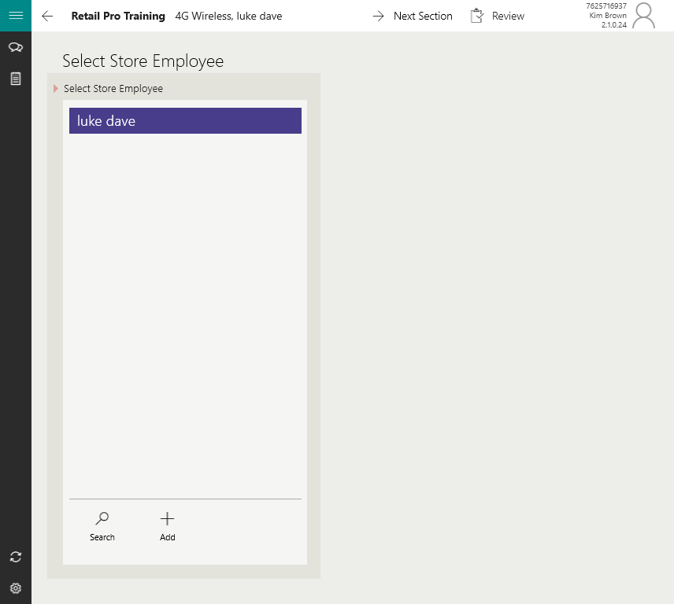
Once added or selected, select the Next Icon in the lower right of the page.

- Add Retail Pro email address if they provide it.
- Add Notes on the Retail Pro as desired.
- Note if they are registered at Expert Zone
- Add their Expert Zone ID if available
- Check off Accreditation
- Show the Retail Pro the Privacy Statement
- Have them sign stating they have reviewed the Privacy Statement
This information will remain with this account perpetually and only is required to be added once.
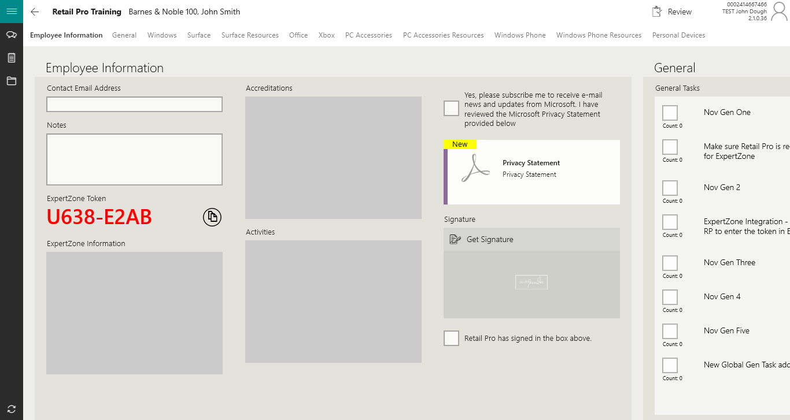
Note: When Retail Pros are added new and their first training information is sent to the Outbox to be sent to the server, their information is not fully synchronized yet. If you opt to go back during the same exact store visit to train this newly added Retail Pro, they will not be in the selectable names list until synchronization or your next visit to the store.
As you swipe right, each Retail Pro training task and associated files are displayed.

As you check off each item the Retail Pro is trained on, the section changes color and shows as a check box next to that item. You can also swipe down from the top to see the section jump menu display.
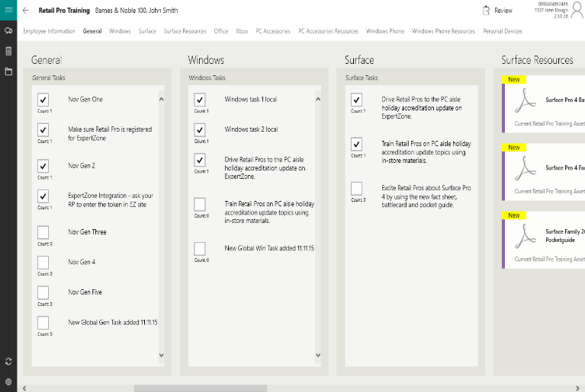
These trainings have memory and will remain checked for this Rep moving forward.
Note, this section is changing in 2015. There will be some indication in which a Rep has been trained on a topic but you the Rep will be able to go back and train/concentrate that effort on the same item to the same Rep more than one time.
When complete, select the Review and Submit button.

Windows Phone

Windows Phone Set Up
Step 1 - The Windows Phone application is in the Store. You can enter the store on the phone and search for: Retail Engagement Program. Or, you can copy and paste (exactly) one of the two links shown here to your phone and then click on one of them. Both will take you directly to the download page in the store:
http://ow.ly/ucC2Z (case sensitive)

or

http://www.windowsphone.com/s?appid=fe80470d-8a36-4bc6-bce5-c9e2ee30dda0

In all cases, you will need to register with the Microsoft Store.
Step 2 – Select the Install button.
Step 3 – Select Allow for Location. This will start the download process.
Step 4 – Wait for the download and install process to finish. This will display the View Button.
Step 5 – Select the View Button.
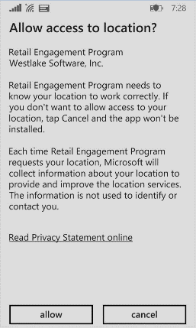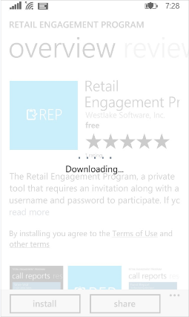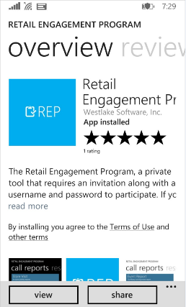

Step 6 – Find Retail Engagement Program on your Windows Application page and select.
Step 7 – You will be asked to enter in the ID number discussed earlier in this document. Enter your ID number and select the check box surrounded by a circle at the bottom of the page. This will trigger the application to start to load.
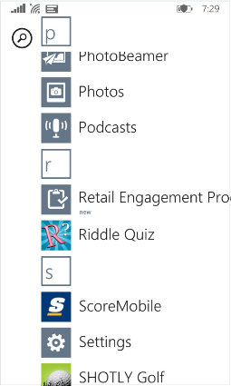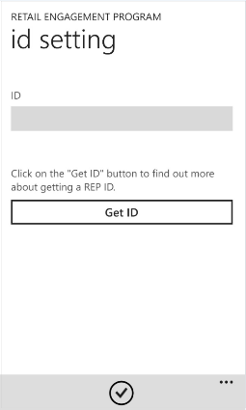
Step 8 - The connecting screen will run. This will trigger a “Files Required” popup menu. By selecting Yes (recommended), associated training files for your activities will download. It is recommened that if you select Yes, do so with a Wifi connection and not a cellular connection. This is often over 100 Megabytes of data new every month.
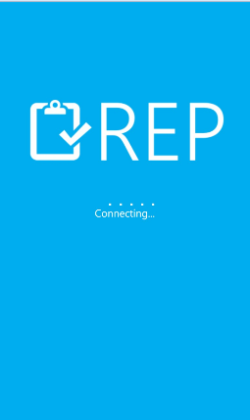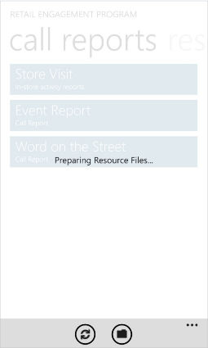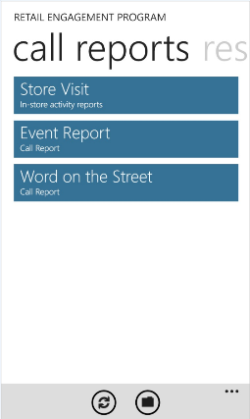
Step 9 – it is recommened that you wait to allow all files to download before you start using the application. This can take a few minutes or as many as 30 minutes depending on your connection strength and number and size of files.
If you swipe across your screen, this will display access to these resources. Click into the first item: My Training. This will show the files and their progress in downloading. The picture below shows Xbox and Office pitch as completed but it also shows Band, etc. are still in progress.
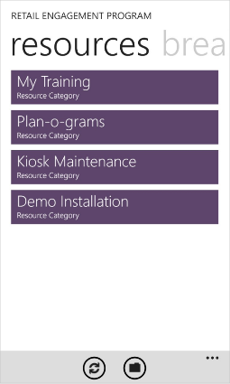
You can use the back arrow button on your phone to move back to any previous screen or view.
We recommend that you put your phone down for a few minutes and come back to it later to allow all associated files to synchonize. Timing on this is different for every user (number of files, size, signal stregth, etc.).

Windows Phone Usage Instructions
The Windows Phone application organizes access to everything you need into 4 sections: Call Reports, Resources, Breaking News, Settings. You can swipe across your screen, left and right. Try this now.
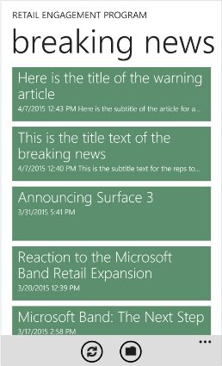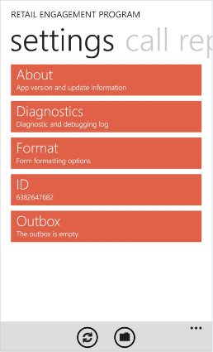
What if I click into Resources and there are no files, nothing displays under Breaking News, etc.?
It is possible you entered in your ID number incorrectly. Swipe to Settings, enter ID, and check your ID number now. If wrong, make the change and save.

Settings
The application supports multiple general settings and are typicaly not needed unless something went wrong and technical support is needed.
About | About Westlake Software, Inc.
Diagnostic | Used for technical support. This report can by copied and provided to Westlake to review all of for phone settings as well as a diagnostic log of activity and errors from your phone.
Format | Offers two different format views for the user and if you want images to display in your call report or be dispalyed as a button to view.
ID Number | Stored location of your ID number you entered.
Outbox | Status and record of records submitted via the Outbox in the application.

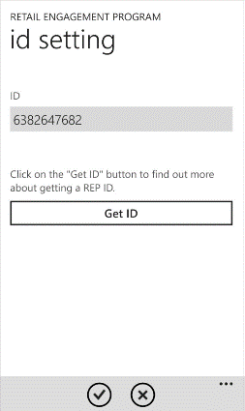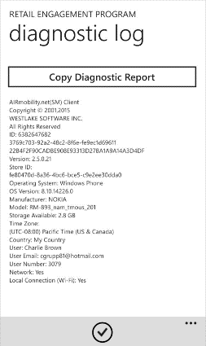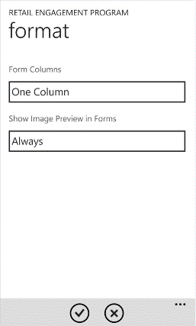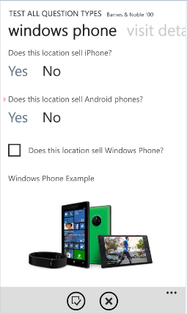

Breaking News
Microsoft Corporate and your company have the ability to create breaking news items at any time. They will list on the Breaking News page. Creators can include:
- Title
- Sub Title
- Graphic
- Message/Body
- Web links

- Content can include links to other content/pages on the Internet (connectivity required).

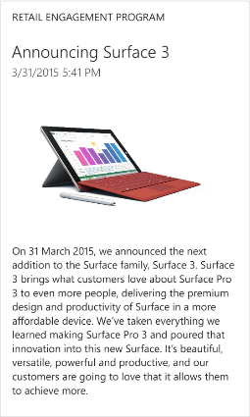


Resource Files
Resources are organized into sections. On the main page they are My Training, Pan-o-grams, Kiosk Maintenance and Demo Installation. This document covers My Training but the others are similar; thgey are just a repository for associated files to do your job.
A Paperless Plan Synchronizing hundreds of Megs of documents dynamically ongoing not only ensures everyone is training and selling from the same materials everyday around the world, we are helping conserve by going paperless.
Enter My Training and you will see sections you can swipe and and right through.

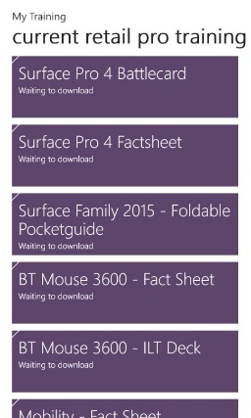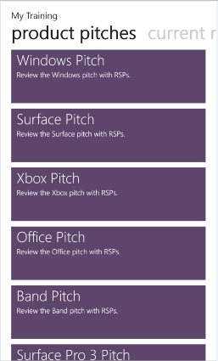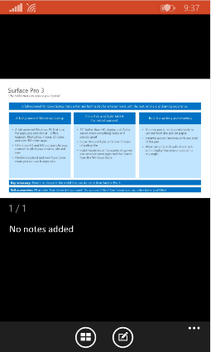

By clicking on the resource (PPT, PDF, Video, Word, etc.), the file will display. Use the back arrow on your phone to close, move back to previous menus, etc.

Call Reports
Call Reports are organized into four sections. Store Visit, Retail Pro Training (accessed when doing a store visit form/not shown on the picture below), Event Report and Word on the Street.
Store Visit | Location of all your basic call reports created by Microsoft and your company.
Retail Pro Training | Form in which you add Retail Pros and track their training progress.
Event Report | Form to complete when doing 1 to many training events.
Word on the Street | Form to capture opinions of Retail Pros, customers and track competitive information.

Common Controls across all call report types:
- Swipe up and down to see and entire section
- Swipe left and right to see different sections
- Use the back arrow button on your phone to move to a previous screen or if you get lost.
- Small red triangles are the way in which we denote required fields.
Note: this menu system is expected to change in 2015. You may see other types of call reports, surveys, etc. in which are available as well such as Special Projects and Sales Tracker depending on your country, etc.

Word on the Street
- Enter Word on the Street form.
- You will be asked for a location, enter your location.
- Select type of feedback (competitive information, customer feedback or Retail Pro feedback)
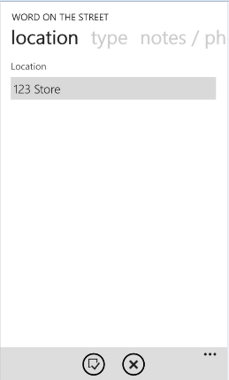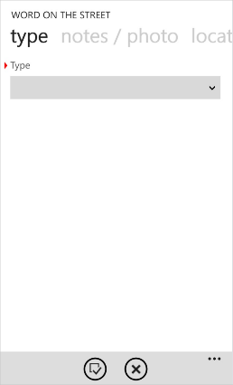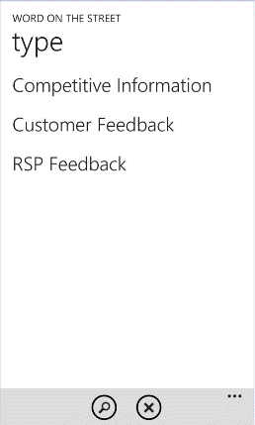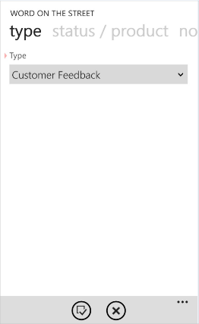
Note: If you select Competitive Information, a list of competitors will display to pick from (not shown).
- Note if the Status is positive, negative or neutral
- Select the Product this is related to
- Not the Issues
- Add Notes
- Take a photo where/when applicable
- Select the icon shown as a form with check box and circle around it.
- Verify your data (you can use the back button on your phone to move back if desired).
- Select the icon with up arrow to submit.
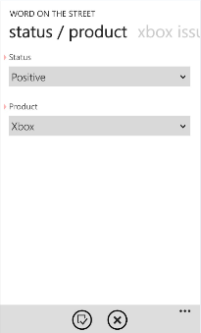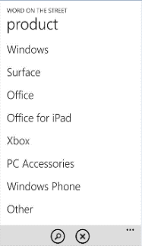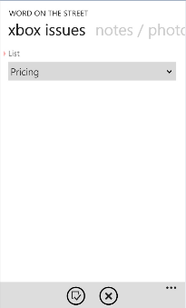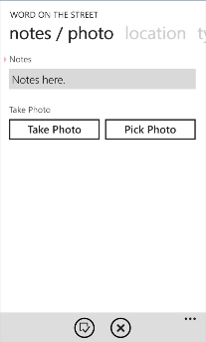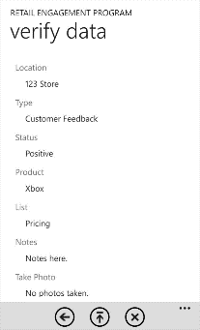

Event Report
- Used for one to many trainings , select Event Report from the Main Call Report Menu:
- Access different sections of the form by scrolling up and down in each section and swiping left and right to access different sections.
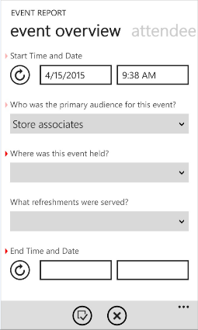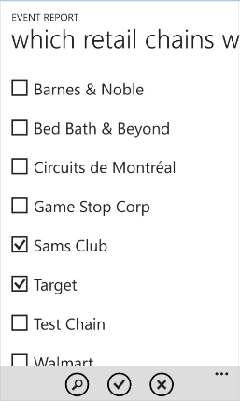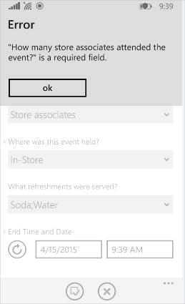
- Select drop down menus to display lists and complete the form. If you forget a required field when trying to submit, an Error pop up will display to remind you.
- When you have answered all of the questions, select the icon shown at the bottom as a form with a check box and circle around it.
- Review/verify your submission and send by selecting the up arrow to submit (verify screen not shown; but shown in previous section for Word on the Street).

Store Visit Report
Depending on your location and how your country manages store visit reports, you can have many stores or just a few; long and/or short call reports or a single or multiple call report types for different visit types. Below is a generic example in which you might see.
- Select Store Visit from the Main Menu
- Click in the Select Store drop down menu and select your store (note, if you are using our calendar controls online, this will filter/limit your store list for you; however, the app will always provide access to your entire store list; you can expand past the filtering).
- Select a Call Report (you may show one or more than one, select just one).
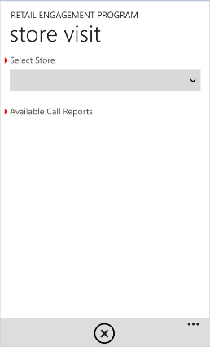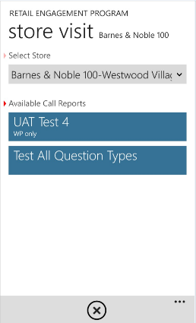
- Complete each section of the call report. Scroll up and down in each section; change sections by swiping left and right as required. There is a wide variety of questions/items available in the form in the format of: check boxes, yes/no, drop down menus, links, photos, graphics, etc.

Every form is different for every country.
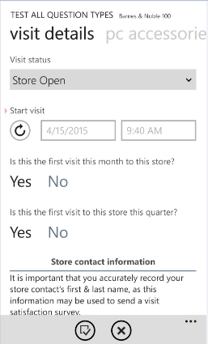
- When complete, select the icon at the bottom shown as a form with a check box and a circle around it.

Retail Pro Training
As discussed in a previous section, Word on the Street can be access as a form within a form. During your store visit, you can stay in the main store visit call report and access Word on the Street on-the-fly and then go back to your store visit form. There is also a store notes feature that will keep a running log of store notes over time for that store. This section is focused on Retail Pro Training as an additional form.
From anywhere in the Store Visit form, select the app menu option denoted as three dots in the bottom right of the screen as shown here:
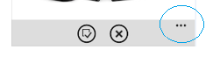
This will expand the menu and show access to Word on the Street, Retail Pro Training, Store Note and Resources.

Select Retail Pro Training:
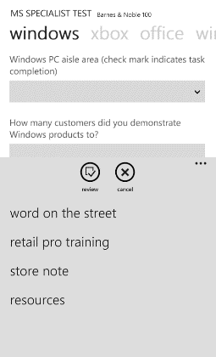
Each store will support a growing list of Retail Pros that you and others may enter and need to manage on-going.
If there are no Retail Pros added to this store, the list will show blank until someone adds one. To add and Retail Pro, select the plus (+) button in the bottom tray (shown below).
Enter First Name and Last Name and select the button that is a check with a circle around it to save.
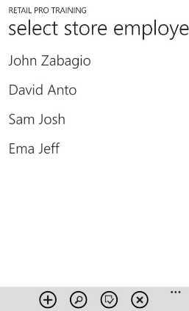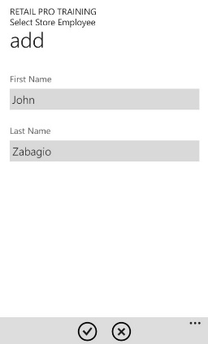
The Employee information section scrolls down to show accreditations, privacy statement and a place for the Retail Pro to sign on the device.
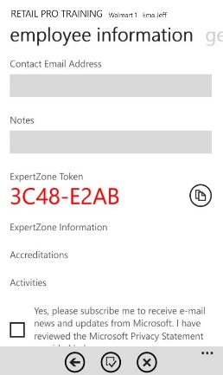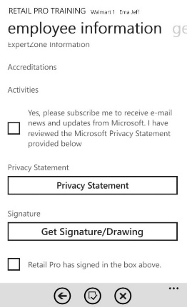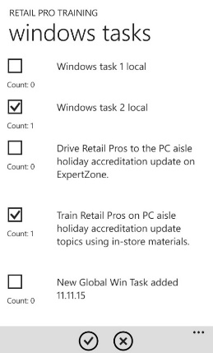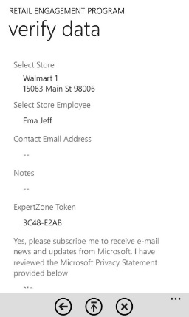
Swiping left, you will find all available trainings listed by sections (products). Open any list, check what you have trained this Retail Pro on, review associated resource files, etc.
Once you have finished training that Retail Pro, select the button that is displayed as a form with a check in it surrounded by a circle and submit. You will be given an option to verify the data before you submit.
Note: Retail Pro Training is expecting changes in 2015. Look for:
- Assigning an Expert Zone token to each Retail Pro
- Expert Zone data/overview being available for review with the application
- Ability to train more than one Retail Pro at a time versus one at a time
- Ability to train the same rep on the same product/task and receive credit for doing so.

MSFTREPS.com - Viewing Your Information Online
The location of the server is at: www.msftreps.com
See section Quick Setup Guide for username, password and setting up your account online.
Once you have logged in, you will be taken to the main page of the website:
Your Name
Your Account Settings
Your ID Number
Menu Items
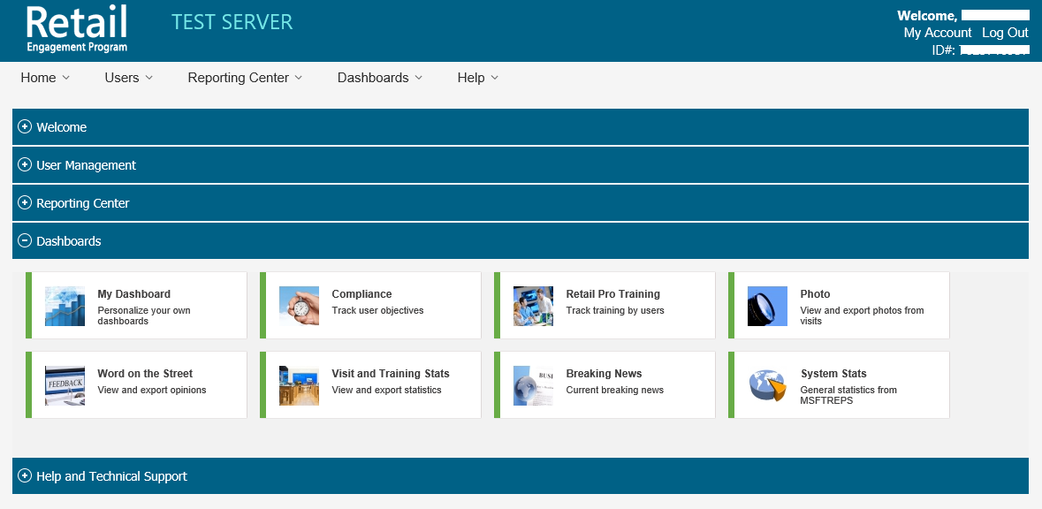
Menu Items for touchscreen and mouse
The screen above shows the Dashboard row of tiles expanded as an example. The sections available to a Rep are:
- Welcome and Setup
- Reporting Center
  - Custom Reporting Center
  - Manage Call Reports
- Dashboards
- User Management
  - Calendar
Each are discussed in detail here.

Welcome and Set Up
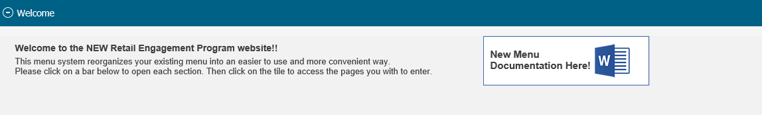
The information on Welcome and Set Up can change by each company/country that uses the system. The Administration account can place messages and text on this page. However, this is not used often with this project.

Call Reports
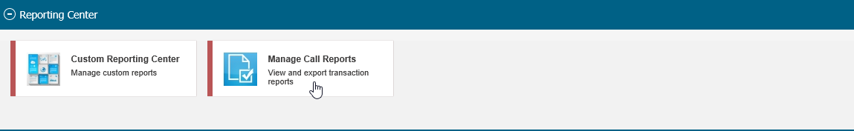
All call reports in which are assigned to you are displayed down the left side of the page. The controls that are available for your account are active links (Transaction Report and GPS for your account).
All active call reports are defaulted to list; old call reports can be shown if you check off the Show Inactive box in the upper left.
Click on Transaction Report next to the call report listed in which you want to view data submitted. The example below is Word on the Street from an account in Australia; personal information blocked.

- Select your date range
- Select the Get Results button
Get Results Button
Name of User
Date Range
Export to XLSX
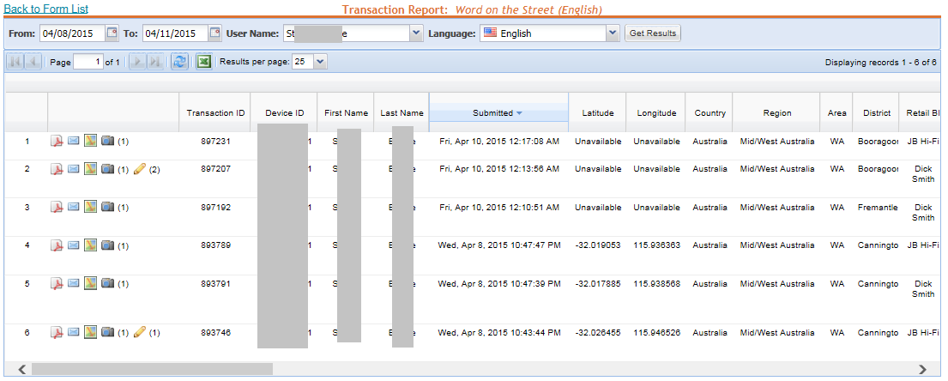

Scroll right to see the entire call report.
Store Visit Notes (shown on store visit call reports)
Photos taken (display)
Quick email option to send the report to someone else.
GPS Mapping of report (when coordinates are available)
PDF Export of your report.
Experiment with each option. Do not miss the option to export to Microsoft Excel as desired.

GPS/Mapping
From the previous menu, click on GPS.
If GPS is available and being captured on your device (typically Windows Phone), you can click into GPS to see GPS coordinates and map you daily activities. This view shows multiple reps as an example; your view should only show you.

- Check next to your name on the left
- Selecting the mapping icon next to the Microsoft Excel icon.
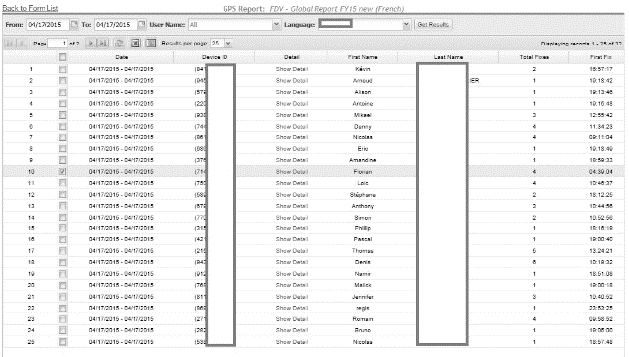
A map of your location will display and show basic GPS movement. This deployment is not set to capture GPS coordinates aggressively. It is designed to show basic movement and locations in which records were submitted. Our organization does support GPS tracking in such a manner but not for this particular deployment.
Records submitted will show up a numeric values on the map. Those values are interactive.
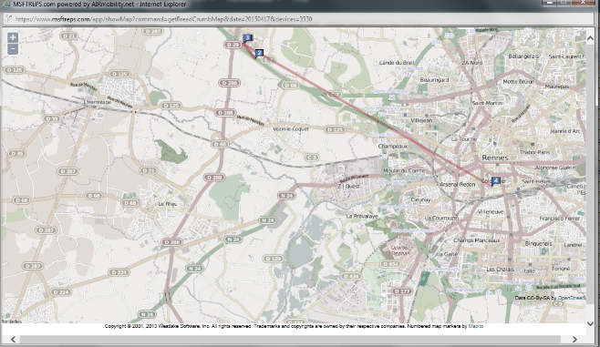
By clicking on the value, some basic information will display about the job, a link to the full PDF report, GPS coordinates to link to Bing Maps and photos taken at that store:
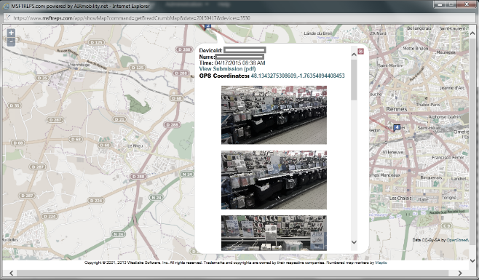

Custom Reporting Center
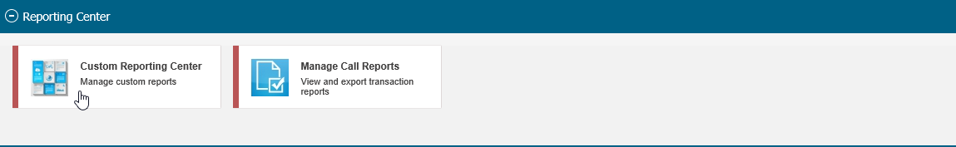
The Custom Reporting Center was designed to allow you to extract the same questions across multiple call reports. For example, if your country has you visiting 10 different types of stores requiring 10 different call reports, how can you quickly and easily create a single report about a similar Surface question? Without the Custom Reporting Center, you would need to export 10 different call reports to Excel, match up the columns of that question and create your report. The Custom Reporting Center does this for you easily. The center also allows you to track specific information like: making a report from Word on the Street that is about Positive Comments on Pricing for Xbox.
First decide what form set you would like to extract information from? You can create a Call Report, Event Report, Retail Pro Training Report or a Word on the Street Report. Those buttons are along the top of the page as shown:
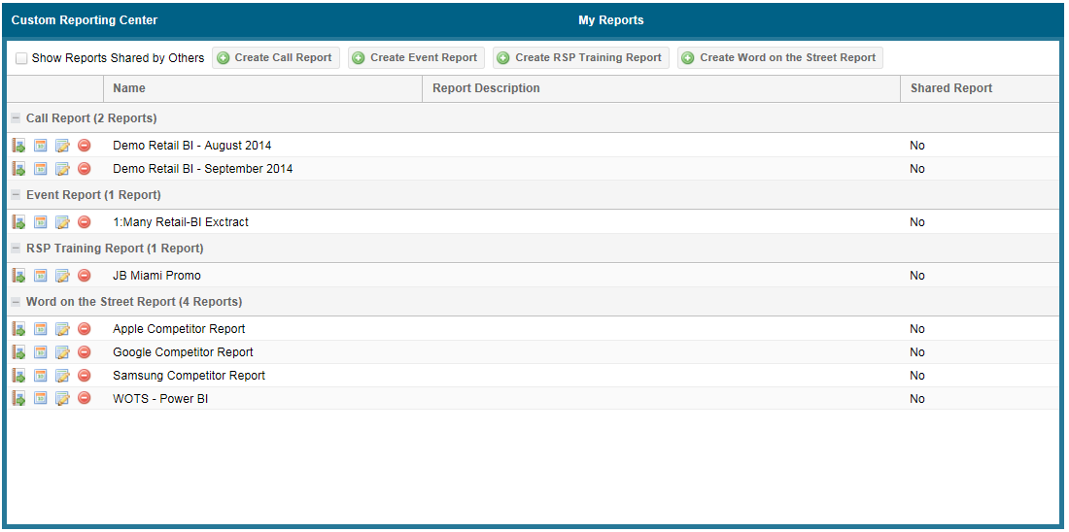
Create a Report
Edit Your Report
Edit Your Report
View the Report
Schedule a Report to be sent to you

Each type of call report has slightly different functions. The example below will be from creating a custom report from Call Reports.
After clicking to create a new Call Report, select the names of the call reports in which you want to extract data. Place a check in the box on the left side as shown. Four are selected below in the example. Then select the Next button in the lower right.
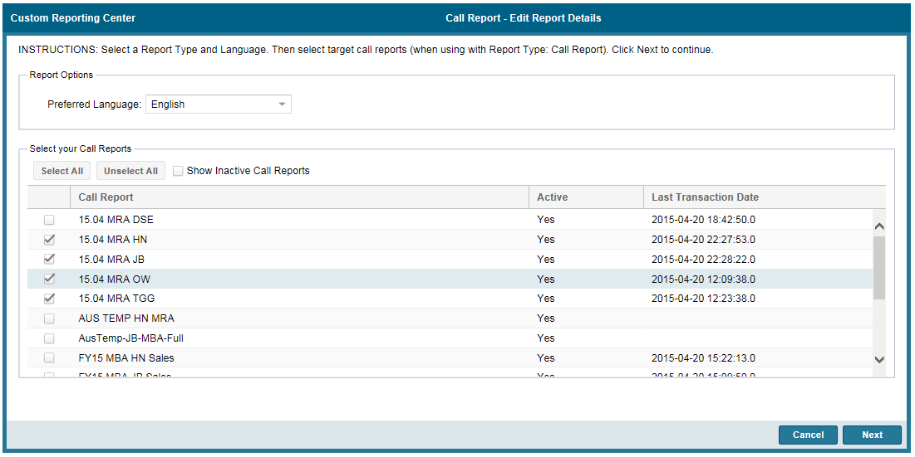
All of the questions that are available in that call report list in the bottom section of the screen. It will show what type the question is and how many reports you selected in the previous screen have that question in common.
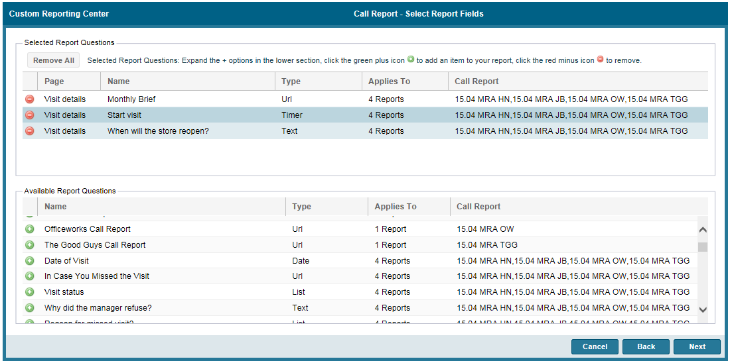
The above is a drag-and-drop design.
Drag and drop questions you want to include in your report to the upper section to be included. Drag and Drop questions to the bottom section to be removed.
Select Next.
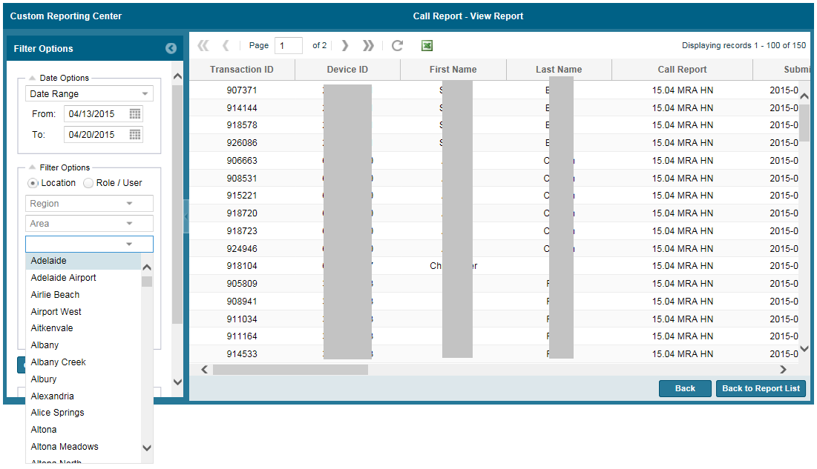
Choose your filters on the left side of the page (title selection open as shown for example) and select Go. The data from your report will show and can be exported now. It can also be saved as a defined report to access later for your convenience. If you select Save, these items will now display on the main page when entering the Custom Reporting Center as shown here:

Scheduling Custom Reports
By selecting the schedule icon, the following screen will display. Select Add.
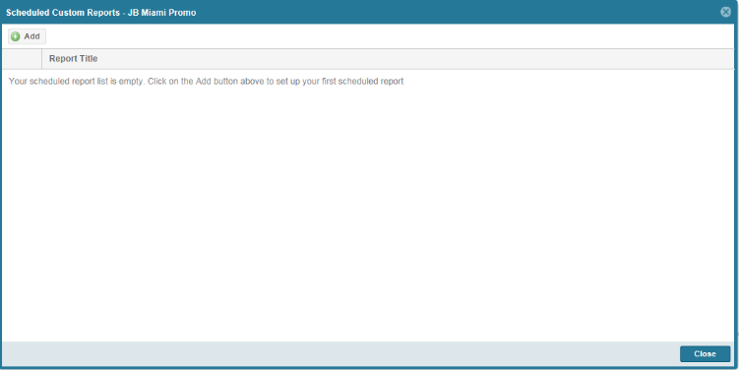
- Select a name to define the scheduled report.
- Enter in an email subject so when you receive the scheduled report is most easily identified.
- Add additional text to the email message (optional)
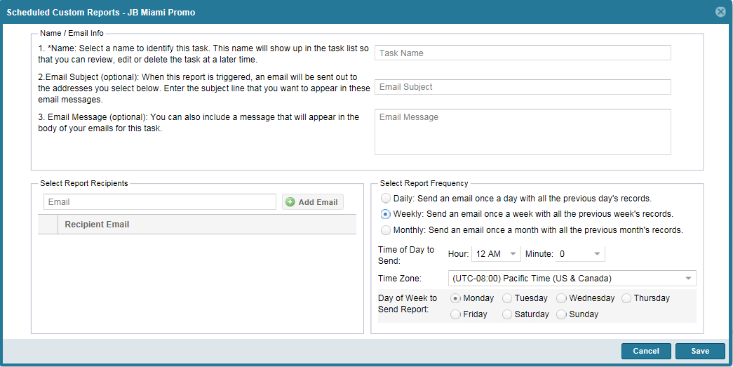
- Add all email addresses you wish to receive the scheduled report.
- Select what interval in which you would like to receive this report.
- Select Save

Dashboards
There are a wide variety of dashboards supporting as many as 70 different views. The next section will support a brief overview of each dashboard section but will not cover all 70+ views. We encourage you to explore and experiment with your views and data.
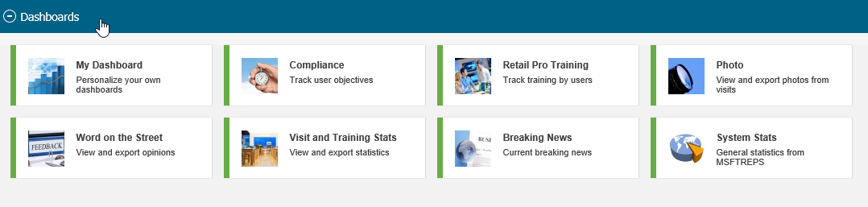
My Dashboard | Helps to personalize the dashboard views
Compliance | Graphic look at your compliance stats; see stores visited in the month and store not visited in the month.
Retail Pro Training | Graphic look at your Retail Pro Trainings.
Photo | Photo dashboard to view and export all photos you have taken in the field.
Word on the Street (WOTS) | Graphic look at Word on the Street Submissions.
Visit and Training Stats | Chart of your visit and training stats.
Breaking News | Shows all the current Breaking News
System Stats | Provides general Statistics of the activities

Common Controls
Filters in the left side of most of the dashboards are similar in function. If the field is left blank, it will include all items. You can pick from a drop down list to filter your displayed data.
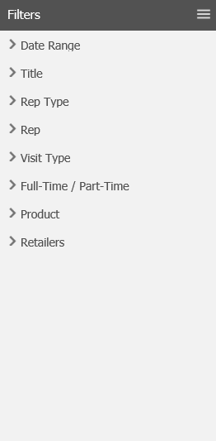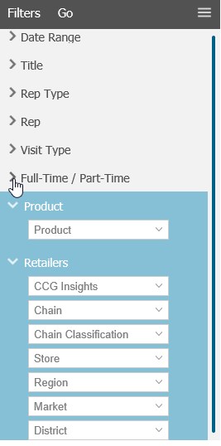

Compliance
This is used and configured differently by each country/vendor using the system. Compliance is driven from Admins assigning you stores and setting a frequency to that store per month. The Admin can also opt not use compliance in their set up. This may or may not apply to you depending how this is offered.
On your view, there will be a bar indicating your progress for the month.
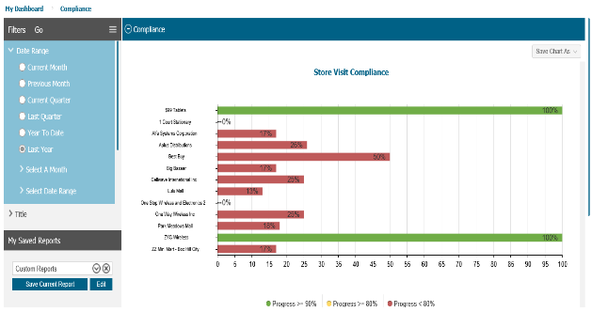
Clicking directly on that bar will drill you into the store details you are assigned to and progress for each.
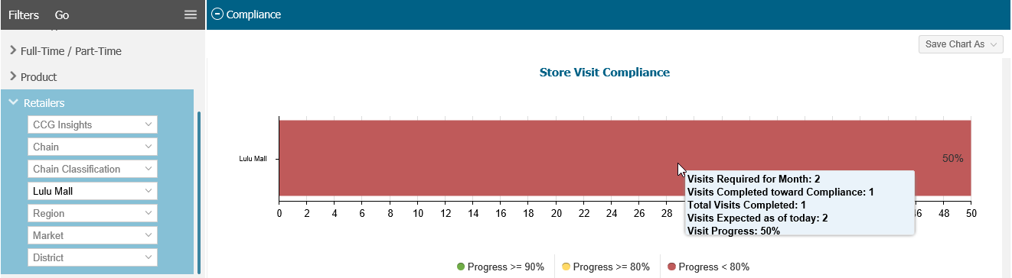
You can filter for different variables on the left side; but a Rep account will already support the defaults appropriate for your level of access.
Bars can be continuously drilled as desired.

There are two other tabs; completed visits and not completed. If compliance is being used, this will ultimately show you your progress throughout the month.
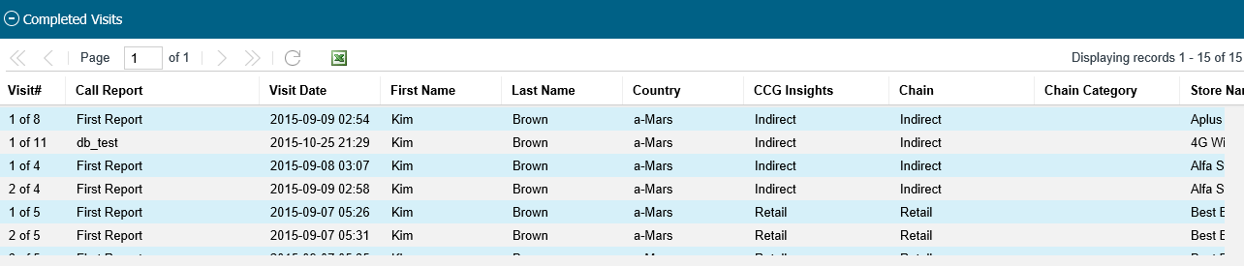
On the Compliance tab in the upper right, there are options to save the chart as an Image or as an export to Microsoft XLS:
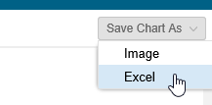
Image will export as a JPG. Export to MS Excel will move the chart over to Microsoft Excel so it can be manipulated as needed:
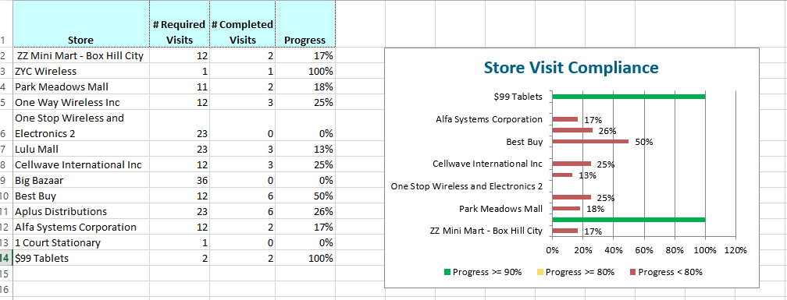

Retail Pro Training
There are many views to display Retail Pro Training. Date ranges and filters are on the left, export options are in the top right, tabs allow you to view Trainings, Topics and raw training data per the filters set on the left. Select your tab, set your filters and select the Go button.
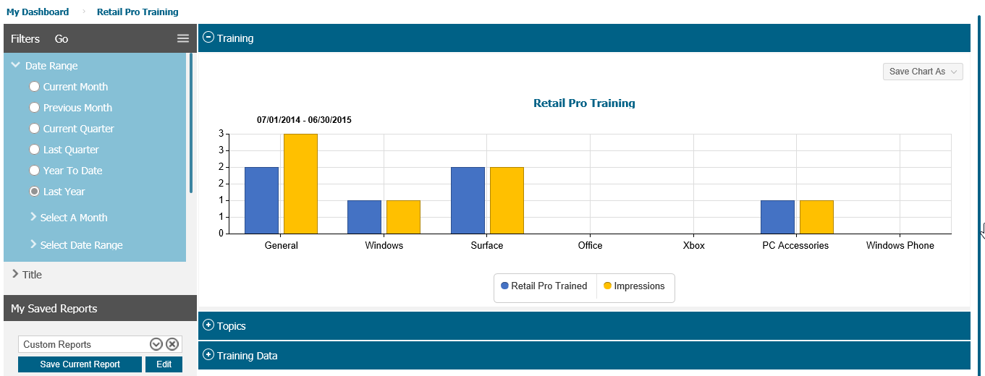
At the left bottom, any view or settings in which you wish to save, you can and label this a custom report.
The best way to learn what is available to you is to experiment with the charts, change them, most bars and pie charts are click-able and will drill into more detailed data.
Below is a topics view for all of Australia, April 1-April 17 2015.
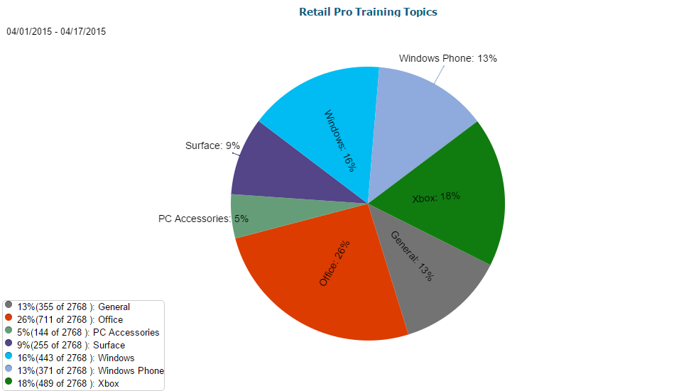
Upon clicking the pie piece of Windows phone, it now shows:
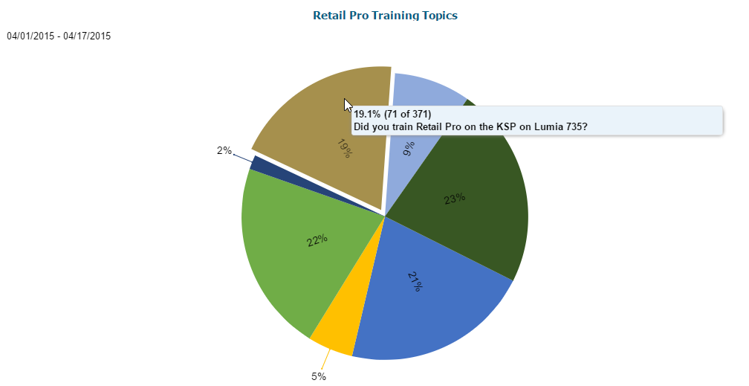
Data displays for the breakdown of Retail Pro Training topics for Windows Phone. Also try hover graphics (do not click). Most elements have hover graphics as shown above.
Below is a topics view broken down by volume per each city/territory.
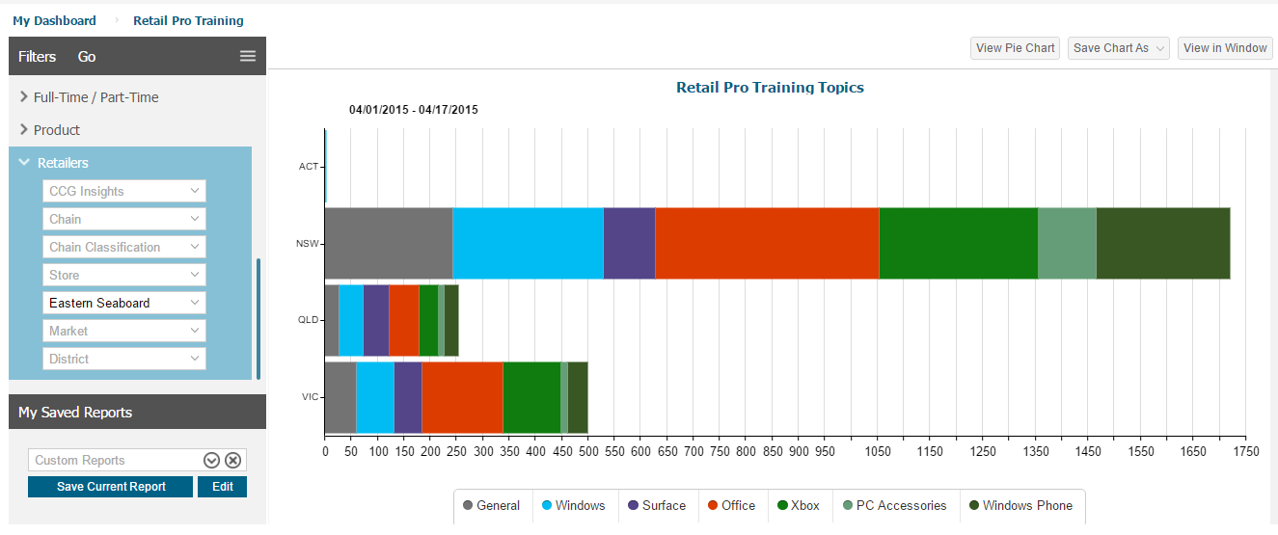
If you drill into information far enough, you can display all Retail Pros that work at an individual store. Drill more and you will see each Retail Pros profile and topics they have been trained on.
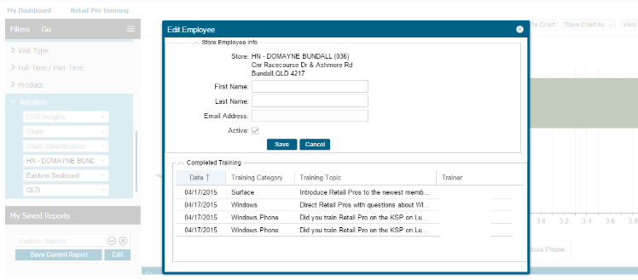

Photo Dashboard
There are a variety of features in the Photo Dashboard view to allow you to re-size, select and export photos as desired.
Note, the left side controls are many; the Go button to display is in the scroll region of the controls.
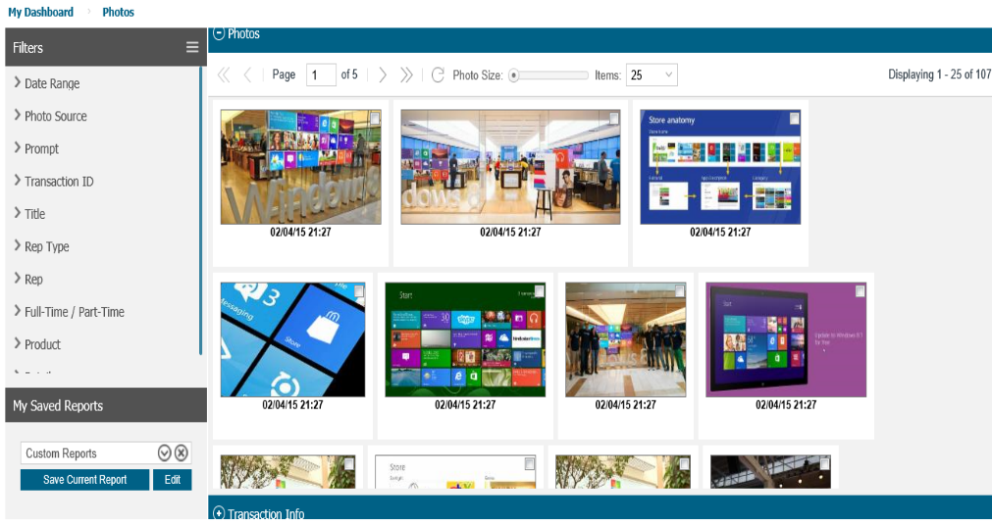
You can determine photo size with the slider and change the number of photos to display at one time.
In each photo, there is a white checkbox. As you check these boxes, you are selecting the photos in which you want to export. This will display a new row of information highlighted in blue below.
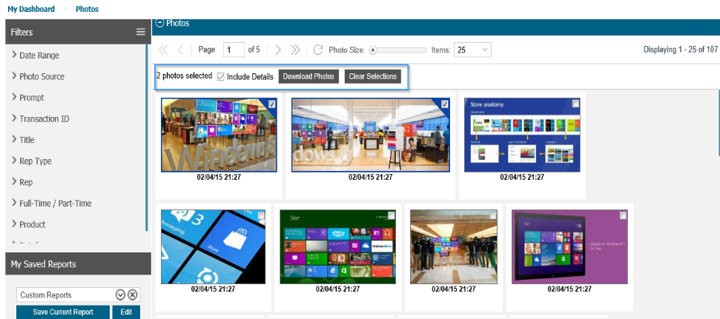
This will show you how many photos you have tagged for export. You can also denote if you want the details of that store visit to be attached to the graphic of the export or not:
Attached:
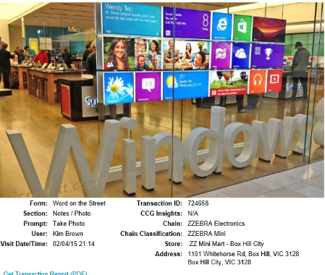
Not Attached:
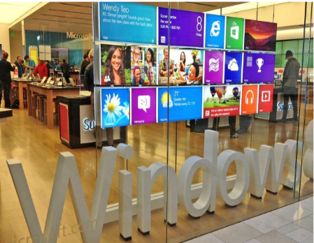
What are the details as shown?
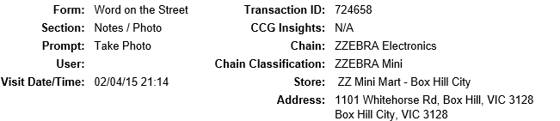

By selecting the Download Photos button, this will trigger the standard Open/Save/Cancel graphic as shown below.
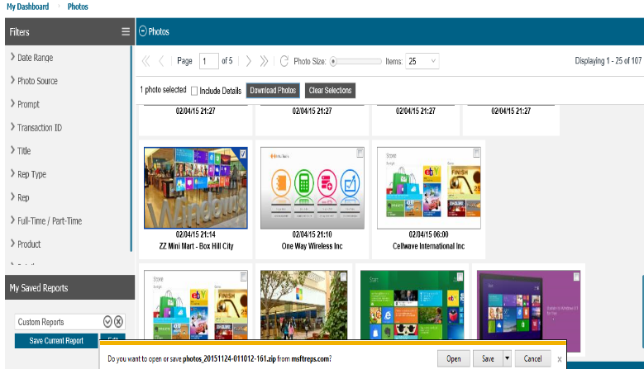

Word on the Street
As you submit your Word on the Street reports, this dashboard will allow you to drill in by feedback, sentiment, product, and issue and ultimately view notes and photos taken
- Select your Filters on the left
- Select the Go button
- Click pie chart pieces to drill as shown
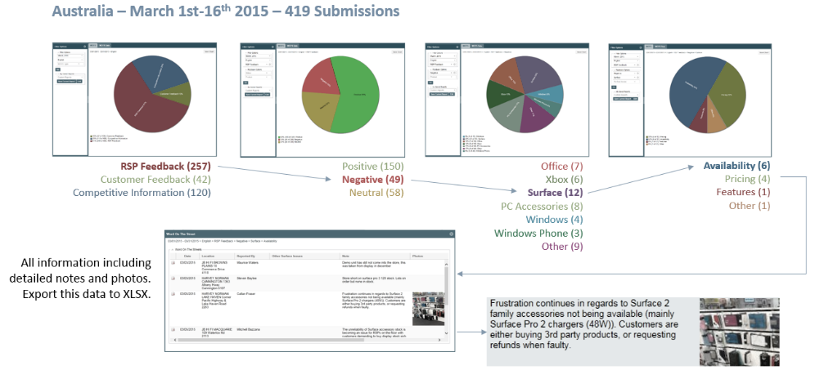
The second tab in Word on the Street allows you to view all of the data, click the PDF icon for a formatted report or export to Microsoft Excel as desired:
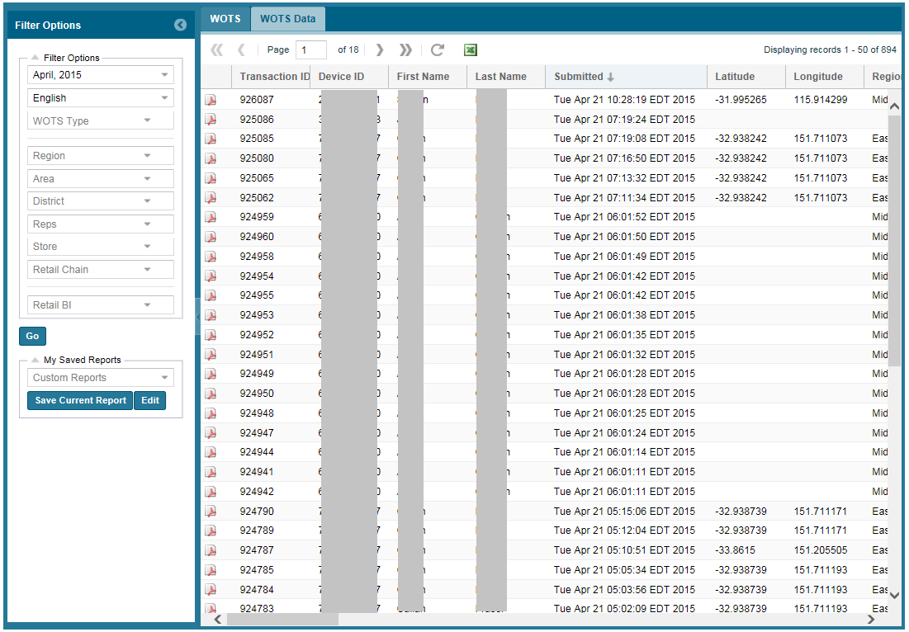

Visit and Training Stats
Select the month in which you would like to view your data. You can select from Store Visit Stats, 1:1 Training Stats or 1:Many Training Stats.
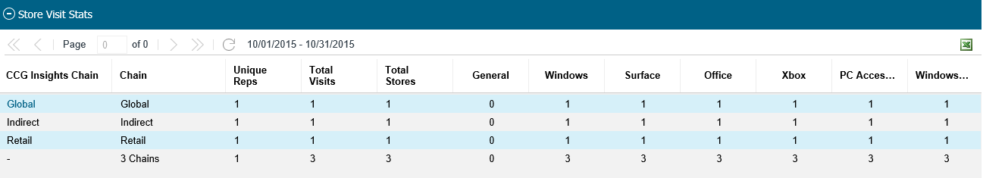
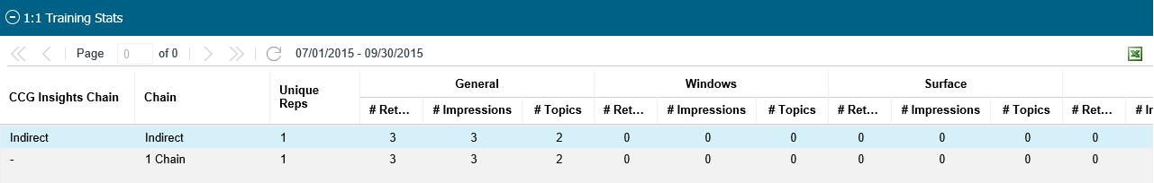
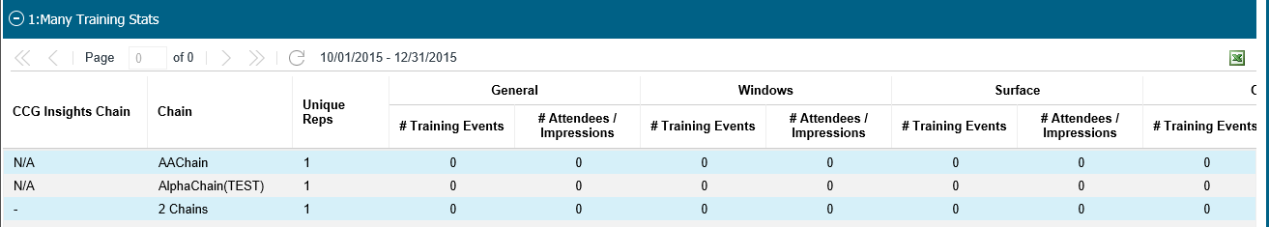
The statistical views are exportable to Microsoft Excel.

Breaking News
Breaking news shows all the current news items. Each news item can be expanded by clicking on the corresponding tiles.
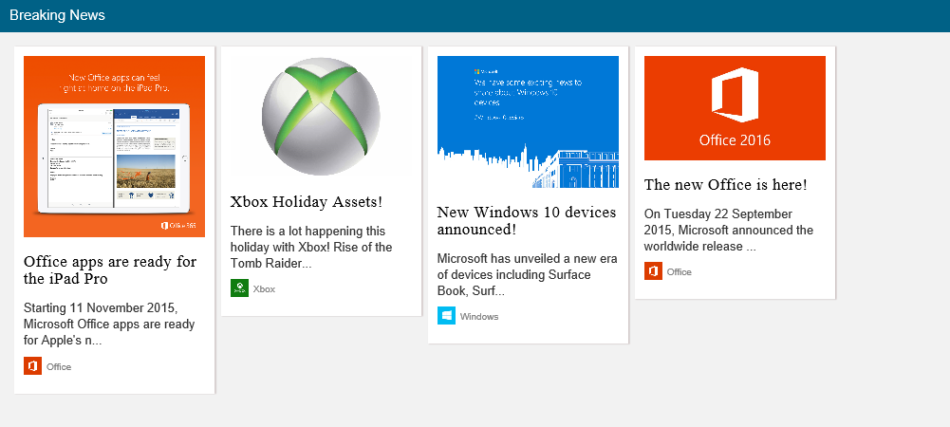

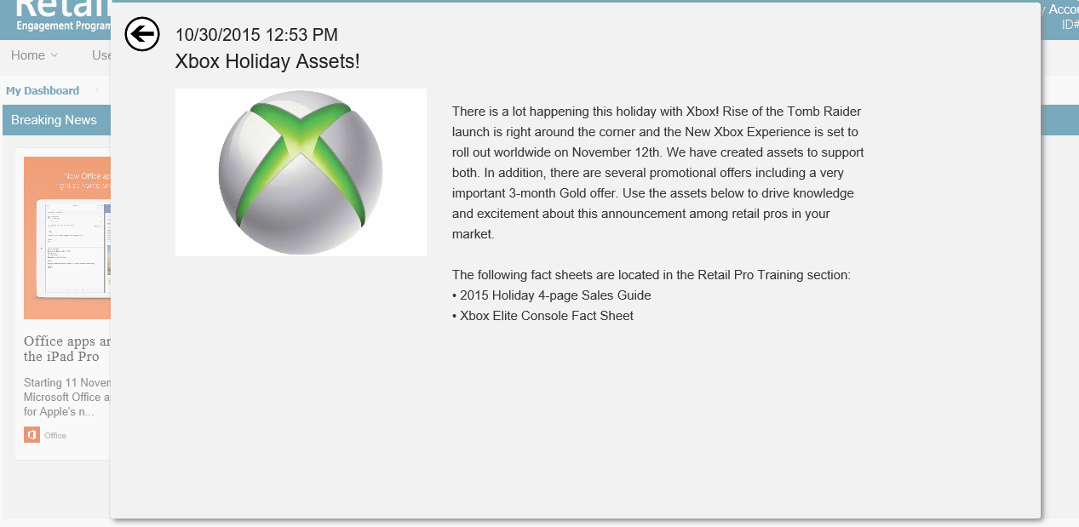

System Stats
The Current Statistics provide the statistics for the current month and the previous two months.
The Percentage is calculated based on the previous month statistics.
The Graphical representation of the system statistics is available on the right hand corner. The drop down provides the option to select various graphs as required.
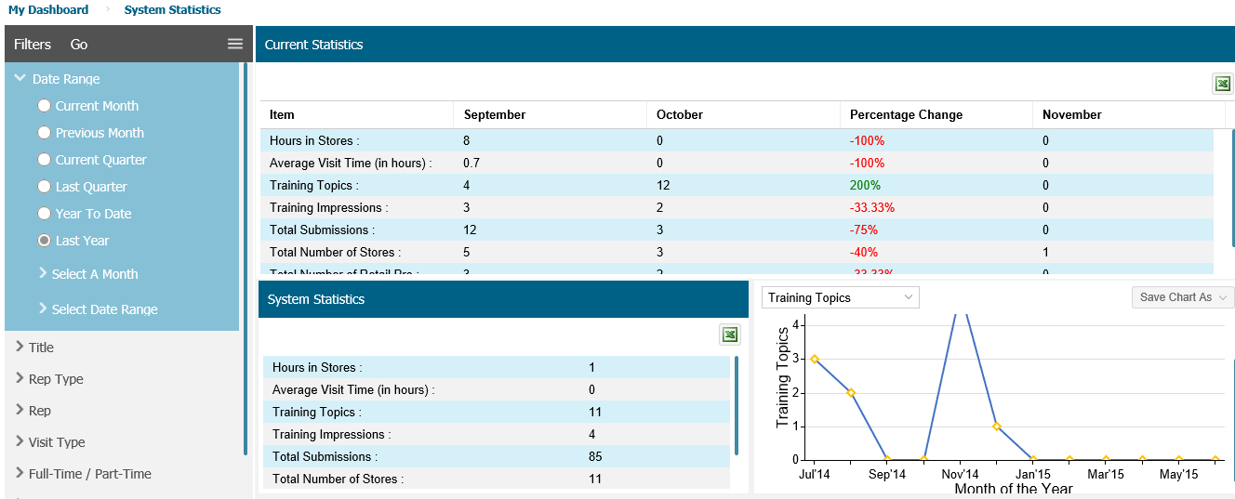

Calendar
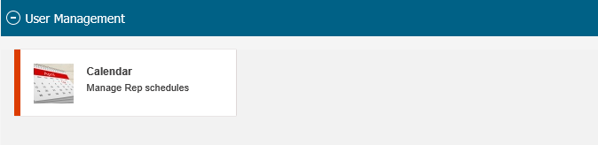
NOTE: CALENDAR FUNCTIONALITY IS CHANGING (11/24/15). THE DATA BELOW MAY NOT BE ACCURATE AT THE TIME OF READING THIS:
All stores assigned to you are located in the Calendar. Stores will list on the left; they can be drag-and-dropped to the calendar date. When compliance tools are used, and you need to visit the same store 5 times in a month, 5 listings of that same store will display on the left side list.
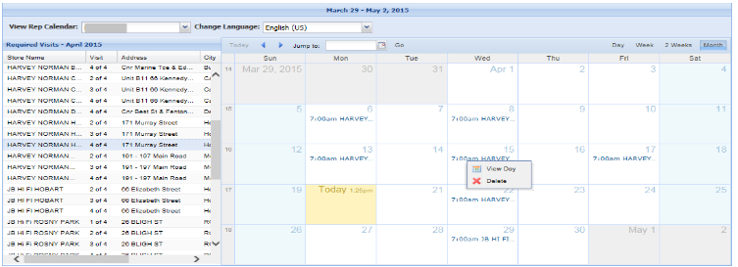
This is a view of a fully scheduled calendar; the list on the left is now empty.
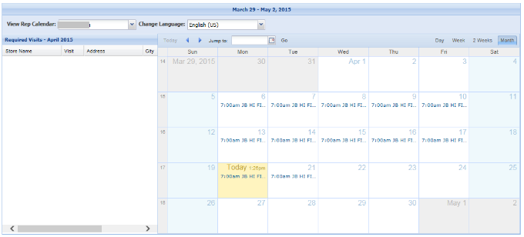
On the Windows Phone and the Window 8.1+ versions, your store pick list will be narrowed to display the stores you placed on your calendar. You can always expand your store list on your device; just a note that the calendar and the devices have interaction together in this way. If you do not use the calendar, all of yours stores will display.


Frequently Asked Questions
Q | Is there a comprehensive troubleshooting guide?
A | Yes, login at www.msftrepscom, go to Help and then Documents
Q | What do I do if I have records in my Outbox and they will not send?
A | Turn your device off, wait a few seconds and turn your device back on. Do not run any other application on your device other than to establish Internet service. Open the application and leave it alone for 15 minutes. If the records are still in your Outbox, enter Settings, Outbox and select Send All Outbox items. If this does or does not work, it is recommended that you delete the application and re-install. Something has likely been corrupted and this will most often solve this issue. Also: see answer to the next question.
Q | I work for Mosaic in the USA. What do I do if I click on a store and there are no call reports?
A | Contact your IT department. There is a mismatch between Mpower and MSFTREPS; this can only be resolved by Mosaic IT.
Q | App is crashing when filling out a report. What do I do?
A | Are you experiencing issues with other aspects of your phone, tablet or PC? Given we are the most common application our users use, we experience a high volume of IT related support calls. We often ask if there are other problems occurring on the device such as lock ups, touch screen issues, other applications crashing. If this is the case, we recommend you inform your IT department that multiple problems are occurring on your device as this is an indication of a larger hardware problem with your device. This can also include records stuck in the Outbox if other apps are having problems. If there are no other problems on your device, contact our support center; see next page.
Q | What if I am missing records that I have submitted to the MSFTREPS.com server?
A | - Did you save a record and forgot to send it?  - Did you check the correct transaction report to look for your submission?  - Are there records in your Outbox now that have not sent yet?  - If you copy and paste the diagnostic report into Word/email, can you see the record in that list and does it show it was sent? If yes, copy this and send us the report via email (see next page). Please indicate the date, call report and store in which you believe is missing.
Q | My initial username and password is not working. What do I do?
A | Please contact your Admin in your country to ensure they have set up your account.
Q | Where do I get my REP 10 digit ID number from?
A | See pages 6-7 of this guide.

Technical Support
There is a troubleshooting guide located at www.msftreps.com under Help – Documents. This is the same document our support techs use to provide support.
Technical support is available 24 X 7 X 365. When possible, please use the online form under the Help section by clicking on the Get Started button:
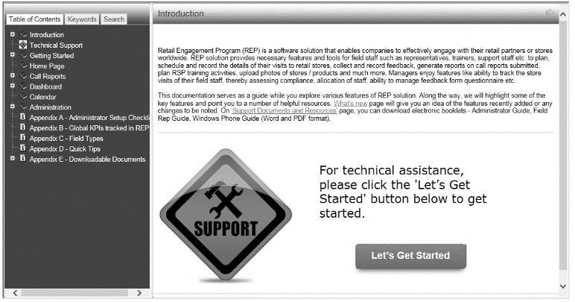
You can also email msftreps@westlakesoftware.com. If you do, please try and provide enough detail as to your issue. For example:
- A – I am having a problem with reports; they do not work.
- B – I am a Rep in Canada. When I enter into my account online and go to Compliance Dashboard and view Not Visited Tab, I am unable to export this data to Microsoft Excel. I have tried from two computers and still no luck.
B allows us to more quickly identify and resolve the problem.
If you are having issues with your mobile device, please make note to send us your diagnostic report (see how to do this in this guide). This is valuable to support staff in assisting you faster.
Thank you
REP Development Team at Westlake Software, Inc.

