The new Event Attendance Module with Check-in enables the Reps to identify Retail Pros in attendance as well as to start, complete or confirm their link to both the Retail Engagement Program and ExpertZone programs when attending an event. Note that some options require internet connectivity at the event.

There are changes added to the existing Event Report in which Retail Pros are the primary audience. Visible changes are:
- The text ‘Store Associates’ has been replaced by ‘Retail Pros’ throughout the Event Report form.
- Two global questions are removed from the Attendee Details section.
- Added the Check In Attendees button to trigger an attendance sub-form.
- Count of total attendees is shown right above the new Check-in Attendees button.
There will be no change if the primary audience of the event is selected as Customers.

The notable changes made to the Event Report (Figure A) includes deletion of the Retail Pro related global questions under the Attendee Details section, “Which retail chains were represented at this event?” and “How many Retail Pros attended this event?” Secondly for Retail Pros audience only, there is a new Check In Attendees button and counter. (No changes will be made for Customer events.)

Figure A - Event report form after enabling the check-in feature enabled
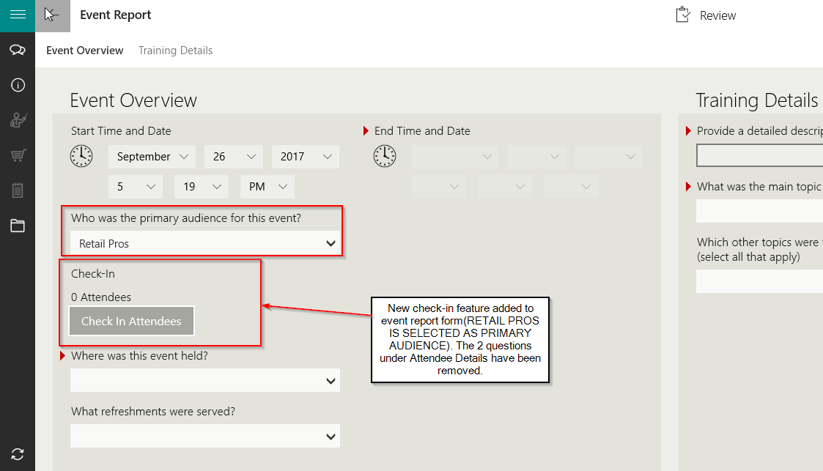

The Check-in feature is available on the Windows app and the Windows Phone app. The feature is expected to be available in Web Entry later in FY18.

How to record the attendee details using new Check-in feature.
The attendee details are recorded using the Event Check-in sub-form which will get triggered once the Check In Attendees button is clicked. There are two options by which attendees can be checked in to an Event.
- Using ExpertZone loyalty ID (EZ ID) - requires internet connectivity at the event
- Using the RP name without an EZ ID (uses REP RP database name search)
- Bulk attendee entry with a +/- control (with or without a chain or store)
The attendee can be classified as follows:
- RPs or other attendees that are not linked to any chain or store (fully anonymous)
- RPs or other attendees that are linked to a chain or store (but no name)
- Registered RP - as known in existing database (by name of the RP associated to chain and store).

Figure B
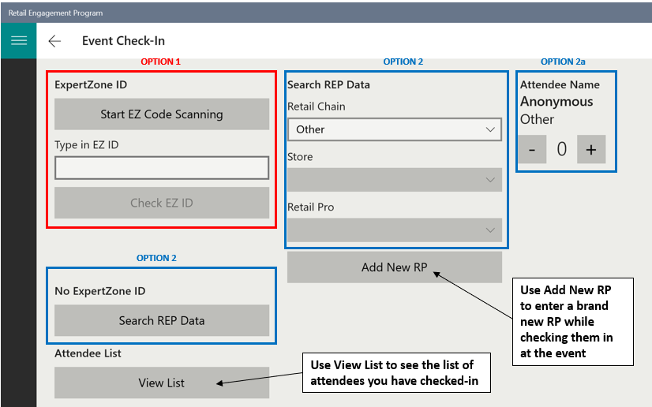

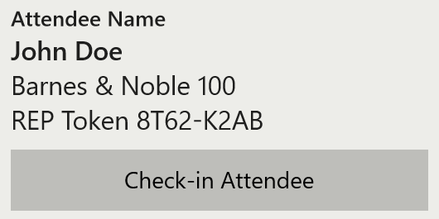
Tap the Check-in Attendee button after each entry. Once the attendee sub-form is completed, return to the main Event Report to complete, review and submit as normal.

Note: the rest of this user guide contains more detailed instructions, troubleshooting and reporting tips. Continue reading on from this point only if needed.

Option 1 - Using EZ ID (requires internet connectivity)
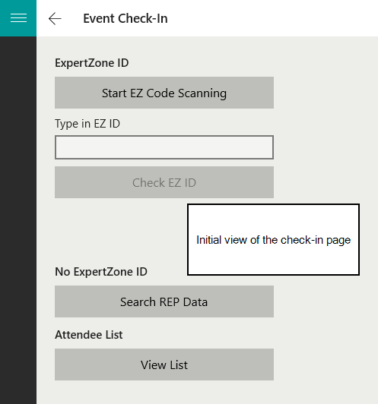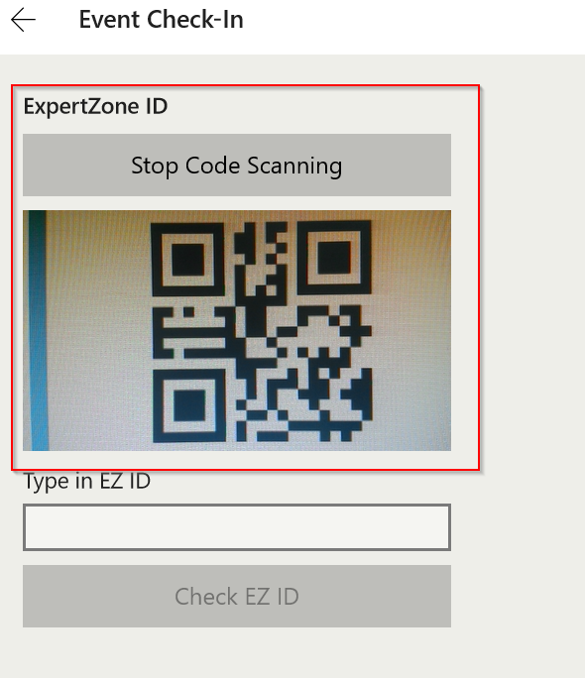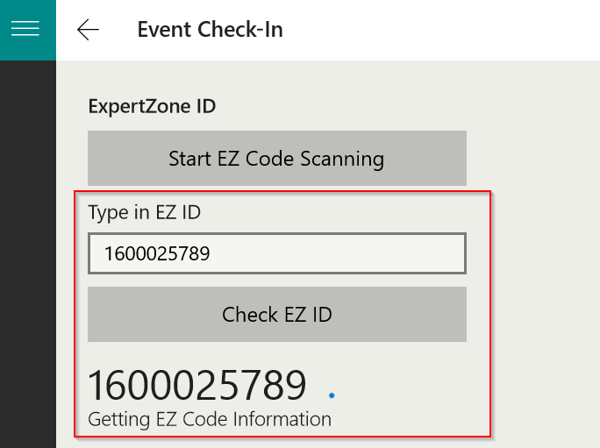

Tap the Start EZ Code Scanning button to open the camera app on the device. Scan the EZ ID QR code or manually enter the EZ ID. If the device is online and the EZ ID is recognized in the ExpertZone database, the RP data will populate. Then click the Check-in Attendee button as shown below.

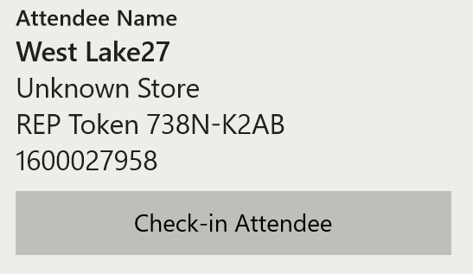

Next, a preview of what would happen if not online, and scanning an EZ ID QR Code or manually entering an EZ ID. The EZ ID is a numeric value that is the ID of the user in the Expert Zone system. It is completely separate from the REP token value.
Rep has 3 options for checking them in. For first 2, the EZ ID becomes a name in the UI.

- Click Check-in Attendee; no retailer is associated with the EZ ID and the attendee is not counted in the reporting as an attendee. (Fully-anonymous)
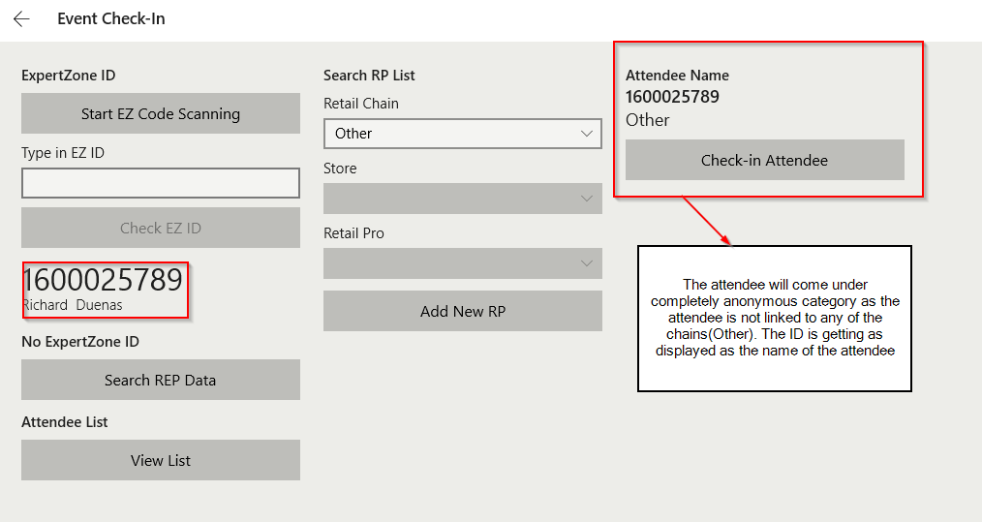

- Click Search REP Data it will let rep pick a retailer to associate with the EZ ID; the attendee is counted in the reporting. (Semi-anonymous). Representatives can also pick a name using this method, which will override the EZ ID being used as the name.

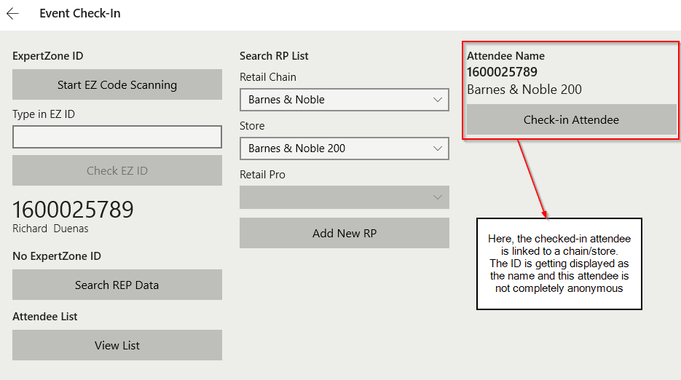
- The rep can still use the Search REP Data button on the left, clearing the EZ ID altogether, and check them in using the downloaded REP database; the attendee is counted in the reporting (“Registered” attendee in our REP database). This clears the EZ ID, so it is only recommended if the ID is suspected to be bad or if the RP decides to just leave and not get checked in.

Option 2 - Using the RP name
The Search Rep Data functionality provides us the access to all the chains, corresponding stores and the RPs under each store in our database. We can check-in attendees in bulk or individually using this method. On clicking the Search Rep Data button, a set of dropdowns gets displayed i.e, Retail Chain, Store and Retail Pro dropdowns. Using Search Rep Data, we can check-in the RPs
- By selecting as chain as Other: Initially, the chain is set to ‘Other’ by default. Using the spinner on the right, we can update the count of attendees. These attendees are completely anonymous and are not considered in dashboard and widgets calculation.
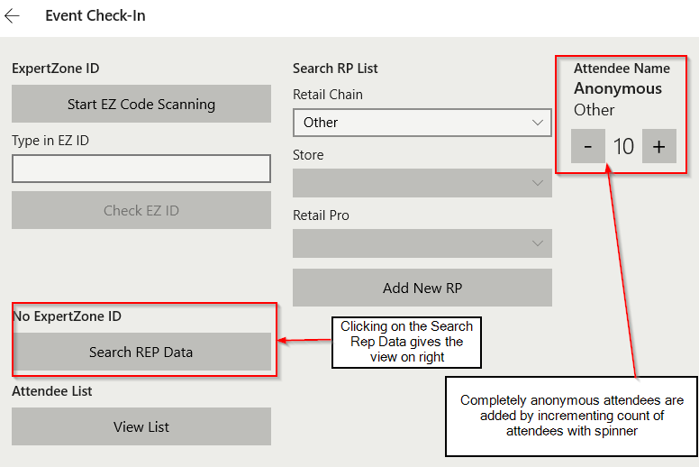
- By selecting a store under a chain or a chain alone: Select a store or just select a chain, keep the Retail Pro drop down as ‘Other’. Add the attendees using spinner and click on check-in attendee. These attendees are semi anonymous and will be considered in dashboard and widgets calculation.
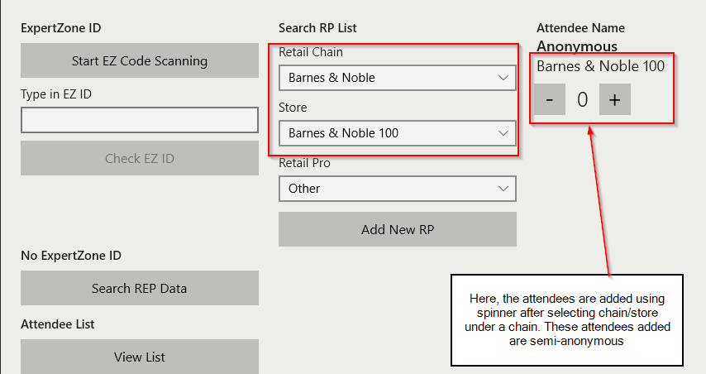

- By selecting an RP by name: On selecting a chain and a store under the selected chain, the RP dropdown becomes active. On clicking this dropdown, we can see the list of RPs under this selected store. Select an RP and click on check-in attendee button to add an RP to the event. The RPs who are checked-in by their name will have their name and store getting displayed with the transaction reports in call report manage page and custom reporting center.
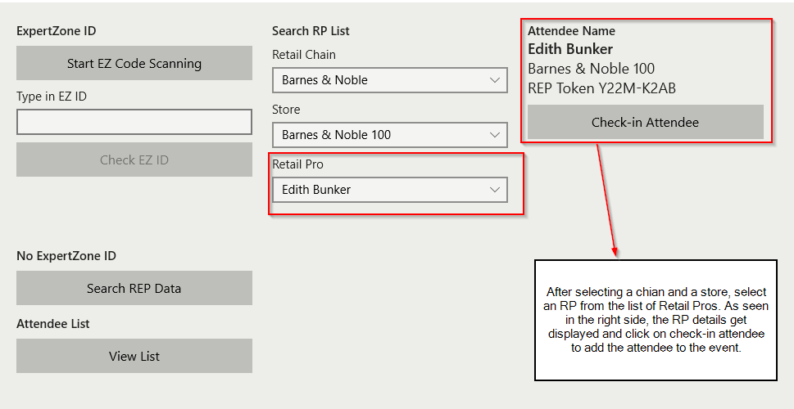
How to add a new RP from Event check in form
- Select a chain and then a store under the selected chain
- Click on Add new RP button
- Fill the fields which are now displayed below the store field ( First Name, Last Name and email )
- Click on the Ready button. On the right side, the RP details gets displayed with their token.
- On clicking the check in button the RP will be checked into the list.
- The new RP will only be added to the database once the event report is submitted to the server.
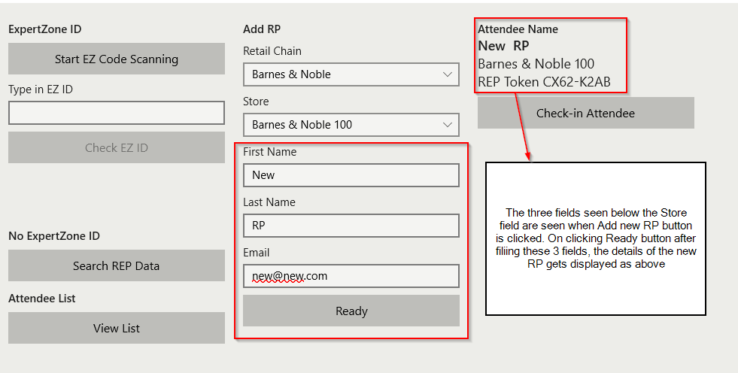

View or Edit the List of attendees checked-in to the event
- The list of attendees checked-in can be seen by clicking on the View List button under the Search Rep Data. The RPs added by name are displayed individually in the list with their chain and token.
- The anonymous RPs are displayed with the count of attendees added under each chain.
- In order to remove a checked-in attendee from the list, select the attendee which then enables a delete button at the bottom the list. The tapping of delete button will remove the attendee. In case of the attendees added in bulk, each click on the delete button will remove the attendees one by one.
