

Sales Form Review
Version 112415

November 24nd, 2105

SALES FORM REVIEW


After reading this document, you should be able to:
Understand the sales tracking options are and its limitations as it is available today.
Track the basic sales of Microsoft products and attach photos, barcodes (Windows Phone Only) and notes.
Make written requests to inform us what modifications this for could take to better fit your sales tracking needs.

Table of Contents
Overview 4
Sales Form – Administration 5
Sales Form – Application Usage 7
Reporting and Dashboard 9
Support 10

Overview
There has been a demand from multiple countries requesting a separate form to track sales. As the needs to track sales are expected to expand in 2016, 2017 and beyond, the sales form presented here should be considered a 1.0 version.
The objective of this first generation sales form is to (1) accommodate the initial needs of Microsoft and (2) to learn what is needed to better accommodate the tracking of sales for all field labor vendors.
The first generation sales forms will come with some basic tracking of Microsoft branded sales items as well as optional photo support, notes and barcode support. Note about barcode support. This option is only available to Windows Phone users. It is not interactive with inventory, server data, etc. The barcode function will simply lift a barcode off of a box and place that alphanumeric value in a field to be sent in with the record.
Feedback:
We are aware that no one sales form will accommodate everyone the same way. We are asking the field to help drive the second generation of this sales form by providing feedback for approximately 90 days (to early March 2016). Feedback will be reviewed ongoing during this time and will be considered for the next generation of the sales form. Please send feedback to:
- Email: msftreps@westlakesoftware.com
- Subject Line: Sales Form Feedback
- Body: Provide whatever detail is necessary to allow us to best understand your change request to the Sales Form.
Thank you for your assistance. We hope to launch this new feature to all countries soon after this short trial period.
Westlake Management Team

Sales Form – Administration
When the Sales Form is placed into your country account, it will list like the other forms you support today.
When the Sales Tracker form becomes available in your account, it will be in non-active status. Check to show Inactive in Call Report – Manage page; select configure to the right of the Sales Tracker form:
Check the Active box and select Save:
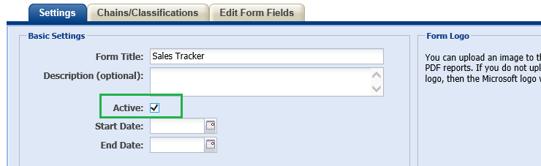
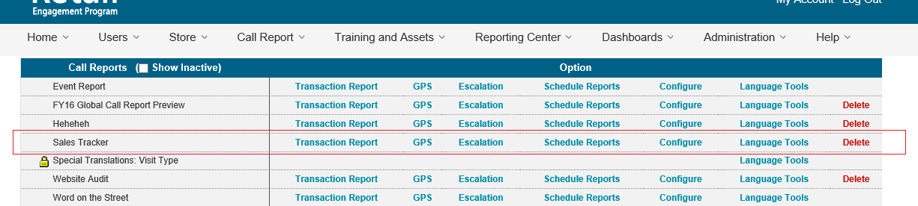
This will enable the Sales form and make it Live in your account. This will also turn on Transaction Reports, Escalation, Scheduled Reporting, Configuration and Language Tools are all support in a similar way to other forms in the system.
To get started:
- Select Configure in the screen shot above next to Sales Tracker
- Click on Tab: Edit Form Fields
- Scroll to bottom of options to see pictures, barcode and comments options.
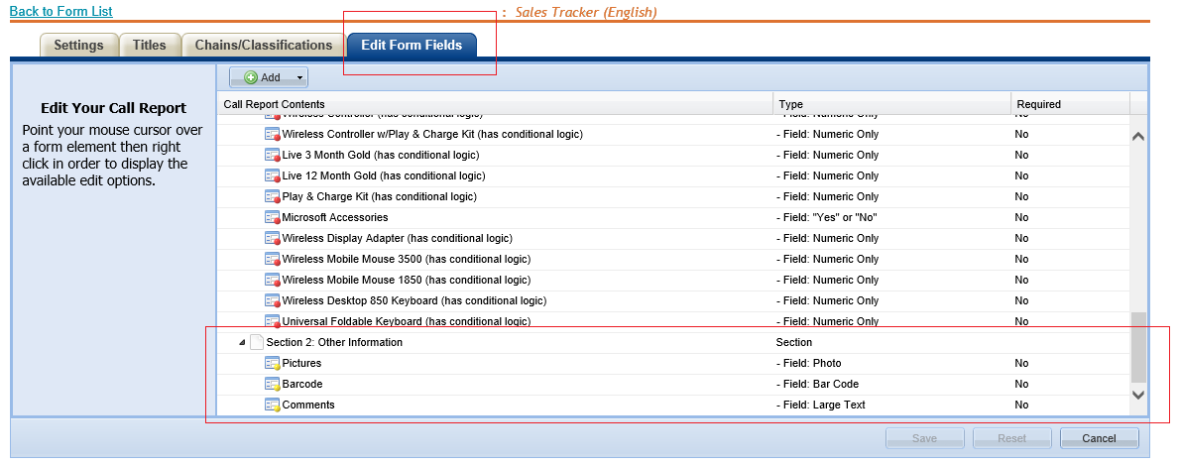
In addition to mandatory non-editable product fields and some additional demographic information (demographic questions not shown at the time of this manual), the options of Pictures, Barcoding and Comments are optional to use. You can remove them or keep them for your sales form.
Note: Barcoding is only supported for/by Windows Phone. If you opt to leave the barcoding option as active, it will only show up as a field to use using Windows Phone and not on Surface or any other PC device.
You may also use the other tabs above to select to have this form only show up with certain titles and certain chains of stores.

Note all of the following:
- There is no option at this time to create multiple sales forms
- There is no option at this time supporting the sales form in the Dashboard
- There is no option at this time in supporting the sales form in the custom reporting center
In this basic state, the form is available to use and you can collect data with it to the transaction report. Sales forms can be exported from there to Microsoft Excel for further analysis as desired.
Why all the limitations?
This sales form is a 1.0 version. We are seeking your feedback (see overview) to assist us in the direction of what else can be added (features, collection, reporting data to dashboard, etc.).

Sales Form – Application Usage
The Sales form behaves similar to other forms currently in the system. When available in Windows, the Sales Tracker form can be accessed by clicking on the shopping cart icon; in Windows Phone, Sales Tracker will be present in the menu system:
Windows | Windows Phone
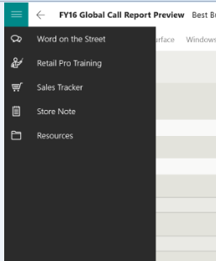 | 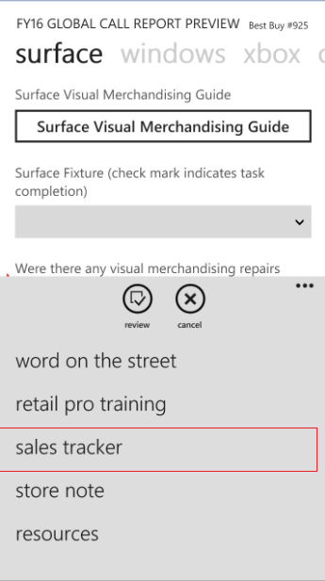

The Sales form is heavy conditional logic driven. The list of core product are collapsed. Once you check a product, additional detail about how many of that product was purchased and tracking for additional attachments:
Collapsed view of the Products list:
Windows | Windows Phone
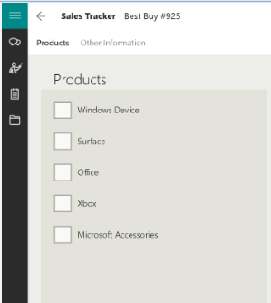 | 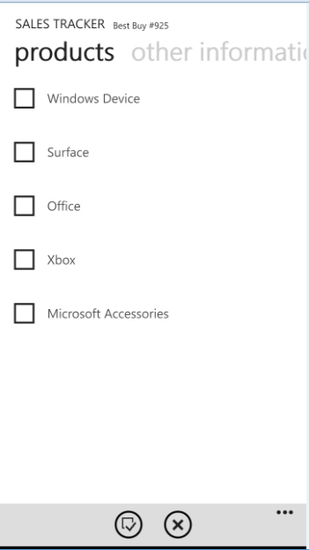

Expanded View of the Products list:
Windows | Windows Phone
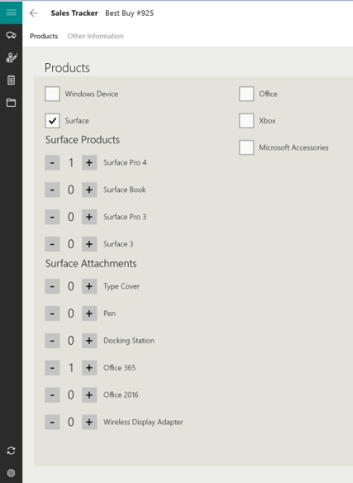 | 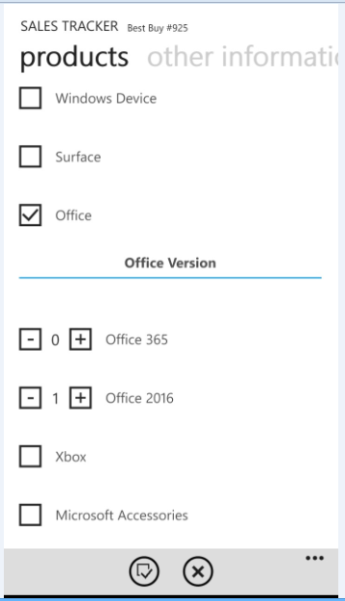

Use the + and – options next to each product and possible attachment to denote what items transacted in this one sale.
Swipe to the next section, Complete some basic demographic information, then take a photo (optional feature denoted by the Admin), scan a barcode (optional feature denoted by the admin and only for Windows Phone and or add notes (optional field denoted by the admin).
Other Information:
Windows | Windows Phone
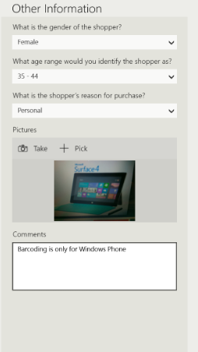 | 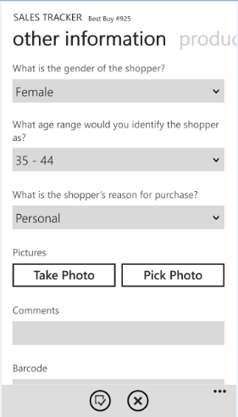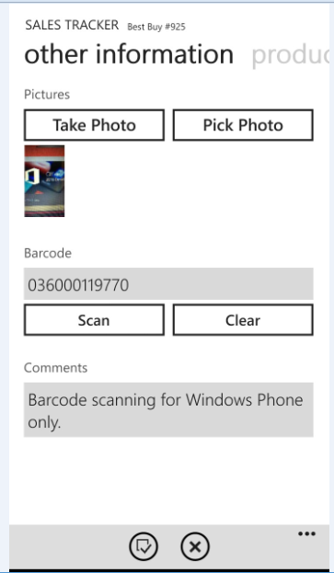

Select to review/verify the sales tracker data and submit.

Reporting and Dashboard
Version 1.0 of the sales form supports limited reporting and no dashboard capabilities as of yet. All sales tracker data can be exported though the Transaction Report option in Call Reports – Manage.

Support
There are two ways to contact us for help and support:
Website: https://www.msftreps.com and then use the Help menu to open a support ticket.
Email: msftreps@westlakesoftware.com
Make sure if you include all necessary details to describe the issue. Details include:
- Screenshots ( if applicable)
- Contact information
- Device model / type
- Every step taken that caused the problem (filter settings, what you clicked on and in what order, can you repeat the process, etc.).
- Expected behavior and behavior you experienced
Thank you
Westlake Support Team

