SALES TRACKER
Sales Tracker is a form that is designed to enable you to track sales of Microsoft Products. This form is expected to change over time and at times with little to no notice to Reps. This quick overview covers the first generation of the Sales Tracker form. The form acts similar to WOTS, RP Training, etc. For Windows, click on the Shopping Cart icon; for Windows Phone, select from the Menu a shown:
Windows | Windows Phone
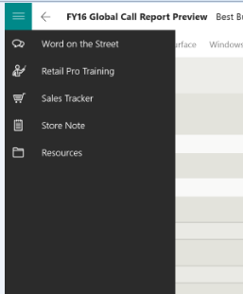 | 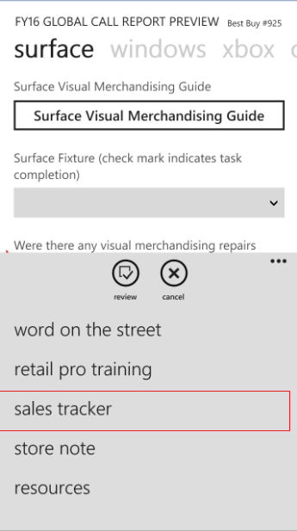

The initial view will show Microsoft Products in a collapsed view as shown here:
Windows | Windows Phone
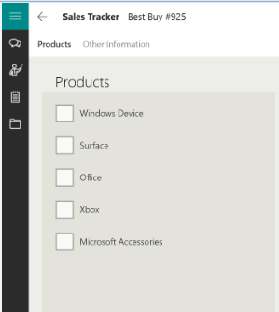 | 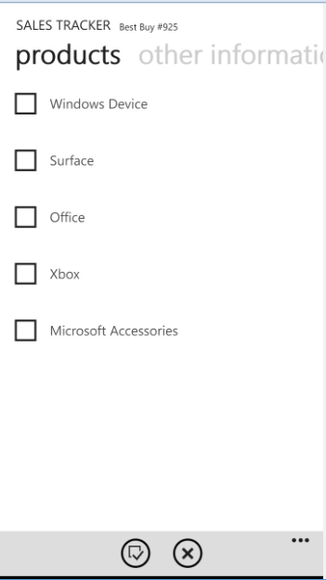

When you click on a Microsoft Product, the section will expand and ask you (1) how many were sold in this transaction and (2) if applicable, track the number of attachments sold along with that product:
Windows | Windows Phone
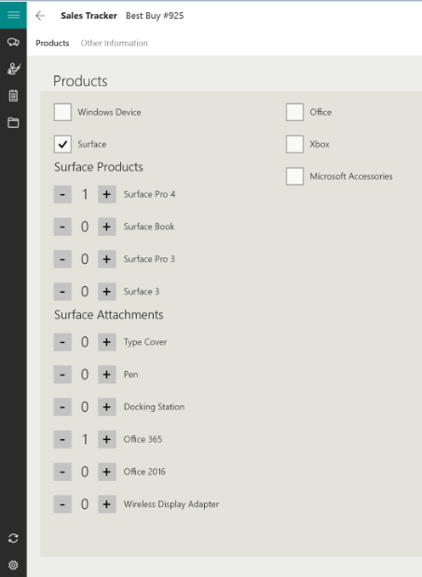 | 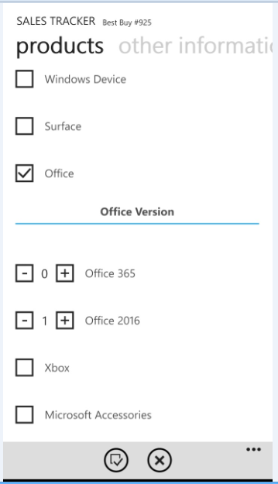

After the Products section, you may find several additional questions around demographics and may be asked to take a photo, scan a barcode (Windows Phone only), notes, etc. Complete like any other form by review and submit:
Windows | Windows Phone
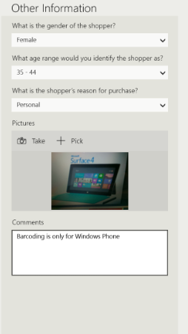 | 